Sources:

CISC190 Java Programming

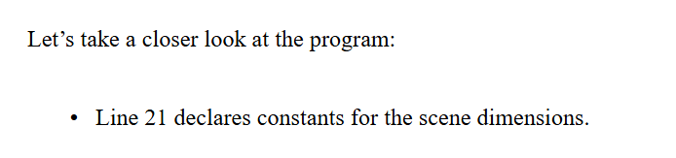

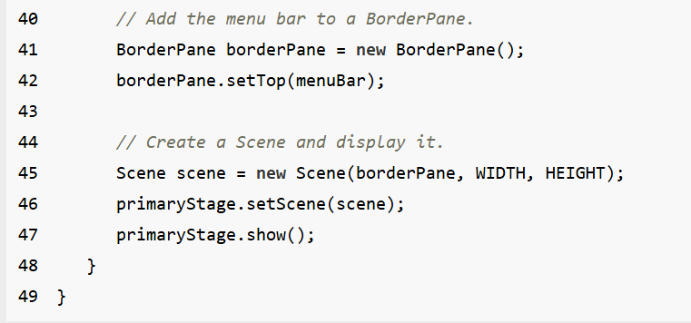

Ex:

**package** application;

**import** java.util.ArrayList;

**import** javafx.application.Application;

**import** javafx.stage.Stage;

**import** javafx.scene.Scene;

**import** javafx.scene.control.Label;

**import** javafx.scene.control.Button;

**import** javafx.scene.control.TextField;

**import** javafx.scene.image.Image;

**import** javafx.scene.image.ImageView;

**import** javafx.scene.control.ListView;

**import** javafx.scene.control.SelectionMode;

**import** javafx.collections.ObservableList;

**import** javafx.scene.control.ComboBox;

**import** javafx.scene.control.MenuBar;

**import** javafx.scene.control.Menu;

**import** javafx.scene.control.MenuItem;

**import** javafx.scene.layout.HBox;

**import** javafx.scene.layout.VBox;

**import** javafx.scene.layout.GridPane;

**import** javafx.scene.layout.BorderPane;

**import** javafx.scene.layout.StackPane;

**import** javafx.scene.layout.AnchorPane;

**import** javafx.geometry.Insets;

**import** javafx.geometry.Pos;

**import** javafx.event.ActionEvent;

**import** javafx.event.EventHandler;

**public** **class** **Main** **extends** Application {

**public** **Label** label1;

**public** **Button** button1;

**public** **HBox** hbox1;

**public** **VBox** vbox1;

**public** **BorderPane** borderPane1;

**public** **Scene** scene;

**public** **static** **void** **main**(**String**[] args) {

***launch***(args);

}

**@Override**

**public** **void** **start**(**Stage** primaryStage) {

primaryStage.**setTitle**(**"GUI Applicaiton"**);

**MenuBar** **menuBar1** = **new** **MenuBar**();

**Menu** **menu1** = **new** **Menu**(**"⏬ Menu"**);

**MenuItem** **menuItem1** = **new** **MenuItem**(**"1. Image"**);

**MenuItem** **menuItem2** = **new** **MenuItem**(**"2. Tools"**);

**MenuItem** **menuItem3** = **new** **MenuItem**(**"3. Exit"**);

menu1.**getItems**().**addAll**(menuItem1,menuItem2,menuItem3);

menuBar1.**getMenus**().**add**(menu1);

menuItem1.**setOnAction**(**event**->{

label1.**setText**(**"Result: "**+menuItem1.**getText**());

});

menuItem2.**setOnAction**(**event**->{

label1.**setText**(**"Result: "**+menuItem2.**getText**());

});

menuItem3.**setOnAction**(**event**->{

primaryStage.**close**();

});

button1 = **new** **Button**(**"👉 Click Me!!!"**);

label1 = **new** **Label**(**"Result: "**);

vbox1 = **new** **VBox**(**10**, menuBar1, button1, label1);

vbox1.**getStyleClass**().**add**(**"main_content1"**);

vbox1.**setPadding**(**new** **Insets**(**10**));

vbox1.**setAlignment**(Pos.**CENTER**);

borderPane1 = **new** **BorderPane**();

borderPane1.**setCenter**(vbox1);

scene = **new** **Scene**(borderPane1);

scene.**getStylesheets**().**add**(**"file:style1.css"**);

primaryStage.**setScene**(scene);

primaryStage.**show**();

}

}

