**Faculty of Computer Science and Engineering**

**Ho Chi Minh City University of Technology**



Nguyễn Phương Vương – 1614186

Lab 2

Môn kiểm thử phần mềm

# Testcase cho project

import org.junit.Test;  
import static org.junit.Assert.*;  
public class TriangleTypeTest {  
 TriangleTester test = new TriangleTester();  
 TriangleType output;  
 //Test phuong thuc delta  
 @Test  
 public void test_Delta() {  
 test.setDelta(0.002);  
 double delta = test.getDelta();  
 *assertEquals*(0.002, delta, 1);  
 }  
  
 //------------------  
 //Test tam giac deu khong  
 @Test  
 public void test_EquiTri_1() {  
 output = test.kindOfTriangle(10, 10, 10);  
 *assertTrue*(output.isEquilateralTriangle());  
 }  
  
 //------------------  
 //Test do la tam giac can k  
 @Test  
 public void test_IsoTri_1() {  
 output = test.kindOfTriangle(1, 4, -10);  
 *assertFalse*(output.isIsoscelesTriangle());  
 }  
 @Test  
 public void test_IsoTri_2() {  
 output = test.kindOfTriangle(5, 5, 5);  
 *assertTrue*(output.isIsoscelesTriangle());  
 }  
 //------------------  
 //Test do la tam giac hop le khong  
 @Test  
 public void test_NotTri_1() {  
 output = test.kindOfTriangle(2,5,10,0.02);  
 *assertFalse*(output.isRightTriangle());  
 }  
 @Test  
 public void test_NotTri_2() {  
 output = test.kindOfTriangle(11,3,10,0.02);  
 *assertFalse*(output.isRightTriangle());  
 }  
 @Test  
 public void test_NotTri_3() {  
 output = test.kindOfTriangle(-1,15,9,0.02);  
 *assertFalse*(output.isRightTriangle());  
 }  
 //------------------  
 //Test tam giac phai ko?  
 @Test  
 public void test_RighTri_1() {  
 output = test.kindOfTriangle(3, 4, 5);  
 *assertTrue*(output.isRightTriangle());  
 }  
 @Test  
 public void test_RighTri_2() {  
 output = test.kindOfTriangle(3, 5, 4);  
 *assertTrue*(output.isRightTriangle());

}  
 @Test  
 public void test_RighTri_3() {  
 output = test.kindOfTriangle(5, 4, 3);  
 *assertTrue*(output.isRightTriangle());  
 }  
}

Kết quả kiểm thử các test:

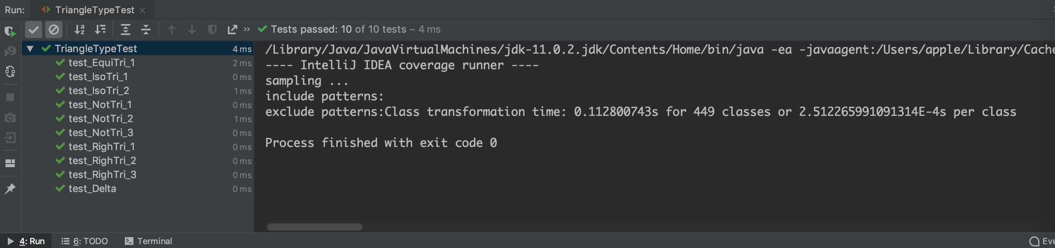

Đánh giá độ phủ: 100%

