|  |  |
| --- | --- |
|  | |
| **Intelligent Tourist Recommender System** | |
| Version 1.0 | |
|  | |
| Author: | Quan Thanh Tho |

|  |
| --- |
| HCMUT, Nov 2014 |

**Document History**

|  |  |  |  |
| --- | --- | --- | --- |
| **Date** | **Version** | **Changes** | **Changed by** |
| Nov 05, 2014 | 1.0 | Initial Proposal | Quan Thanh Tho |
|  |  |  |  |
|  |  |  |  |

Table of Contents

1. Introduction 4

2. System Vision 4

3. Current Status 5

4. Suggested Solutions 5

5. Conclusion and Future Work 5

# Introduction

This document presents an approach for the development of an intelligent Tourist Recommender System, to be applied at Airlink company. The proposal is made by Laboratory of Systems Analysis and Verification (SAVE), Ho Chi Minh City University of Technology.

Once successfully done, this approach will help Airlink to distinguish itself with other competitors by the intelligent techniques that can automatically recommend a potential customer the appropriate tours matching with customer's need.

# System Vision

The proposed Tourist Recommender System is given in Figure 1.

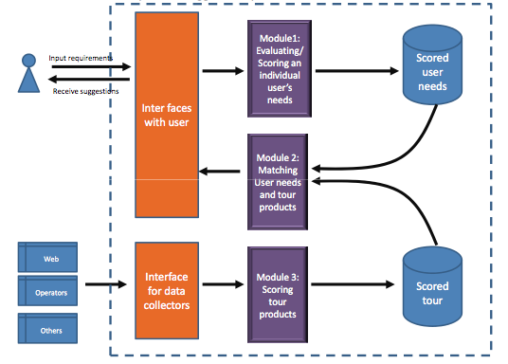

Figure 1 – The intelligent Tourist Recommender System

As described in Figure 1, the Tourist Recommender System consists of three major modules as follows:

- *Module* 1*:* It collects feedback/comments from users regarding tour quality. Then, the comments are processed and evaluated as numerical scores of the mentioned tour. The evaluated scores are then stored in database for further use. For Vietnamese market, the Natural Language Processing (NLP) techniques for local language are heavily involved.

- *Module* 3*:* It collects information from the Web, operators and other external sources. Information collected from there sources can be automatically standardized and evaluated as scores and stored to database.

- *Module* 2*:* It integrates information collected from *Module* 1 and *Module* 3 to recommend an appropriate tour for users. Some intelligent matching and decision making techniques are needed for this module.

# Current Status

Currently, a simple version of *Module* 2 is being implemented by two undergraduate students from HCMUT. Some engineers from Airlink may be needed for enhance this module for practical usage upon its preliminary completion.

Thus, Module 1 and Module 3 are the target of this proposal.

# Suggested Solutions

We propose to investigate solutions and develop prototypes for *Module* 1 and *Module* 3. The tentative schedule would be:

- Module 3 development: 1 year, including interface.

- Module 1 development: 1 year, with a certain level of language processing (i.e. the system may fail with some complex Vietnamese sentences, but yield high accutate rating for normal Vietnamese sentences).

We propose the support from Airlink as follows:

- The financial support of 25,000 USD for 2 years of research. The support can be transfer yearly. That is, the support of the second year will be made based on the review of the achievement of the first year.

- At least one engineer will co-operate in terms of system implementation. This engineer will enhance our research prototype into workable package for the real system at Airlink.

During the project development, monthly meetings will be organized by all members of two parties to review, evaluate and adjust the directions if needed.

# Conclusion and Future Work

In this proposal, we propose an approach of an intelligent Tourist Recommender System for Airlink company. Such system can help Airlink benefit from not only more productive operations but also distinguishing itself from other competitor. In the near future, we are looking forward to collaborating with Airlink to make this proposal practical.