# ESTUDIEZ

# PORTAL

|  |
| --- |
| **SOFTWAVE REQUIREMENTS SPECIFICATION** |
| **VERSION 1.0** |

### LINK DEMO

Team’s website: <https://phuopham.github.io/Techwiz2022/#!/>

Home team on GitHub: <https://github.com/phuopham/Techwiz2022>

Data access:

1. Student: Nguyen Hoang Nam
2. Teacher: Le Kim Tung
3. Parent: Tran Duy Anh

### PROBLEM DEFINITION

Nowadays, education and training is a field that plays an important role for all countries and ethnic groups at all times. In today’s trend of knowledge development, education – training is considered the most important policy and measure for development in many countries around the world and VietNam is no exception. Education contributes to raising people’s intellectual level in all countries and ethnic groups. Today, education and training also contribute to the creation of a new social value system. In the current knowledge economy, knowledge is the product of education and training and the most valuable asset of people and society. Ownership of knowledge becomes the most important property recognized and protected by countries. Resources for socio-economic development in each country and ethnic group from natural resources and muscular labor are the main sources of human resources, whose knowledge is the most basic.

However, the general education system still has many difficulties in updating and managing information in the learning process of students for Teachers/Parents/Guardians. Students who fail exams might not reveal their marks to their Parents/Guardians because of fear. Teachers too are overloaded with work, because of which it becomes difficult to remember each child’s academic progress. Also, students too must be kept aware of their score progress and marks required for passing External Exams.

With the power of technology 4.0 – the period of strong development of artificial intelligence and the internet, those difficulties are gradually solved. Therefore, it helps teachers easily remember students' learning progress and have a reasonable teaching direction. Their parents update their child’s information accurately and quickly.

And we – the HelloWorld.txt team bring the design of a website called “eStudiez” that will be used to track students' academic progress born. The system will accept different types of users such as students, Parents/Person Guardians, and Teachers to view and track progress. Students with poor academic performance will be provided with additional materials through this portal to improve their performance your

your ability. The Portal will also provide information about Exam Preparation classes to improve performance. Students and Parents/Guardians can view and track the student’s progress.

To have the main benefits of the website, "eStudiez Portal" is built with functions that are highly interactive, easy to manipulate, and suitable for ages and positions. Following are the functions available in the "eStudiez Portal".

### DESIGN SPECIFICATIONS

### DIAGRAMS

Diagram showing the relationship of data between json files

### DATABASE DESIGN

According to the requirement specification, we decided to manipulate the JSON file with a structure of 3 JSON files as follows:

1. feedback.json

Contain a list of feedback. Each feedback has the following entry:

* Recipient name
* Sender name
* Title of the feedback
* Main content of the feedback

Content file:

[

    {

        "from": "Tran Danh Tu",

        "to": "Tran Duy Anh",

        "title": "You are good at math",

        "message": "Please work hard on Physic"

    },

    {

        "from": "Le Kim Tung",

        "to": "Tran Duy Anh",

        "title": "You are so good at math",

        "message": "Help your friends"

    },

    {

        "from": "Tran Duy Anh",

        "to": "Le Kim Tung",

        "title": "You are not good at math",

        "message": "Please work hard"

    },

    {

        "from": "Nguyen Hoang Nam",

        "to": "Le Kim Tung",

        "title": "You are good at physic",

        "message": "Please help Nguyen Van A on exercise 5"

    }

]

1. revclass.json

Contain a list of teachers with their classes. Each of the items has the following entry:

* Name of responsible teacher
* Name of student
* Schedule for the next learning lesson

Content file:

[

    {

        "studentname": "Nguyen Hoang Nam",

        "teacher": "Le Kim Tung",

        "time": "2022-08-10 08:00:00"

    },

    {

        "studentname": "Nguyen Toan",

        "teacher": "Le Kim Tung",

        "time": "2022-08-10 08:00:00"

    },

    {

        "studentname": "Nguyen Phuong",

        "teacher": "Nguyen Duy Anh",

        "time": "2022-08-10 14:00:00"

    },

    {

        "studentname": "Tran Nam",

        "teacher": "Nguyen Duy Anh",

        "time": "2022-08-10 14:00:00"

    }

]

1. students.json

Contain a list of students. Each student will have the following entry:

* Name of student
* Name of parent or guardian
* Name of responsible teacher
* Marks of 3 subjects
* Study the progress of the student, which is evaluated by the responsible teacher

Content file:

[

    {

        "name": "Nguyen Hoang Nam",

        "mark": {

            "math": 10,

            "physic": 7,

            "chemist": 6

        },

        "parents": "Tran Duy Anh",

        "progress": "60",

        "teachername": "Le Kim Tung"

    },

    {

        "name": "Nguyen Hoang A",

        "mark": {

            "math": 5,

            "physic": 7,

            "chemist": 8

        },

        "parents": "Tran Toan",

        "progress": "80",

        "teachername": "Le Kim Tung"

    },

    {

        "name": "Nguyen Hoang V",

        "mark": {

            "math": 6,

            "physic": 8,

            "chemist": 8

        },

        "parents": "Le Kim Tung",

        "progress": "30",

        "teachername": "Tran Duy A"

    },

    {

        "name": "Nguyen Hoang S",

        "mark": {

            "math": 9,

            "physic": 5,

            "chemist": 7

        },

        "parents": "Tran Duc",

        "progress": "50",

        "teachername": "Tran Duy A"

    }

]

### FEATURE DESCRIPTION

Users click on the Start Now box to have the computer screen scroll down to the bottom of the page

1. Home page

If the input data is correct, the login will be successful and the user will be notified.

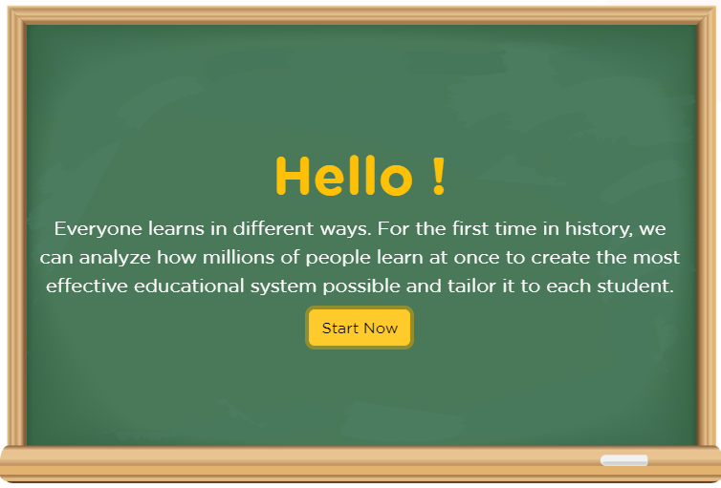

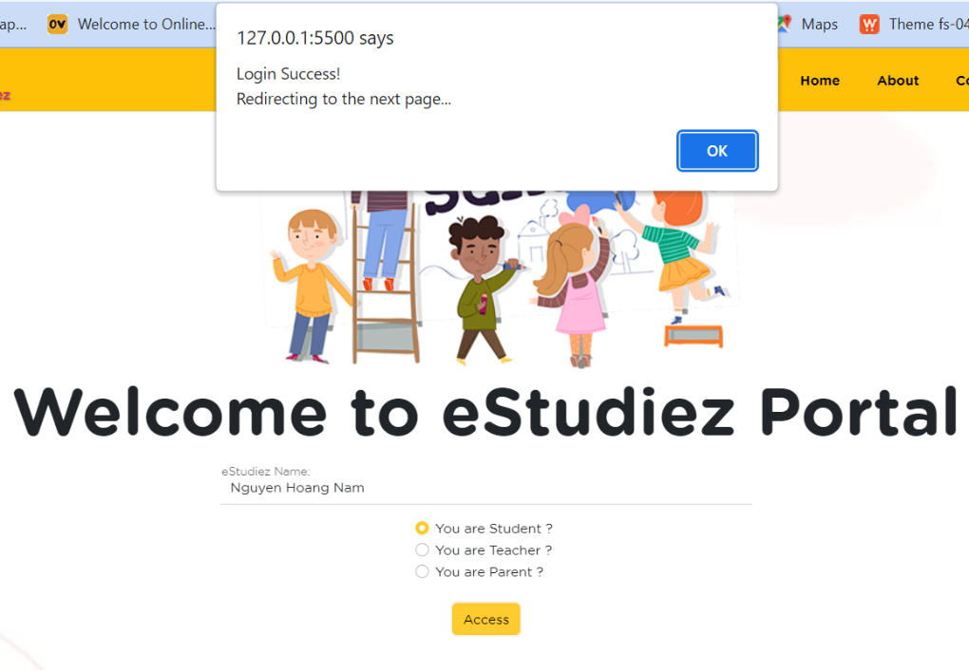

The user enters their name and selects their role, and clicks on the Access box to sign in.

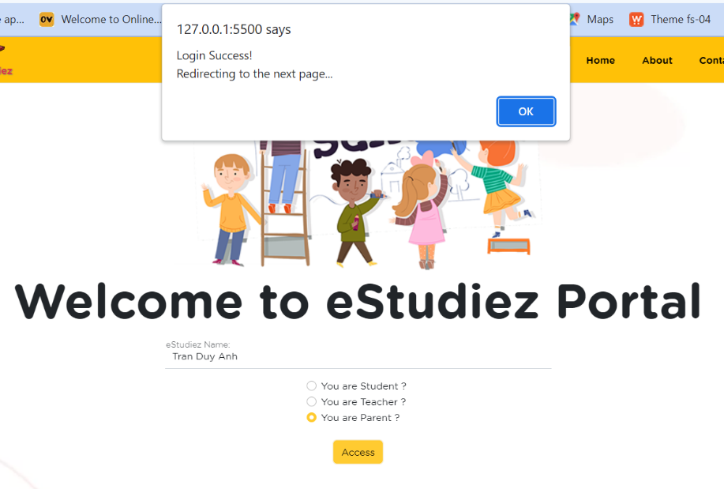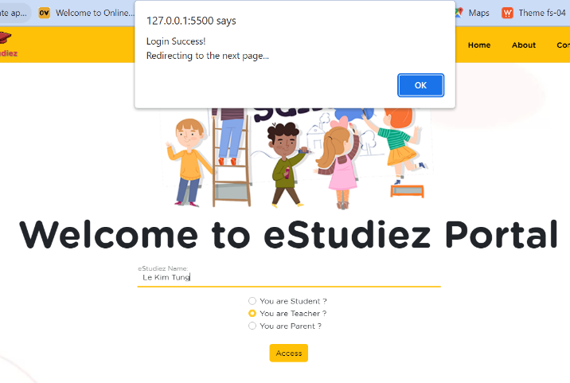

The user enters their name and selects their role, and clicks on the Access box to sign in.

If the input data is correct, the login will be successful and the user will be notified.

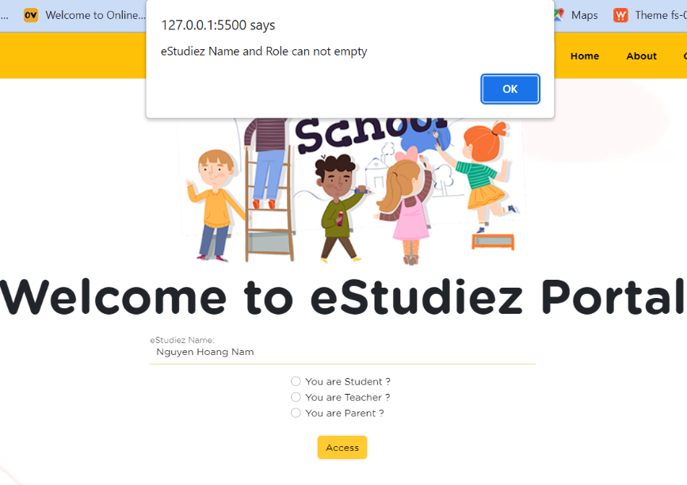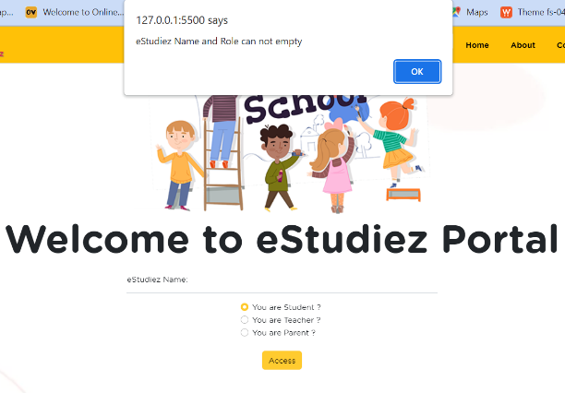

If the user is logged in with only their name or role, there is an error and message to the user.

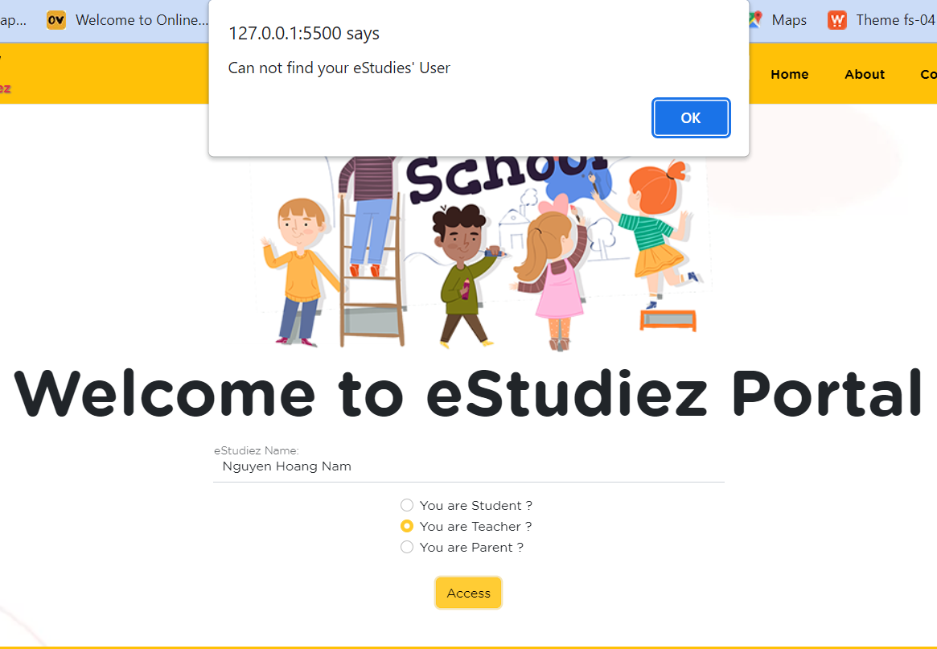

If the user is logged in with the correct name, the wrong role, or vice versa, there is an error and notify the user.

1. 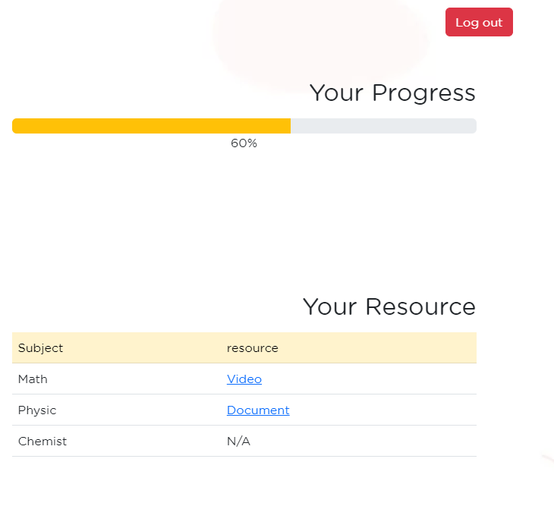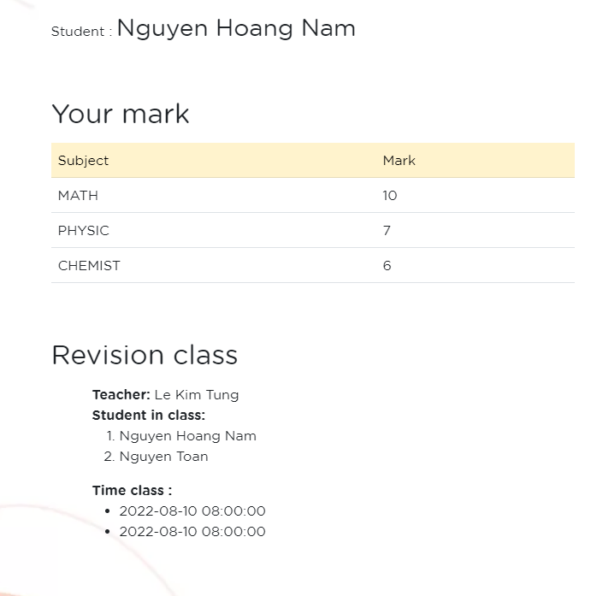Student page

Return to the home page

Display student information: full name, grades, learning progress, class information, and learning materials.

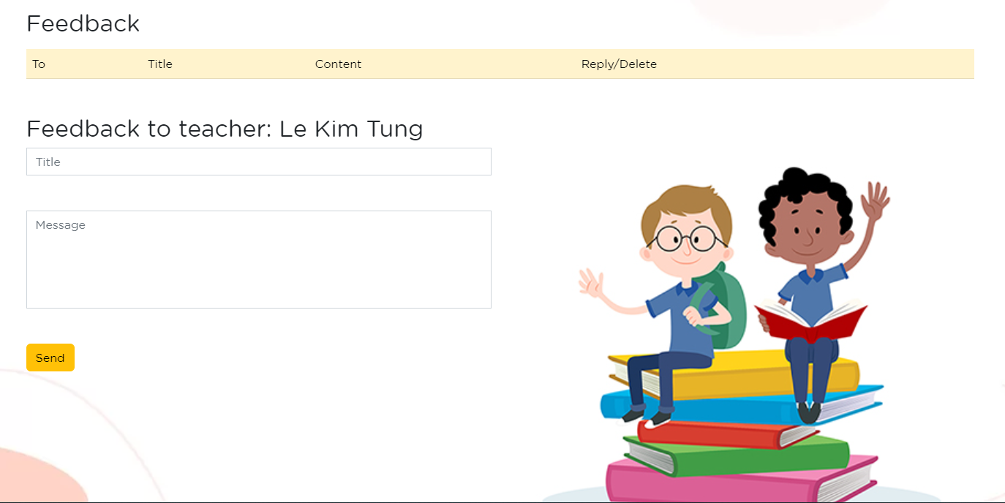

The feedback menu option should enable users to provide their feedback on the issues they are facing through the feedback form.

1. 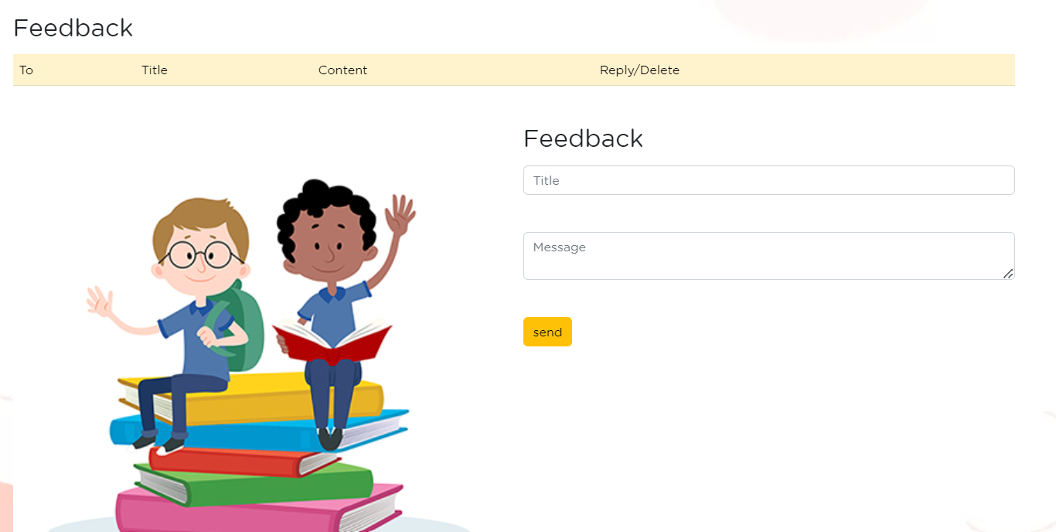Parent page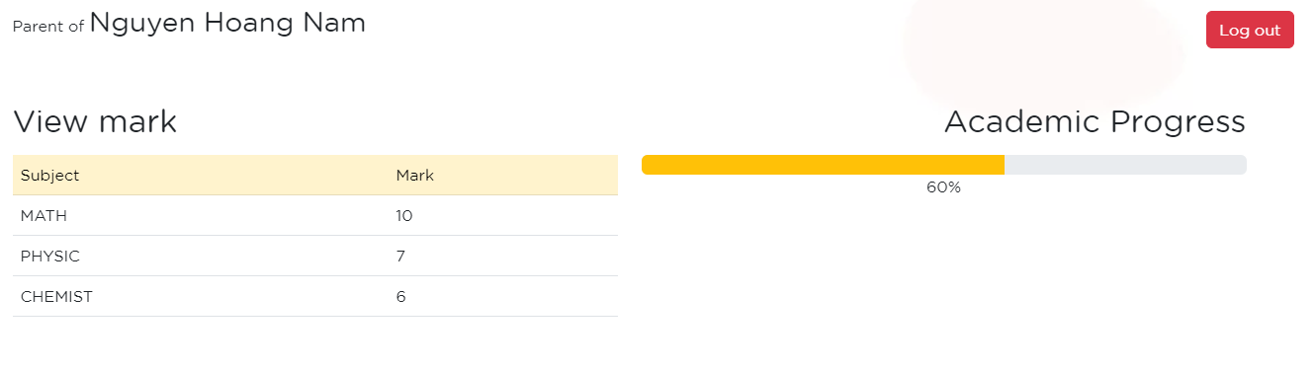

Return to the home page

Display student’s full name, grades, and academic progress.

The feedback menu option should enable users to provide their feedback on the issues they facing through the feedback form.

1. Teacher page

Where teachers add, edit and delete students and their grades.

Where the teacher adds to learn the material.

Where the teacher adds to the student’s timetable.

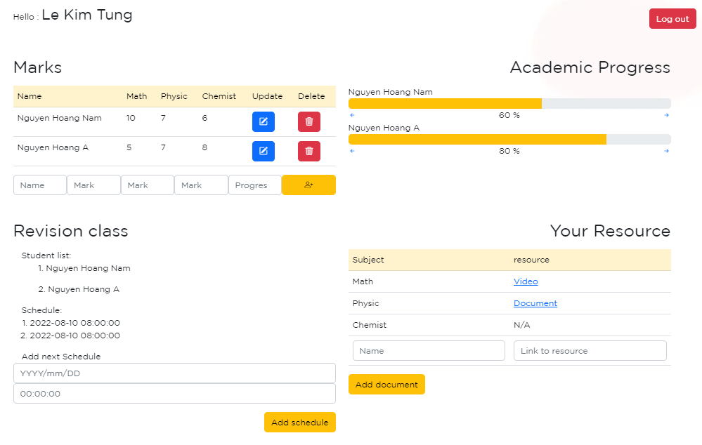

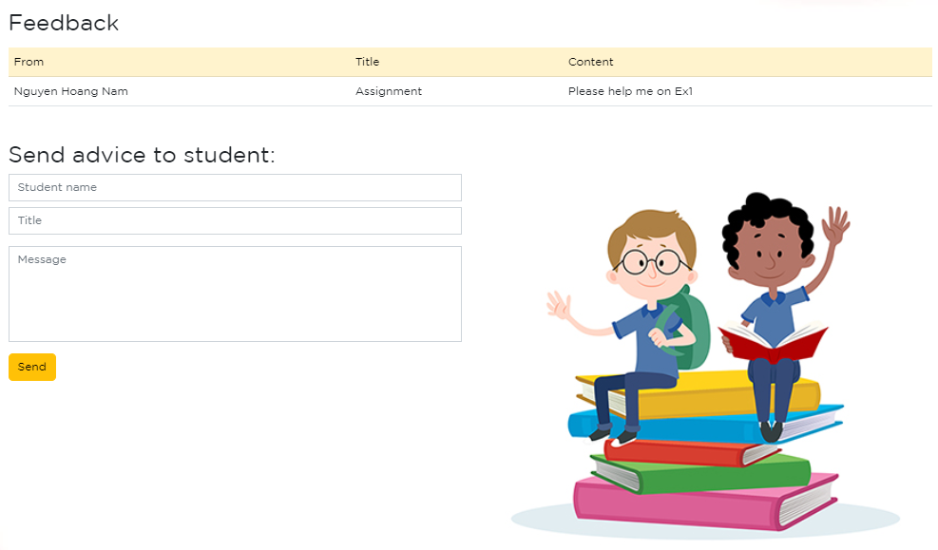

Section receiving feedback from students and their parents.

Where teachers exchange information with students.

### STRESS TEST REQUEST

### FUNCTIONAL REQUIRE