Curriculum vitae

Personal Details
FullName: | Bui van Nguyen | 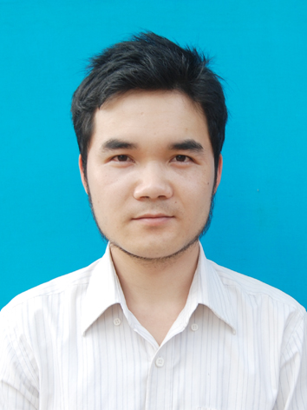
Gender: | Male
Marital status: | Single
Date of birth: | 13/02/1989
Place of birth: | Thanh Hoa –Vietnam
Email: | toi@buivannguyen.com
Website: | http://buivannguyen.com
Mobile: | 086-8871-330

Skills:

- Independent or team work
- Team lead
- Communication and interpersonal skills
- Writing skill, i'm a blogger, writer
- Catch new technologies quickly

Work Experences:

- 4 years in web development with PHP – MySql, Codeigniter framework, MVC partern, Object oriented programing
- HTML, CSS
- Design template by using Photoshop
- Psd to html, css
- Javascript, Bootstrap, Jquery, jquery mobile
- Other: git, svn, less, phonegap...
Projects:

(For more projects, please visit: http://dev.buivannguyen.com)

HocVui E-learning network
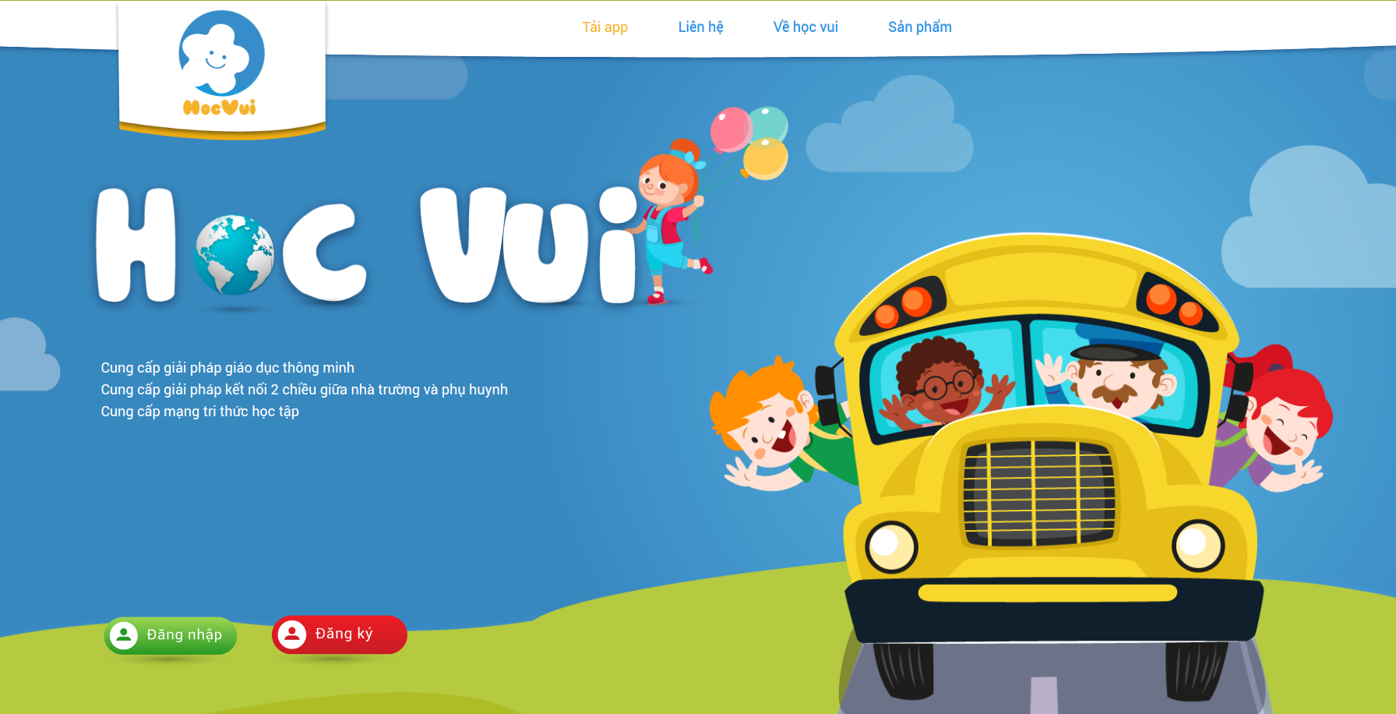 | Project description: |  | An e-learning network for kids with many feature as a social network, communicate teachers and students.
 | Position: |  | Team leader, backend developer, research
 | Used programing languages: |  | Php, PostgreSql, NodeJs, HTML5 canvas
HVN web builder
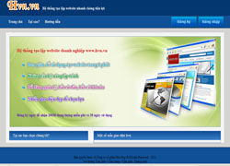 |  | Project description: |  | A website builder to create custom website with no coding skills needed. Run on subdomain or custom domain.
 |  | Position: |  | Developer
 |  | Used programing languages: |  | Php, mysql, html, javascript, css
Based wap pet online game
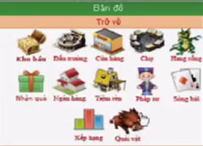 |  | Project description: |  | A wap based wap online game, play on mobile phone browser with many features
 |  | Position: |  | Developer
 |  | Used programing languages: |  | Php, mysql, html, javascript, css
Malibu Travel website
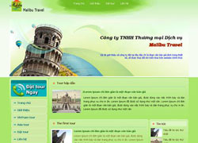 |  | Project description: |  | Official website of Malibu Travel company
 |  | Position: |  | Developer, designer
 |  | Used programing languages: |  | Php, mysql, html, javascript, css
T&T Company website
 |  | Project description: |  | Official website of Dalat T&T company
 |  | Position: |  | Developer
 |  | Used programing languages: |  | Php, mysql, html, javascript, css

Strengths and Weakness:

- Strengths:
  - Creative thingking and logical, fast absorbing
  - Aesthetic
  - Passion for web development
- Weakness: Indetermined

Hobbies and characters:

- Hobbies: Program, write Blog, Sing Karaoke, Perform magic tricks, making robots by using arduino board.
- Characters: Sociable, humor, hard-working

More Information:

- Have the ability to search for information on the Internet
- The ability to express
- Have relationship with webmaster, take part in more forum as ddth.com, vn-zoom.com, thongtincongnghe.com
- Read and understand English document
- Smoking
- In addition, for more information, you can visit my website http://buivannguyen.com

