|  |  |
| --- | --- |
| **CSDE 502 Winter 2021**  **Assignment 10**  **Introduction to Add Health**  **Instructor: Phil Hurvitz**  [**phurvitz@uw.edu**](mailto:phurvitz@uw.edu) | **My Name:**  **My UWNetID:** |

**Due Date: 2020-03-18 09:00**

**Instructions:**

1. Fill out your name and UWNetID at the top of this page.
2. Add your answers to this document.
3. Use the "00Answers" style (

Calibri font

1. ) for your answers so they will be clearly discernible from the questions.
2. When you are completed with your work, create a PDF from the Word document.
3. Name your PDF document with the pattern UWNetID_HW_n.pdf where UWNetID is your UWNetID and n is the week number when the homework was assigned. For example, the first assignment by me would be named *phurvitz_HW_1.pdf*. Upload your completed document to Canvas.
4. Upload any specified data or code files to Canvas.

**Explanation**:

This exercise will give you the opportunity to define and execute a brief research project. The intention is for you to use some of the data processing skills you have learned in this course to a novel data set. The second objective is for you to create a report in R Markdown to create html and PDF documents that include both your code and output. The third objective is for you to become minimally introduced to GitHub—at least to the point where you have created an account and uploaded your work.

1. Go to <http://www.mortality.org>.

2. Create a user name and password.

3. Click a link for a country.

4. Download one or more of the data files (for example, the 1 age x 1 year deaths data link is shown in Figure 1. You will be prompted for your username and password when you access the first file. To download the file, R-click the link and then *save as*.

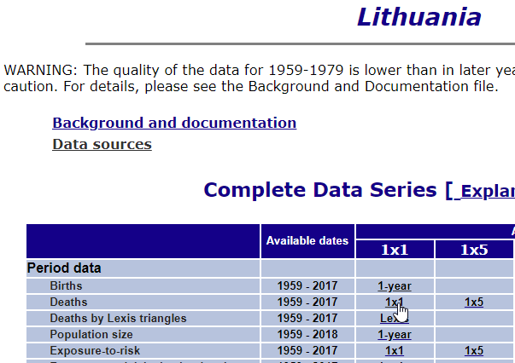

Figure : Web interface for mortality.org

*Note: the raw tables contain metadata in the first row and the second row is blank. To read these into R as data frames, use*

dat <- read.table(filename, skip = 2, header = TRUE)

5. Using R Markdown, write a brief paper (less than 5 pages) about the data from country that you have chosen, or make a comparison of two or more countries. Include in this paper:

a) A brief introductory paragraph describing the country.

b) Verbiage that describes the data and references the HMD data source.

c) An analysis of the data to describe something interesting about the country.

d) Include at least one of each of the following

* text with imbedded R
* hyperlink
* table
* plot

Follow the standard scientific paper format, with these sections:

* Introduction
* Methods
  + Data
  + Analysis
* Results
* Discussion
* Conclusions
* Reference (if any)

6. Store your input and output files in a GitHub repository and include the URL below so I can download your work. Include the following: