Word outputs

Jane Q. Public

2021-01-21

# Header 1

## R Markdown

This is an R Markdown document. Markdown is a simple formatting syntax for authoring HTML, PDF, and MS Word documents. For more details on using R Markdown see <http://rmarkdown.rstudio.com>.

When you click the **Knit** button a document will be generated that includes both content as well as the output of any embedded R code chunks within the document. You can embed an R code chunk like this:

kable(summary(cars), caption = "Caption for cars")

Caption for cars

|  |  |  |
| --- | --- | --- |
|  | speed | dist |
|  | Min. : 4.0 | Min. : 2.00 |
|  | 1st Qu.:12.0 | 1st Qu.: 26.00 |
|  | Median :15.0 | Median : 36.00 |
|  | Mean :15.4 | Mean : 42.98 |
|  | 3rd Qu.:19.0 | 3rd Qu.: 56.00 |
|  | Max. :25.0 | Max. :120.00 |

### Header 3

#### Header 4

##### Header 5

## Including Plots

You can also embed plots, for example:

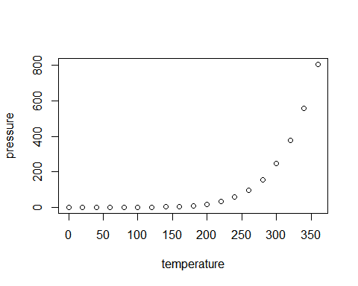

Caption for pressure

Note that the echo = FALSE parameter was added to the code chunk to prevent printing of the R code that generated the plot.