# **This document provides instructions for use of Remote Desktop on Windows and OSX operating systems.**

# Remote Desktop Instructions for Windows OS

1. 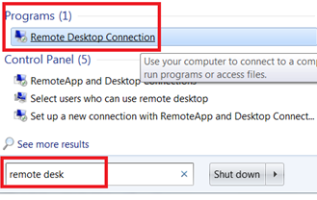On your laptop, ensure your screen resolution is set to 1600 x 900 or higher.
2. In the search box on the taskbar on your laptop, type **remote desk,** then select **Remote Desktop Connection** from the Programs section.﻿
3. If needed, select **Show Options** to see the tabs in the next step.

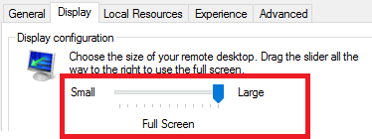

1. Select the **Display** tab. Ensure the Display Configuration slider is all the way to the right for **Large,** **Full Screen**:

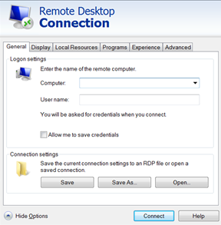

1. On the **General** tab, enter values in the **Computer:** (supplied by Instructor) and **User name:**  **phuseldw**. Click **Connect**.
2. When prompted, enter the password value from the **Info Sheet** and click **OK**.

# Remote Desktop Instructions for OSX

First download Microsoft Remote Desktop 10 from App Store:

[https://itunes.apple.com/se/app/microsoft-remote-desktop-10/id1295203466?l=en&mt=12](https://clicktime.symantec.com/a/1/oJFiHNs_eFpjZDWYuGElU3DhJuuxYa7kFAbYEoxLne8=?d=ZVXZtPLw_isZUKc86Zvuae4Apv6Pn5d3oyx5eXvfVGbYzuxHAJgGx8EXMsdmS6eH6iYcVfz3ta3lWp0lOecxd1Dm_hpWV9Y6_BThF8Y5cu8JTvaLkp5EF5lRje1vPNlwoVa7iQw6SPRpORhKoABpU785ZN_7BKTIv6ZBmv66Ic9dLGHv6-oUZizVcjtuK9K4nOG4Q5OuFYwKpN5lf7Dh5w5R_p-DhcdHZr4dWA9-wk8AB_MtX3hxTtoS0P80QOn97nS4Hz9M0MW2eCjeoM6PPsg7tn6Mufdnoj-vtzZpW4rmF0oDQYttXg6WH8yCMAkMVrfolw3H7O3lT67Le1o1UCKnJai3Ax5neNSrKfi5SBT8n_AwHBV_jWxP06aRnmqdLciumJZWeQZUB_8sZDBJdcVT16TzciReAj0XWP7wOwCR4B7VmE5lMjiChfzoFQc2&u=https%3A%2F%2Fitunes.apple.com%2Fse%2Fapp%2Fmicrosoft-remote-desktop-10%2Fid1295203466%3Fl%3Den%26mt%3D12)

(Seems to exist two different versions. I'm using 10, which is linked above. Never tried Microsoft Remote Desktop 8.)

When you have started Remote Desktop. Click + to add a new desktop:

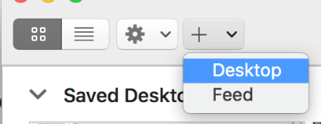

Add IP address in PC name:

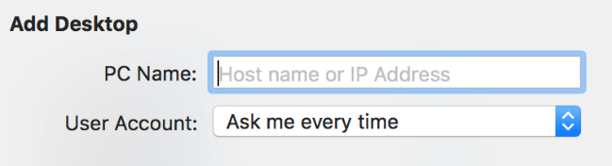

A new "desktop" will appear among your saved desktops with the IP address you assigned (so it is probably not the same as here.):

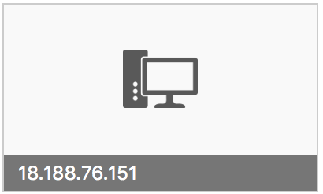

Double-click the "desktop" and enter user name and password and click done:

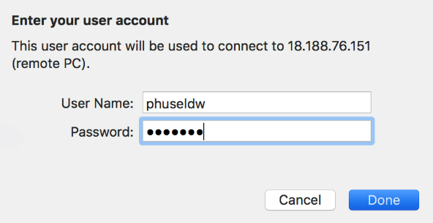

Then you will get the "may not be secure"-message:

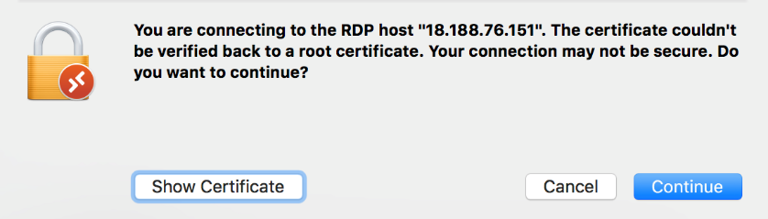

Click continue and it should be done.

The resolution should default to full screen.

If you want to change it. "Right-click" on the "desktop"-icon to show the extended menu and click edit:

(Alternatively, highlight the desktop and select *Connection -> Edit desktop* from the menu bar.)

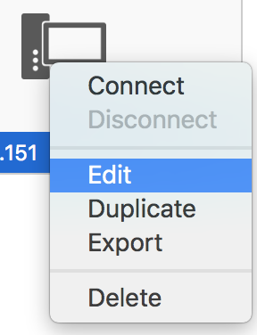

In the new window, choose the *Display* tab and select resolution:

