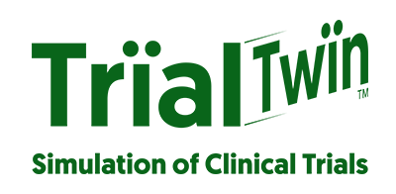

BLOG POST CONTENT (well have to create some graphics):
Today’s US Active Clinical Trials Available*
PHUSE, with the help of NIHPO through the PODR tool is generating realistic, Synthetic Health Data for the 39K active clinical trials in the US.
What is PODR about?
The structure and functionality of a Python-based platform that generates synthetic health data at scale from Real-World Data.

This non-real (yet realistic) Synthetic Health Data provided by PHUSE can be of assistance during software development and testing. And to evaluate corner cases.

Early adopters report that Synthetic Health Data can potentially shorten Quality Assurance cycles, and also provide a crucial tool for end-to-end System Validation. Finally, and very importantly, this Synthetic Health Data is available with no copyright, legal, privacy, or regulatory blocks.

The motivation behind this platform is to allow all staff levels at an organization participating in clinical trials to easily create and use synthetic data with no restrictions. It is our hope that this platform will accelerate the development and approval of both new medical devices and pharmaceutical products.

Empowering PODR
Some of you may already know about the benefits of using PODR. With the objective of serving valuable and useful CDISC Synthetic Health Data for Clinical Trial test, generated synthetic subjects ("SynthPerson") with full medical history ("SynthPHR") and with SDTM test data ("SynthTrial") is created.
All this relevant information will be freely available to PHUSE members for search and download through PODR on the NIHPO website.
What type of studies will be shared?
All studies which are currently active at https://ClinicalTrials.gov with the following requirements:
* Not yet recruiting
* Recruiting
* Enrolling by invitation
* Active, not recruiting
Right now, there are 38,920 studies in the US that match those conditions.
Files will be uploaded to NIHPO’s website by XX September. NIHPO, creating the studies in Rave EDC using a NIHPO-specific ALS and Patient Journey files, will be generated a downloadable “Rave extract” for each of the 39K US studies.
How can I access to it?
Please, access to 10 cases for each of the following countries:United Kingdom (or GB) Canada, Colombia, Germany, Spain, France, Mexico and US by clicking on the link below.
BUTTON.
Contact us: hello@nihpo.com
INCLUDE SALESFORCE / FUNNEL
HASHTAGS FOR PHUSE

