Lab03

TranAnh

20215179

Latest versions of projects in release branch serve as the submitted assignment

before:

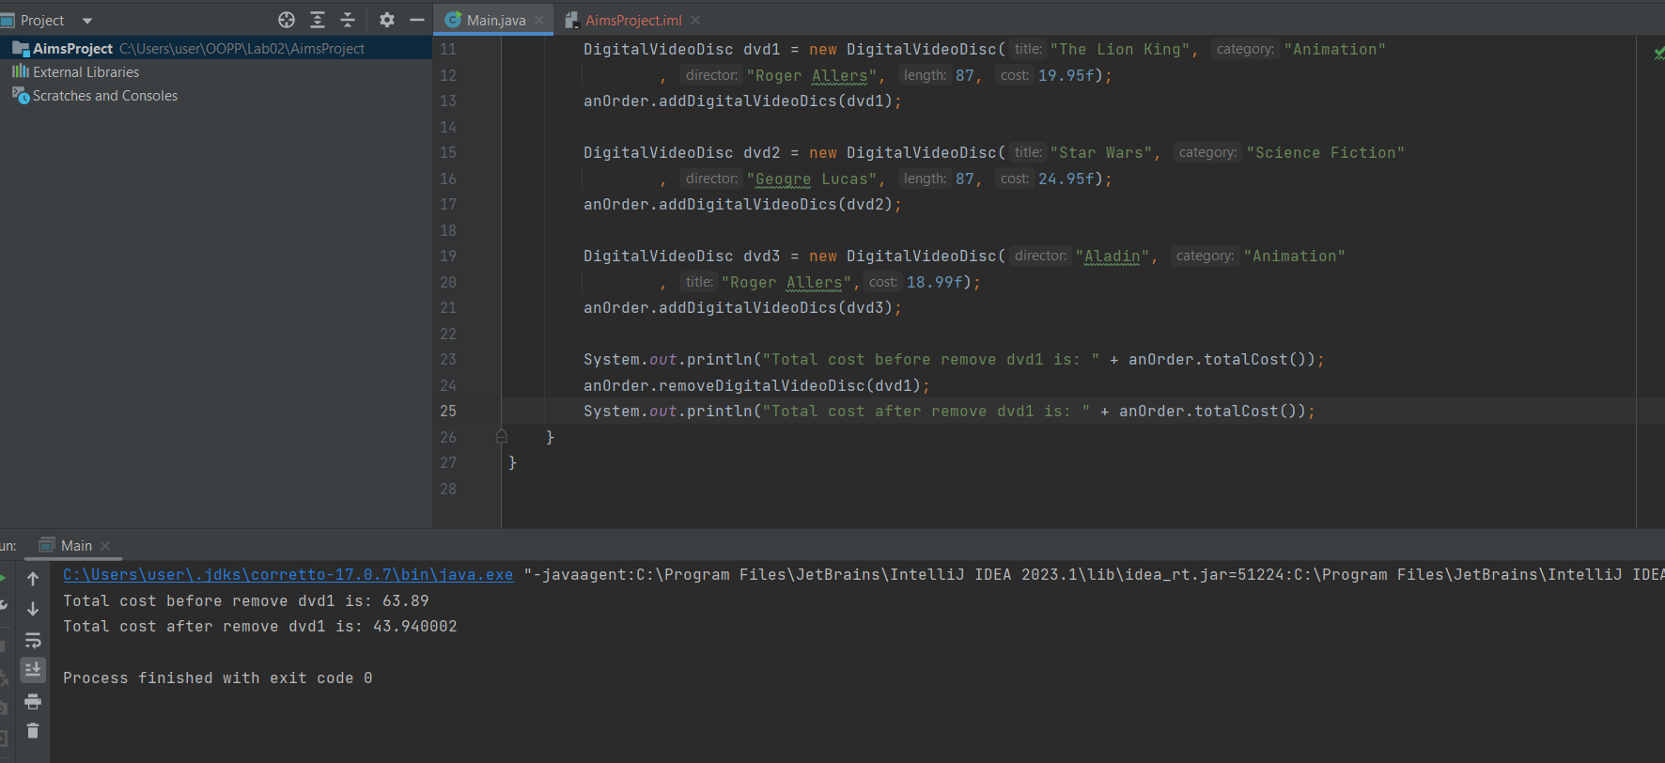

after:

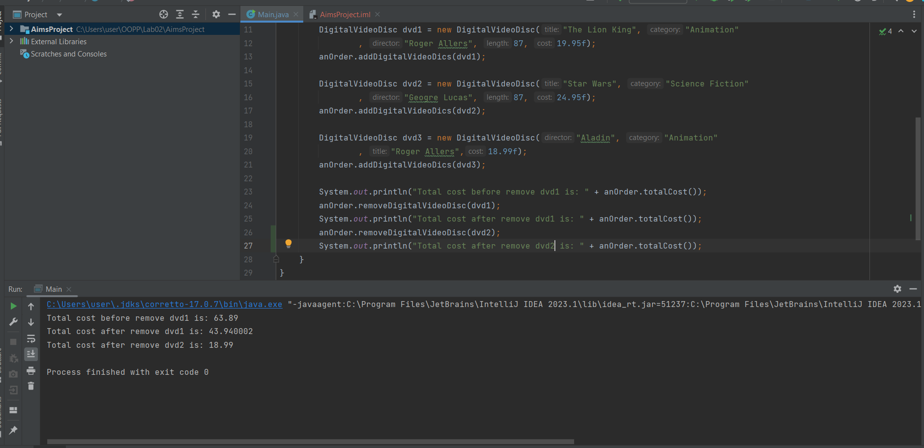

afterMerge:

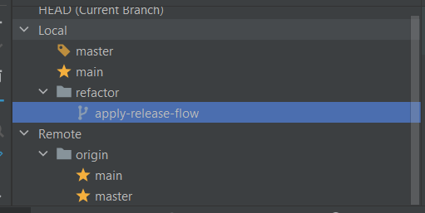

2.Working with method overloading:

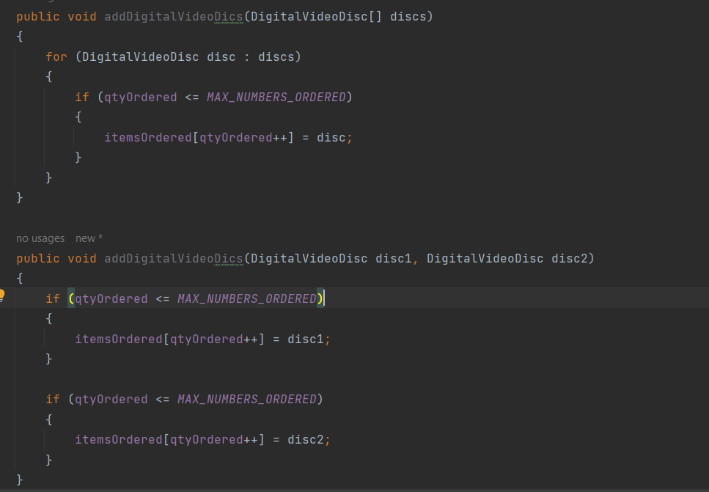3. Passing parameter:

Ans: Java is a pass by value programming language.

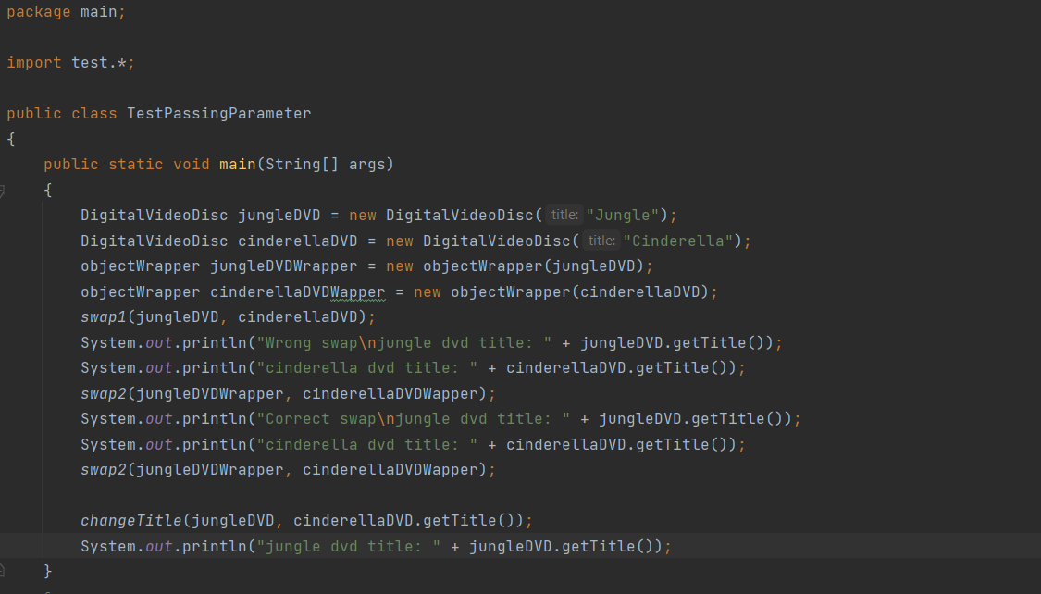

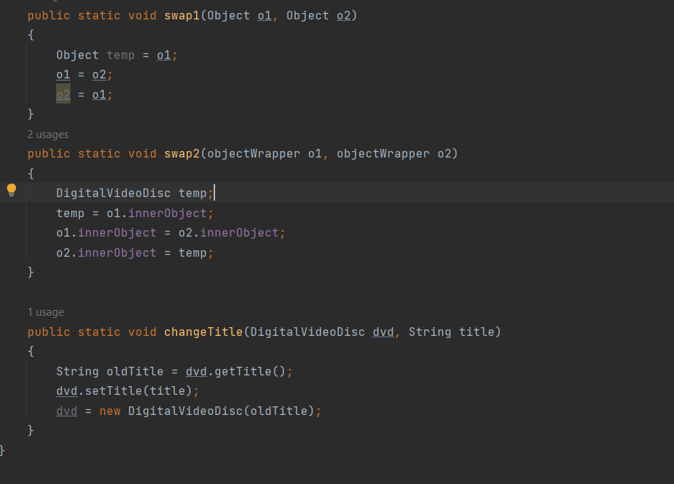

After the call of swap(jungleDVD, cinderellaDVD) why does the title of these two objects still remain?

Because o1 and o2 in swap(jungleDVD, cinderellaDVD) just the copy of the real jungleDVD and cinderellaDVD => we actually swapping the copy one not the real one.

After the call of changeTitle(jungleDVD, cinderellaDVD.getTitle()) why is the title of the JungleDVD changed?

because dvd ref to the object in heap => dvd.setTitle(title) do the work.

correct swapMethod:

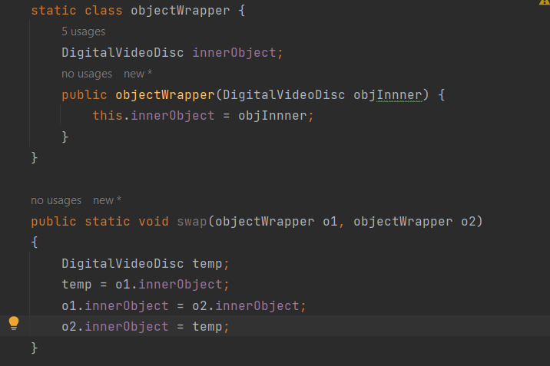

4. Use debug run:

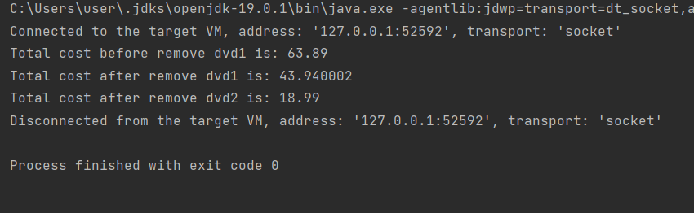

5.Class member - instance member:

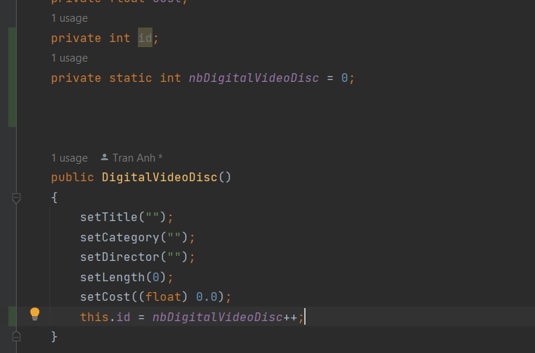

6. Open the Cart class

Code:

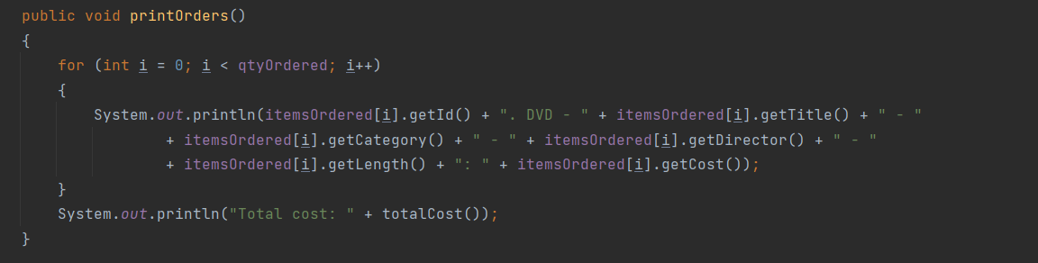

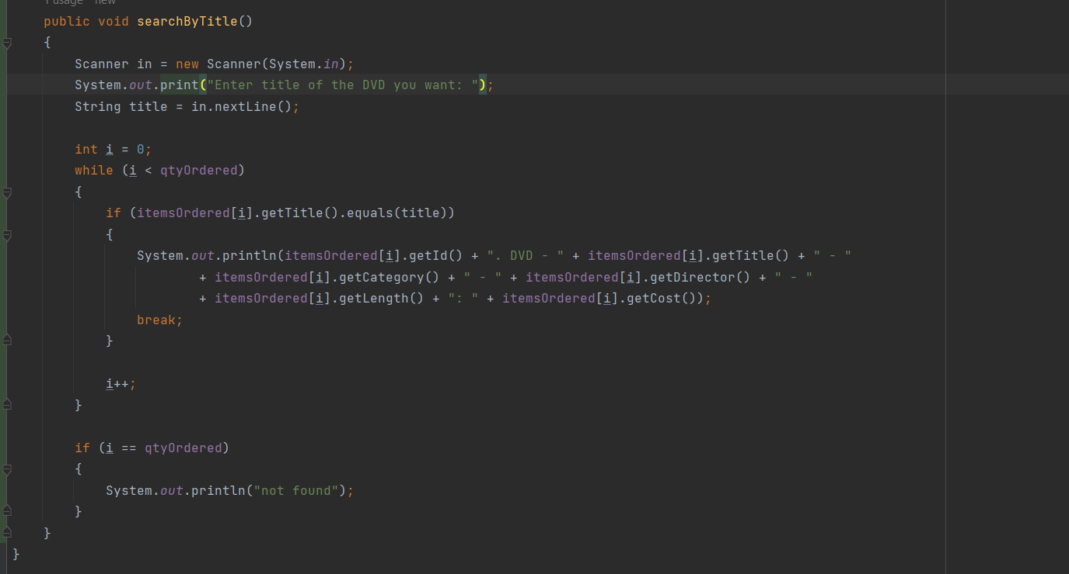

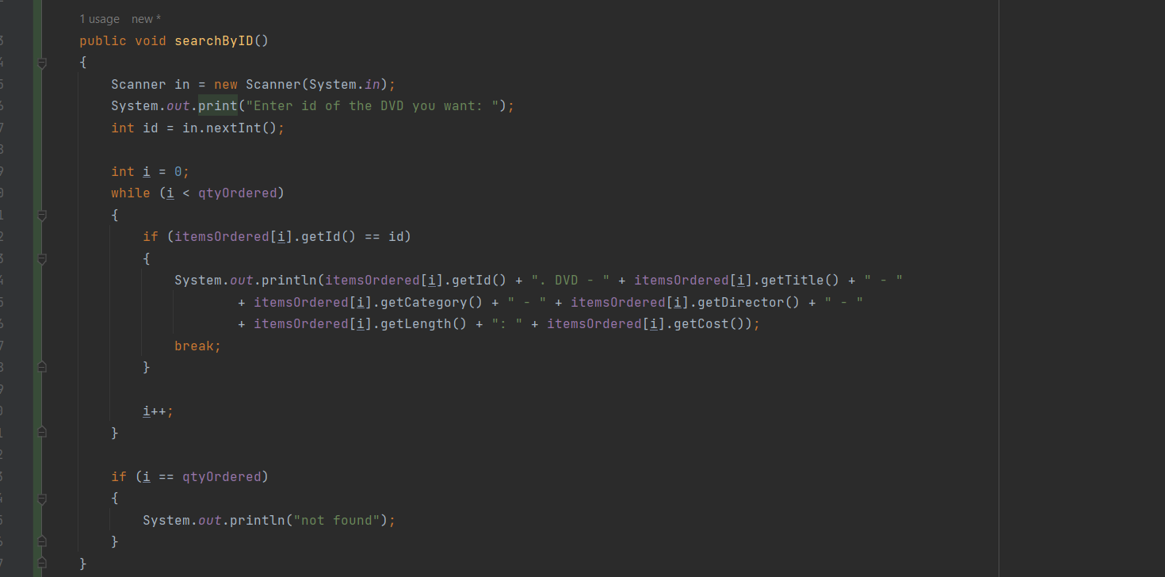

Test:

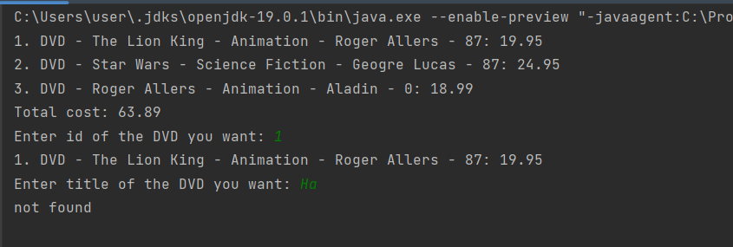

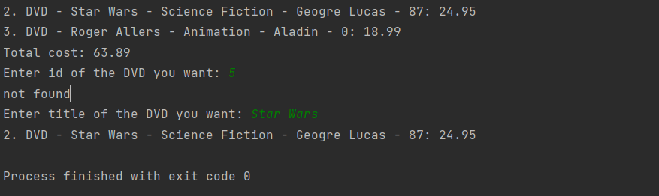

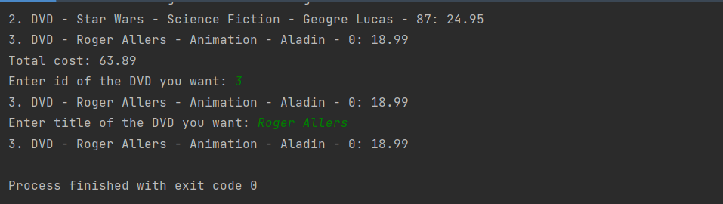

7.Implement the Store class

code:

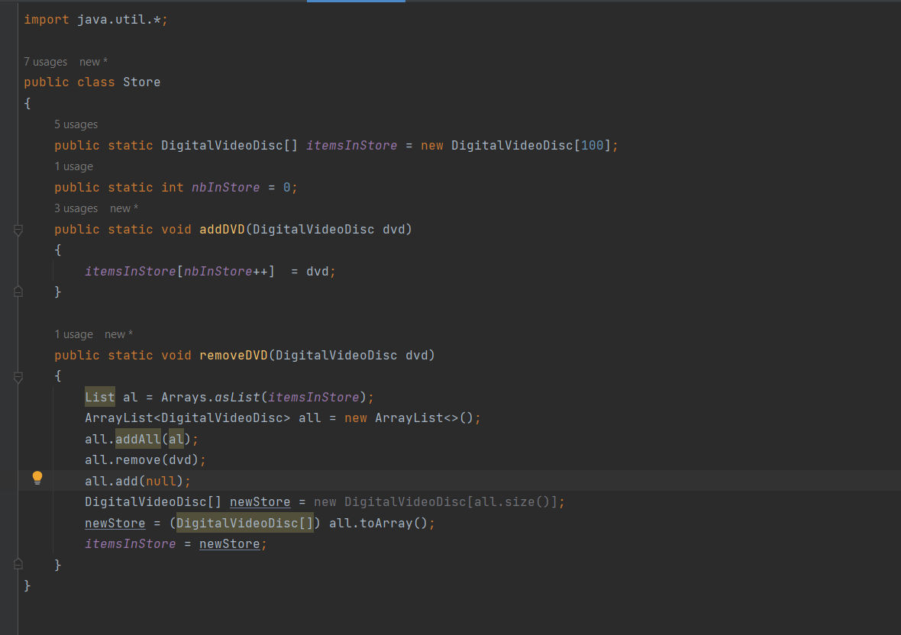

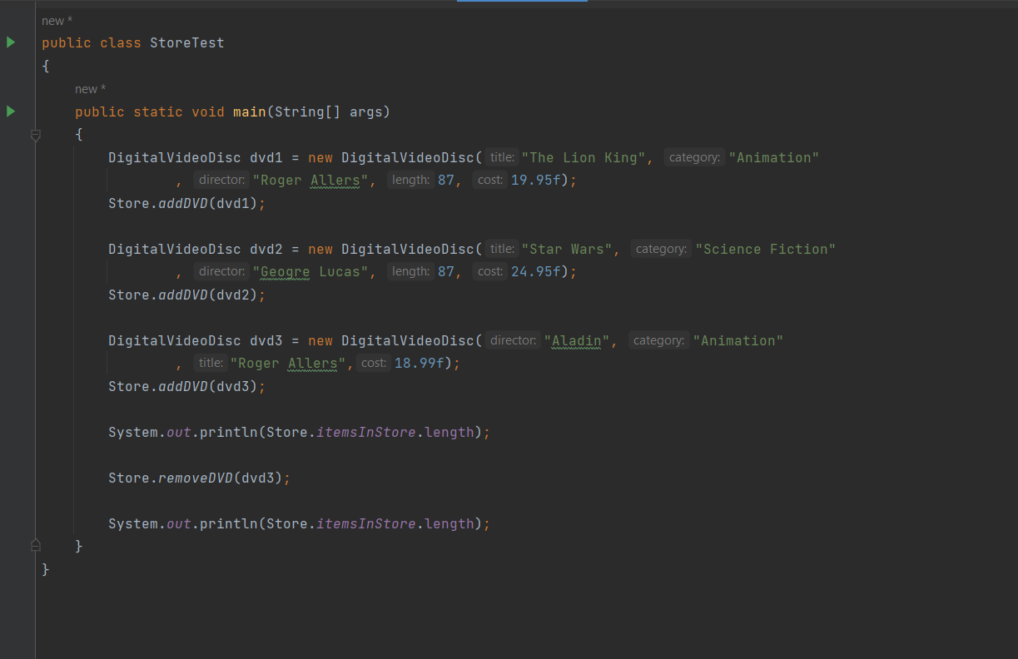

8.Re-organize your projects

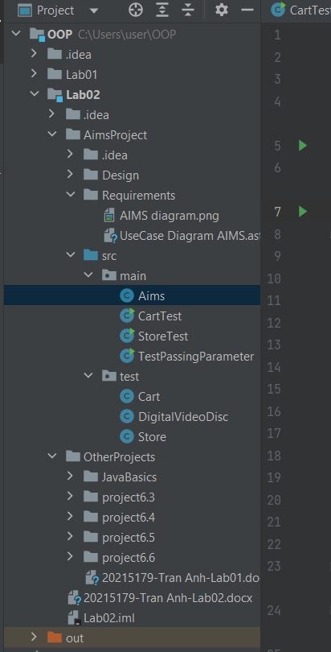

9.String, StringBuilder and StringBuffer

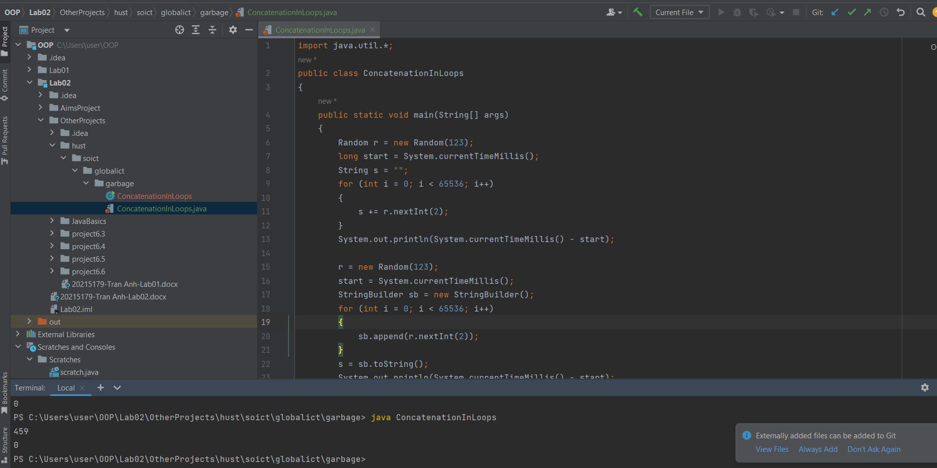

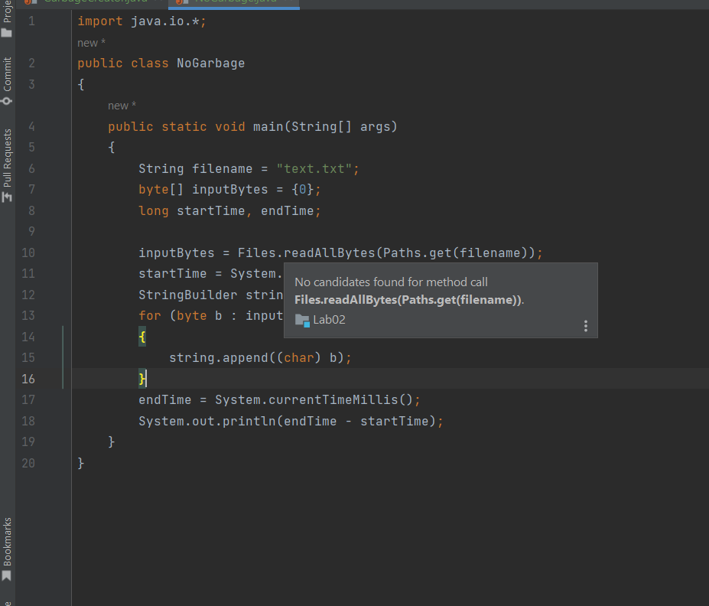

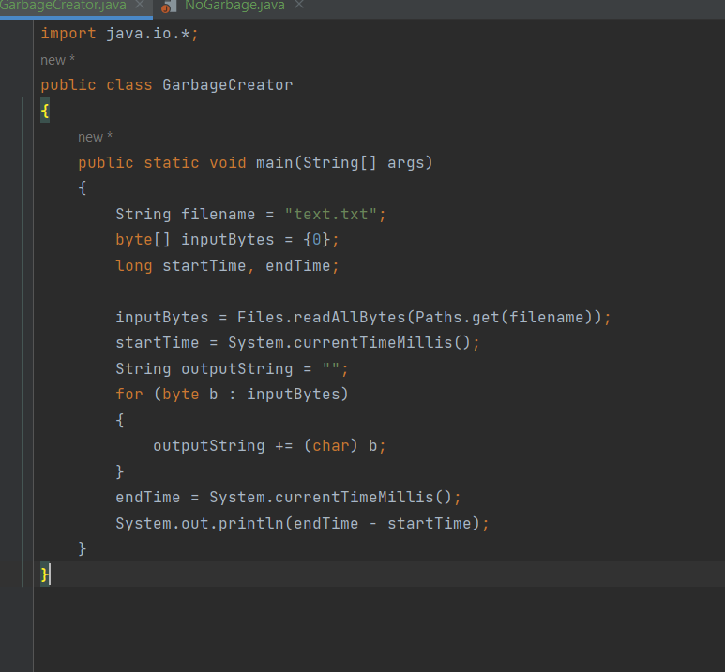

10.