Group: Number 1

**Member**: Nguyen Manh Tien - 20184312 (Leader)

Nguyen Phu Truong - 20184319

Hoang Tho Tung - 20184325

**Topic**: Management Store

1. Business analysis

A store owner wants to manage retail store. The management has two main periods : import merchandise and sell merchandise.

1. The first period: import merchandise.

There is a list of vendors which include some main information:

* Vendor Id
* Vendor Code (identify the vendor, unique, easy to remember ) - not null
* Vendor Name - not null
* Address
* Phone Number – not null
* Email - not null
* Tax Number
* State - not null

These vendors provide items which include some main information:

* Item id
* Vendor id
* Category id – not null
* Item code (identify the item, unique, easy to remember ) - not null
* Item name – not null
* Description
* Unit ( example: pair, dozen, ...)
* Price importing (from the vendors) – not null
* State – not null

Each category can contain many item, but item just belong one category. Category has name and description about it. Category to group some item with same properties. Category include:

* Category id
* Category name - not null
* Description

The vendors can provide one or many kind of item, one item can be provided from one or many vendors. When a vendor stop providing, but we don’t want to delete information about the vendor ( to keep infor about the vendor, keep contact, ..). Each vendor has attribute state to know that: the vendor still provide merchandise or not. And each item is stopped providing, we also don’t delete information about it, so the item has attribute: state to know that: it still is provided or not

When item was imported from vendor to storehouse, there are invoice (to confirm that vendors provided merchandise). The invoice can contain one or many items, but these item(in the invoice) just belong to one vendor. The invoice has to contains information about employee who buy these items. The invoice also have to record when transaction happen. In the invoice, we also need to know information about who imported these item at that time. The time also need to record in the invoices. The invoice includes:

* Invoice id
* Invoice code (identify the invoice, unique, easy to remember ) – not null
* Item id - not null
* Employee id – not null
* Quantity
* Date - not null
* Vendor id - not null

When store owner imported goods, these items will be store in storehouse.

So store owner also need to manage the storehouse. The storehouse may contain many items, price celling, quantity, ...

Storehouse include:

* Item id
* Quantity
* Price selling

Besides, we need some basic function to make important decision

* With same item, we want to know which vendor provide cheapest and most expensive
* Top vendors provide most item
* Which items in the store exhaust. A item consider exhaust when its unit smaller than or equal 10 (unit)
* Major item and minor one in the store

1. The second period: sell merchandise

The store owner hires part time employee. Each employee works in three shift: morning, afternoon, evening. When a employee stop working, but we don’t want to delete information about the employee ( to keep infor about the employee, keep contact, ..). Each employee has attribute state to know that: the employee still working, or not.

Employee has attribute: Group to privileges: employee, manager , ... Password to authen when employee login the system. Formula to compute salary: coefficients salary * base salary ( specified) + sales * 5%. Coefficients salary = 1 + (number working months) / 12. Sale: total cost of items which the employee sells in this month. Otherwise, to manage employee, employee also has some information as following

Employee includes some information:

* Employee id
* Employee code (identify the employee, unique, easy to remember ) – not null
* Employee name
* Age
* DOB
* Address
* Gender
* Phone number – not null
* Email - not null
* Identify number – not null
* Shift
* Password
* Group id
* Status - not null
* EnjoinDate – when employee enjoin company

Each employee belongs to one Group. Group contains:

* Group id
* Group name
* Base salary – not null

Customer can buy one or more items. After paying, customer will receive bill ( order). Each time buying, customer will receives cumulative point. Cumulative point was computed by: cumulative point = total amount * percentage rate(E.g: 1%). Cumulative point can be used as money. E.g 1 point = 1vnd. Each customer has status to point that the customer in black list nor not.

Customer include some information:

* Customer id
* Customer name – not null
* Age
* DOB
* Address
* Phone number – not null
* Email
* Status
* Cumulative point

Order contain:

* Order id
* Customer id – not null
* Discount voucher id
* Items
* Quantity
* Employee id – not null
* Date
* Amount = sum (quantity * price of items)
* VAT tax = amount * 10%
* Cumulative point used
* Total amount = amount * ( 1- Discount percentage rate (%)) + VAT tax – cumulative point

When customers make a payment, they can use only one discount voucher and cumulative points. Store only accept discount voucher when it is valid ( mean : in effective date, not out expired date, in range apply). When apply valid discount, total amount will decrease. Each order accept only one discount voucher.

Discount voucher has some police to apply: it have to satisfied effective and expired date, just apply for some category, total amount of the order reach a specified number, limit max discount.

Discount voucher contain:

* Discount voucher id
* Expired date
* Category ID
* Min total amount ( min amount in the order to get discount)
* Effective date
* Discount percentage rate (%)
* Max discount amount

1. Entity relationship

1. Import merchandice

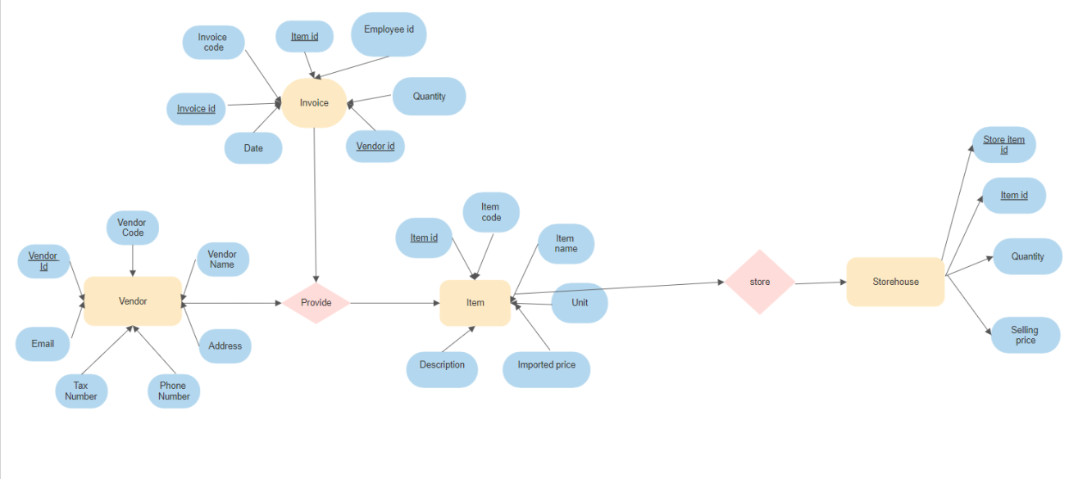

2. Selling items

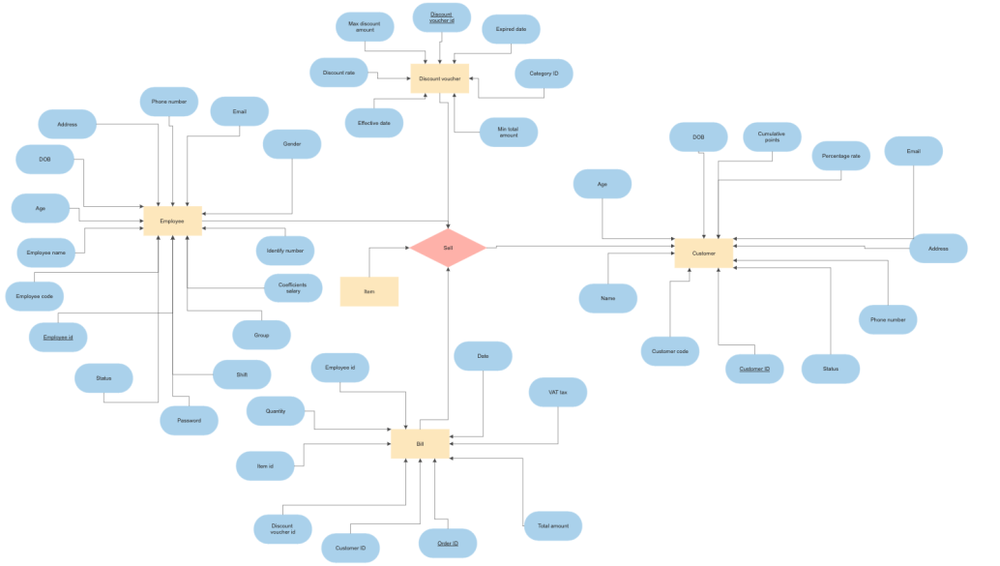

Schemas

