**AHBLITE multi-layer interconnect**

|  |  |  |  |
| --- | --- | --- | --- |
| **Revision** | **Date** | **Author** | **Description** |
| 1.0 | Apr 5, 2024 | Phu Vuong | Initial |
|  |  |  |  |
|  |  |  |  |
|  |  |  |  |
|  |  |  |  |
|  |  |  |  |
|  |  |  |  |
|  |  |  |  |

Catalog

1. Introduction 6

2. Features 7

3. Functional description 8

3.1. Masterport 8

3.2. Slaveport 8

3.3. HREADY and HREADYOUT routing 9

4. Interface 11

4.1. Parameter 11

4.2. Signal list 11

5. Design 13

5.1. Masterport 13

5.2. Slaveport 14

**List of Figure**

Figure 1-Example Multi-layer interconnect 6

Figure 2-Example interconnect system with 2 masters and 3 slaves 8

Figure 3-HREADYOUT and HREADY Routing 9

Figure 4-Single Master/Slave Routing 9

Figure 5-Block diagram of Masterport 13

Figure 6-Master control latched 13

Figure 7-Output control/addr/data from master to slave 14

Figure 8-HSEL generator 14

Figure 9-switch generator 14

Figure 10-cr_slave generator 14

Figure 11-Arbiter's architecture 15

Figure 12-Priority level register 15

Figure 13-upd_priority signal 15

Figure 14-nx_priority signal 15

Figure 15-Larger or equal comparator 15

Figure 16-True table of comparator 1-bit 16

Figure 17-Priority request decoder 16

Figure 18-Asserted request check 16

Figure 19-Request enable 17

Figure 20-Request mask 17

Figure 21-new_grant signal 17

Figure 22-nx_grant signal 17

Figure 23-grant and no_grant signal 17

Figure 24-slave's HREADYOUT 18

Figure 25-Send address/control to slave 18

# Introduction

AHBLite multi-layer interconnect (The interconnect) is a fully parameterized high performance, low latency interconnect for AHBLite. It allows a virtually unlimited number of AHBLite bus masters and slaves to be connected without the need for bus arbitration to be implemeted by the bus masters. Instead, slave side arbitration is implemented for each slave port within the core.

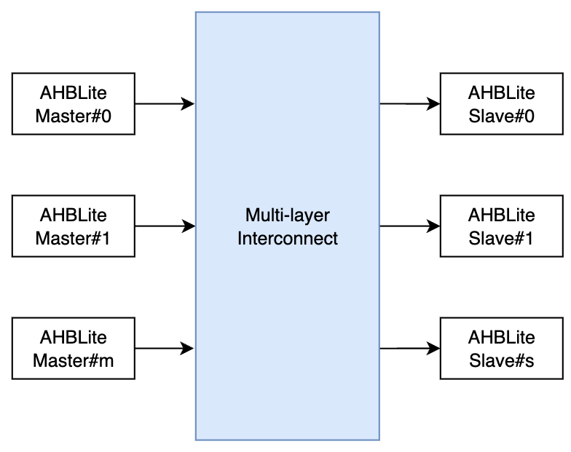

Figure 1-Example Multi-layer interconnect

The interconnect supports round-robin arbitration when multiple masters request access to the same slave port. Typically, arbitration completes within 1 cycle clock.

# Features

1. AMBA AHB-Lite compatible
2. Fully parameterized
3. Unlimited number of bus master and slave
4. Slave side round robin arbitration
5. Slave port address decoder

# Functional description

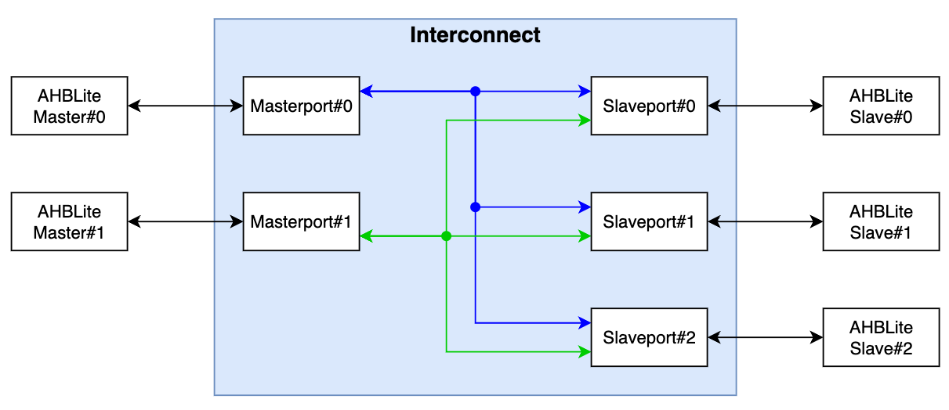

Figure 2-Example interconnect system with 2 masters and 3 slaves

Connections are dynamically created based on which slave a master is addressing, and once created enable direct communication between master and slave without other masters being aware or interfering.

A new connection is typically created within one clock cycle, providing high bandwidth and low latency communication between master and slave.

## Masterport

An AHB-Lite bus master connects to a master port of the Multi-layer Interconnect. The master port is implemented as a regular AHB-Lite slave interface thereby allowing support for complex bus structures.

To access a slave, master send to masterport the address of that slave. If the address is valid, masterport sends a select signal (mst_HSEL_o) to that slave to request access. After slave accept the request, master and slave can communicate without intervention from other masters. At the end of the command transaction, master will generate a pulse of swith signal (mst_switch_o) to notify slave, then slave can stop current grant, and generate new grant for other requests.

## Slaveport

An AHB-Lite bus slave connects to a slave port of the Multi-layer Interconnect. The slave port is implemented as a regular AHB3-Lite master interface thereby allowing support for complex bus structures.

Each slave port has an address base (slv_HADDR_base) and address mask (slv_HADDR_mask) port. Together these set the address range covered by the slave port.

The address base port specifies the base address for the address range covered by the slave port and the address mask port defines the address range covered by the slave port. The internal port select signal is specified as slv_HADDR_base AND slv_HADDR_mask.

The address base and address mask values may be changed dynamically, however assigning static values results in a smaller Interconnect and reduces timing paths. Address base and address mask may only be changed when the slave port(s) are idle. Since multiple masters may be active at the same time trying to access the interconnect, special care must be taken to ensure no master accesses the Interconnect while updating the address base and address mask values.

Example 1:

slave_addr_base = 32’h1000_0000

slave_addr_mask = 32’hF000_0000

Address-range = 32’h1000_0000 to 32’h1FFF_FFFF

Example 2:

slave_addr_base = 32’h4000_0000

slave_addr_mask = 32’hE000_0000

Address-range = 32’h4000_0000 to 32’h5FFF_FFFF

Slaveport receives access requests from masterports, then grant access to masterport for a transfer. Since the last data in that transfer, slaveport receives mst_switch_o and de-asserts grant signal, then generate new grant for next master based on priority level register. During comunicate, slaveport connect slave’s signal to granted master. Besides, slaveport also control HREADY feedback to masters. If master is granted, HREADY is exactly slave’s HREADY, else HREADY equals 1’b0 to notify master this transaction is busy.

## HREADY and HREADYOUT routing

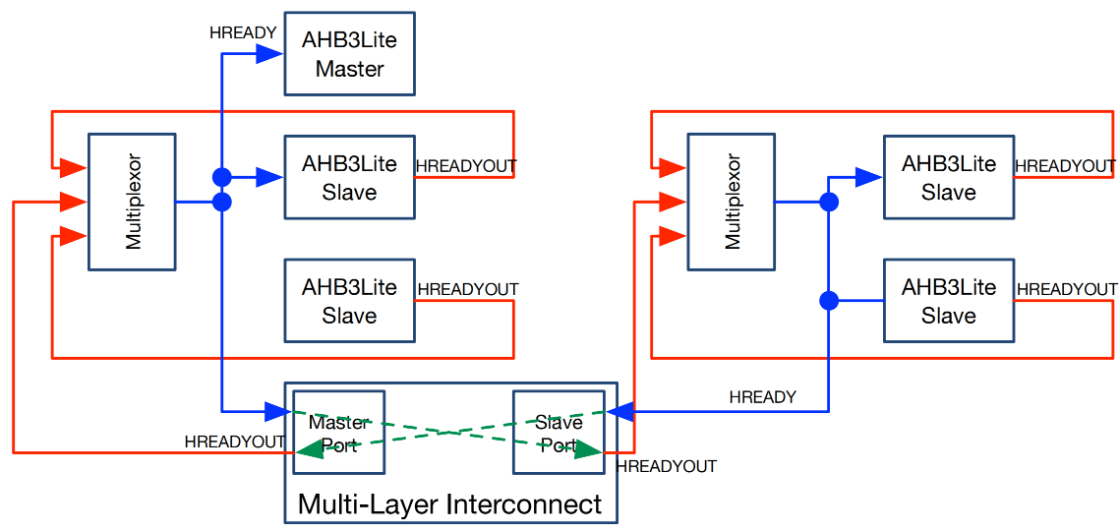

Figure 3-HREADYOUT and HREADY Routing

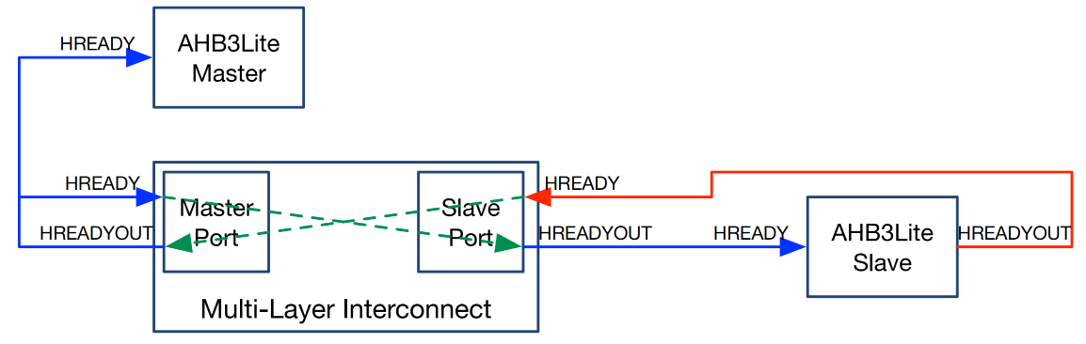

Figure 4-Single Master/Slave Routing

The slave port has an HREADYOUT port, which is not part of the AHB-Lite specification. It is required to support slaves on the master’s local bus. The HREADY signal, generated by the multiplexor on the master local bus, drives the addressed slave’s HREADYOUT port.

The simple case of where only one master is connected to a master port or where only a single slave is connected to a slave port is figure 4.

There are no multiplexors on either the master bus or the slave bus. Since there is no other slave on the master bus, its HREADY signal is only driven by the master port’s HREADYOUT signal. Thus the master port’s HREADYOUT drives both the master’s HREADY input and the master port’s HREADY input.

Similarly since there is no other slave on the slave bus, the slave port’s HREADYOUT signals drives the slave’s HREADY input and the slave’s HREADYOUT signal drives the slave port’s HREADY input.

# Interface

## Parameter

|  |  |
| --- | --- |
| **Parameter** | **Description** |
| MASTER | Number of masterport |
| SLAVE | Number of slaveport |
| HADDR_WIDTH | Address width |
| HDATA_WIDTH | Data width |

## Signal list

* Global signal

|  |  |  |  |
| --- | --- | --- | --- |
| **Signal name** | **Type** | **Width** | **Description** |
| HCLK | input | 1 | Common clock |
| HRESETn | input | 1 | Reset active low-level |

* Connect with ahb master

|  |  |  |  |
| --- | --- | --- | --- |
| **Signal name** | **Type** | **Width** | **Description** |
| HCLK | input | 1 | Common clock |
| HRESETn | input | 1 | Reset active low-level |
| mst_HRDATA_o | output | HDATA_WIDTH | Read data from slave to master |
| mst_HREADYOUT_o | output | 1 | Ready feedback from selected slave |
| slv_HTRANS_i | input | 2 | Transfer type |
| slv_HBURST_i | input | 3 | Transfer burst |
| slv_HSIZE_i | input | 3 | Transfer size |
| slv_HWRITE_i | input | 1 | Write select |
| slv_HADDR_i | input | HADDR_WIDTH | Address bus |
| slv_HWDATA_i | input | HDATA_WIDTH | Write data bus |
| slv_HMASTLOCK_i | input | 1 | Transfer master lock (1) |
| slv_HPROT_i | input | 7 | Transfer protect (1) |
| slv_HNONSEC_i | input | 1 | Transfer non-secure (1) |
| slv_HEXCL_i | input | 1 | Transfer exclusive access monitor (1) |
| slv_HMASTER_i | input | 4 | Transfer exclusive access monitor(1) |
| slv_HREADY_i | input | 1 | Ready feedback to selected slave |

* Connect with ahb slave

|  |  |  |  |
| --- | --- | --- | --- |
| **Signal name** | **Type** | **Width** | **Description** |
| slv_HTRANS_o | output | 2 | Transfer type |
| slv_HBURST_o | output | 3 | Transfer burst |
| slv_HSIZE_o | output | 3 | Transfer size |
| slv_HWRITE_o | output | 1 | Write select |
| slv_HADDR_o | output | HADDR_WIDTH | Address bus |
| slv_HWDATA_o | output | HDATA_WIDTH | Write data bus |
| slv_HMASTLOCK_o | output | 1 | Transfer master lock (1) |
| slv_HPROT_o | output | 7 | Transfer protect (1) |
| slv_HNONSEC_o | output | 1 | Transfer non-secure (1) |
| slv_HEXCL_o | output | 1 | Transfer exclusive access monitor (1) |
| slv_HMASTER_o | output | 1 | Transfer exclusive access monitor(1) |
| slv_HREADYOUT_o | output | 1 | Ready feedback from current master |
| slv_HRDATA_i | input | HDATA_WIDTH | Read data bus |
| slv_HREADY_i | input | 1 | Ready signal |
| slv_HRESP_i | input | 1 | Response signal |
| slv_HEXOKAY_i | input | 1 | Exclusive okay |
| slv_HADDR_base_i | input | HADDR_WIDTH | Slave address base |
| slv_HADDR_mask_i | input | HADDR_WIDTH | Slave address mask |

* Note

1. Current version not support these features, just directly send from master to slave.

# Design

## Masterport

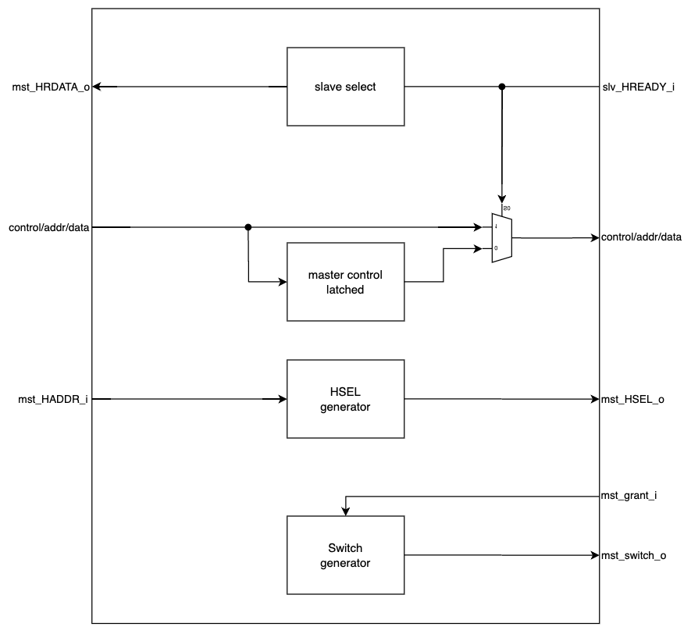

Figure 5-Block diagram of Masterport

* Master control latched: Masterport stores control/address/data when received NONSEQ command, the first transfer. These datas will be sent to slaveports if requested slave is busy.

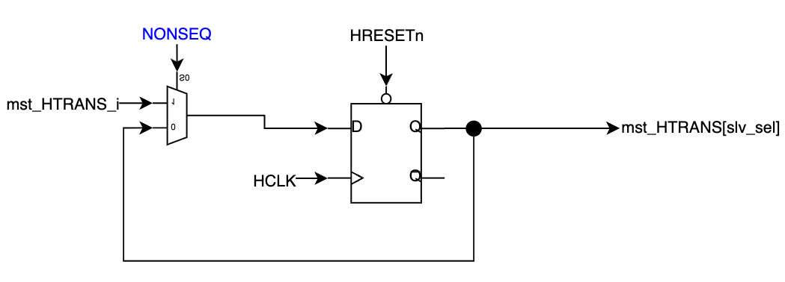

Figure 6-Master control latched

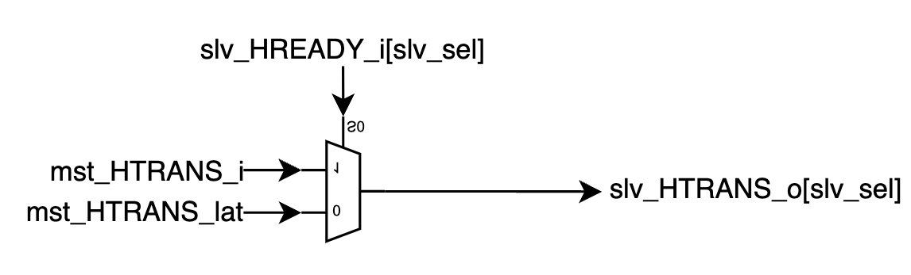

Figure 7-Output control/addr/data from master to slave

* HSEL generator: When master give an address which is in range of any slave’s address, hsel connected to that slave will be asserted.

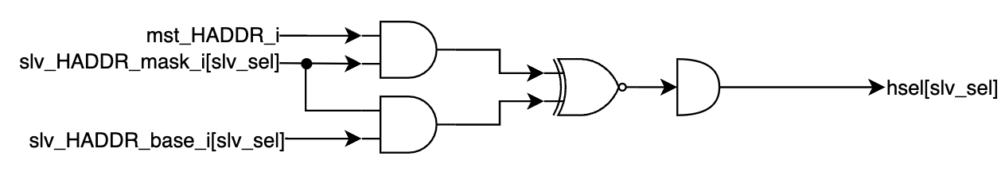

Figure 8-HSEL generator

* Master switch generator: Base on current slave HREADY and granted master to generate switch pulse at new transfer or end of the transfer.

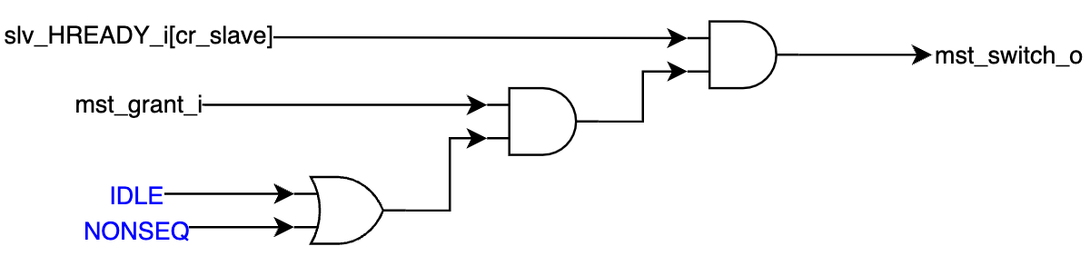

Figure 9-switch generator

* cr_slave decode: Base on current connection, identify that slave is connecting to master. If not any connection, keep value of cr_slave.

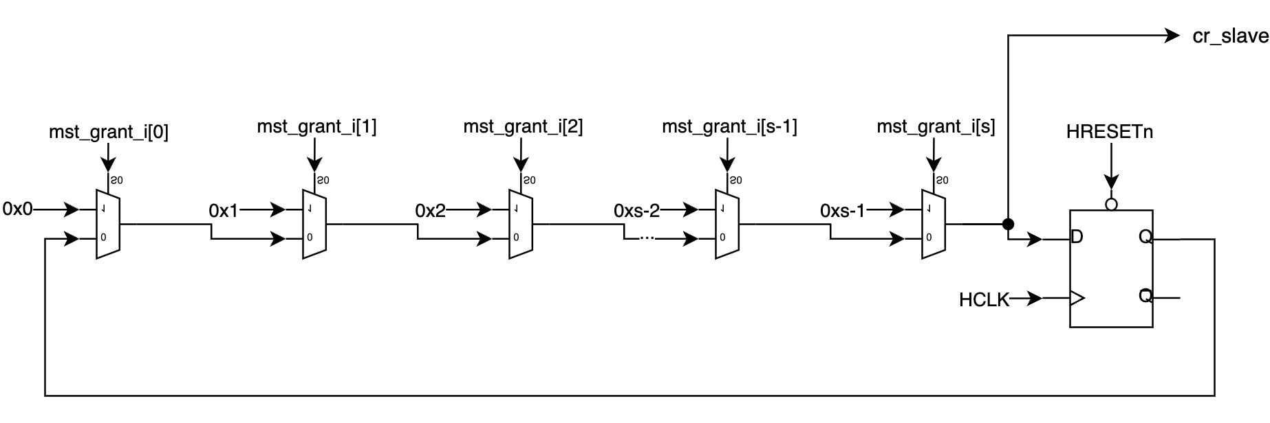

Figure 10-cr_slave generator

## Slaveport

* Arbiter:

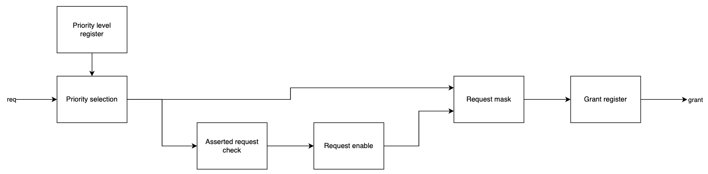

Figure 11-Arbiter's architecture

This round robin arbiter use priority level register to indicate to priority level of request sources. That regiters will be updated after value at the end of the transfer. The current request will be changed current level to lowest level. The other requests which is have priority level larger or equal than current request level will be updated to next level.

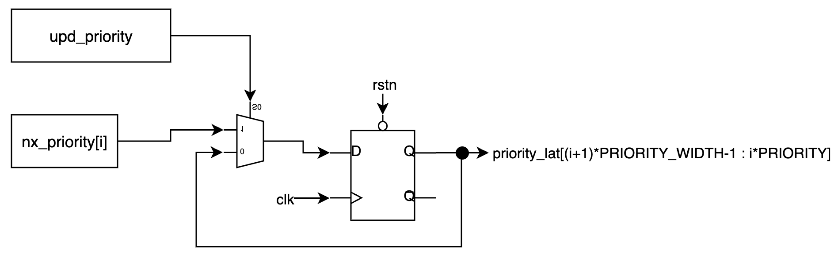

Figure 12-Priority level register

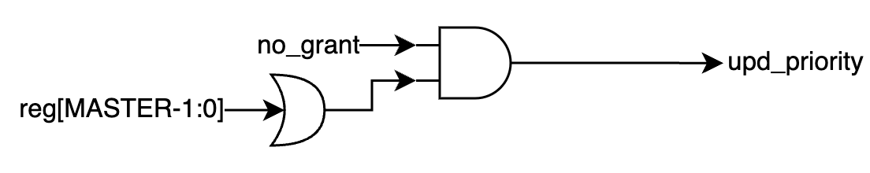

Figure 13-upd_priority signal

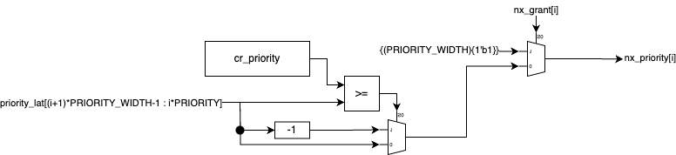

Figure 14-nx_priority signal

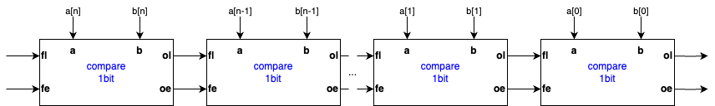

Figure 15-Larger or equal comparator

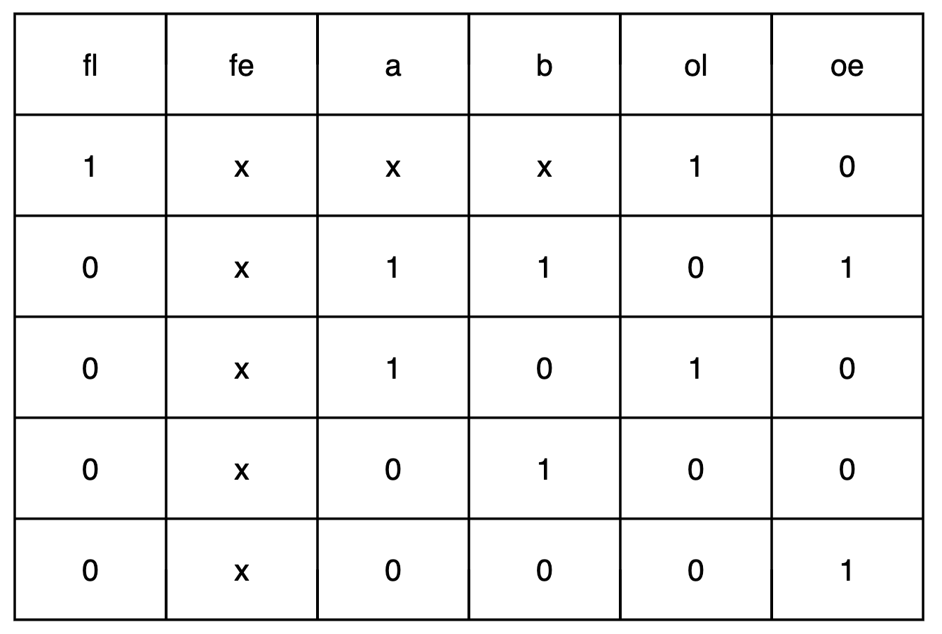

Figure 16-True table of comparator 1-bit

Priority selection: When master send a request to slave, one of outputs of priority selection is asserted. This output, is called by request level, includes priority level information.

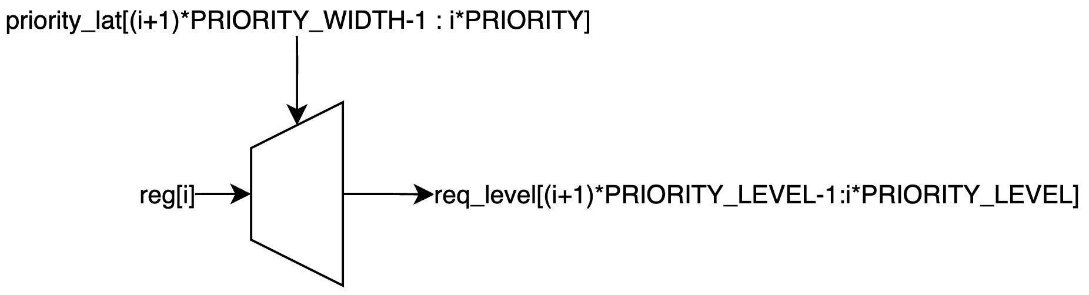

Figure 17-Priority request decoder

Asserted request check: Group all request the same level

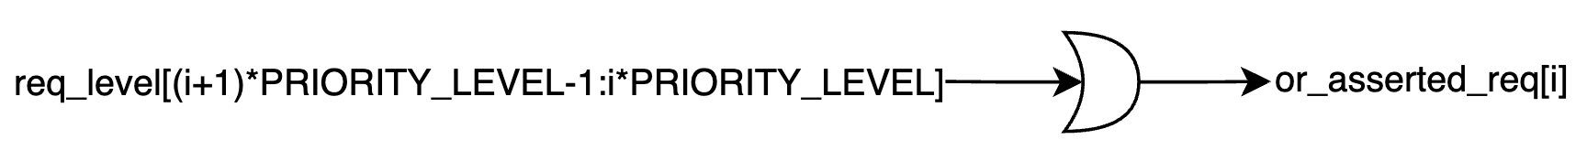

Figure 18-Asserted request check

Request enable: Identify to highest request level in all requests.

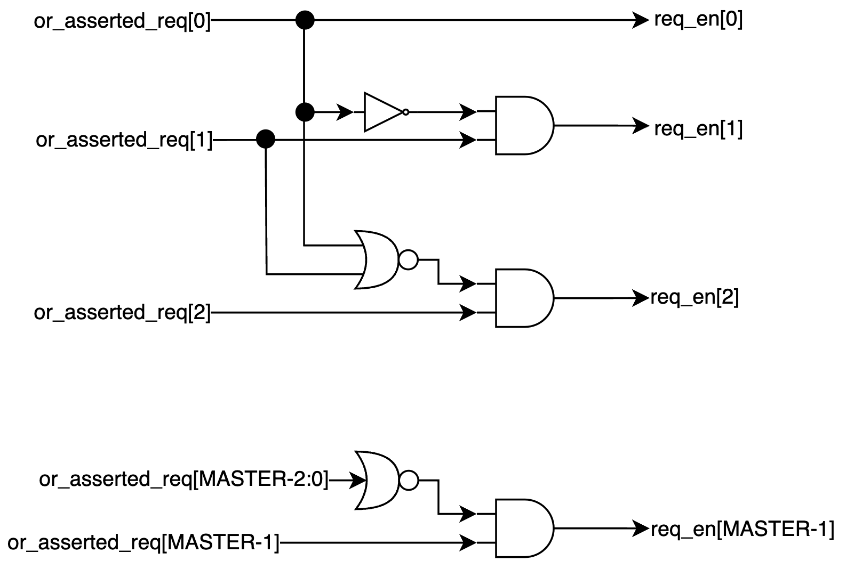

Figure 19-Request enable

Request mask: Mask requests lower priority.

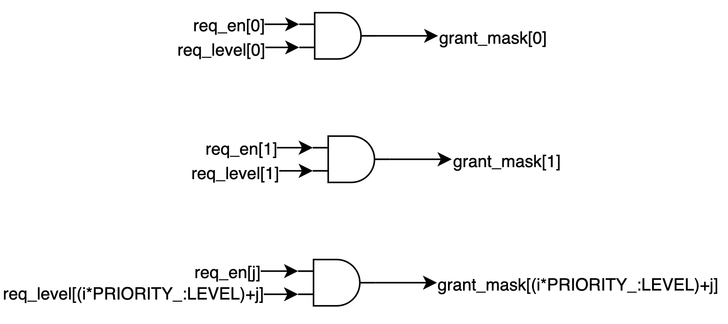

Figure 20-Request mask

Grant register: Generate grant signal. Grant signal is asserted after 1 cycle request asserted.



Figure 21-new_grant signal

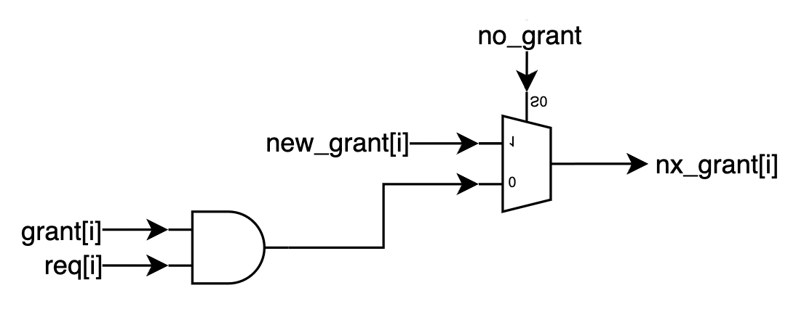

Figure 22-nx_grant signal

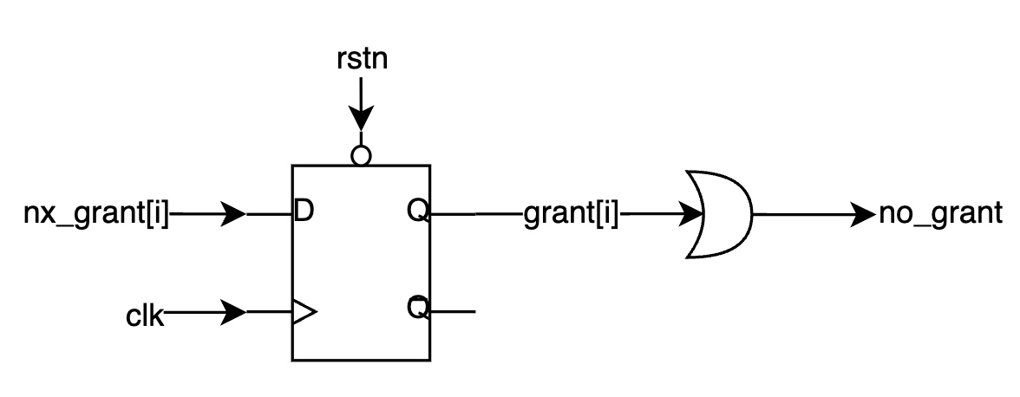

Figure 23-grant and no_grant signal

* HREADYOUT control: In reset state or not any grant, all masterports are received HREADY from slave. When access granted, master which is granted is received HREADY from slave. The orthers are de-asserted.

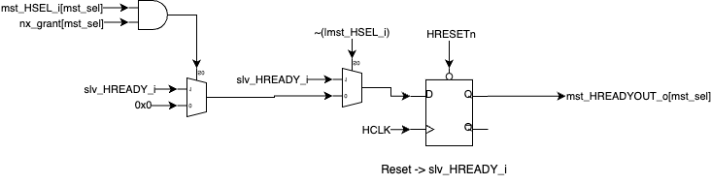

Figure 24-slave's HREADYOUT

* Master signal: receive address/control and receive send data/response to master which is granted access.

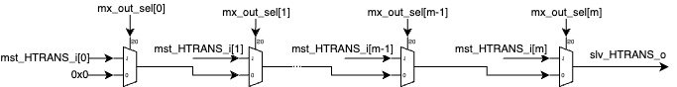

Figure 25-Send address/control to slave