11-07-2020





Importar as bibliotecas

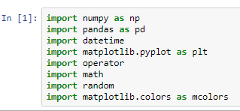

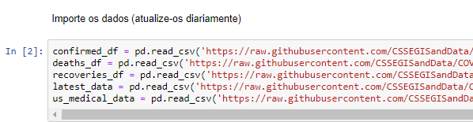

Listar o head confirmed_df

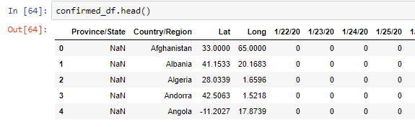

colunas

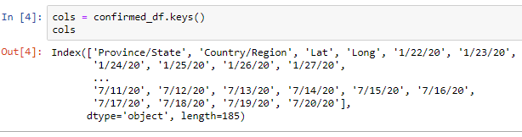

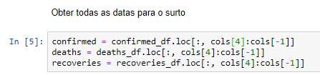

dates = confirmed.keys()

world_cases = []

total_deaths = []

mortality_rate = []

recovery_rate = []

total_recovered = []

total_active = []

china_cases = []

italy_cases = []

us_cases = []

spain_cases = []

france_cases = []

germany_cases = []

uk_cases = []

russia_cases = []

brazil_cases = []

china_deaths = []

italy_deaths = []

us_deaths = []

spain_deaths = []

france_deaths = []

germany_deaths = []

uk_deaths = []

russia_deaths = []

brazil_deaths = []

china_recoveries = []

italy_recoveries = []

us_recoveries = []

spain_recoveries = []

france_recoveries = []

germany_recoveries = []

uk_recoveries = []

russia_recoveries = []

brazil_recoveries = []

for i in dates:

confirmed_sum = confirmed[i].sum()

death_sum = deaths[i].sum()

recovered_sum = recoveries[i].sum()

# confirmadas, mortes, recuperadas e ativas

world_cases.append(confirmed_sum)

total_deaths.append(death_sum)

total_recovered.append(recovered_sum)

total_active.append(confirmed_sum-death_sum-recovered_sum)

# calcular taxas

mortality_rate.append(death_sum/confirmed_sum)

recovery_rate.append(recovered_sum/confirmed_sum)

# estudos de caso

china_cases.append(confirmed_df[confirmed_df['Country/Region']=='China'][i].sum())

italy_cases.append(confirmed_df[confirmed_df['Country/Region']=='Italy'][i].sum())

us_cases.append(confirmed_df[confirmed_df['Country/Region']=='US'][i].sum())

spain_cases.append(confirmed_df[confirmed_df['Country/Region']=='Spain'][i].sum())

france_cases.append(confirmed_df[confirmed_df['Country/Region']=='France'][i].sum())

germany_cases.append(confirmed_df[confirmed_df['Country/Region']=='Germany'][i].sum())

uk_cases.append(confirmed_df[confirmed_df['Country/Region']=='United Kingdom'][i].sum())

russia_cases.append(confirmed_df[confirmed_df['Country/Region']=='Russia'][i].sum())

brazil_cases.append(confirmed_df[confirmed_df['Country/Region']=='Brazil'][i].sum())

china_deaths.append(deaths_df[deaths_df['Country/Region']=='China'][i].sum())

italy_deaths.append(deaths_df[deaths_df['Country/Region']=='Italy'][i].sum())

us_deaths.append(deaths_df[deaths_df['Country/Region']=='US'][i].sum())

spain_deaths.append(deaths_df[deaths_df['Country/Region']=='Spain'][i].sum())

france_deaths.append(deaths_df[deaths_df['Country/Region']=='France'][i].sum())

germany_deaths.append(deaths_df[deaths_df['Country/Region']=='Germany'][i].sum())

uk_deaths.append(deaths_df[deaths_df['Country/Region']=='United Kingdom'][i].sum())

russia_deaths.append(deaths_df[deaths_df['Country/Region']=='Russia'][i].sum())

brazil_deaths.append(deaths_df[deaths_df['Country/Region']=='Brazil'][i].sum())

china_recoveries.append(recoveries_df[recoveries_df['Country/Region']=='China'][i].sum())

italy_recoveries.append(recoveries_df[recoveries_df['Country/Region']=='Italy'][i].sum())

us_recoveries.append(recoveries_df[recoveries_df['Country/Region']=='US'][i].sum())

spain_recoveries.append(recoveries_df[recoveries_df['Country/Region']=='Spain'][i].sum())

france_recoveries.append(recoveries_df[recoveries_df['Country/Region']=='France'][i].sum())

germany_recoveries.append(recoveries_df[recoveries_df['Country/Region']=='Germany'][i].sum())

uk_recoveries.append(recoveries_df[recoveries_df['Country/Region']=='United Kingdom'][i].sum())

russia_recoveries.append(recoveries_df[recoveries_df['Country/Region']=='Russia'][i].sum())

brazil_recoveries.append(recoveries_df[recoveries_df['Country/Region']=='Brazil'][i].sum())

