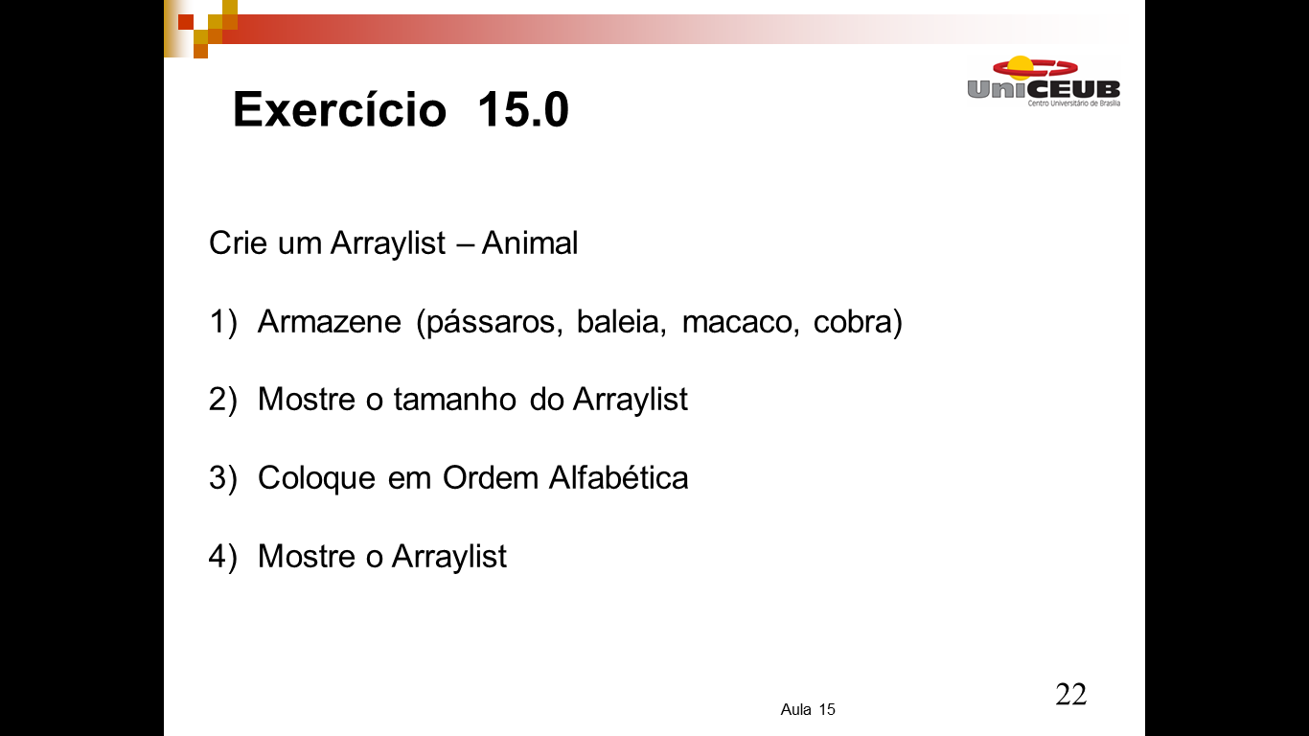
package aula_15_ex;
import java.util.ArrayList;
import java.util.Collections;

public class Aula_15_ex {
public static void main(String[] args) {
ArrayList<String> animal = new ArrayList<>(); // Criando Lista
animal.add("Passaros");
animal.add("Baleia");
animal.add("Macacos");
animal.add("Cobra");
System.out.println(animal.toString());
Collections.sort(animal);
System.out.println(animal.toString());
int tam = animal.size();
for (int i =0; i < tam; i++) {
System.out.println(animal.get(i));
}
}
}

