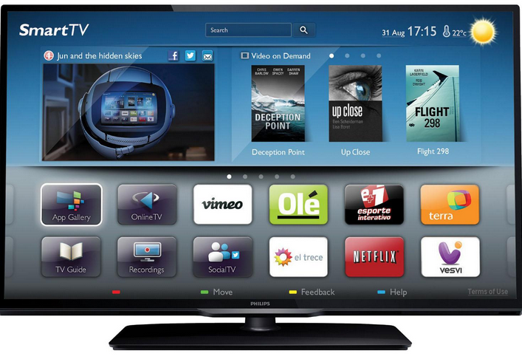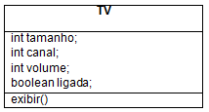
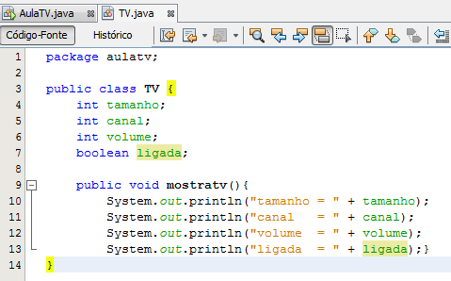
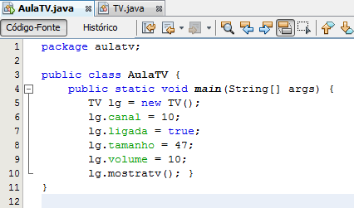
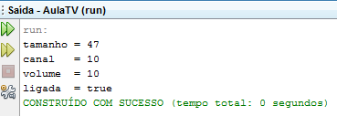
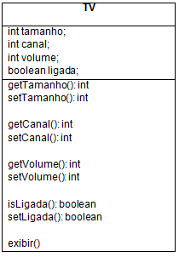
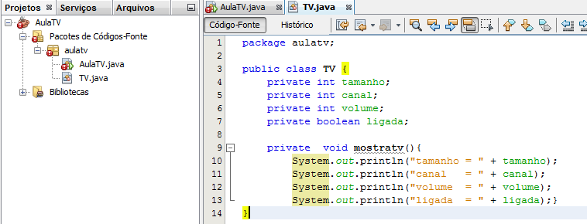
Gabarito

package aulatv;
public class TV {
private int tamanho;
private int canal;
private int volume;
private boolean ligada;

public void mostratv(){
System.out.println("tamanho = " + getTamanho());
System.out.println("canal = " + getCanal());
System.out.println("volume = " + getVolume());
System.out.println("ligada = " + isLigada());}

public int getTamanho() {
return tamanho; }

public void setTamanho(int tam) {
this.tamanho = tam; }

public int getCanal() {
return canal;}

public void setCanal(int can) {
this.canal = can;}

public int getVolume() {
return volume; }

public void setVolume(int vol) {
this.volume = vol;}

public boolean isLigada() {
return ligada; }

public void setLigada(boolean lig) {
this.ligada = lig; }
}

package aulatv;

public class AulaTV {
public static void main(String[] args) {
TV lg = new TV();
//lg.canal = 10;
//lg.ligada = true;
//lg.tamanho = 47;
//lg.volume = 10;
//lg.mostratv();
lg.setCanal(10);
lg.setTamanho(47);
lg.setVolume(10);
lg.setLigada(true);
lg.mostratv();

}
}

