AD3552R 4-Channel DAC Mezzanine — Design Manual
Nov 2, 2026 · @Philip

Overview
The board is a 95 × 60 mm, 6-layer mezzanine that adds four differential analog outputs to a Red Pitaya STEMlab 125-14 4-Input. It plugs onto the Red Pitaya's E1 and E2 extension headers from above, takes SPI/QSPI from the FPGA through E1, and drives eight SMA jacks (one ± pair per channel).
- Converters: two Analog Devices AD3552R dual 16-bit current-output DACs (U1, U2), giving channels 0–3.
- Reference: one shared ADR4525 2.5 V reference (U7) for both DACs.
- Output chain per channel: an ADA4807-1 transimpedance amplifier (U3–U6) makes the positive output. A unity-gain inverter (U16–U19) makes the negative output. Each output has an isolation resistor, a BAV99 clamp and a bleeder resistor before its SMA jack.
- Logic: four 74AVC4T774 / SN74AXC4T774 bidirectional level translators (U8–U11) between the Red Pitaya's 3.3 V I/O and the DACs' VLOGIC domain.
- Power: one external DC input feeds an on-board power tree: buck converter, ±5 V charge pump, low-noise LDOs, and AVDD/DVDD/VLOGIC rails (Power supply section).
- Source: the design follows the notebook AD3552R_four_channel_DAC_circuit_design_tutorial.ipynb. That includes the board outline and Red Pitaya header/hole coordinates from its section 10.4.
The schematic and PCB are in ad3552r_dac/ad3552r_dac/ (KiCad 10). The final board passes DRC with 0 errors, 0 warnings, 0 unconnected nets and 0 schematic-parity issues.

System architecture
Four identical channels turn a DAC current into a push-pull voltage pair. Each pair swings about ±4.9 V per electrode, so up to about 9.8 V appears across an electrode pair.
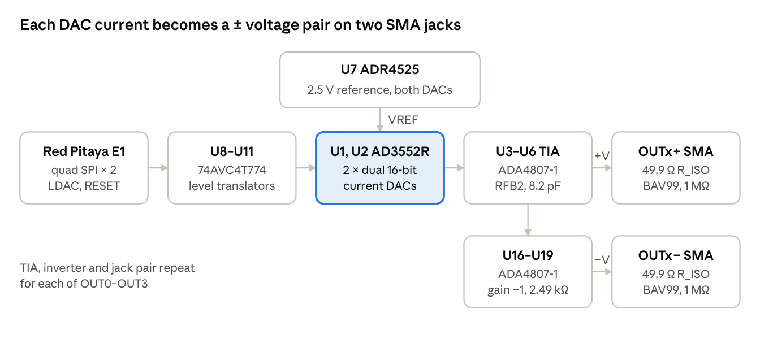
signal chain · one of four channels
Channel mapping: U1 CH0 → OUT0 (J4/J5), U1 CH1 → OUT1 (J6/J7), U2 CH0 → OUT2 (J8/J9), U2 CH1 → OUT3 (J10/J11).
The Red Pitaya computes four codes and writes them to both DACs in parallel over two independent quad-SPI groups that share SCLK. A common active-low LDAC then updates all four outputs together. The DAC side runs at 1.8 V logic, so every E1 signal passes through an explicit-direction translator. The analog side runs from ±5 V rails made on the board from a single +12 V input.
The outputs are bipolar on purpose. The load is a pair of electrodes acting on a charged particle, and the drive must swing both ways about 0 V. A unipolar output centred on 2.5 V would put a static force on the particle.

Digital interface
Every DAC control signal passes through a 74AVC4T774 translator, because E1 is 3.3 V LVCMOS and the AD3552R logic pins tolerate only VLOGIC + 0.3 V (VLOGIC = 1.8 V here). The reverse direction needs translation too: a 1.8 V SDIO or ALERT output is below the 2.0 V input-high threshold of 3.3 V LVCMOS.

Headers
- J1 (E1), 2 × 13 socket on the bottom side. It carries all DAC signals and +3.3 V (pins 1–2) for the translators' A side (VCCA). Ground is on pins 25–26. Pins 3, 4 and 24 are unused, which keeps DIO0 free for its stock trigger functions.
- J12 (E2), 2 × 13 socket on the bottom side. It is used only for mechanical support and extra ground (pins 12, 22, 25, 26). Its +5 V and −3.4 V pins are deliberately left unconnected. They are shared with USB, noisy and too weak for the analog rails.

Translators
Ref | A side (E1, 3.3 V) | B side (DAC, 1.8 V) | Direction
U8 | E1_DQ_A0–A3 | U1 SDIO0–3 via R3–R6 | DIR_A from the FPGA (write H, read L)
U9 | E1_DQ_B0–B3 | U2 SDIO0–3 via R7–R10 | DIR_B from the FPGA
U10 | E1_SCLK, CS_A_N, CS_B_N, LDAC_N | via R11–R14 | all tied A→B
U11 | E1_RESET_N, ALERT_A_N, ALERT_B_N | RESET_N via R15; ALERTs direct | RESET out, ALERTs in; channel 4 unused (A4 grounded)
The parts are explicit-direction translators so that the FPGA decides the bus turnaround in a known clock cycle during readback. Auto-direction parts (TXB/TXS) sense the driver and are sensitive to pull-ups and capacitive load. Both ports go high-impedance when either supply is off (Ioff), so the Red Pitaya and the mezzanine may power up in either order. All four OE pins share XLAT_OE_N with a 10 kΩ pull-up to 3.3 V (R16). The DACs stay isolated until the bitstream drives that line low.

Resistors on the 1.8 V side
Ref | Value | Net | Purpose
R3–R15 | 33 Ω | SDIO, SCLK, CS, LDAC, RESET | Source termination at the translator B outputs
R17, R18, R19 | 10 kΩ to VLOGIC | CS_A_N, CS_B_N, LDAC_N | Idle-high before the FPGA drives them
R20 | 10 kΩ to GND | SCLK | Defined clock level at power-up
R21 | 10 kΩ to GND | RESET_N | Holds both DACs in reset (IOUT and VCM at 0 V) until the FPGA releases it
R22, R23 | 10 kΩ to VLOGIC | ALERT_A_N, ALERT_B_N | The DAC's internal pull-up is off after reset
R24–R31 | 100 kΩ to GND | DQ lanes | Defined level on the SDIO lanes while high-impedance
R1, R2 | 1 kΩ to VLOGIC | QSPI pin 31 of U1, U2 | Strap that selects quad SPI (data sheet Figure 94)
RESET_N is pulled low on purpose. The data sheet shows an optional 1 kΩ pull-up, but holding reset until the FPGA is ready keeps every output near 0 V during power-up and bitstream loading.

Pin assignment and timing
The twelve fast nets (SCLK, LDAC_N, two CS lines and eight DQ lanes) sit on E1 DIO1–DIO6, which are in Zynq I/O bank 35, so they have similar package delays. RESET, ALERT, XLAT_OE_N and SYNC_OUT use DIO8–DIO10 in bank 13. SCLK, LDAC_N and RESET_N fan out from one translator output each to both DACs. The PCB keeps the two stubs short. The translators sit within about 1–2 cm of E1, as the notebook requires, because E1 has only two ground pins for 22 signals.

SYNC_OUT
TP1 is a 1.5 mm test pad on SYNC_OUT (E1 pin 23, DIO10_P). It is a 3.3 V marker straight from the FPGA, used to trigger a scope on each update and to measure latency. It does not pass through a translator.

DACs and reference
U1 and U2 are AD3552R dual 16-bit current-output DACs (LFCSP-32, 5 × 5 mm). Each channel uses the on-chip RFB2 feedback resistor (3.228 kΩ nominal) with output-range code 0b011, which gives a nominal −5 V to +5 V span. The starting register write is CH0_CH1_OUTPUT_RANGE (0x19) ← 0x33.
The transfer law is V_OUT = V_CM − R_FB · I_OUT. The range includes about 3% overrange (−5.165 V / +5.166 V). The ±5 V amplifier rails stop the ADA4807-1 about 0.1 V short of each rail, so firmware should clamp commands to about ±4.85 V.

Pin connections per DAC
Pin | Net | Part (U1 / U2) | Notes
1 DVDD | +1.8 V | C1 / C2, 1 µF | Bursty current follows SPI traffic (about 53 mA typ. while streaming); own ferrite branch FB1
2 VLOGIC | +1.8 V | C3 / C4, 1 µF | Separate ferrite branch FB2 keeps DVDD noise out of the I/O supply
19 AVDD | +5.0 V | C5 / C6 10 µF 0805 + C7 / C8 100 nF | See AVDD bulk below
20 VREF | VREF_2V5 | from U7 | External-reference mode; program the reference select to match
21 CVREF | U1_CVREF / U2_CVREF | C17 / C18, 470 nF | Reference decoupling to ground; high-K dielectric is acceptable
28, 13 NCAP0/1 | Ux_NCAPn | C9–C12, 470 nF NP0 1206 | Noise-control nodes to ground; in the output-voltage path, so NP0
29, 12 PCAP0/1 | Ux_PCAPn | C13–C16, 470 nF NP0 1206 | Noise-control nodes to AVDD; NP0
27, 14 VCM0/1 | OUTn_VCM | C25–C28, 100 nF | Go directly to the TIA's + input
26, 15 IOUT0/1 | OUTn_IOUT | — | To the TIA's − input; shortest practical trace
24, 17 RFB2_0/1 | OUTn_RFB | — | To the TIA output, before the 49.9 Ω isolation resistor
16, 18, 23, 25 RFB1/RFB4 | unconnected | — | Left open, not grounded
31 QSPI | QSPI_A / QSPI_B | R1 / R2, 1 kΩ to VLOGIC | Selects quad SPI
32 DNC | unconnected | — | Do not connect
22, 30, EPAD | GND | — | AGND and DGND joined under the device to the solid ground plane

AVDD bulk capacitor (C5, C6)
Each DAC has one 10 µF X7R, ≥10 V, 0805 within a few millimetres of pin 19, with its own ground via. The value comes from the regulator, not the DAC:
- The TPS7A4901 needs at least 2.2 µF of effective output capacitance, and TI recommends 10 µF.
- AD3552R AVDD current is nearly constant (22 mA typ., 28.5 mA max), so the capacitor's job is high-frequency noise. The DAC's AVDD rejection falls from 80 dB at 1 kHz to 43 dB at 1 MHz.
- A 10 µF X7R can lose 30–50% at 5 V DC bias. The 0805 size keeps the effective value at ≥5 µF. Confirm against the vendor's bias curve.
At bring-up, measure AVDD ripple at pin 19. If 500 kHz switching noise from the buck or charge pump appears, add 1 µF or a ferrite.

Voltage reference (U7)
U7 is an ADR4525BRZ (SOIC-8), a low-noise 2.5 V reference fed from AVDD (C19, 100 nF at its input). Its output VREF_2V5 goes to pin 20 of both DACs, with C20 (4.7 µF 0603) at the output. One reference for both chips gives all four channels the same gain reference. The AD3552R also has an internal 2.5 V reference. If it is ever used instead, the VREF pin must not see two active sources.
U7 sits to the right of the DACs on their analog side, away from the SCLK/SDIO pins on the left.

Analog output stage
Each channel copies the circuit the AD3552R data sheet uses to measure its dynamic performance: an ADA4807-1 transimpedance amplifier closed through RFB2 with an 8.2 pF NP0 feedback capacitor. An identical amplifier at gain −1 produces the negative output. Both drive source-terminated 50 Ω coax to an electrode pair.

Parts per channel (n = 0–3)
Function | Refs (OUT0 / OUT1 / OUT2 / OUT3) | Value | Why
TIA | U3 / U4 / U5 / U6 | ADA4807-1, SOT-23-6 | Data sheet characterisation amplifier: 180 MHz, 225 V/µs, rail-to-rail output, 2.7–11 V supply
TIA feedback cap | C21–C24 | 8.2 pF NP0, 0402 | Data sheet value for the ±5 V range (Figs. 56, 59); small footprint, NP0
VCM decoupling | C25–C28 | 100 nF | VCM goes straight to the + input with 0.1 µF to ground (Fig. 94); no series resistor
Inverter | U16 / U17 / U18 / U19 | ADA4807-1, gain −1 | Same amplifier, swing and rails as the TIA
R_G, R_F | R32–R35, R36–R39 | 2.49 kΩ 0.1% thin film | Matched gain of −1. The data sheet's 499 Ω would draw 9.8 mA per resistor at full swing. 2.49 kΩ keeps all eight amplifiers at 24 mA per rail
C_F | C45–C48 | 1.0 pF NP0 | Phase margin 35° → 68°, flat response to 53 MHz, about 4.3 ns delay
Bias resistor | R40–R43 | 1.24 kΩ to GND | R_F ∥ R_G, cancels input-bias-current offset
Output isolation | R44–R47 (+), R48–R51 (−) | 49.9 Ω | Outside the feedback loop; isolates the amplifier from cable capacitance and source-terminates the coax
Clamp | D1–D8 | BAV99 to +5 V and −5 V | Stray charge and ESD from the chamber wiring; R_ISO limits the diode current
Bleeder | R52–R59 | 1 MΩ to GND | Defines the electrode potential with the amplifiers off and drains charge
Connectors | J4/J5, J6/J7, J8/J9, J10/J11 | SMA, Amphenol 132134, vertical THT | OUTn+ / OUTn−; 50 Ω, matches the Red Pitaya inputs and standard UHV feedthroughs
Supply bypass | C29–C36 (TIAs), C49–C56 (inverters) | 100 nF each to +5 V and −5 V | At the amplifier supply pins
Each ADA4807-1 has its DISABLE pin (pin 5) tied to +5 V, the enable level; it never floats.

Design decisions
- Push-pull pair. J_n+ carries +V_OUT and J_n− carries −V_OUT. That doubles the field per DAC volt and keeps the trap centre near 0 V. Up to about 9.8 V appears across the pair, and one DAC channel still drives one axis.
- 49.9 Ω source termination. Each electrode is the open, high-impedance end of a 50 Ω line. The wave doubles at the open end, so the electrode sees the full amplifier voltage and the reflection is absorbed at the source. There is no ringing and no DC current. Without R_ISO the ADA4807-1 overshoots about 17% into only 15 pF.
- Feedback node before R_ISO. RFB2 connects at the amplifier output pin, not at the jack, so the DAC's gain does not include the 49.9 Ω resistor.
- Not for 50 Ω loads. A 50 Ω-terminated instrument halves the voltage, and ±5 V across 50 Ω would need about 100 mA, beyond the ADA4807-1's 50/60 mA. Use a scope's 1 MΩ input during bring-up.
- Speed. With RFB2 the ±5 V range settles in about 180 ns to 0.1% (notebook model), about twice the data sheet's 100 ns for the 0–5 V range. Slew is about 180 V/µs. The inverter adds about 4 ns to the negative electrode.

Layout rules applied
Each TIA sits right of its DAC, next to IOUT and RFB2. The inverter sits next to its TIA, R_ISO at each amplifier output, and the BAV99 and bleeder at each jack. The jacks are in ± pairs at 10 mm pitch along the top edge (OUT0, OUT1) and bottom edge (OUT2, OUT3), so a torque wrench fits.

Power supply
The board takes one external +12 V supply and makes every rail itself. It draws about 145 mA (1.7 W), so any 12 V adapter of 0.5 A or more is enough. The Red Pitaya's E2 +5 V and −3.4 V are not used.
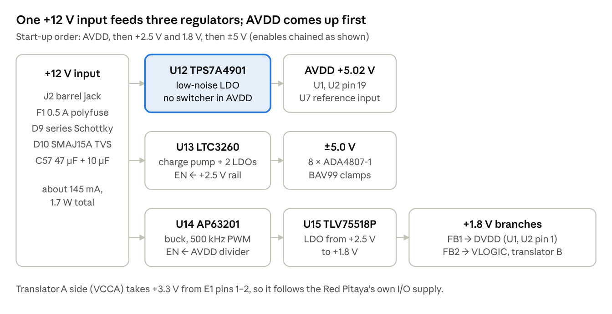
power tree · single +12 V input

Rails
Rail | Regulator | Setting | Loads | Why this part
+12V | J2 → F1 → D9 | — | U12, U13, U14 | 2.1 mm jack; 0.5 A-hold polyfuse; 40 V / 2 A Schottky in series for reverse polarity; SMAJ15A TVS (D10); C57 47 µF + C58 10 µF 25 V. All three regulators are rated ≥35 V, above the TVS clamp
AVDD +5.02 V | U12 TPS7A4901 (HVSSOP-8) | 1.185 V × (1 + R60 324 k / R61 100 k) | U1, U2 AVDD (2 × 28.5 mA max); U7 | 21 µV rms; 72 dB PSRR at 120 Hz. The DAC data sheet singles out AVDD noise, so no switcher is in this path. C61 10 nF NR/SS, C62 10 nF feed-forward, C59 10 µF in, C60 10 µF out
+5.0 V / −5.0 V | U13 LTC3260 (MSOP-16E) | ±1.2 V × (1 + 316 k / 100 k) via R62/R63, R64/R65 | 8 × ADA4807-1, about 24 mA per rail at full swing | One IC makes both rails: inverting charge pump (+12 V → about −10.8 V on VNEG_PUMP) plus LDO+ and LDO−, 50 mA each. Constant 500 kHz (MODE and RT grounded), not Burst Mode. C64 1 µF flying cap; C63, C65–C67 10 µF; C68/C69 10 nF bypass; C70 10 pF across the ADJ− divider
+2.5 V | U14 AP63201 (TSOT-23-6) | 0.8 V × (1 + R66 131 k / R67 62 k) | U15, LTC3260 enables | Forced-PWM buck at 500 kHz. Saves about 1 W against a linear drop from 12 V to 1.8 V. L1 3.3 µH, C71 10 µF in, C72/C73 22 µF out, C74 100 nF bootstrap, C75 100 pF feed-forward
+1.8 V | U15 TLV75518P (SOT-23-5) | fixed | DVDD (2 × 60 mA max), VLOGIC, translator VCCB | Cleans the buck ripple. One source for DVDD and VLOGIC keeps VLOGIC ≤ DVDD + 0.3 V (absolute maximum). C76/C77 1 µF
DVDD, VLOGIC | FB1, FB2 ferrite beads from +1.8 V | — | DAC pins 1 and 2; U8–U11 VCCB | Separate branches keep the bursty DVDD current out of VLOGIC
+3.3 V | Red Pitaya E1 pins 1–2 | — | Translator VCCA, A-side pull-up R16 | Follows the Red Pitaya's I/O supply

Start-up order
The AD3552R data sheet recommends AVDD, then DVDD, then VLOGIC to minimise the power-up glitch, with the amplifiers last. The enables chain gives exactly that:
- U12 starts with the +12 V input and ramps AVDD over about 14 ms (1.4 ms per nF on NR/SS).
- The buck's EN comes from AVDD through R68 100 k / R69 36 k, so +2.5 V starts once AVDD passes about 4.3–4.7 V.
- U15 follows the 2.5 V rail, bringing DVDD and VLOGIC up together.
- The LTC3260's EN+ and EN− connect to the 2.5 V rail, so ±5 V starts last.
Throughout, R21 holds RESET_N low, so both DACs stay in reset with IOUT and VCM at 0 V until the FPGA releases them.

Noise and thermal notes
- The charge-pump ripple is about 2.4 mVpp at 500 kHz. The LDO− rejects about 45 dB there, leaving about 13 µVpp on −5 V and about 0.1 µV at the outputs (notebook estimate). Confirm it with a spectrum analyser on OUT0–OUT3.
- U12 dissipates about 0.38 W (about 24 °C rise in HVSSOP), so its exposed pad is soldered to a ground pour with vias. The LTC3260 runs about 16 °C above ambient.
- The power block sits at the left board edge, away from the TIAs and reference. U12 sits near the DACs at about (59.5, 29) mm so that AVDD is short.

Component reference
The board has 191 schematic parts plus four mounting holes (H1–H4, board-only). Groups are listed by reference designator. Capacitors are X7R/X5R unless marked NP0.
Refs | Qty | Value | Footprint | Function
U1, U2 | 2 | AD3552R | LFCSP-32 5 × 5 mm | Dual 16-bit current-output DACs
U3–U6 | 4 | ADA4807-1 | SOT-23-6 | TIAs, OUT0–OUT3 positive outputs
U7 | 1 | ADR4525BRZ | SOIC-8 | 2.5 V reference for both DACs
U8–U11 | 4 | 74AVC4T774 | TSSOP-16 | 3.3 V ↔ 1.8 V translators (DQ_A, DQ_B, clock/strobes, reset/alerts)
U12 | 1 | TPS7A4901 | HVSSOP-8 + EP | AVDD +5.02 V LDO
U13 | 1 | LTC3260 | MSOP-16 + EP | Charge pump + ±5 V LDOs
U14 | 1 | AP63201 | TSOT-23-6 | 12 V → 2.5 V buck
U15 | 1 | TLV75518P | SOT-23-5 | 2.5 V → 1.8 V LDO
U16–U19 | 4 | ADA4807-1 | SOT-23-6 | Gain −1 inverters, negative outputs
J1 | 1 | 2 × 13 socket | PinSocket 2.54 mm, bottom | Red Pitaya E1
J12 | 1 | 2 × 13 socket | PinSocket 2.54 mm, bottom | Red Pitaya E2 (ground and support only)
J2 | 1 | +12 V IN | Barrel jack, horizontal | Power input
J4–J11 | 8 | SMA | Amphenol 132134 vertical | OUT0+ … OUT3−
TP1 | 1 | SYNC_OUT | 1.5 mm pad | FPGA timing marker
F1 | 1 | 0.5 A hold | 1206 | Input polyfuse
D9 | 1 | 40 V 2 A Schottky | SMA | Reverse-polarity protection
D10 | 1 | SMAJ15A | SMA | Input TVS
D1–D8 | 8 | BAV99 | SOT-23 | Output clamps to ±5 V
L1 | 1 | 3.3 µH | Taiyo Yuden NR-50xx | Buck inductor
FB1, FB2 | 2 | Ferrite bead | 0603 | DVDD and VLOGIC branches
C1–C4 | 4 | 1 µF | 0402 | DVDD (C1, C2) and VLOGIC (C3, C4) at the DACs
C5, C6 | 2 | 10 µF | 0805 | AVDD bulk, one per DAC
C7, C8 | 2 | 100 nF | 0402 | AVDD HF bypass
C9–C12 | 4 | 470 nF NP0 | 1206 | NCAP0/1 to GND
C13–C16 | 4 | 470 nF NP0 | 1206 | PCAP0/1 to AVDD
C17, C18 | 2 | 470 nF | 0603 | CVREF
C19, C20 | 2 | 100 nF, 4.7 µF | 0402, 0603 | U7 input, VREF output
C21–C24 | 4 | 8.2 pF NP0 | 0402 | TIA feedback
C25–C28 | 4 | 100 nF | 0402 | VCM decoupling
C29–C36, C49–C56 | 16 | 100 nF | 0402 | ±5 V bypass at each amplifier
C37–C44 | 8 | 100 nF | 0402 | Translator VCCA (+3.3 V) and VCCB (VLOGIC) bypass
C45–C48 | 4 | 1 pF NP0 | 0402 | Inverter C_F
C57 | 1 | 47 µF | Electrolytic 6.3 × 5.4 | +12 V bulk
C58, C59, C63, C71 | 4 | 10 µF 25 V | 0805 | +12 V at the input and at each regulator input
C60, C65–C67 | 4 | 10 µF | 0805 | AVDD out, VNEG_PUMP, +5 V, −5 V
C61, C62, C68, C69 | 4 | 10 nF | 0402 | TPS7A4901 NR/SS and feed-forward; LTC3260 BYP+/BYP−
C64 | 1 | 1 µF 25 V | 0603 | LTC3260 flying capacitor
C70 | 1 | 10 pF | 0402 | LTC3260 ADJ− compensation
C72, C73 | 2 | 22 µF | 0805 | Buck output
C74, C75 | 2 | 100 nF, 100 pF | 0402 | Buck bootstrap, feed-forward
C76, C77 | 2 | 1 µF | 0402 | TLV75518P in/out
R1, R2 | 2 | 1 kΩ | 0402 | QSPI straps
R3–R15 | 13 | 33 Ω | 0402 | Series termination, 1.8 V side
R16–R23 | 8 | 10 kΩ | 0402 | XLAT_OE_N, CS, LDAC, ALERT pull-ups; SCLK, RESET pull-downs
R24–R31 | 8 | 100 kΩ | 0402 | DQ lane pull-downs
R32–R39 | 8 | 2.49 kΩ 0.1% | 0402 | Inverter R_G, R_F
R40–R43 | 4 | 1.24 kΩ | 0402 | Inverter bias-current balance
R44–R51 | 8 | 49.9 Ω | 0402 | Output isolation / source termination
R52–R59 | 8 | 1 MΩ | 0402 | Output bleeders
R60, R61 | 2 | 324 kΩ, 100 kΩ | 0402 | AVDD divider
R62–R65 | 4 | 316 kΩ, 100 kΩ | 0402 | ±5 V dividers
R66, R67 | 2 | 131 kΩ, 62 kΩ | 0402 | Buck feedback
R68, R69 | 2 | 100 kΩ, 36 kΩ | 0402 | Buck EN from AVDD (sequencing)
C5–C8 carry hidden Role/Spec/Notes fields in the schematic and on the PCB footprints, and several power capacitors carry a hidden Spec field (voltage rating and dielectric).

PCB design
The PCB is a 95 × 60 × 1.6 mm, 6-layer board. It sits directly on the Red Pitaya's E1 and E2 headers, with one solid ground plane and one split power layer. Every placement decision serves two rules: keep the translators within 1–2 cm of E1, and keep the DAC-to-TIA analog loops short and away from the digital edges.
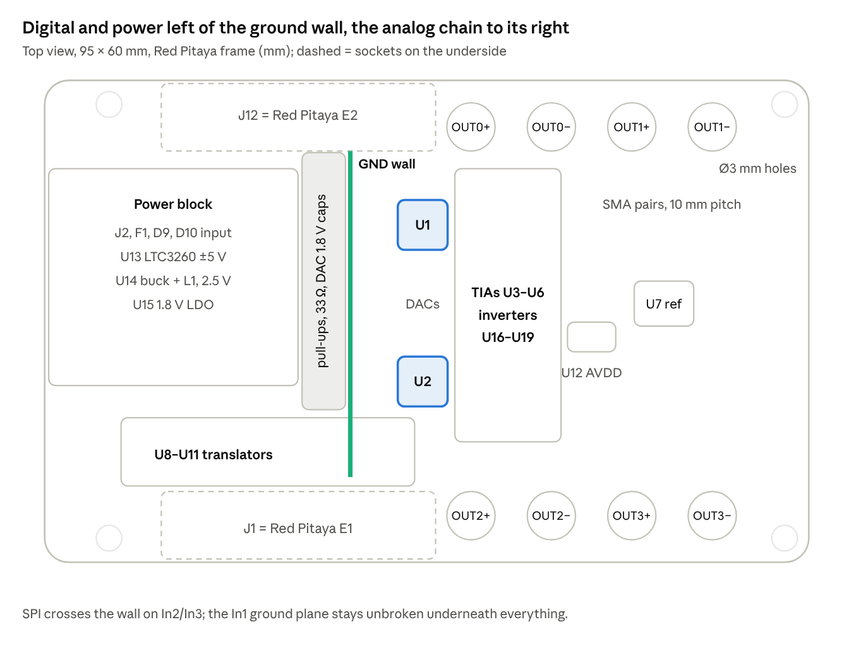
board placement map · top view

Mechanics
- Outline and holes. The outline, 3 mm corner radius and four 3.0 mm holes at (0, 0), (84, 0), (0, 54) and (84, 54) mm follow the Red Pitaya's own 3D model, so the mezzanine's holes line up with the Red Pitaya's. Board file coordinates are the Red Pitaya frame shifted by (+20, +10) mm.
- Sockets. J1 (E1) and J12 (E2) are 2 × 13 sockets on the underside, 50.80 mm apart, with pin 1 at x = 38.81 mm on both. Pin-1 orientation was taken from Red Pitaya's extension module. Confirm it against the key slot on the real shrouds before ordering.
- Height. Use elevated sockets (Red Pitaya suggests about 16 mm insulation height, e.g. Samtec ESW-113-33-T-D) to clear the heatsink (11.7 mm with clips) and the Ethernet/USB jacks. Keep tall parts off the underside.
- Labels. The board title is on the bottom silkscreen above J1. All reference designators that would overlap pads were moved to clear positions.

Stackup and layer use
Layer | Copper | Use | Dielectric below
F.Cu | 35 µm | Components, short signal routing, local GND pours | 0.10 mm FR4 (εr 4.2)
In1.Cu | 17.5 µm | Solid GND plane, unbroken | 0.50 mm
In2.Cu | 17.5 µm | Signal (SPI crossings, longer rail feeds) | 0.26 mm
In3.Cu | 17.5 µm | Signal | 0.50 mm
In4.Cu | 17.5 µm | Split power islands (+5V, AVDD, +12V, +2V5, VLOGIC, +3V3) | 0.10 mm
B.Cu | 35 µm | Signal, GND pour, E1/E2 sockets | —
The stackup is approximate (JLC-like); confirm it with the fab before impedance-critical work. The thin 0.10 mm dielectric puts F.Cu tightly over the In1 ground, so fast edges on the top layer return directly underneath.
In4 islands (Red Pitaya frame, mm): +5V (44.4, 4)–(78, 48) with two AVDD carve-outs at the DACs' right side and around U7; AVDD (37.2, 5)–(44.4, 46); +12V (7, 11)–(25, 26.5); +2V5 (7, 27)–(26, 35.5); VLOGIC (26.5, 5)–(37, 38); +3V3 (1, 36)–(26, 55). −5V, DVDD, +1V8 and VNEG_PUMP do not cluster, so they run as tracks.

Placement strategy
- U1 was placed first, and its passives were placed by hand around it. The U2 group copies U1's layout 19.5 mm lower.
- U7 sits right of the DACs on the analog side, with its capacitors next to its pins.
- Each TIA sits right of its DAC, next to IOUT and RFB2. Each inverter sits next to its TIA. The clamps and bleeders sit at the jacks.
- The power block sits at the left edge, away from the analog chain. U12 was moved next to the DACs so the AVDD feed is short.
- The translators sit in a row just above E1: U11 (6, 45), U9 (14.5, 43.5), U8 (21.5, 43.5) and U10 (34.5, 43.5).

Ground guard
A 0.5 mm GND track runs on F.Cu at x = 30 mm from y = 5.8 to 46.4 mm, stitched to the In1 plane with 18 vias. The 1.8 V DAC pull-ups, series resistors and decoupling sit left of it. The DACs, references and amplifiers sit right of it. SPI signals cross the wall on the inner layers. C9 and C11 (NCAP0 capacitors) were deliberately left at their hand-placed positions. The ground plane itself is never split.

Rules and net classes
Class | Nets | Track | Clearance | Via
Default | all signals | 0.15 mm | 0.10 mm | 0.4 / 0.2 mm
Coax50 | OUT?_P, OUT?_N | 0.16 mm | 0.10 mm | 0.4 / 0.2 mm
Power | +12V, ±5V, AVDD, DVDD, VLOGIC, +2V5, +1V8, +3V3, VNEG_PUMP, VIN_*, BUCK_SW | 0.30 mm | 0.10 mm | 0.4 / 0.2 mm
Board minimums: track 0.10 mm, copper-to-edge 0.30 mm, hole clearance and hole-to-hole 0.20 mm, silkscreen text 0.8 mm high and 0.12 mm thick. These suit common 6-layer fabs (JLCPCB class). Clearances were relaxed to 0.10 mm for routing density. The Coax50 class is a routing label, not a controlled-impedance definition.

Routing
The board was routed in stages with Freerouting 2.5.0 plus hand fixes, checking DRC after each stage:
- Power block, +12V and +2V5.
- Supply rails to the DACs and amplifiers.
- The analog nets of U1's block, then U2's block (IOUT, RFB, VCM, CAP nets, inverters, 50 Ω outputs).
- SPI and control lines, crossing the guard wall on In2/In3.
- GND fan-out: every ground pad gets a via to In1.
The dense pin lanes beside U1 and U2 needed hand work. Staggered escape vias were added at 0.5 mm pin pitch, and VLOGIC and DVDD stubs that blocked the lanes were moved to plane vias. Two parts were nudged to free ground vias: R20 by (+0.75, −0.5) mm and rotated 90°, and C31 by 0.5 mm, flipped.

Verification status and bring-up
The design is complete in CAD and passes every automated check. It has not been built or measured.
Check | Result
Schematic ERC (KiCad 10) | 0 errors, about 11 cosmetic warnings
PCB DRC | 0 errors, 0 warnings, 0 unconnected nets
Schematic–PCB parity | 0 issues
Data sheets checked | AD3552R, ADR4525, LTC3260, TPS7A4901, SN74AXC4T774, ADA4807-1, AP63201, TLV755P

Known caveats
- Header pin 1. The E1/E2 pin-1 end comes from Red Pitaya's extension module markings, not from the shrouds. Check it on a real board before ordering.
- Stackup. The 6-layer stackup is approximate. The OUT nets are not impedance-controlled; the 49.9 Ω source termination does not depend on the trace impedance over these short runs.
- Analog trace lengths. The IOUT traces from the DACs to the TIAs are about 5–6 mm. NCAP capacitors C9, C11 and C12 sit 5–7 mm from their pins. U1_NCAP1 (C10) reaches its pin through an inner-layer link of about 15 mm. The data sheet asks for short IOUT and noise-control runs, so measure settling and noise on these channels first.
- +12V feed. The +12 V feed to U12 runs as a long diagonal on In2 under the DAC area. In1 ground separates it from the top-layer analog nets.
- Translator distance. U10 (clock and strobes) is about 6.6 mm on average from its E1 pins, inside the 1–2 cm target.
- Feedback capacitors. The 8.2 pF TIA and 1 pF inverter capacitors are characterisation and model values. Confirm the step response on the real layout and cables.
- Test points. Only SYNC_OUT has a dedicated test pad. Supplies, VREF and the amplifier outputs are probed on component pads.
- Project rules. If the KiCad GUI holds an old copy of the project open, saving from it reverts the net-class rules. Close the project without saving before editing the files with scripts.

Bring-up checklist
- ☐ Power only, no Red Pitaya: +12 V input current about 145 mA. AVDD 5.02 V, ±5.0 V, +2.5 V, +1.8 V. Check the start-up order on a scope: AVDD → 2.5/1.8 V → ±5 V.
- ☐ Ripple: AVDD at U1/U2 pin 19 and ±5 V at the amplifiers; look for 500 kHz.
- ☐ Reference: VREF_2V5 = 2.5 V at both DACs; VCM pins at 0 V while RESET_N is low.
- ☐ Translators: XLAT_OE_N high isolates the B side. RESET_N stays low through a Red Pitaya reboot. 1.8 V levels on every DAC input.
- ☐ SPI at slow SCLK: read chip IDs, then a SCRATCH_PAD walking-ones test on both chips to find swapped or stuck lanes.
- ☐ Range: write CH0_CH1_OUTPUT_RANGE = 0x33 and set external reference mode. Command zero, ±quarter and ±4.85 V and check channel mapping and polarity on all eight jacks with a 1 MΩ scope input.
- ☐ LDAC: stage codes on both chips, strobe LDAC, and confirm all four outputs update together.
- ☐ Stability: step response on each TIA and inverter output, with no load and then with the real coax and electrodes. Confirm settling of about 180 ns to 0.1% and no ringing.
- ☐ Latency: measure update-to-output delay with SYNC_OUT (TP1) and the OUT3-to-spare-input loopback.
- ☐ Safety: confirm the outputs return to 0 V when the FPGA releases XLAT_OE_N or drives RESET_N low.

Project files and tooling
Everything lives in kicad-claude/ad3552r_dac/ad3552r_dac/ and opens in KiCad 10.0. The scripts in tools/ built the board incrementally and can re-check it. Run the pcbnew scripts with /usr/bin/python3, not a virtual-env Python.
Path | What it is
ad3552r_dac.kicad_pro | Project, net classes and design rules
ad3552r_dac.kicad_sch + dac_digital, dac_analog, dac_translators, dac_output, dac_power .kicad_sch | Hierarchical schematic (root + five sheets)
ad3552r_custom.kicad_sym, sym-lib-table | Custom symbols: AD3552R, 74AVC4T774, TPS7A4901, LTC3260
ad3552r_dac.kicad_pcb | The routed 6-layer board
output/ad3552r_dac_schematic.pdf | Schematic PDF
tools/netlist.xml | Netlist export that every placement script reads
tools/build_pcb.py | Original board generator. It refuses to overwrite without --force, because parts were placed by hand afterwards
tools/add_*.py, move_group.py, spread.py, relocate_power.py, place_u10.py, guard_wall.py, redraw_islands.py | Incremental placement steps, ground wall and In4 islands
tools/route_stage.py | Staged Freerouting run (export DSN, filter nets, keep existing copper as keep-outs, import SES)
tools/manual_route.py, link_routed.py, fix_*.py, gnd_*.py | Hand-routing helpers and the targeted fixes
tools/nudge.py | Searches small part moves that free a via spot
tools/trim_dangling.py, fix_silk.py, fix_title.py, fix_parity.py | Final DRC, silkscreen and parity clean-up
tools/check.py | Runs DRC and summarises violations and open nets
tools/backups/ | Board snapshot before every scripted change
tools/freerouting/ | Freerouting 2.5.0 app image used for autorouting

Re-checking the design
cd kicad-claude/ad3552r_dac/ad3552r_dac
python3 tools/check.py # DRC summary
kicad-cli pcb drc --schematic-parity --severity-all ad3552r_dac.kicad_pcb
kicad-cli sch erc ad3552r_dac.kicad_sch
The design source is AD3552R_four_channel_DAC_circuit_design_tutorial.ipynb in kicad-claude/. Its sections 5 (analog channel), 8 (supplies) and 10 (Red Pitaya interface) are the authority for component values. The manufacturer data sheets are in kicad-claude/datasheets/.

