使能存储姿控K包（记录姿态数据）

eb 90 01 00 01 01 00 00 00 00 00 00 01 00 01 02 00 14 00 00 00 00 00 0e 00 00 00 00 03 02 00 0a ff ff ff ff ff ff 19 e6 26 1a

说明：调姿态之前发该指令

惯性指向四元数上注

eb 90 01 00 01 01 00 00 00 00 00 00 01 00 7e 37 00 14 00 00 00 00 00 11 00 00 00 00 08  
 00 00 00 00 00 00 00 00 00 00 00 00 eb ee c2 2a

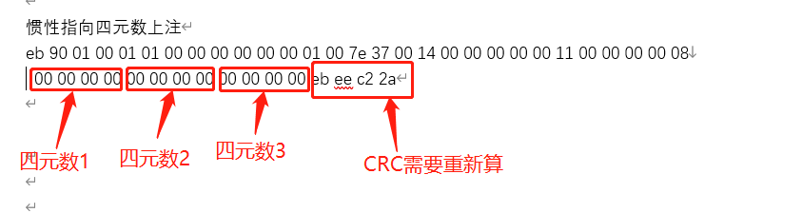

执行指令序列（调用bin文件）

eb 90 01 00 01 01 00 00 00 00 00 00 01 00 01 00 00 14 00 02 00 00 00 15 00 00 00 00 04  
 00 00 00 00 00 00 00 00 00 00 00 00 00 00 00 00 5a a5 fc f3

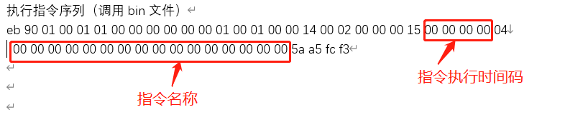

设置普通惯性指向模式

eb 90 01 00 01 01 00 00 00 00 00 00 01 00 7e 33 00 14 00 00 00 00 00 08 00 00 00 00 33 29 00 aa 40 58 1a 76

运行惯性指向模式

eb 90 01 00 01 01 00 00 00 00 00 00 01 00 7e 34 00 14 00 00 00 00 00 08 00 00 00 00 34 07 aa aa f5 b7 18 bb

说明：提前8min切姿态

运行太阳指向模式

eb 90 01 00 01 01 00 00 00 00 00 00 01 00 7e 34 00 14 00 00 00 00 00 08 00 00 00 00 34 04 aa aa 1f 99 d8 c8

禁止存储姿控K包（记录姿态数据）

eb 90 01 00 01 01 00 00 00 00 00 00 01 00 01 02 00 14 00 00 00 00 00 0e 00 00 00 00 04 02 00 00 00 00 ff ff ff ff ed 65 4d df

说明：此条指令在试验结束后发