Spreadtrum Linux I2C Guide

Revision History

Revision | Date | Description
0.1 | 2013-9-4 | Initial version for Spreadtrum Linux I2C Guide
0.2 | 2013-9-30 | Add Figure 3.1 Spreadtrum i2c data transfer work flow
1.0 | 2013-10-9 | Descript steps of adding Unit Test to LTP

1. Introduction 3
1.1. Purpose 3
1.2. References 3
2. I²C System Overview 4
2.1. THE I2C-BUS CONCEPT 5
2.2. I2C Bus Protocol 6
2.2.1. START and STOP conditions 6
2.2.2. Byte format 6
2.2.3. Acknowledge (ACK) and Not Acknowledge (NACK) 7
2.2.4. The slave address and R/W bit 7
2.2.5. 10-bit addressing 8
2.2.6. SMBus - System Management Bus 9
3. Linux I2C 9
3.1. i2c mechanisms provided by Linux 9
3.1.1. I2c_adapter 9
3.1.2. I2c_algorithm 9
3.1.3. I2c_driver 9
3.1.4. I2c_client 9
3.1.5. I2c_msg 10
3.2. Linux I2C Core 10
3.2.1. Important functions of I2c core 10
3.3. Linux I2C BUS Driver 11
3.3.1. I2C adapter 11
3.3.2. I2C bus communication method 11
3.4. Linux I2C Device Driver 12
4. Spreadtrum Linux I2C 12
4.1.1. Register i2c driver on board 12
4.1.2. Register pointer of i2c_algorithm function 13
4.1.3. Register pointer of i2c_algorithm function 14
4.1.4. I2c data transfer 14
5. Testing by the i2c-dev interface 16
5.1. User Mode I2C 16
5.1.1. Overview 16
5.1.2. Test cases 16
6. Compare with Freescale & Samsung 19
6.1. Difference of Freescale i2c bus driver 19
6.2. Difference of Samsung i2c bus driver 20
6.3. Spreadtrum i2c bus driver 21
6.3.1. polling vs. interrupt 21
6.3.2. Spreadtrum colleagues using interrupts to implement 23
6.3.3. Try to use the register of 2WS_CMD_BUF 23

Introduction

Purpose

This document is a manual to introduce i2c protocols, linux i2c and Spreadtrum’s i2c bus driver implement.

References
- “Micro-Controller Unit Peripheral Spec.doc”
- THE I 2C-BUS SPECIFICATION Version 2.1
- I2C Specification Version 4.0
- …

Websites:

- http://www.kernel.org/
- http://kernelnewbies.org/

I²C System Overview
Linux I2C-architecture consists of three parts. I2C Core, I2C bus driver and I2C device driver. And I2C bus driver includes algorithms and I2C adapter.
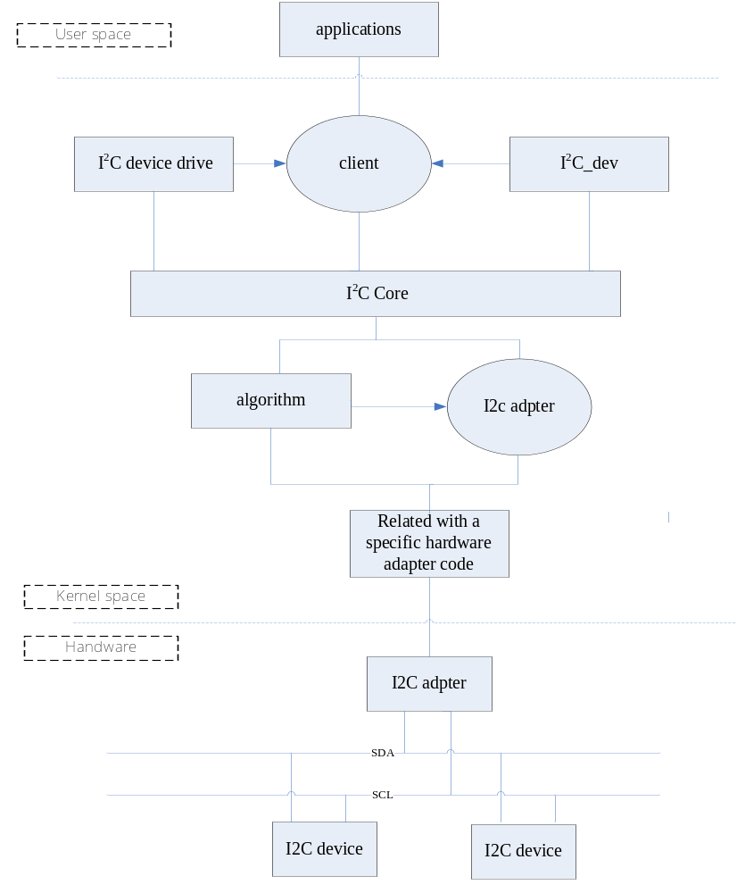
Figure 2.1 Linux I2C architecture

THE I2C-BUS CONCEPT
Two wires, serial data (SDA) and serial clock (SCL), carry information between the devices connected to the bus. Each device is recognized by a unique address (whether it is a microcontroller, LCD driver, memory or keyboard interface) and can operate as either a transmitter or receiver, depending on the function of the device.
Table2-1 Definition of I2C-bus terminology
TERM | DESCRIPTION
Transmitter | The device which sends data to the bus
Receiver | The device which receives data from the bus
Master | The device which initiates a transfer, generates clock signals and terminates a transfer
Slave | The device addressed by a master
Multi-master | More than one master can attempt to control the bus at the same time without corrupting the message
Arbitration | Procedure to ensure that, if more than one master simultaneously tries to control the bus, only one is allowed to do so and the winning message is not corrupted
Synchronization | Procedure to synchronize the clock signals of two or more devices

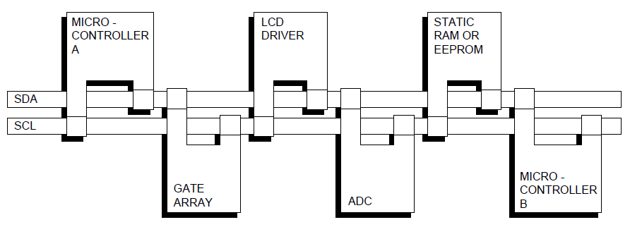
Figure 2.2 Example of an I2C-bus configuration using two microcontrollers
This example highlights the master-slave and receiver-transmitter relationships found on
the I2C-bus. Note that these relationships are not permanent, but only depend on the
direction of data transfer at that time. The transfer of data would proceed as follows:
1. Suppose microcontroller A wants to send information to microcontroller B:
– microcontroller A (master), addresses microcontroller B (slave)
– microcontroller A (master-transmitter), sends data to microcontroller B
(slave-receiver)
– microcontroller A terminates the transfer.
2. If microcontroller A wants to receive information from microcontroller B:
– microcontroller A (master) addresses microcontroller B (slave)
– microcontroller A (master-receiver) receives data from microcontroller B
(slave-transmitter)
– microcontroller A terminates the transfer.
Even in this case, the master (microcontroller A) generates the timing and terminates the
transfer.

I2C Bus Protocol

START and STOP conditions
All transactions begin with a START (S) and are terminated by a STOP (P). A HIGH to LOW transition on the SDA line while SCL is HIGH defines a START condition. A LOW to HIGH transition on the SDA line while SCL is HIGH defines a STOP condition.
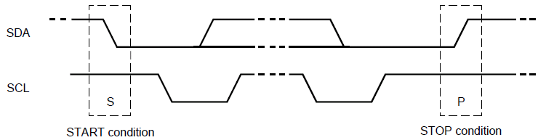
Figure 2.3 START and STOP conditions
START and STOP conditions are always generated by the master. The bus is considered to be busy after the START condition. The bus is considered to be free again a certain time after the STOP condition.

Byte format
Every byte put on the SDA line must be eight bits long. The number of bytes that can be transmitted per transfer is unrestricted. Each byte must be followed by an Acknowledge bit. Data is transferred with the Most Significant Bit (MSB) first. If a slave cannot receive or transmit another complete byte of data until it has performed some other function, for example servicing an internal interrupt, it can hold the clock line SCL LOW to force the master into a wait state. Data transfer then continues when the slave is ready for another byte of data and releases clock line SCL.
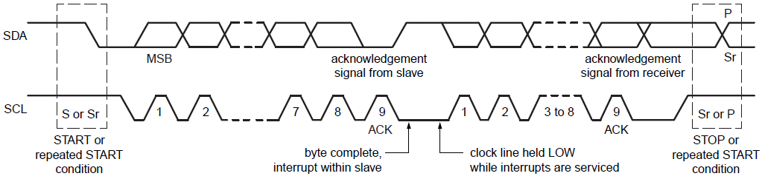
Figure 2.4 Data transfer on the I2C-bus

Acknowledge (ACK) and Not Acknowledge (NACK)
The acknowledge takes place after every byte. The acknowledge bit allows the receiver to signal the transmitter that the byte was successfully received and another byte may be sent. The master generates all clock pulses, including the acknowledge ninth clock pulse. The Acknowledge signal is defined as follows: the transmitter releases the SDA line during the acknowledge clock pulse so the receiver can pull the SDA line LOW and it remains stable LOW during the HIGH period of this clock pulse. Set-up and hold times must also be taken into account. When SDA remains HIGH during this ninth clock pulse, this is defined as the Not Acknowledge signal. The master can then generate either a STOP condition to abort the transfer, or a repeated START condition to start a new transfer.

The slave address and R/W bit
Data transfers follow the format shown in Figure 9. After the START condition (S), a slave address is sent. This address is seven bits long followed by an eighth bit which is a data direction bit (R/W) — a ‘zero’ indicates a transmission (WRITE), a ‘one’ indicates a request for data (READ) . A data transfer is always terminated by a STOP condition (P) generated by the master. However, if a master still wishes to communicate on the bus, it can generate a repeated START condition (Sr) and address another slave without first generating a STOP condition. Various combinations of read/write formats are then possible within such a transfer.
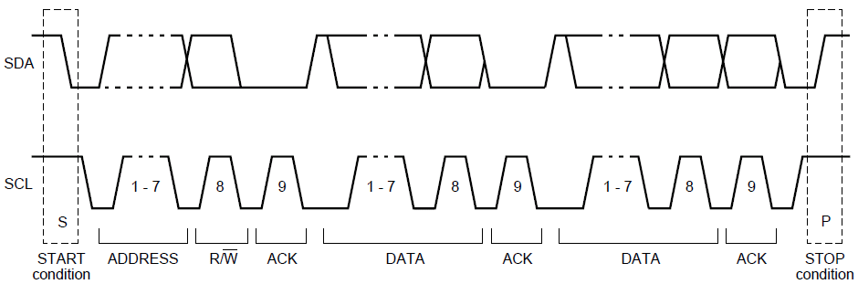
Figure 2.5 A complete data transfer
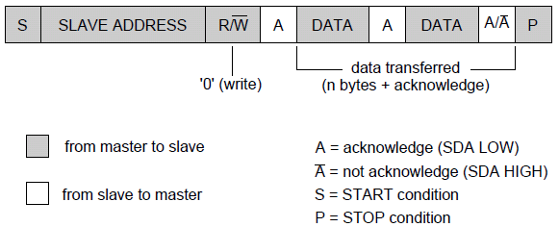
Figure 2.6 A master-transmitter addressing a slave receiver with a 7-bit address
(the transfer direction is not changed)

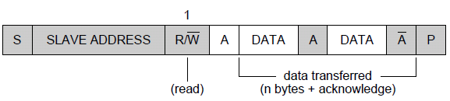
Figure 2.7 A master reads a slave immediately after the first byte

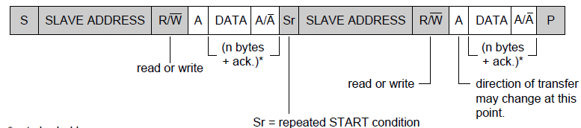
Figure 2.8 Combined format

10-bit addressing
10-bit addressing expands the number of possible addresses. Devices with 7-bit and 10-bit addresses can be connected to the same I2C-bus, and both 7-bit and 10-bit addressing can be used in all bus speed modes. Currently, 10-bit addressing is not being widely used. The 10-bit slave address is formed from the first two bytes following a START condition (S) or a repeated START condition (Sr). The first seven bits of the first byte are the combination 1111 0XX of which the last two bits (XX) are the two Most-Significant Bits (MSB) of the 10-bit address; the eighth bit of the first byte is the R/W bit that determines the direction of the message.
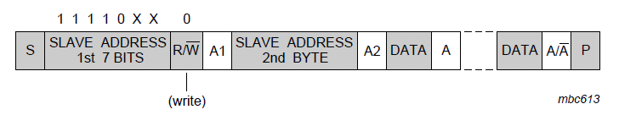
Figure 2.9 A master-transmitter addresses a slave-receiver with a 10-bit address
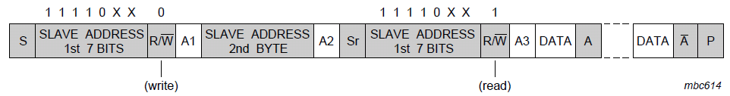
Figure 2.10 A master-receiver addresses a slave-transmitter with a 10-bit address

SMBus - System Management Bus
The SMBus uses I2C hardware and I2C hardware addressing, but adds second-level software for building special systems. In particular, its specifications include an Address Resolution Protocol that can make dynamic address allocations. Dynamic reconfiguration of the hardware and software allow bus devices to be ‘hot-plugged’ and used immediately, without restarting the system. The devices are recognized automatically and assigned unique addresses. This advantage results in a plug-and-play user interface. In both those protocols, there is a very useful distinction made between a System Host and all the other devices in the system that can have the names and functions of masters or slaves.

Linux I2C

i2c mechanisms provided by Linux

I2c_adapter
An Adapter effectively represents a bus – it is used to tie up a particular I2C/SMBus with an algorithm and bus number. It is represented by the ‘struct i2c_adapter‘ structure.

I2c_algorithm
An Algorithm performs the actual reading and writing of I2C messages to the hardware. An Algorithm is represented by the very straight-foward ‘struct i2c_algorithm‘ structure and allows you to define function pointers to functions that can write I2C messages (master_xfer) or SMBus messages (smbus_xfer).

I2c_driver
A I2c driver, represented by a ‘struct i2c_driver‘ structure represents the device driver for a particular class of I2C/SMBus slave devices, e.g. a touchscreen driver. The structure contains a bunch of function pointers – the ones of interest to us are the ‘probe’ and ‘remove’ pointers

I2c_client
A Client represents a chip (slave) on the I2C/SMBus such as a Touchscreen peripheral and is represented by a ‘struct i2c_client‘ structure. This includes various members such as chip address, name and pointers to the adapter and driver

I2c_msg
An i2c_msg is the low level representation of one segment of an I2C transaction. It is visible to drivers in the i2c_transfer() procedure, to userspace from i2c-dev, and to I2C adapter drivers through the i2c_adapter master_xfer() method. And the associate structure is ‘struct i2c_msg‘.

Linux I2C Core
The Linux kernel I2C framework consists of a core layer where resides all the routines and data structures available to bus drivers and client drivers. The core also provides a level of indirection that allows the underlying drivers to change from one system to another without affecting I2C subsystem that relies on them. This philosophy of a core layer and its attendant benefits is an example of how Linux helps portability. For instance, enabling I2C on a new platform (which is precisely the objective of this project) requires only to design the hardware-dependent components, namely the bus driver and the client drivers, whereas the core layer needs not to be changed.

Important functions of I2c core
（1）add and remove i2c_adapter
int i2c_add_adapter(struct i2c_adapter *adapter);
This routine is used to declare an I2C adapter when its bus number doesn't matter.
int i2c_del_adapter(struct i2c_adapter *adap);
This unregisters an I2C adapter which was previously registered

（2）register and delete 2c_driver
int i2c_register_driver(struct module *owner, struct i2c_driver *driver);
An i2c_driver is used with one or more i2c_client (device) nodes to access i2c slave chips, on a bus instance associated with some i2c_adapter.

void i2c_del_driver(struct i2c_driver *driver);
increments the reference count of the i2c client structure

（3）i2c_client attach and detach，2.6.63 above were not used. automatically attached by the core；

（4）I2C transfer, send and receive data
int i2c_transfer(struct i2c_adapter *adap, struct i2c_msg *msgs, int num);
execute a single or combined I2C message:

int i2c_master_send(const struct i2c_client *client, const char *buf, int count);
issue a single I2C message in master transmit mode
int i2c_master_recv(const struct i2c_client *client, char *buf, int count);
issue a single I2C message in master receive mode

i2c_transfer() function is used for translating messages between i2c adapter and devices, i2c_master_send() function and the i2c_master_recv() function internally calls i2c_transfer() function, to complete a written message and one message read.
I2c_transfer() function itself does not have the ability of driving physical hardware to complete interact messages, it's just looking for i2c_adapter and its corresponding i2c_algorithm, and use i2c_algorithm the master_xfer() function really drive the hardware processes.

Linux I2C BUS Driver

I2C adapter
I2C bus driver follow these two steps:
1) Initialize the I2C adapter hardware resources that are used, such as requesting I / O address, interrupt number, and so on.
2) The data of structure i2c_adapter will be added by i2c_add_adapter() or i2c_add_numbered_adapter() function, of course, the members of the data structure i2c_adapter xxx adapter has been initialized with the corresponding function pointer.

I2C bus driver module unload function work to be done with the loading function opposite.
1) the release of i2c adapter uses hardware resources, such as the release of I / O address and interrupt number, etc.;
2) delete the data structure i2c_adapter by i2c_del_adapter ().

I2C bus communication method
In the Linux I2C subsystem a bus driver consists of an adapter driver and an algorithm driver. The motivation behind this further division is to improve the software reuse and to allow portability. In fact, an algorithm driver is intended to contain general code that can be used for a whole class of I2C adapters, while each specific adapter driver either depends on one algorithm driver, or includes its own implementation. However, while having a generic algorithm that works for multiple adapters is suitable for many cases, in embedded systems, where each I2C bus adapter has its own way of interfacing with the processor and the bus, it is usual to develop the adapter driver together with its corresponding algorithm driver.
The bus driver registers with the I2C subsystem by using a struct i2c_adapter that is instantiated and initialized by the driver’s probe() function, as shown in Listing 12. The i2c_adapter structure’s algo member is set up to point to a struct i2c_algorithm which in turn holds two pointers:
• master_xfer points to the function that implements
the actual I2C transmit and receive algorithm.
• functionality points to a function that returns the
features supported by the I2C adapter.
To communicate with a client the I2C subsystem offers two class of functions: one for I2C plain communication which includes i2c_master_send(), i2c_master_recv() and i2c_transfer(), and a second one that uses SMBus commands. However, whichever method is used, the data transfer relies on the bus driver’s function pointed to by master_xfer, as the I2C core ultimately calls this function for the actual transfer to take place.

Linux I2C Device Driver
During initialization the driver registers itself with the I2C core. This is achieved by populating a struct i2c_driver and passing it as argument to the function i2c_add_driver().
The structure i2c_driver holds pointers to the probe and remove functions that are executed respectively on device probing and when the device is removed (if ever). The id_table member of the structure i2c_driver informs the I2C framework about which slave devices are supported by the driver.
The binding process consists of associating a device with a driver that can control it. In embedded systems where the number of the I2C bus and the devices connected to it are known for a fact, it is possible to declare in advance the I2C slaves which live on the bus. This is typically done in the board setup file.

Spreadtrum Linux I2C

Register i2c driver on board

arch/arm/mach-sc/board-sp8835eb.c:

static struct i2c_board_info i2c2_boardinfo[] = {
#if(defined(CONFIG_INPUT_LIS3DH_I2C)||defined(CONFIG_INPUT_LIS3DH_I2C_MODULE))
{ I2C_BOARD_INFO(LIS3DH_ACC_I2C_NAME, LIS3DH_ACC_I2C_ADDR),
.platform_data = &lis3dh_plat_data,
},
#endif
#if(defined(CONFIG_INV_MPU_IIO)||defined(CONFIG_INV_MPU_IIO_MODULE))
{ I2C_BOARD_INFO("mpu9150", 0x68),
.irq = GPIO_GYRO_INT1,
.platform_data = &mpu9150_platform_data,
},
#endif
#if(defined(CONFIG_INPUT_LTR558_I2C)||defined(CONFIG_INPUT_LTR558_I2C_MODULE))
{ I2C_BOARD_INFO(LTR558_I2C_NAME, LTR558_I2C_ADDR),
.platform_data = &ltr558_pls_info,
},
#endif
#if(defined(CONFIG_SENSORS_AK8975)||defined(CONFIG_SENSORS_AK8975_MODULE))
{ I2C_BOARD_INFO(AKM8975_I2C_NAME, AKM8975_I2C_ADDR),
.platform_data = &akm8975_platform_d,
},
#endif
};

static struct i2c_board_info i2c1_boardinfo[] = {
{I2C_BOARD_INFO("sensor_main",0x3C),},
{I2C_BOARD_INFO("sensor_sub",0x21),},
};

static struct i2c_board_info i2c0_boardinfo[] = {
{
I2C_BOARD_INFO(FOCALTECH_TS_NAME, FOCALTECH_TS_ADDR),
.platform_data = &ft5x0x_ts_info,
},
};

static int sc8810_add_i2c_devices(void)
{
i2c_register_board_info(2, i2c2_boardinfo, ARRAY_SIZE(i2c2_boardinfo));
i2c_register_board_info(0, i2c1_boardinfo, ARRAY_SIZE(i2c1_boardinfo));
i2c_register_board_info(1, i2c0_boardinfo, ARRAY_SIZE(i2c0_boardinfo));
return 0;
}

Register pointer of i2c_algorithm function
drivers/i2c/busses/i2c-sprd.c:

static u32 sprd_i2c_func(struct i2c_adapter *adap)
{
return I2C_FUNC_I2C | I2C_FUNC_SMBUS_EMUL;
}

static const struct i2c_algorithm sprd_i2c_algo = {
.master_xfer = sprd_i2c_master_xfer,
.functionality = sprd_i2c_func,
};}

Register pointer of i2c_algorithm function
drivers/i2c/busses/i2c-sprd.c:

static int sprd_i2c_probe(struct platform_device *pdev)
{
struct sprd_i2c *pi2c;
struct resource *res;
int ret;
......
res = platform_get_resource(pdev, IORESOURCE_MEM, 0);
if (!res) {
ret = -ENODEV;
goto free_adapter;

pi2c->adap.owner = THIS_MODULE;
pi2c->adap.retries = 3;
pi2c->adap.algo = &sprd_i2c_algo;
pi2c->adap.algo_data = pi2c;
pi2c->adap.dev.parent = &pdev->dev;
pi2c->adap.nr = pdev->id;
pi2c->membase = (void *)(res->start);

sprd_i2c_reset(pi2c);
sprd_i2c_enable(pi2c);

ret = i2c_add_numbered_adapter(&pi2c->adap);
if (ret < 0) {
dev_err(&pdev->dev, "add_adapter failed!\n");
goto release_region;
}

sprd_i2c_ctl_id[pdev->id] = pi2c;
platform_set_drvdata(pdev, pi2c);

return 0;
......
}

I2c data transfer
The data transfer follows the functions calls and the sequence is:
drivers/i2c/busses/i2c-sprd.c:
sprd_i2c_master_xfer->
sprd_i2c_handle_msg->
sprd_i2c_writebytes->
sprd_i2c_write_byte->
sprd_wait_trx_done->
sprd_i2c_wait_int->
sprd_i2c_poll_ctl_status:

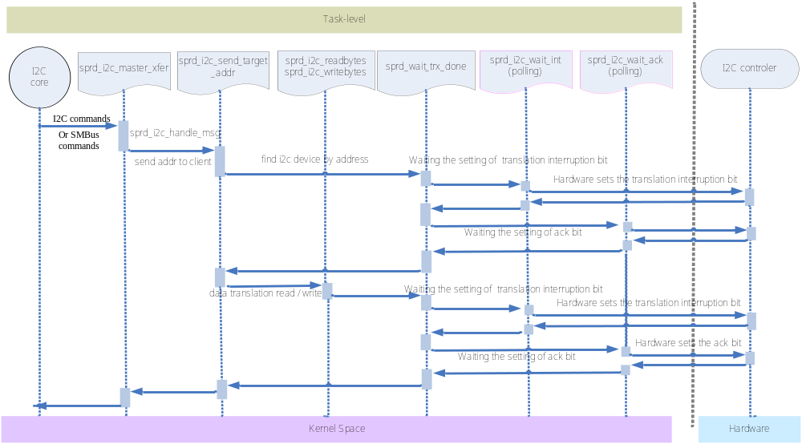
Figure 3.1 Spreadtrum i2c data transfer work flow

Testing by the i2c-dev interface
The i2c test unit program is based on i2c-dev.c。

User Mode I2C

Overview
In Chapter 2, "The Inter-Integrated Circuit Protocol," you learned to develop kernel mode drivers for I2C devices; but sometimes, when you need to enable support for a large number of slow I2C devices, it makes sense to drive them from user space. The i2c-dev module enables the development of user mode I2C/SMBus device drivers. User-space code can access I2C host adapters via device nodes. To operate on the nth adapter, open /dev/i2c-n. After you have a file descriptor tied to a host adapter device node, you can command it through ioctls to connect to specific slave devices attached to it. You can then use the services of a family of data access routines to exchange data with the slaves.

Test cases
Adding the test unit to LTP follows these steps bellow:
Step 1:
Add the “i2c” string to scenario_groups/sprd_default
--- a/scenario_groups/sprd_default
+++ b/scenario_groups/sprd_default
@@ -24,3 +24,4 @@ sprd_power_management_tests
numa
hugetlb
commands
+i2c

Step 2:
add i2c file to the directory of ltp/runtest/i2c
+++ b/runtest/i2c
@@ -0,0 +1 @@
+i2c test_i2c

Step 3:
add Makefile of i2c test unit to directory such as testcases/sprd/kernel/i2c/
+++ b/testcases/sprd/kernel/i2c/Makefile
@@ -0,0 +1,7 @@
+top_srcdir := ../../../..
+
+include $(top_srcdir)/include/mk/testcases.mk
+
+INSTALL_TARGETS := test_i2c
+
+include $(top_srcdir)/include/mk/generic_leaf_target.mk

Step 4:
add i2c test unit source code to the dictionary of testcases/sprd/kernel/i2c/test_i2c.c
/* Global Variables */
char *TCID = "sprd_test_i2c"; /* LTP test program identifier. */

int main(int argc, char **argv)
{
……
strcpy(i2c_bus, "/dev/i2c-1");

fd = open(i2c_bus, O_RDWR);

if (!fd) {
printf("Error on opening the device file\n");
return -1;
}

work_queue.nmsgs = 2; /* amount of messages */
work_queue.msgs = (struct i2c_msg*)malloc(work_queue.nmsgs *sizeof(struct
i2c_msg));
memset(work_queue.msgs, 0, sizeof(struct i2c_msg));
if (!work_queue.msgs) {
printf("Memory alloc error\n");
close(fd);
return -1;
}

ioctl(fd, I2C_TIMEOUT, 2); /* set time out */
ioctl(fd, I2C_RETRIES, 1); /* set the numbers of retries */

slave_address = 0x38; /* the i2c device address of touch screen ft53x6_ts */
reg_address = 0xA1; /* the register of FT5X0X_REG_LIB_VERSION_H */
val = reg_address;

(work_queue.msgs[0]).len = 1;
(work_queue.msgs[0]).addr = slave_address;
(work_queue.msgs[0]).buf = &val;

(work_queue.msgs[1]).len = 1;
(work_queue.msgs[1]).flags = I2C_M_RD;
(work_queue.msgs[1]).addr = slave_address;
(work_queue.msgs[1]).buf = &val;

ret = ioctl(fd, I2C_RDWR, (unsigned long) &work_queue);
if (ret < 0 || 0x30 != val) {
tst_resm(TFAIL, "i2c bus and driver not work well! \n");
printf("Error during I2C_RDWR ioctl with error code: %d %s\n", ret, strerror(errno));
return -1;
}
else {
tst_resm(TPASS, "i2c bus and driver is working \n");
printf("reg:%02x val:%02x\n", reg_address, val);
}

reg_address = 0xA2; /* the register of FT5X0X_REG_LIB_VERSION_L */
val = reg_address;

(work_queue.msgs[0]).len = 1;
(work_queue.msgs[0]).addr = slave_address;
(work_queue.msgs[0]).buf = &val;

(work_queue.msgs[1]).len = 1;
(work_queue.msgs[1]).flags = I2C_M_RD;
(work_queue.msgs[1]).addr = slave_address;
(work_queue.msgs[1]).buf = &val;

ret = ioctl(fd, I2C_RDWR, (unsigned long) &work_queue);
if (ret < 0 || 0xf8 != val) {
tst_resm(TFAIL, "i2c bus and driver not work well! \n");
printf("Error during I2C_RDWR ioctl with error code: %d %s\n", ret, strerror(errno));
return -1;
}
else {
tst_resm(TPASS, "i2c bus and driver is working \n");
printf("reg:%02x val:%02x\n", reg_address, val);
}

reg_address = 0xA3; /* the register of FT5X0X_REG_CIPHER */
val = reg_address;

(work_queue.msgs[0]).len = 1;
(work_queue.msgs[0]).addr = slave_address;
(work_queue.msgs[0]).buf = &val;

(work_queue.msgs[1]).len = 1;
(work_queue.msgs[1]).flags = I2C_M_RD;
(work_queue.msgs[1]).addr = slave_address;
(work_queue.msgs[1]).buf = &val;

ret = ioctl(fd, I2C_RDWR, (unsigned long) &work_queue);
if (ret < 0 || 0x0a != val) {
tst_resm(TFAIL, "i2c bus and driver not work well! \n");
printf("Error during I2C_RDWR ioctl with error code: %d %s\n", ret, strerror(errno));
return -1;
}
else {
tst_resm(TPASS, "i2c bus and driver is working \n");
printf("reg:%02x val:%02x\n", reg_address, val);
}
……
}

Step 5:
run the test unit in LTP
/opt/ltp # . sprd_alltests.sh i2c
And then the outputs are:
Running tests.......
Enabling dmesg output logging for each test...
INFO: ltp-pan reported all tests PASS
LTP Version: 20130503-8-g44aec76
rm: '/opt/ltp/temp/ltp-dmesg-output-150-05:22:43' is a directory
No Kernel messages were generated for LTP tests 20130503-8-g44aec76

###############################################################

Done executing testcases.
LTP Version: 20130503-8-g44aec76
###############################################################
cat temp/result.log, we can see:
TPASS i2c

Compare with Freescale & Samsung
Samsung and Freescale’s i2c bus drivers are commonly used.

- Freecale’s i2c busses driver locate at:
/driver/busses/i2c_imx.c

- Samsung’s i2c busses driver locate at:
/driver/busses/i2c_s3c2410.c

- Spreadturm’s i2c busses driver locate at:
/driver/busses/i2c_sprd.c

Mainly Difference between Spreadturm, Samsung and the Freescale is:
When i2c bus completely translate client address or read/write data with i2c device, the interrupt which were registered would be called, but our Spreadtrum uses polling instead.

Difference of Freescale i2c bus driver
At Freescale’s probe() function：
ret = request_irq(i2c_imx->irq, i2c_imx_isr, 0, pdev->name, i2c_imx);

Freescale Datasheet：
I2C Status Register Field Descriptions
IIF bit [1] | I2C interrupt. Must be cleared by the software by writing a “0” to it in the interrupt routine.  Note: The software cannot set the bit.  0 No I2C interrupt pending.  1 An interrupt is pending.  This causes a processor interrupt request (if the interrupt enable is asserted [IIEN = 1]). The interrupt is set  when one of the following occurs:  • One byte transfer is completed (the interrupt is set at the falling edge of the ninth clock).  • An address is received

Code:
static irqreturn_t i2c_imx_isr(int irq, void *dev_id)
{
struct imx_i2c_struct *i2c_imx = dev_id;
unsigned int temp;

temp = readb(i2c_imx->base + IMX_I2C_I2SR);
if (temp & I2SR_IIF) {
/* save status register */
i2c_imx->i2csr = temp;
temp &= ~I2SR_IIF;
writeb(temp, i2c_imx->base + IMX_I2C_I2SR);
wake_up(&i2c_imx->queue);
return IRQ_HANDLED;
}

return IRQ_NONE;
}

Difference of Samsung i2c bus driver
At Samsung’s probe() function：
ret = request_irq(i2c->irq, s3c24xx_i2c_irq, 0,dev_name(&pdev->dev), i2c);

Samsung Datasheet：
I2C Status Register Field Descriptions
Tx/Rx Interrupt bit [5] | IIC-Bus Tx/Rx interrupt enable/disable bit.  0: Disable, 1: Enable

Code:

static irqreturn_t s3c24xx_i2c_irq(int irqno, void *dev_id)
{
struct s3c24xx_i2c *i2c = dev_id;
unsigned long status;
unsigned long tmp;

status = readl(i2c->regs + S3C2410_IICSTAT);

if (status & S3C2410_IICSTAT_ARBITR) {
/* deal with arbitration loss */
dev_err(i2c->dev, "deal with arbitration loss\n");
}

if (i2c->state == STATE_IDLE) {
dev_dbg(i2c->dev, "IRQ: error i2c->state == IDLE\n");

tmp = readl(i2c->regs + S3C2410_IICCON);
tmp &= ~S3C2410_IICCON_IRQPEND;
writel(tmp, i2c->regs + S3C2410_IICCON);
goto out;
}

/* pretty much this leaves us with the fact that we've
* transmitted or received whatever byte we last sent */

i2c_s3c_irq_nextbyte(i2c, status);

out:
return IRQ_HANDLED;
}

Comparing with Samsung and Freescale’s i2c bus driver, the programming of Freescale is more concise, and more similar to our achieve.

Spreadtrum i2c bus driver

polling vs. interrupt
The registers is descript by the Shark Datasheet, as follow:
0x0000 | 2WS_CONTROL
0x0004 | 2WS_COMMAND
0x0008 | 2WS_DIVIDOR0
0x000C | 2WS_DIVIDOR1
0x0010 | 2WS_RST
0x0014 | 2WS_CMD_BUF

Among it, the register 2WS_CONTROL
2ws_ie bit[3] | 2ws interrupt enable

It also has interrupt ability. But our programs didn’t use interrupt to get the info of one byte has translated, instead, we used polling the tag bit to get the information.
And our U-boot also use polling.
static inline int
sprd_i2c_poll_ctl_status(struct sprd_i2c *pi2c, unsigned long bit)
{
int loop_cntr = 5000;

do {
udelay(1);
}
while (!(__raw_readl(pi2c->membase + I2C_CTL) & bit)
&& (--loop_cntr > 0));

if (loop_cntr > 0)
return 1;
else
return -1;
}

static inline int sprd_i2c_wait_int(struct sprd_i2c *pi2c)
{
return sprd_i2c_poll_ctl_status(pi2c, I2C_CTL_INT);
}

The average number of polls that loop_cntr is approximately equal to 60 times. Such as:

<4>[ 38.010816] c0 ### 005 sprd_i2c_poll_ctl_status final loop_cntr = 4945
<4>[ 38.010829] c0 ### 002 sprd_i2c_readbytes ii = 2
<4>[ 38.010840] c0 ### 003 sprd_i2c_read_byte() cmd=8
<4>[ 38.010849] c0 ### 002 sprd_wait_trx_done()
<4>[ 38.010859] c0 ### 003 sprd_i2c_wait_int
<4>[ 38.010868] c0 ### 004 sprd_i2c_poll_ctl_status
<4>[ 38.010935] c0 ### 005 sprd_i2c_poll_ctl_status final loop_cntr = 4946
<4>[ 38.010949] c0 ### 002 sprd_i2c_readbytes ii = 3
<4>[ 38.010959] c0 ### 003 sprd_i2c_read_byte() cmd=8
<4>[ 38.010969] c0 ### 002 sprd_wait_trx_done()
<4>[ 38.010978] c0 ### 003 sprd_i2c_wait_int
<4>[ 38.010987] c0 ### 004 sprd_i2c_poll_ctl_status
<4>[ 38.011055] c0 ### 005 sprd_i2c_poll_ctl_status final loop_cntr = 4945
<4>[ 38.011069] c0 ### 002 sprd_i2c_readbytes ii = 4
<4>[ 38.011079] c0 ### 003 sprd_i2c_read_byte() cmd=8
<4>[ 38.011089] c0 ### 002 sprd_wait_trx_done()
<4>[ 38.011098] c0 ### 003 sprd_i2c_wait_int
<4>[ 38.011108] c0 ### 004 sprd_i2c_poll_ctl_status
<4>[ 38.011175] c0 ### 005 sprd_i2c_poll_ctl_status final loop_cntr = 4946
<4>[ 38.011189] c0 ### 002 sprd_i2c_readbytes ii = 5
<4>[ 38.011199] c0 ### 003 sprd_i2c_read_byte() cmd=1a
<4>[ 38.011209] c0 ### 002 sprd_wait_trx_done()
<4>[ 38.011218] c0 ### 003 sprd_i2c_wait_int
<4>[ 38.011227] c0 ### 004 sprd_i2c_poll_ctl_status
<4>[ 38.011306] c0 ### 005 sprd_i2c_poll_ctl_status final loop_cntr = 4935
<4>[ 38.079972] c0 ### 000 sprd_i2c_master_xfer() msg im=0
<4>[ 38.079990] c0 ### 001 sprd_i2c_handle_msg() flag=0, adr=68, len=1
<4>[ 38.080004] c0 ### 001 aaa sprd_i2c_send_target_addr() cmd=d024
<4>[ 38.080015] c0 ### 002 sprd_wait_trx_done()
<4>[ 38.080024] c0 ### 003 sprd_i2c_wait_int
<4>[ 38.080033] c0 ### 004 sprd_i2c_poll_ctl_status
<4>[ 38.080109] c0 ### 005 sprd_i2c_poll_ctl_status final loop_cntr = 4939
<4>[ 38.080124] c0 ### 001 sprd_i2c_handle_msg() sprd_i2c_writebytes
<4>[ 38.080135] c0 ### 002 sprd_i2c_writebytes ii = 0
<4>[ 38.080146] c0 ### 003 sprd_i2c_write_byte() cmd=7204
<4>[ 38.080156] c0 ### 002 sprd_wait_trx_done()
<4>[ 38.080165] c0 ### 003 sprd_i2c_wait_int
<4>[ 38.080174] c0 ### 004 sprd_i2c_poll_ctl_status
<4>[ 38.080241] c0 ### 005 sprd_i2c_poll_ctl_status final loop_cntr = 4947

We could refer to Freescale's implementation
Try to use wait queue completion notification data read and write in interrupt response function, instead of wasting CPU time to execute queries interrupt flag.

Spreadtrum colleagues using interrupts to implement
At Spreadtrum platform directory, we can find i2c bus driver that using interrupt to notify one byte transform.
/driver/busses/i2c-sc8810.c
In the code, our colleagues also try to use interrupt. And the architecture is similar with Samsung.
ret = request_irq(i2c->irq, sc8810_i2c_irq, IRQF_SHARED,pdev->name,i2c);

Try to use the register of 2WS_CMD_BUF
In our i2c bus driver the register 2WS_CMD_BUF is not being used.
Field Name | Bit | Type | Reset Value | Description
 | [31 : 16] | R/O | 31’h0 | Reserved
2ws_cmd_buf | [15 : 0] | R/W | 16’h0 | Write command to this register will save the command to command buffer. Read from this register after the commands are all finished will return the results of the corresponding commands. The format of the command and the return results is the same as i2c_command register.

Maybe it would be used with the interrupt response function to save the 2WS_CMD register’s status.

