ABD_Design_and_Implementation

Document Number: |  | Document Version:
Owner: |  | Date:
Document Type:
NOTE: | ALL MATERIALS INCLUDED HEREIN ARE COPYRIGHTED AND CONFIDENTIAL UNLESS OTHERWISE INDICATED. The information is intended only for the person or entity to which it is addressed and may contain confidential and/or privileged material. Any review, retransmission, dissemination, or other use of or taking of any action in reliance upon this information by persons or entities other than the intended recipient is prohibited.  This document is subject to change without notice. Please verify that your company has the most recent specification.  Copyright © 2013 Spreadtrum Communications Inc.


www.spreadtrum.com

Revision History

Revision | Date | Description
0.1 | 2015-11-27 | Initial version for ABD_Design_and_Implementation Guide

1. Introduction 5
1.1. Purpose 5
1.2. References 5
2. ADB Overview 6
3. ADB 组成 6
3.1. ADB各模块定义 6
3.2. adb整体架构和数据传输流程图 7
4. ADBD 7
4.1.1. Register i2c driver on board 7
4.1.2. Register pointer of i2c_algorithm function 8
4.1.3. Register pointer of i2c_algorithm function 9
4.1.4. I2c data transfer 9
5. ADB Server 13
5.1. User Mode I2C 13
5.1.1. Overview 13
5.1.2. 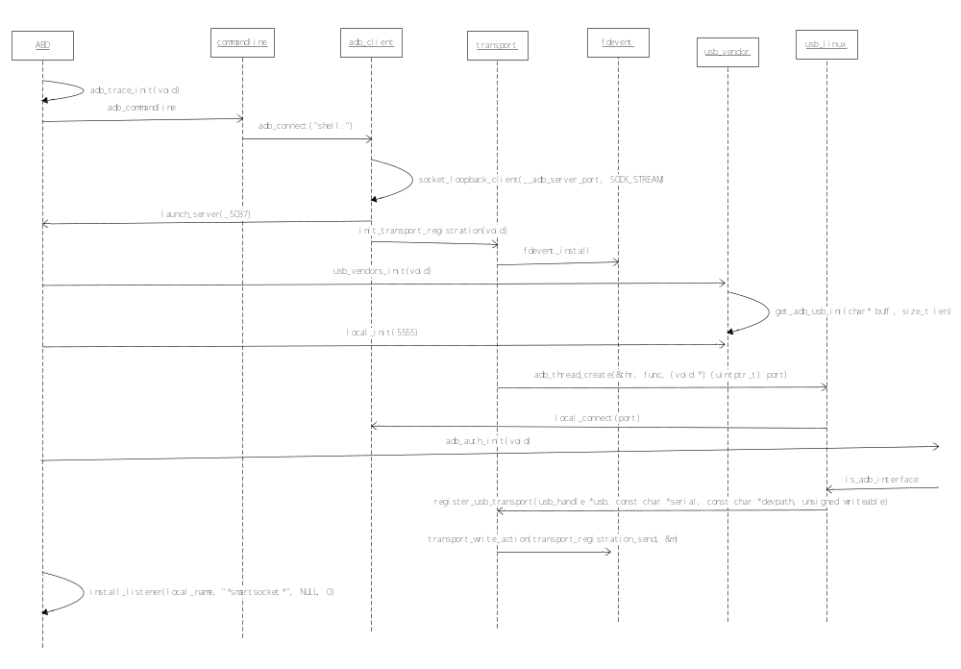Test cases 13
6. ADB Client 16
6.1. Difference of Freescale i2c bus driver 17
6.2. Difference of Samsung i2c bus driver 18
6.3. Spreadtrum i2c bus driver 19
6.3.1. polling vs. interrupt 19
6.3.2. Spreadtrum colleagues using interrupts to implement 20
6.3.3. Try to use the register of 2WS_CMD_BUF 21
7. ADB 通信 21
8. Transport是 一个中继器 21
9. Fdevent是消息处理与分发 21

Introduction

Purpose

This document is a manual to introduce i2c protocols, linux i2c and Spreadtrum’s i2c bus driver implement.

References
- “Micro-Controller Unit Peripheral Spec.doc”
- THE I 2C-BUS SPECIFICATION Version 2.1
- I2C Specification Version 4.0
- …

Websites:

- http://www.kernel.org/
- http://kernelnewbies.org/

ADB Overview
Android Debug Bridge (adb) 是一个android开发人员必会的多功能的调试工具，如它的名字一样，它在开发者和目标机器之间，架起了一座bridge。
adb的用法很简单，只要看完SDK文档关于ADB的部分，(android-sdk-linux_86/docs/guide/developing/tools/adb.html)，再稍加练习，基本上就满上就能很熟练的使用了。
adb源码位置是：system/core/adb.

ADB 组成
adb由两个物理文件组成：
adb/adb.exe
运行于PC端，包括Linux、Windows、Mac OS等系统之中，通常是x86架构上（下文中，ADB指整个模块，而adb单独指这一部分）；
adbd
运行于Android设备的底层Linux之中，ARMv5架构上。

构建不同文件，通过传入Android.mk的$(BUILD_SIMULATOR)变量是否为真。源码中由ADB_HOST宏用来区分本地主机(adb)和目标机(adbd)。
区分不同OS，通过传入Android.mk的$(HOST_OS)。它的有效取值包括linux、darwin、freebsd和windows。不同平台的主要差异是USB的控制方法和文件路径。

ADB各模块定义
adb server： 计算机上的一个服务进程，进程名为adb
adbd (adb daemon) ： Android 手机上的一个服务进程，进程名为adbd
adb client：你可以认为是计算机上的一个终端窗口，进程名也为adb
DDMS：Dalvik Debug Monitor Service
Jdwp： Java Debug Wire Protocol

adb整体架构和数据传输流程图
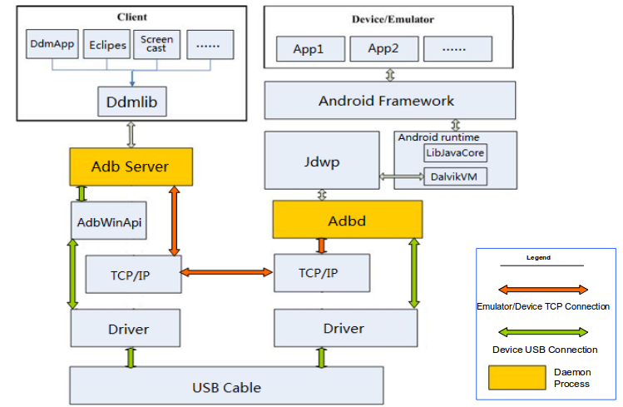

ADBD
运行1，用来连接device/emulator和adb server，device通过USB连接，emulator通过TCP连接。
2，为device/emulator提供服务--> adb service（adb服务，注意与adb服务端的区别）的概念，指adbd提供的功能。
在emulator/device端，adbd也创建local socket和remote socket，前者与通过jdwp与dalvik VM进层通信，后者通过TCP/USB与adb server通信。
于device/emulator的守护进程（Local service）。其作用如下：

Register i2c driver on board

arch/arm/mach-sc/board-sp8835eb.c:

static struct i2c_board_info i2c2_boardinfo[] = {
#if(defined(CONFIG_INPUT_LIS3DH_I2C)||defined(CONFIG_INPUT_LIS3DH_I2C_MODULE))
{ I2C_BOARD_INFO(LIS3DH_ACC_I2C_NAME, LIS3DH_ACC_I2C_ADDR),
.platform_data = &lis3dh_plat_data,
},
#endif
#if(defined(CONFIG_INV_MPU_IIO)||defined(CONFIG_INV_MPU_IIO_MODULE))
{ I2C_BOARD_INFO("mpu9150", 0x68),
.irq = GPIO_GYRO_INT1,
.platform_data = &mpu9150_platform_data,
},
#endif
#if(defined(CONFIG_INPUT_LTR558_I2C)||defined(CONFIG_INPUT_LTR558_I2C_MODULE))
{ I2C_BOARD_INFO(LTR558_I2C_NAME, LTR558_I2C_ADDR),
.platform_data = &ltr558_pls_info,
},
#endif
#if(defined(CONFIG_SENSORS_AK8975)||defined(CONFIG_SENSORS_AK8975_MODULE))
{ I2C_BOARD_INFO(AKM8975_I2C_NAME, AKM8975_I2C_ADDR),
.platform_data = &akm8975_platform_d,
},
#endif
};

static struct i2c_board_info i2c1_boardinfo[] = {
{I2C_BOARD_INFO("sensor_main",0x3C),},
{I2C_BOARD_INFO("sensor_sub",0x21),},
};

static struct i2c_board_info i2c0_boardinfo[] = {
{
I2C_BOARD_INFO(FOCALTECH_TS_NAME, FOCALTECH_TS_ADDR),
.platform_data = &ft5x0x_ts_info,
},
};

static int sc8810_add_i2c_devices(void)
{
i2c_register_board_info(2, i2c2_boardinfo, ARRAY_SIZE(i2c2_boardinfo));
i2c_register_board_info(0, i2c1_boardinfo, ARRAY_SIZE(i2c1_boardinfo));
i2c_register_board_info(1, i2c0_boardinfo, ARRAY_SIZE(i2c0_boardinfo));
return 0;
}

Register pointer of i2c_algorithm function
drivers/i2c/busses/i2c-sprd.c:

static u32 sprd_i2c_func(struct i2c_adapter *adap)
{
return I2C_FUNC_I2C | I2C_FUNC_SMBUS_EMUL;
}

static const struct i2c_algorithm sprd_i2c_algo = {
.master_xfer = sprd_i2c_master_xfer,
.functionality = sprd_i2c_func,
};}

Register pointer of i2c_algorithm function
drivers/i2c/busses/i2c-sprd.c:

static int sprd_i2c_probe(struct platform_device *pdev)
{
struct sprd_i2c *pi2c;
struct resource *res;
int ret;
......
res = platform_get_resource(pdev, IORESOURCE_MEM, 0);
if (!res) {
ret = -ENODEV;
goto free_adapter;

pi2c->adap.owner = THIS_MODULE;
pi2c->adap.retries = 3;
pi2c->adap.algo = &sprd_i2c_algo;
pi2c->adap.algo_data = pi2c;
pi2c->adap.dev.parent = &pdev->dev;
pi2c->adap.nr = pdev->id;
pi2c->membase = (void *)(res->start);

sprd_i2c_reset(pi2c);
sprd_i2c_enable(pi2c);

ret = i2c_add_numbered_adapter(&pi2c->adap);
if (ret < 0) {
dev_err(&pdev->dev, "add_adapter failed!\n");
goto release_region;
}

sprd_i2c_ctl_id[pdev->id] = pi2c;
platform_set_drvdata(pdev, pi2c);

return 0;
......
}

I2c data transfer
The data transfer follows the functions calls and the sequence is:
drivers/i2c/busses/i2c-sprd.c:
sprd_i2c_master_xfer->
sprd_i2c_handle_msg->
sprd_i2c_writebytes->
sprd_i2c_write_byte->
sprd_wait_trx_done->
sprd_i2c_wait_int->
sprd_i2c_poll_ctl_status:

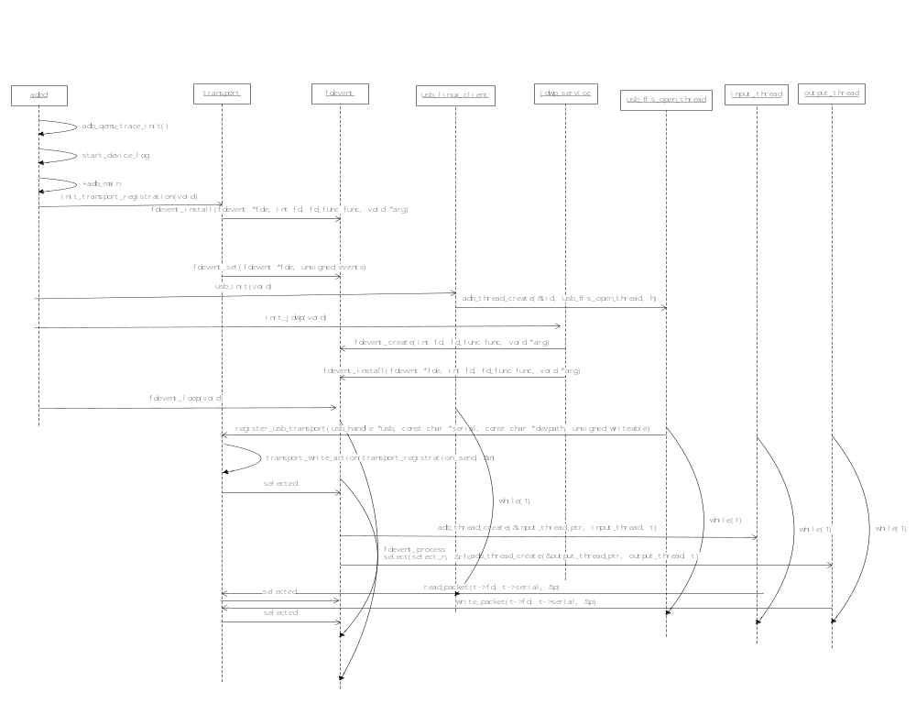
Figure 3.1 Spreadtrum i2c data transfer work flow

ADB Server
The i2c test unit program is based on i2c-dev.c。

User Mode I2C

Overview

Test cases
Step 5:
run the test unit in LTP
/opt/ltp # . sprd_alltests.sh i2c
And then the outputs are:
Running tests.......
Enabling dmesg output logging for each test...
INFO: ltp-pan reported all tests PASS
LTP Version: 20130503-8-g44aec76
rm: '/opt/ltp/temp/ltp-dmesg-output-150-05:22:43' is a directory
No Kernel messages were generated for LTP tests 20130503-8-g44aec76

###############################################################

Done executing testcases.
LTP Version: 20130503-8-g44aec76
###############################################################
cat temp/result.log, we can see:
TPASS i2c

ADB Client
Samsung and Freescale’s i2c bus drivers are commonly used.

- Freecale’s i2c busses driver locate at:
/driver/busses/i2c_imx.c

- Samsung’s i2c busses driver locate at:
/driver/busses/i2c_s3c2410.c

- Spreadturm’s i2c busses driver locate at:
/driver/busses/i2c_sprd.c

Mainly Difference between Spreadturm, Samsung and the Freescale is:
When i2c bus completely translate client address or read/write data with i2c device, the interrupt which were registered would be called, but our Spreadtrum uses polling instead.

Difference of Freescale i2c bus driver
At Freescale’s probe() function：
ret = request_irq(i2c_imx->irq, i2c_imx_isr, 0, pdev->name, i2c_imx);

Freescale Datasheet：
I2C Status Register Field Descriptions
IIF bit [1] | I2C interrupt. Must be cleared by the software by writing a “0” to it in the interrupt routine.  Note: The software cannot set the bit.  0 No I2C interrupt pending.  1 An interrupt is pending.  This causes a processor interrupt request (if the interrupt enable is asserted [IIEN = 1]). The interrupt is set  when one of the following occurs:  • One byte transfer is completed (the interrupt is set at the falling edge of the ninth clock).  • An address is received

Code:
static irqreturn_t i2c_imx_isr(int irq, void *dev_id)
{
struct imx_i2c_struct *i2c_imx = dev_id;
unsigned int temp;

temp = readb(i2c_imx->base + IMX_I2C_I2SR);
if (temp & I2SR_IIF) {
/* save status register */
i2c_imx->i2csr = temp;
temp &= ~I2SR_IIF;
writeb(temp, i2c_imx->base + IMX_I2C_I2SR);
wake_up(&i2c_imx->queue);
return IRQ_HANDLED;
}

return IRQ_NONE;
}

Difference of Samsung i2c bus driver
At Samsung’s probe() function：
ret = request_irq(i2c->irq, s3c24xx_i2c_irq, 0,dev_name(&pdev->dev), i2c);

Samsung Datasheet：
I2C Status Register Field Descriptions
Tx/Rx Interrupt bit [5] | IIC-Bus Tx/Rx interrupt enable/disable bit.  0: Disable, 1: Enable

Code:

static irqreturn_t s3c24xx_i2c_irq(int irqno, void *dev_id)
{
struct s3c24xx_i2c *i2c = dev_id;
unsigned long status;
unsigned long tmp;

status = readl(i2c->regs + S3C2410_IICSTAT);

if (status & S3C2410_IICSTAT_ARBITR) {
/* deal with arbitration loss */
dev_err(i2c->dev, "deal with arbitration loss\n");
}

if (i2c->state == STATE_IDLE) {
dev_dbg(i2c->dev, "IRQ: error i2c->state == IDLE\n");

tmp = readl(i2c->regs + S3C2410_IICCON);
tmp &= ~S3C2410_IICCON_IRQPEND;
writel(tmp, i2c->regs + S3C2410_IICCON);
goto out;
}

/* pretty much this leaves us with the fact that we've
* transmitted or received whatever byte we last sent */

i2c_s3c_irq_nextbyte(i2c, status);

out:
return IRQ_HANDLED;
}

Comparing with Samsung and Freescale’s i2c bus driver, the programming of Freescale is more concise, and more similar to our achieve.

Spreadtrum i2c bus driver

polling vs. interrupt
The registers is descript by the Shark Datasheet, as follow:
0x0000 | 2WS_CONTROL
0x0004 | 2WS_COMMAND
0x0008 | 2WS_DIVIDOR0
0x000C | 2WS_DIVIDOR1
0x0010 | 2WS_RST
0x0014 | 2WS_CMD_BUF

Among it, the register 2WS_CONTROL
2ws_ie bit[3] | 2ws interrupt enable

It also has interrupt ability. But our programs didn’t use interrupt to get the info of one byte has translated, instead, we used polling the tag bit to get the information.
And our U-boot also use polling.
static inline int
sprd_i2c_poll_ctl_status(struct sprd_i2c *pi2c, unsigned long bit)
{
int loop_cntr = 5000;

do {
udelay(1);
}
while (!(__raw_readl(pi2c->membase + I2C_CTL) & bit)
&& (--loop_cntr > 0));

if (loop_cntr > 0)
return 1;
else
return -1;
}

static inline int sprd_i2c_wait_int(struct sprd_i2c *pi2c)
{
return sprd_i2c_poll_ctl_status(pi2c, I2C_CTL_INT);
}

The average number of polls that loop_cntr is approximately equal to 60 times. Such as:

<4>[ 38.010816] c0 ### 005 sprd_i2c_poll_ctl_status final loop_cntr = 4945
<4>[ 38.010829] c0 ### 002 sprd_i2c_readbytes ii = 2
<4>[ 38.010840] c0 ### 003 sprd_i2c_read_byte() cmd=8
<4>[ 38.010849] c0 ### 002 sprd_wait_trx_done()
<4>[ 38.010859] c0 ### 003 sprd_i2c_wait_int
<4>[ 38.010868] c0 ### 004 sprd_i2c_poll_ctl_status
<4>[ 38.010935] c0 ### 005 sprd_i2c_poll_ctl_status final loop_cntr = 4946
<4>[ 38.010949] c0 ### 002 sprd_i2c_readbytes ii = 3
<4>[ 38.010959] c0 ### 003 sprd_i2c_read_byte() cmd=8
<4>[ 38.010969] c0 ### 002 sprd_wait_trx_done()
<4>[ 38.010978] c0 ### 003 sprd_i2c_wait_int
<4>[ 38.010987] c0 ### 004 sprd_i2c_poll_ctl_status
<4>[ 38.011055] c0 ### 005 sprd_i2c_poll_ctl_status final loop_cntr = 4945
<4>[ 38.011069] c0 ### 002 sprd_i2c_readbytes ii = 4
<4>[ 38.011079] c0 ### 003 sprd_i2c_read_byte() cmd=8
<4>[ 38.011089] c0 ### 002 sprd_wait_trx_done()
<4>[ 38.011098] c0 ### 003 sprd_i2c_wait_int
<4>[ 38.011108] c0 ### 004 sprd_i2c_poll_ctl_status
<4>[ 38.011175] c0 ### 005 sprd_i2c_poll_ctl_status final loop_cntr = 4946
<4>[ 38.011189] c0 ### 002 sprd_i2c_readbytes ii = 5
<4>[ 38.011199] c0 ### 003 sprd_i2c_read_byte() cmd=1a
<4>[ 38.011209] c0 ### 002 sprd_wait_trx_done()
<4>[ 38.011218] c0 ### 003 sprd_i2c_wait_int
<4>[ 38.011227] c0 ### 004 sprd_i2c_poll_ctl_status
<4>[ 38.011306] c0 ### 005 sprd_i2c_poll_ctl_status final loop_cntr = 4935
<4>[ 38.079972] c0 ### 000 sprd_i2c_master_xfer() msg im=0
<4>[ 38.079990] c0 ### 001 sprd_i2c_handle_msg() flag=0, adr=68, len=1
<4>[ 38.080004] c0 ### 001 aaa sprd_i2c_send_target_addr() cmd=d024
<4>[ 38.080015] c0 ### 002 sprd_wait_trx_done()
<4>[ 38.080024] c0 ### 003 sprd_i2c_wait_int
<4>[ 38.080033] c0 ### 004 sprd_i2c_poll_ctl_status
<4>[ 38.080109] c0 ### 005 sprd_i2c_poll_ctl_status final loop_cntr = 4939
<4>[ 38.080124] c0 ### 001 sprd_i2c_handle_msg() sprd_i2c_writebytes
<4>[ 38.080135] c0 ### 002 sprd_i2c_writebytes ii = 0
<4>[ 38.080146] c0 ### 003 sprd_i2c_write_byte() cmd=7204
<4>[ 38.080156] c0 ### 002 sprd_wait_trx_done()
<4>[ 38.080165] c0 ### 003 sprd_i2c_wait_int
<4>[ 38.080174] c0 ### 004 sprd_i2c_poll_ctl_status
<4>[ 38.080241] c0 ### 005 sprd_i2c_poll_ctl_status final loop_cntr = 4947

We could refer to Freescale's implementation
Try to use wait queue completion notification data read and write in interrupt response function, instead of wasting CPU time to execute queries interrupt flag.

Spreadtrum colleagues using interrupts to implement
At Spreadtrum platform directory, we can find i2c bus driver that using interrupt to notify one byte transform.
/driver/busses/i2c-sc8810.c
In the code, our colleagues also try to use interrupt. And the architecture is similar with Samsung.
ret = request_irq(i2c->irq, sc8810_i2c_irq, IRQF_SHARED,pdev->name,i2c);

Try to use the register of 2WS_CMD_BUF
In our i2c bus driver the register 2WS_CMD_BUF is not being used.
Field Name | Bit | Type | Reset Value | Description
 | [31 : 16] | R/O | 31’h0 | Reserved
2ws_cmd_buf | [15 : 0] | R/W | 16’h0 | Write command to this register will save the command to command buffer. Read from this register after the commands are all finished will return the results of the corresponding commands. The format of the command and the return results is the same as i2c_command register.

Maybe it would be used with the interrupt response function to save the 2WS_CMD register’s status.

ADB 通信

Transport是 一个中继器

Fdevent是消息处理与分发
Install的functions
ss_listener_event_func
listener_event_func
framework_fd
adb_auth_listener
local_socket_event_func
transport_socket_events
transport_registration_func
fdevent_subproc_event_func
jdwp_process_event
jdwp_control_event

