Brain connectivity toolbox for MRI data processing:

Tutorial
Flore Harlé
GIPSA-LAB

09/10/2012

This tutorial briefly introduces the toolbox BrainConnectivity, developed to process MRI data to extract informations about brain connectivity. The aim of this tools is to provide a code that manages all existing functions for successive steps in data processing, and display for user a graphical interface or read a parameter file to define which processes he wantsto do.
Two kind of processing are possible, depending on data nature:
  - building functional connectivity map, from functional MRI data
  - building diffusion connectivity map, from diffusion MRI data.
Main parts of the code are written in Python, but some functions are also in R and Matlab.
This document in divided in two parts: at first program principle and use are explained, and then some information are given for future development. Code principle is briefly explained, but you can refer to the doc string of each function or classes to have more details. To display this documentation, start Python, import the function and use help.

Example for function list2text in GUItools.py:

$
$ python
Enthought Python Distribution (EPD) free version -- www.enthought.com
Version: 7.2-2 (32-bit)
(type 'upgrade' or see www.enthought.com/epd/upgrade to get the full EPD)

Python 2.7.2 |EPD_free 7.2-2 (32-bit)| (default, Sep 7 2011, 09:16:50)
[GCC 4.0.1 (Apple Inc. build 5493)] on darwin
Type "packages", "demo", "upgrade" or "enthought" for more information.
>>>
>>>
>>> from GUItools import list2text
>>> help(list2text)

The doc string appears (type q to quit):

Help on function list2text in module GUItools:

list2text(l)
Convert a list of strings or variable strings (l) into a text (t).
Return text t.
If the list is empty, the text is empty.

example :
l = ['line 1','line 2','last line']
-> t =
'line1
line 2
last line'
(END)

Principle and use

Installation
Tests have been done on Mac OS X 10.6.8 and linux (Ubuntu 11.10). On this system graphical interface preforms well, but have not be tested for Windows. However some troubles have been noticed with linux, see last part of the document.
To run this program, you need to install Python in your computer. All codes have been developed with python 2.7, and using further versions may cause troubles.
Python modules that are needed are:
- os
- time
- sys
- glob
- subprocess
- platform
- Tkinter for graphical interface
- tkFileDialog for graphical interface
- tkMessageBox for graphical interface
- nibabel to read nifti files, see http://nipy.sourceforge.net/nibabel/
- numpy for arrays, see http://numpy.scipy.org/
- matplotlib for images displaying, see http://matplotlib.org/
- rpy2 for compatibility with R scripts, see http://rpy.sourceforge.net/rpy2.html
Other softwares or packages may be necessary depending on functions that user wants to apply. To process functional MRI data, you need Matlab and SPM8 (see http://www.fil.ion.ucl.ac.uk/spm/software/spm8/) for preprocessing, and then R for time series extraction and graph computing. To do this steps, install following R libraries:
- oro.nifti
- brainwaver
- igraph0
- methods
- Cairo

Before running the code, you have to configure parameters in file config.py. Some instructions are given in doc string. In method settings, you have to complete a few parameters values for your system:
- matlabPath: if you need Matlab (functional data preprocessing), and you don't have set PATH in your .bashrc or .bash_profile file, give path to launch Matlab here.
- repSPM: if you need SPM8 functions (functional data preprocessing), set directory to folder of SPM functions here.
- repTools: if you need SPM8 functions (functional data preprocessing), set directory to folder of Matlab functions too (Matlab_tools/preproc_SPM8) here.
- repR: if you need functions for time series extractions or graph computing, set directory to their folder here.
If you don't need all of these variables, remove them from file, add # before, or set nothing.

Example:
param["matlabPath"] = "/Applications/MATLAB_R2008b.app/bin/"
param["repSPM"] = "/Volumes/home2/Software/spm8/"
param["repTools"] = "/Users/username/Desktop/demo_python/Matlab_tools/preproc_SPM8/"
param["repR"] = "/Users/username/Desktop/demo_python/R_tools/"

Matlab and R tools are given in the toolbox.

Organization
The main python script is in main.py. All other methods or functions are called from it. The organization between files, classes (they represent one of their methods) and functions is given in following charts. Links between elements are calls that may happen.
For the moment diffusion data processing have not been implemented yet, so corresponding functions are missing. However main steps are the same in main.py for both cases:
- loading settings (in config.py)
- loading parameters (with graphical interface or text file, in loadAndCheck.py) and write a temporary file
- processing data with a loop on each step (with functionsInfo.py).
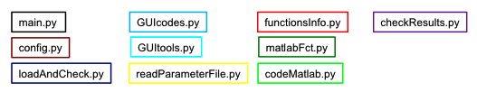
Each color of a box represents a file. Code for colors is:

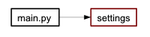Figure 1: step 1: loading settings
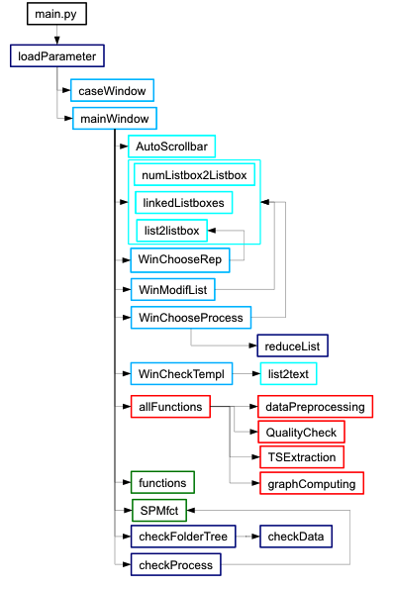Figure 2: step2: loading parameters from graphical interface
The other way to load parameters is:

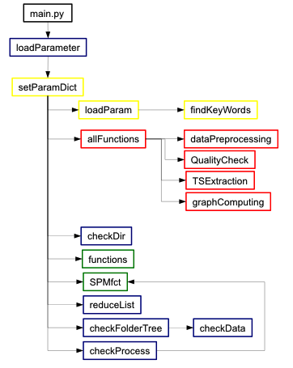Figure 3: step2: loading parameters from text file
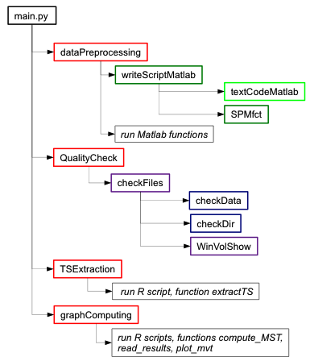Figure 4: step3: data processing for each dataset

Data are saved in a folder tree, with this convention:
- Folders level 1: pathologies
- folders level 2: patient
- folders level 3: Original (other folders Processed and Final are created by code)
- folders level 4: medical examination, where data are. For functional case, you have a folder Anat with anatomical file, and a folder Functional with all functional files.
If this organization is not respected the program can't run. File format supported for functional case is NIFTI, with extension .nii.

Start
Once you have set paths to appropriate folders, you can define what mode you want: graphical interface or file reading. It is recommended for user which is not familiar with this program to start with graphical interface. This choice is made in config.py: set parameter "mode" to "graph" (graphical interface) or "script" (file reading). Once parameter are loaded, they are saved in a dictionary called param (created in config.py), whose keys are variables names and content their values. The content can be a string, a number, an instance, a list, a dictionary...
Convention for dictionary param: param["variable_name"] = variable

In config.py, another setting is the option:
- if param["option"] = "inter", the program will be a little more interactive with user, and will display images for longer time during quality check step (2 minutes minimum, see variable delay in checkFiles, file checkResults.py);
- if param["option"] = "indep", the program will be as independent as possible, and will display images briefly during quality check step (10 seconds minimum, see variable delay in checkFiles, file checkResults.py).
To run the program, run file main.py. For example in a shell (make this file executable before):
$ ./main.py
This text appear, and the following depends on your mode:

******************************************
* Data Processing *
******************************************

1. Select and check data

- Graphical interface
In config.py, you should have:
param["mode"] = "graph"
param["option"] = "indep" (or "interp")
and other paths if needed.
The first window that appear is for case choice.
Following examples correpond to the case of functional data, but are similar for diffusion.
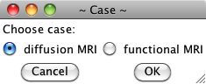Figure 5: window 1: case choice
Once you click on “OK”, the main window is displayed. With it you can select all data sets that you want to process and which function you want to apply. Parts in red on figure 6 appears only for functional case.
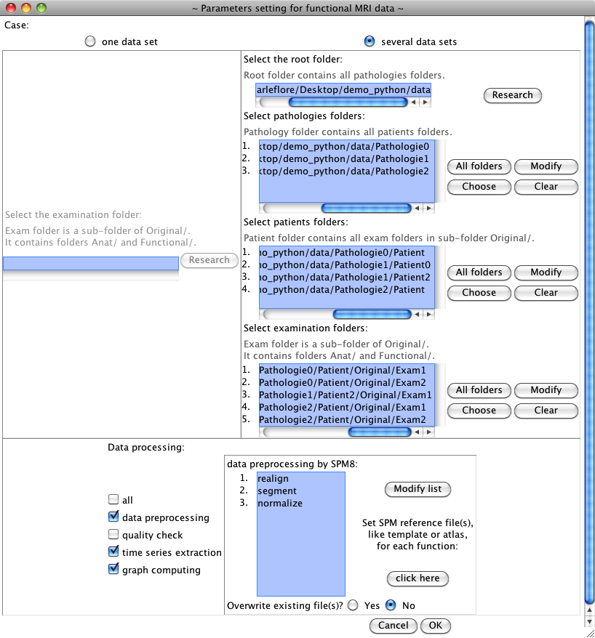Figure 6: main window, functional case
This frame is only in functional case
1
2
3
4
4
List of functions, depends on case
You can process only one or several data sets: select the case in the first frame. If you have several sets, give the directory to general folder in filed 1. A window opens for folder selection. This folder contains pathologies folders.
In field 2 you set directory to pathologies folders, to patient folders in field 3 and to exam folders in filed 4. Use buttons “All folders” (select all folders in level above), “Choose” (see Figure 7), “Modify” (see Figure 8) or “Clear” (clear field) to do that. The list of data sets to process is filled from information in field 4, with this order. If you only have one set, give directory to exam folder (field 4 too). When you click on “OK”, you must have at least one data set, with data inside.
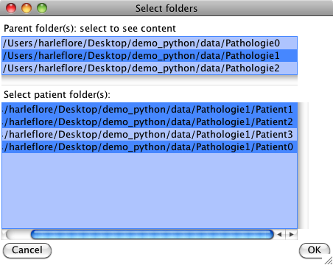
Figure 7: button "Choose"
Parent folders

Folders contained in selected folder of above field, user has selected three of them

Possible actions on selected directory
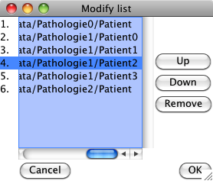Figure 8: button "Modify"
Special frame for functional case: if you select “data preprocessing” in functions listed, the frame “data preprocessing by SPM8” is activated, and you can choose which sub-function you want to apply when you click on “Modify list”. In figure 9, you have and example of the window that appears then. You can refer to following parts for more details about this functions. The list of chosen functions can be modified by buttons on the right. The order of this list will be respected for execution. If you select a name twice, or “dartel” and a function included in, an error message is displayed when you click on “OK”. The “Select all” button avoid redundancy in names, so “dartel” and “finergrid” are not included.
The chosen names appear in main window. You can then change reference file (template or atlas) for function that need one, if you click on “click here”. The window in figure 10 is displayed.
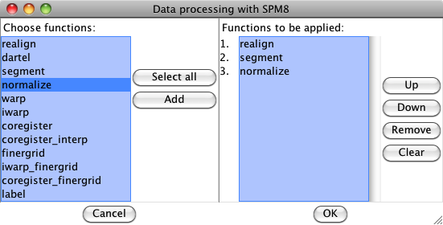Figure 9: choice for preprocessing: list of possible functions and list of chosen functions
Files listed there are default settings. Be careful if you change some of them, you might have to modify the script in matlabFct.py (for number of volumes to load). But for “iwarp” or “coregister” there is no such problem.
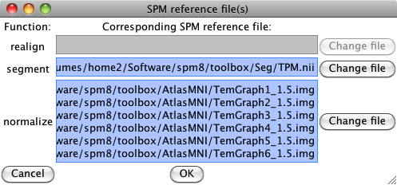Figure 10: setting reference files
Another specific functionality for this case it the possibility to not run again functions that have been done during preprocessing, because this step can be long. Default setting is to not execute this function again, but you can select “Yes” at question “Overwrite existing file(s)?” if you want to run them anyway. The condition for not run a function again is that all output file of this function exist, see following parts for more detail.
Other windows can appear if you don't have set any paths in config.py to folders tools (SPM, R...) and you have chosen processes that need this tools.

When you click on “OK” on main window, checking is done on your data sets (only directory for exam folders) and on your list of processes. Error messages can be displyed to help you to set information correctly.
If you click on “Cancel” the program interrupts.
When the main window closes, you have all parameters for next step. The other way to get them is to read a file.

- Reading text file
In config.py, you should have:
param["mode"] = "script"
param["option"] = "indep" (or "interp")
param["paramFile"] = "path/to/your/file/paramfile.txt"
and other paths if needed, but they can be given in the file (except for matlabPath).
The principle of parameter extraction from a file is to search key words in text and them to load their value. To write a file readable by functions in readParameterFile.py, you must follow this instructions:
- there is maximum one key word by line
- a key word starts a line and is followed by =
- spaces are not taken into account
- text after # is not read
- text is not between “”
- elements of a list are on the same line, separated by ,
The list of key words can be found in function findKeyWords (file readParameterFile.py, variable KWlist), and more information about them on doc string of function loadParam (same file).
Mandatory variables are:
- case: functional or diffusion
- examRep: list of directories to data sets (exam folders).
Set your process step names in variables:
- process, list of functions names (see module functionsInfo to see which ones are available)
- preprocess, list of preprocessing of functional data, see method functions in matlabFct.py.
Paths described for config.py can be given here: repSPM, repR and repTools. Values read from file are saved instead of those loaded from config.py.
You can also set directory to reference files for functions of preprocessing (atlas and templates), or decide write over existing files or not, like with graphical interface, otherwise default values are loaded.
Example of file, for functional data processing:
# data information
case = functional
examRep = path/to/data/Pathology1/Patient1/Original/Exam1, path/to/data/Pathology1/Patient1/Original/Exam2,
path/to/data/Pathology1/Patient2/Original/Exam1

# processes
process = data preprocessing, quality check, time series extraction, graph computing
preprocess = realign, dartel, finergrid, label
overwrite = y

# directory to R functions
repR = path/to/R/functions/R_tools
Note that elements of examRep are one the same line. Don't forget to add data preprocessing in process list if you want that variable preprocess to be loaded.
Checking is done one parameters values, and if there is a problem (wrong paths, redundancy or wrong order in preprocess) an error message is displayed on console and the program breaks.
After validation, these parameters are set in param.

- Temporary file
After parameter loading and before processing, the program writes a text file to save user's choices. This file is called [date]_[time]_processing_info.txt and is saved in a new folder tmp in current directory. During successive steps of processing, new information is added in this file, with corresponding time.

Functional MRI
In functional case, data preprocessing is done with software SPM8. Other useful matlab functions are provided in this toolbox, in Matlab_tools/preproc_SPM8.
A general script is written to run all steps selected, in Matlab language, whose name is preprocessing_[date]_[time].m (saved in Processed/exam/Jobs folder, created during processing). This script is a combination of original codes run_experiment.m and preprocess.m, which call Matlab batches for SPM. All parts are kept in preprocessing_[date]_[time].m, even those that are not supported by python interface, like Classic Segment or QC.

Step names are:
- realign
- segment
- normalize
- warp
- iwarp
- coregister
- coregister_interp
- label
- iwarp_finergrid (or iwarp,finergrid in Matlab script)
- coregister_finergrid (or coregister,finergrid in Matlab script)
- label
Moreover, function dartel groups together functions segment, normalize, warp, iwarp, coregister and coregister_interp, and function finergrid groups together functions iwarp_finergrid and coregister_finergrid.
All information about each function is written in class SPMfct (file matlabFct.py), see part Development for more precisions.
Creation of preprocessing_[date]_[time].m and running is done by method run of class dataPreprocessing (in module functionsInfo.py).
Functions chosen by user are written in variable varargin, and only those one are run. Step to do or done are managed by two matlab variables: tasksTodo.mat and tasksDone.mat. Another matlab function, updateTasksDone.m, is called before preprocessing_[date]_[time].m to update tasksTodo.mat to what user wants to run. Then it is possible to run a function that have been done before (if option overwrite has been chosen).
Example:
chosen functions are realign, dartel and finergrid
realign and segment have already been done.
If existing files can be overwritten varargin is:
varargin = {'procChain',{'realign','segment','normalize','warp','iwarp','coregister','coregister_interp','iwarp_finergrid','coregister_finergrid'}};
If existing files are kept, varargin is:
varargin = {'procChain',{'normalize','warp','iwarp','coregister','coregister_interp','iwarp_finergrid','coregister_finergrid'}};
The script preprocessing_[date]_[time].m can be run directly on Matlab, without Python interface.

When preprocessing is done, quality check can be run.
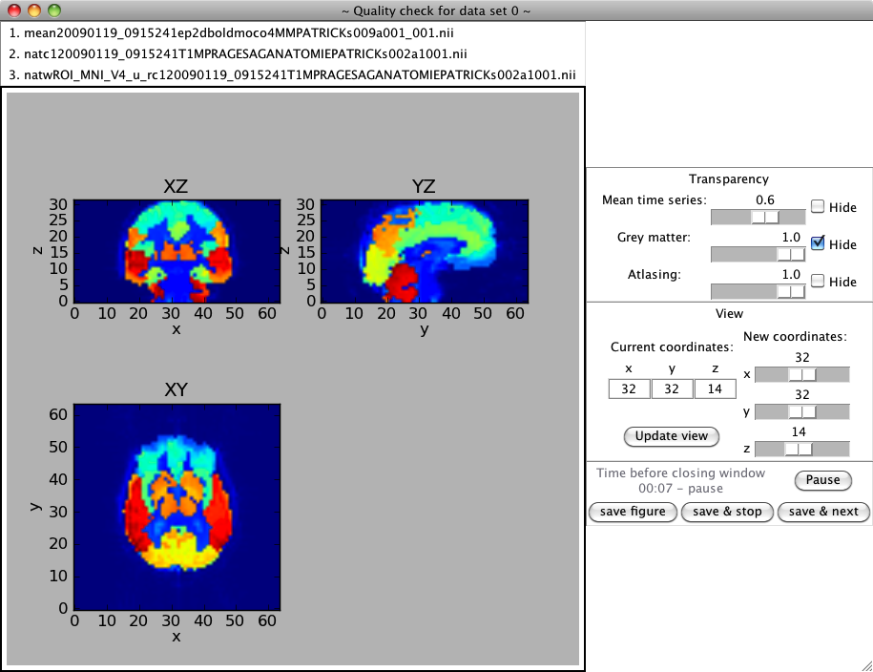
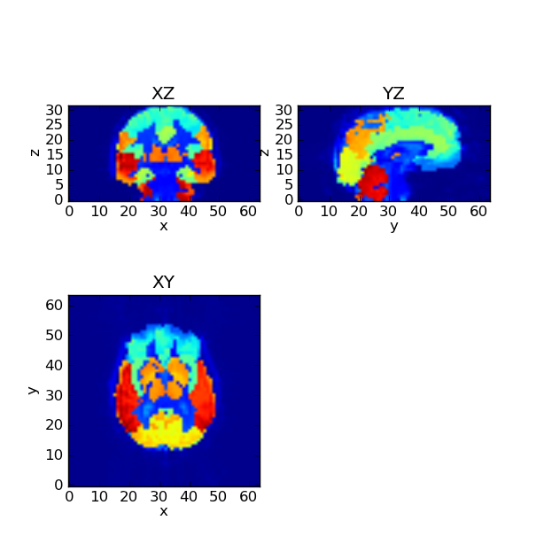

fig_ROI_MNI_V4_1.png

à terminer

Diffusion MRI
To be completed.

Development

Add new parameter
à terminer

Change functional data preprocessing
SPM functions information is set in an instance of class SPMfct (file matlabFct.py), whose main attributes are:
- name, function name (realign, segment, iwarp...)
- initFile, list of input files (with * if complete names are known)
- endFile, list of output files (with * if complete names are known)
- template[“name”], if needed, default reference file (atlas or template) in SPM
- job, name of matlab batch related to this function
See doc string of SPMfct for more details and other attributes. With the methods of this class attributes are updated with new informations, like path to SPM folder or base name of data files.
To change default settings, like file names in intFile, endFile or template[“name”], modify attributes values.
A test a done (in checkProcess) on preprocess functions list to check which ones can be run, and which ones have already been done. The principle is to search initial files (attribute initFile) for each function on each dataset, if they exist, function can be run. If they don't all exist, the code search in output files (attribute endFile) of previous functions, the function can be run. If all output files of a function exist, and if user doesn't want to do it again, this function won't be run. This results are saved in variable param[“run”][i][p] and param[“pb”][i][p] for i-th data set and function p. Value for “run” is True when function can be run and False if it is not necessary. Value for “pb” is True when function can't be run (initial files are missing) and False otherwise.
The function that creates the matlab script is writeScriptMatlab (in matlabFct.py). To change anything in this script you can modify writeScriptMatlab. For instance you can only write code parts that is related to functions chosen by user.

Add new function
à terminer

Bugs
à terminer
- Idle: troubles with matlab

- There are problems with last release of R package igraph, loaded in file computeGraphs.R. In igraph's website, one can read:
“The biggest change in the R interface is that starting from this version vertices and edges are numbered from one. This change might be painful for many people, because it makes already existing code incompatible with igraph 0.6. To make the switch easier, there is now an igraph0 package on CRAN; igraph0 uses 0-based vertex and edge ids, and it can be used to run old code. Note, however, that igraph0 will not be developed in the future. Please use the igraph package for current and future work.”
For the moment only package igraph0 is used.

- Don't close windows of quality check before images displaying, otherwise there is nothing to save.

- There might be problems in functional case when a region is empty. If it happens, correlation coefficient are set to zero for graph computing (see ComputeGraphs.R)

Propositions for improvements
- To solve the bug caused by igraph's version 0.6, you can install package igraph0 (http://cran.r-project.org/web/packages/igraph0/index.html, previous version of igraph with vertices and edges numbered from 0, but no more supported) or update current code to last igraph version, where vertices and edges are numbered from one.
- Window resizing is not aesthetic and functional, it can be improved.
- Instead of working with dictionary param, whose keys are parameters names and content their values, it might be interesting to create an instance of a class, whose attributes are keys of param and content their values. Several steps of current code can be modified into methods of this class (parameter loading, checking, processing...).
- For the moment, Matlab scripts written for data preprocessing keep content of original codes as far as possible, even parts that are never run. This script can be simplified (see function writeScriptMatlab in matalbFct.py).
- The whole code and its modules are written for Python 2.7. Since a major release has been done for Python 3.0, an eventual work can be done to update this code to the last Python version, considering compatibility with other modules, library and languages.

