SFBay Rocky Shore Survey analyses

Karina J. Nielsen

Last compiled on 01 January 2021

# Plots of quadrat data

## Rockweed, *Fucus distichus*

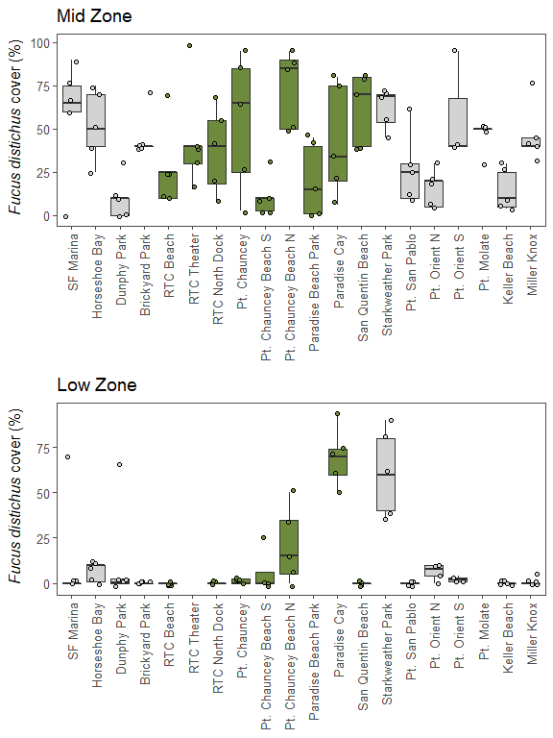 ## Native oyster, *Ostrea lurida* 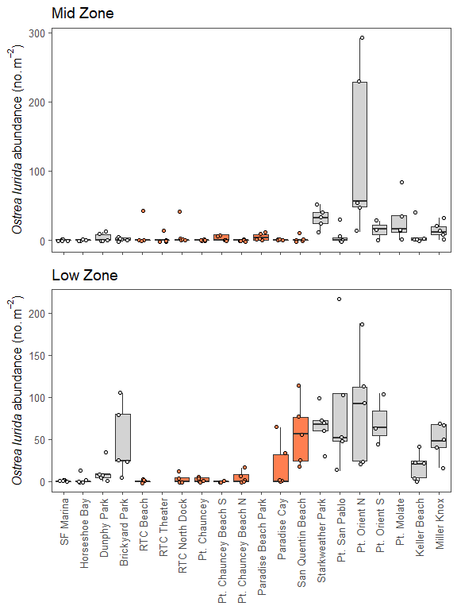 ## Rockweed by site type and zone 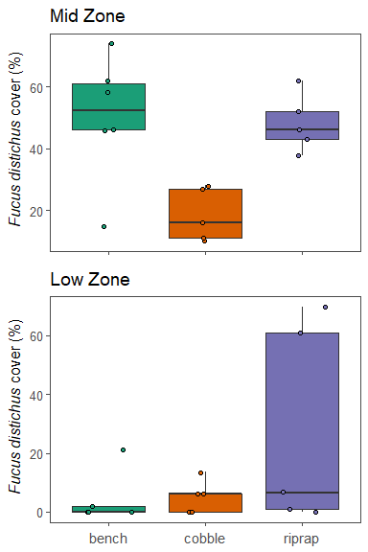 ## Oysters by site type and zone 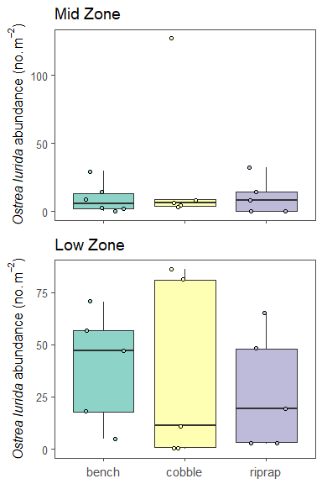

## Oyster scars vs. oysters colored by site

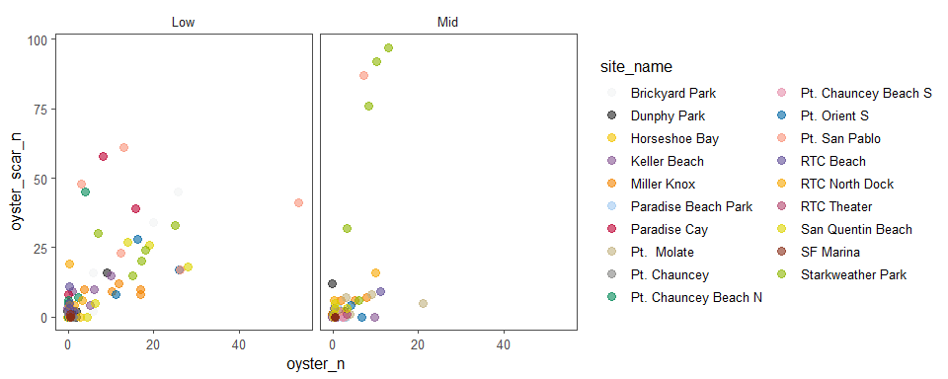

Abundance of native oysters (Ostrea lurida) in the mid and low intertidal by site type.

## Size structure of oysters, mussels, and limpets by site

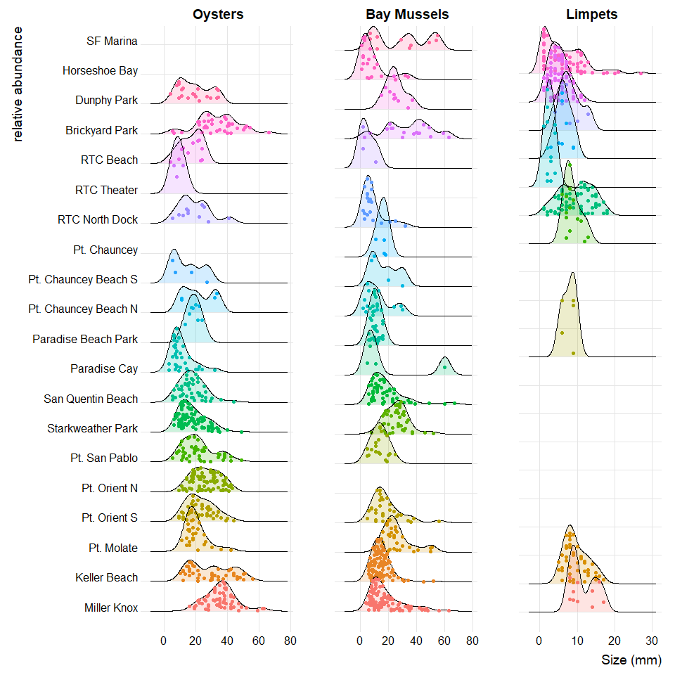

Size structure of oysters, bay mussels and limpets in mid and low intertidal at study sites.