Batch Render Wizard Quick Start Guide
Important to know that this wizard takes into account the position of the playhead. Because of this, if you want to render the entire project using this tool, put the playhead at the beginning of the project and save in that state. In CinelerraGG terminology, the playhead refers to the insertion pointer position and the wizard refers to the menu.

To create the list of jobs for batch rendering, follow the steps in red as shown in the next image:
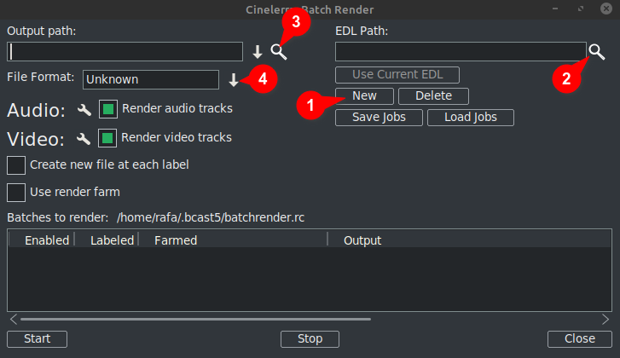
- Click New: This creates a new line in the window below which will be highlighted as active.
- Next designate the project file in the EDL Path textbox. You can manually type in the complete filename or use the magnifying glass to open the Cinelerra GG explorer and locate the file.
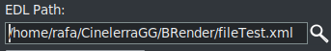
Any changes you make here will be shown in the active line in the window below.
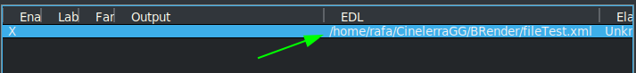

- Then in the Output path textbox, either manually type in the complete path and filename of where to write the results or use the magnifying glass to locate an existing filename.
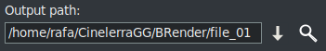
Any changes made here will also be reflected in the active line in the window below.
- Next, choose the format you want to use for the export/output. For FFmpeg, you must also choose its file type.
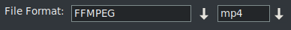
By default, the wizard opens with the FFMPEG encoding system in the .mp4⁽*⁾ format. If you want to use another option that is not FFMPEG, choose this by clicking on the down arrow to the right of the corresponding box as you can see framed in green in the next image.
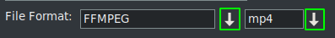
⁽*⁾ The first time using this wizard it opens with the encoding formats of the FFMPEG specification with the extension .mp4 by default. To use this format it is suggested that you put the mp4 extension on the output filename. This can be done in one of two ways, either by typing the name in the output box, or by opening the drop-down and choosing the extension.
Note that when choosing the extension via the drop-down it is automatically added to the Output path filename and if there is already an extension in the textbox, it will be replaced.

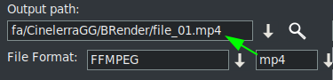
↓There is more content
Once these four steps are complete, if you want to add more batch render jobs, you must repeat the steps for each new line in the list of jobs.
Remember that if any changes are made to the "EDL Path" or "Output path" textboxes, the changes will be implemented on the active selected line.
When creating a new line, by pressing the "New" button, this will be a copy of the one that is currently selected. Initially since there is only one line, it will be a copy of that one.
Now with this new line selected, you can make the changes needed to render another project, or the same one with another format or other render settings.
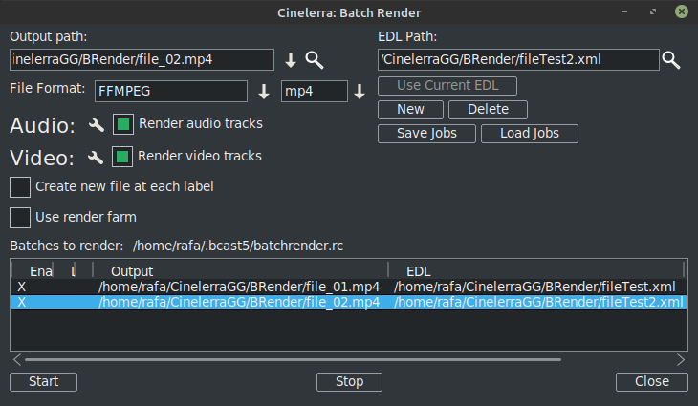
As can be seen in the previous image there are already two lines in the Batch Render list of jobs.
REMEMBER: Whenever you want to add a new line in the batch list, the first step is to create this new line with the option "New", which will be a copy of the one currently selected. Then follow the remaining steps as previously explained.

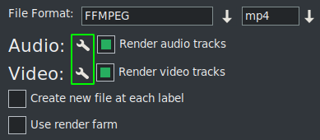
The render settings can be modified by clicking on the tool icon, framed in green in the next image.
If you check "Create a new clip on each label" it does just that when the job is rendered.
If you check the box “Use render farm”, the job will make use of the render farm depending on the parameters you have already set up for that.
IMPORTANT: Any change you make to these 2 check box parameters will only affect the active line.
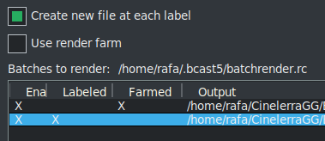
In the previous image you can see activated the option to create new files at each label for the second job while the first job makes use of the render farm.
You can see this at a glance due to the X's that visually indicate the configuration of each line.
These X's are interactive, you can activate and deactivate them from the list itself. And it is the only way if you want to exclude a line from the render without deleting it. In the next image line 3 is disabled so that render job will not be exported.
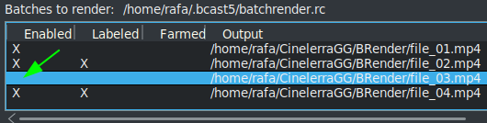
A very useful button in the next image
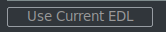
makes it easy to use the project that is currently loaded on the timeline for the “EDL Path” textbox.

To save the current list, or load another one already saved, use the following buttons.

↓There is more content

Once you have the complete list, start the Render of all the active lines by pressing the Start button. This button is the left one on the bottom of the wizard.
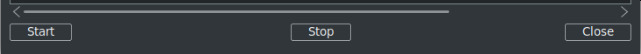
With the Stop button you can stop the Render even if it has not finished.
To close the wizard it is recommended to use the "Close" button, at the bottom right. This automatically saves the current state of the wizard in the file "batchrender.rc" in the CinelerraGG cache, UNLESS you changed the job list by designating a different name using the Save or Load jobs buttons.

New Batch Render List
If in the future you want to create a new list, you must first delete the content that is opened from the cache. To do this use the Delete button, which is next to the New button.

Export fragments of a project
If you want to export only a fragment of a project, you can make a selection that covers the fragment to be exported, save the file in that state and the batch render will only export what is covered in the selection. This is very useful to test effects that prevent you from previewing in real time because they consume many resources.
If you want to export different non-consecutive fragments of the same project, make this selection and save the current project as “Fragment 1.xml”, for example.
Then create a new render line with the 'New' button and load this project that you have in the timeline with the “Use current EDL” button. If the button is not active, close and reopen the wizard and it will then be active. Remember to add the path and the file name in the Output path textbox.
To add another fragment, modify the selection for the second section and save it as “Fragment 2.xml”, for example.
Then again create a new render line and load this project that is in the timeline with the "Use current EDL" button. Remember to change the name of the output file.
Repeat the steps for each new fragment that you want to add to the list.
To render without using the graphical user interface (GUI), this can be done from the terminal if the job list was already set up. You must be in the directory where the CinelerraGG binary “cin” exists or else use the full pathname of where it is. Use the full filename that was saved with the lines to render and execute the following line.
$ cin -r "Name File Render"
For example, if there is a file set up called "My batch render.rc", use its full pathname as shown here.
$ cin -r "My batch render.rc"
* The quotation marks in the names can always be used, they are mandatory in the terminal if the name contains spaces.
For more advanced uses I recommend consulting the "Advanced features" for Batch Render in the online manual.

