

**Online**

**Horoscope**

**System**

# Project Report

## Title Page

Project Name – Online horoscope System

Section - Section 10, Year 2

Credit by KHIN YADANA PHYO

## Abstract

### Online shopping and web browsing are popular nowadays because it is convenient to human life. This project is about online horoscope which tells the future by year, month and day. The purpose of this project is to save time, energy and money for both the fortune teller and customer while they are working together to tell their future. Current system makes the appointments at first and register secondly.

### In this current system, the customer needs to make appointment on the first place then register their information to get astrology about their personal horoscope. However, fortune teller can see only one customer at a time, which the customers may spend their time waiting for the appointment. Current system also runs manually which may have difficulty for maintaining and searching documents of customers and staffs. There is also limitation in the availability of space which can have negative impact on the customers.

### The proposed system meets the requirements of the current system. The proposed system can serve both the fortune teller and the customers to save time, energy; money and can improve the performance and productivity of the job. The current system involves customer registration, view daily, monthly, yearly horoscope based on their birth date and categories. Proposed system can reduce the associated problems of the fortune teller such as handling documents of customers and managing staff.

### Finally, as for payment, the proposed system uses the prepaid payment system. If the customers ask for one time, it subtracts into prepaid card. The customers can use until the credit in the prepaid card is empty. So, this system can be convenient and useful for both sides.

This project will be developed using Object Oriented Analysis Development Methodology (OOADM) and waterfall life cycle model. This project will be implemented using PHP(Hypertext Preprocessor) language and MySQL database management system.

## Content

Contents

Abstract 2

Content 3

Overview of the Computing Artifact to be developed 4

Aim 5

Objectives 5

Work Breakdown Structure and Gantt chart 6

Work Breakdown (See in Appendices: A) 6

Gantt chat 6

Scope of the project (Features will and will not be developed) 8

Functional Scope 8

Out of Scope 8

Development Methods 9

Explanation of Development Lifecycle Model 9

V-Model 9

Spiral Model 9

Waterfall 9

Reason for choosing Waterfall life cycle model 9

Explanation of System Development Methodology 10

Object-Oriented Analysis and Design 10

Advantages of OOAD 10

SSADM 10

Advantages of SSADM 10

Disadvantages of SSADM 10

Reason for choosing of OOADM 10

Development Tools and Platforms 11

Nusphere 11

XAMPP …………………………. 11

Selection of Programming Language 11

PHP 11

JAVA 11

Reason for Choosing PHP 11

Selection of Database 11

MySQL 11

SQL 12

Oracle 12

Reason for Choosing MySQL 12

# Overview of the Computing Artifact to be developed

The current system is horoscope system is that the fortune teller is telling about the fortune such as **daily horoscope, monthly horoscope and yearly horoscope and** by taking appointment with the customer. After booking for an appointment, the customer will make the registration and go ahead hand to hand discussion. Current system can serve daily horoscope, monthly horoscope and yearly horoscope. If the customers book for appointment to see his/her future**, he/she must give their birth date which can be used to check for astrology**. Current system has an office working with staffs and documents.

The current system waste customer time and money to take appointment with the fortune teller and inconvenient to view their horoscope for those customers who wishes to know their daily horoscope. The current appointment system is more sophisticate but it is very important. Although it can give face to face discussion with the fortune teller and the customers, it takes a very long time and there is limited in office space. Other problems are difficult dealing with staffs because our location is outskirt and there is a bit trouble for transportation. In some cases, some people phone to the office because they lost their horoscope paper. So the current system also has difficulty in handling document.

The proposed system overcomes the problems of the current system. For those customers who wish to view daily and monthly horoscope, it is more convenient. It also saves both the customers’ and fortune teller time and money for not requiring appointment, office space and travelling charges. Proposed system also provides very convenient payment system for the customer. It provides customer to view their horoscope at any time and everywhere and the customer can look the balance on the website. It eliminates the problems in handling documents and dealing with staffs as the proposed web-based horoscope system requires no staff.

By developing the current system, the first benefit is that time and cost can reduce. For customers such as student and business men is more convenient. It is not necessary to deal with staff and so man power can be reduced. No paper-document is used and it will reduce the cost and no need for space to keep those documents.

# Aim

My proposed system serves to view the customer’s **daily, monthly and annually horoscope** having to make appointments with the fortune teller.

# Objectives

* To register the customer detail and view horoscope without having to go to the local office
* To top up the balance into the customer account using the prepaid card
* To show the update balance of the prepaid card through the website
* To view various horoscopes without doing appointment
* To view the up to date horoscope telling at everywhere and every time
* To produce the monthly newly reports
* To view the customer reports after administrator log in

# Work Breakdown Structure and Gantt chart

## Work Breakdown (See in Appendices: A)

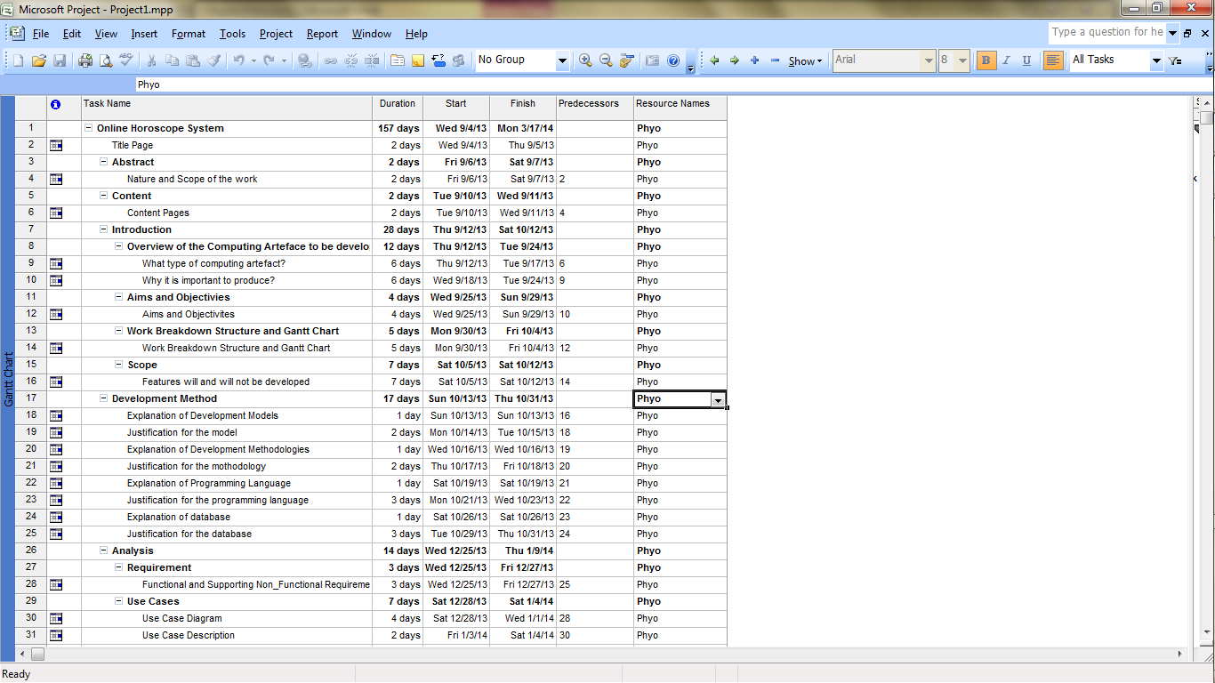

## Gantt chat

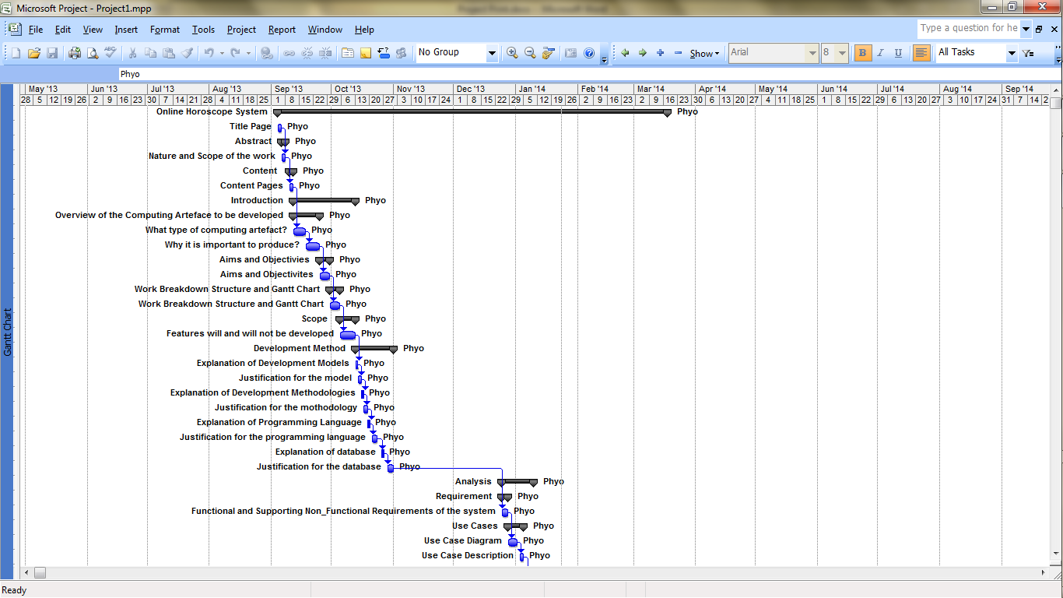

# Scope of the project (Features will and will not be developed)

## Functional Scope

* Make the prepaid card registration by admin
* Log-in process by admin and customers
* To top-up the balance into the customer account prepaid card
* To display customers fortune according to categories and deduct specific price from customer’s account
* Add new astrology and keep up-to-date astrology by admin
* To display the customer available balance automatically
* To produce monthly newly registered member report
* To produce the report for frequency of asking time and total charges by horoscope monthly
* To produce the monthly report for the most foretelling categories and tags

## Out of Scope

* Managing the staffs records and permission authorization of the system log-in staff
* Purchase the prepaid card
* Customer enquiries and feedbacks

# Development Methods

## Explanation of Development Lifecycle Model

### V-Model

V model is one of the information analysis techniques. It is least flexible and very rigid. If we change the diagram in middle, our test document must update. When Model is developed during the implementation stage, early prototypes of the software don’t produce.

### Spiral Model

It is the best for large project but it is unsuitable for portable project. And it can cause much more cost and it is difficult to set up because of the level of complexity. It requires the extensive skill and it appears the uncertain errors suddenly. It works with the protocols and its protocols has very strict rule so it sometimes difficult to follow its protocols.

### Waterfall

Nowadays, it becomes popular of the system development life cycle. It presents a development method for and sequential and linear. It is no ambiguous requirements and products are stable as well as technology can be understood.

### Reason for choosing Waterfall life cycle model

In using and installing model, it is easy and understands at once because the works in each step can be finished. If not, it doesn’t allow on progress next step. It is not difficult to manage in order to the rigidity of the model. It has the deadline for each step so that I think it is systematically.

## Explanation of System Development Methodology

### Object-Oriented Analysis and Design

OOADM is the based on the **Object orientation** which is progression form earlier programming language. It becomes the popular todays and it is used widely. It inspires are the norm for the industry.

### Advantages of OOAD

In OOAD, we can identify the basic of users, describe the detail needs for each requirement, compress and decompress the whole system as you like, define out the interactions and iterate associated step. In this system, analysis and design are very simplest and can easily understand. We can save time for the small project and reuse easily. It can accurately maintain. The best fact for OOADM is that it is so accurate equally for human being lives which is known natural model.

### SSADM

The Structure System Development Method is the design of information system and it is based on data-orientation which is approach the developing diagrams for system. It works through the **DFD-Data Flow Diagram.** These focuses the ways the data stored, manipulated and passed.

### Advantages of SSADM

SSADM can solve with the open discussion of problem and needs as well as perceptions. It can be difficult for perspectives. It has joint solving problem. This system has user participation and commitment.

### Disadvantages of SSADM

Because of the creating the information, we can difficult create the aspect of creating data. Developing this system can rarely understand the data inside it. About the data, wrong recommendations can lead towards the data may be improper. The large problem in SSADM is taking the long time. For real situation, analysis is to take the time a lot. In the company, staff can train for using the SSADM technique so that we can waste the cost as usual.

### Reason for choosing of OOADM

By using it, Design and analysis are very simplest and we can easily efficiently decomposed into units. In maintaining process, we can easily prepare our program anytime. If we have the good result, we can reuse easily inside it.

## Development Tools and Platforms

### Nusphere

**NuSphere is supplier of the PHP Tools and techniques. And also we can call as the home of PHP Editor - state of the art PHP Editor. We can be reliable it because thousands of people use the** tools including our PHP IDE with the leading debugging tool for PHP.

### XAMPP To write the PHP programming, we need the Apache web server. Installing Apache web server is difficult. XAMPP is an easy to set up Apache distribution containing MySQL, PHP and Perl. It supports the distribution for Windows 2000, 2003, XP, Vista, 7 and 8.

## Selection of Programming Language

### PHP

PHP is Hypertext preprocessor and it is widely used in open source and one of the sever-side scripting languages. It is suited for web development and can be embed from command line.

### JAVA

It firstly appears as OAK code and later OAK CODE is complicated into BYTE CODE .Finally, it is appeared into Java language. Java is one of the computer program language and also known as interpreted language and it isn’t available on all platforms. And, it needs a special type of word processing software also known as context sensitive editor.

### Reason for Choosing PHP

The best fact of PHP is easy to maintain and edit web pages. It includes the HTML code inside it so that we don’t worry about design aspect. HTML and PHP codes can contain the single file. In PHP, we can improve the following tasks

* Making and checking simple HTML Form based tasks.
* Database connectivity
* Dynamic pages processing

## Selection of Database

### MySQL

MySQL is an open source of data management system. Inside it, information is stored and related with the form of related table. In Web application development, My SQL is mostly used. A MySQL database can be accessed directly from the computer language such as Java, PHP, Eiffel, Perl, etc. It can access using the SQL commands.

### SQL

SQL has a lot of various types of English vocabularies and syntaxes are used in SQL to reduce the difficulty in writing and understanding it. And the relational algebra as the basic theory of SQL is a complete computation system.

### Oracle

Oracle is one of the databases and becomes popular nowadays. It is the “biggest” all based on your perspective. It is very complexity and it takes high availability and it can bring higher performance. But it is very difficult for installing it and administers Oracle. And it is very expensive to set up.

### Reason for Choosing MySQL

MySQL is suitable for small and medium sized. And it supports **high-performance and low-maintenance. It can receive the permitting for removing database and then can apply for client because of web application database.**