Spring Boot Actuator + Alibaba CloudMonitor Auto Scaling Guide

Architecture Overview
Java Application (Spring Boot)
→ Spring Boot Actuator exposes JVM metrics
→ Custom metric publisher sends metric to Alibaba CloudMonitor
→ Alibaba Auto Scaling monitors the metric
→ Scaling rule triggers ECS instance scale-out / scale-in

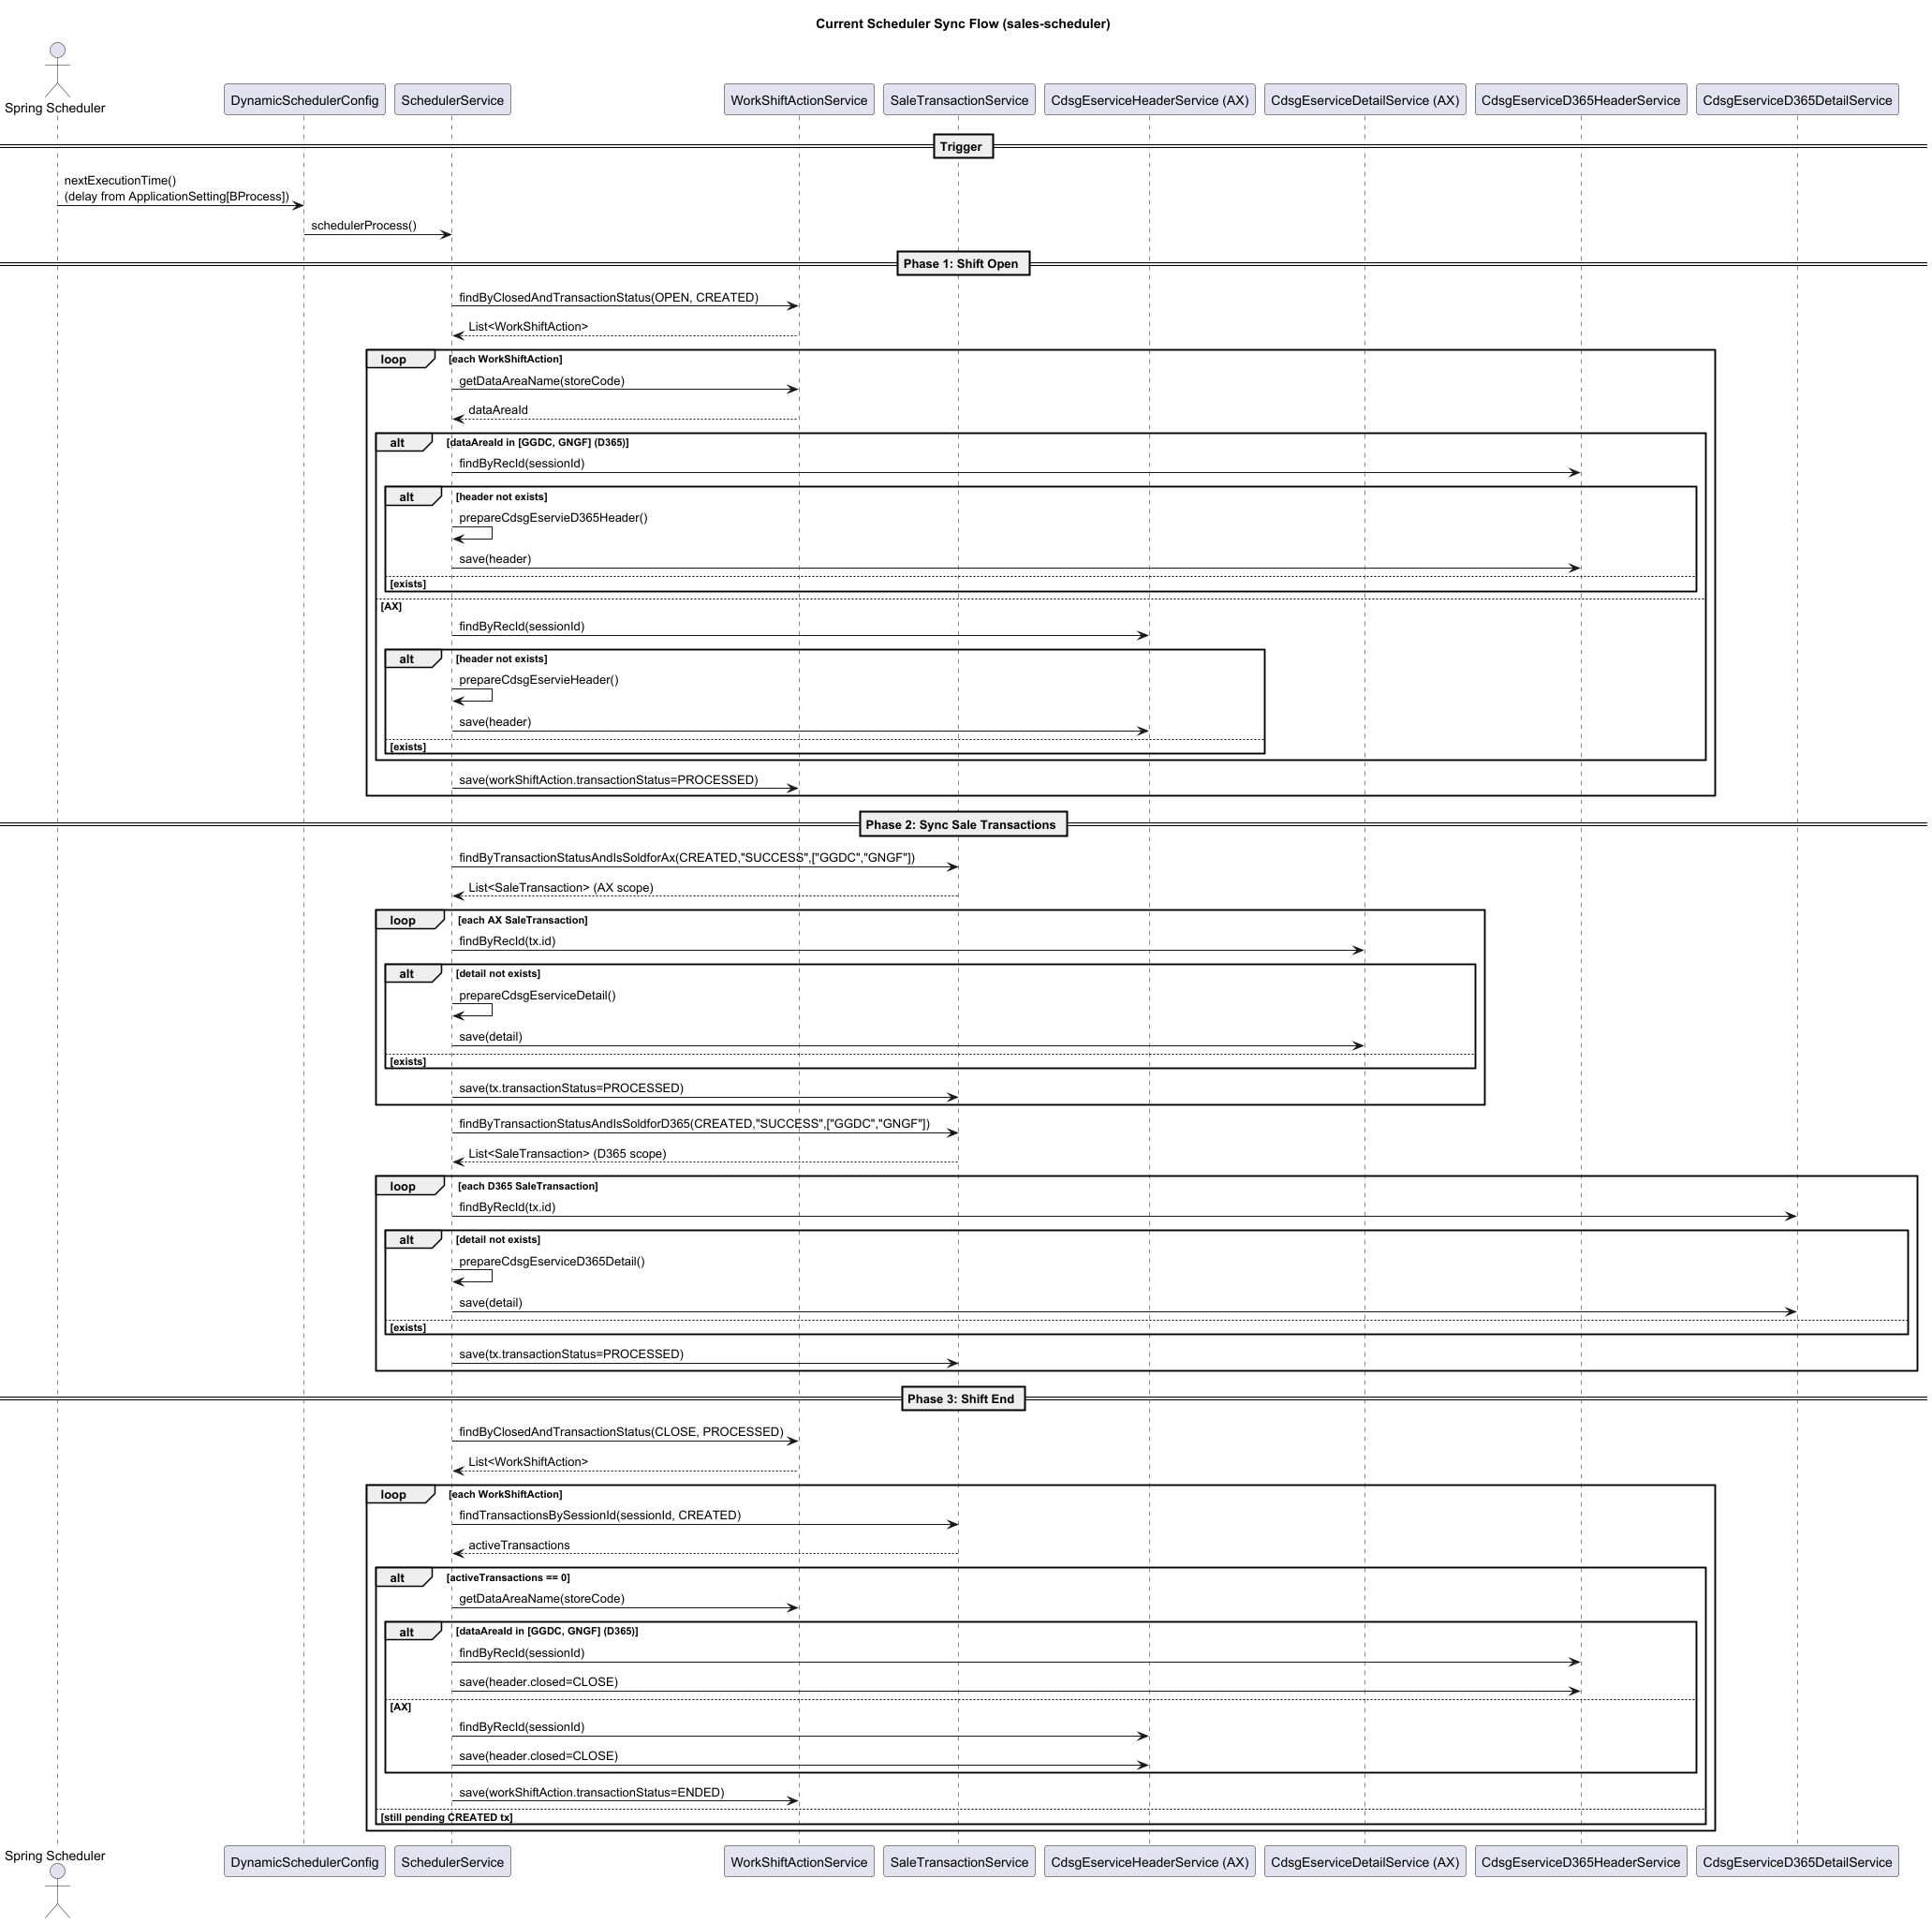

Step 1 – Choose a Scaling Metric
Common Java scaling metrics:
• CPU usage
• JVM heap used percentage
• Request latency
• Queue backlog
• Active threads

Example metric:
jvm_heap_used_percent = used_heap / max_heap * 100

Step 2 – Add Spring Boot Actuator Dependency
Maven dependency:

<dependency>
<groupId>org.springframework.boot</groupId>
<artifactId>spring-boot-starter-actuator</artifactId>
</dependency>

Optional (Prometheus metrics):

<dependency>
<groupId>io.micrometer</groupId>
<artifactId>micrometer-registry-prometheus</artifactId>
</dependency>

Step 3 – Enable Actuator Endpoints
application.yml

management:
endpoints:
web:
exposure:
include: health,info,metrics,prometheus

Step 4 – Create JVM Heap Metric
Example Java code:

MemoryMXBean memoryMXBean = ManagementFactory.getMemoryMXBean();
MemoryUsage heap = memoryMXBean.getHeapMemoryUsage();

long max = heap.getMax();
long used = heap.getUsed();

double percent = (used * 100.0) / max;

Step 5 – Schedule Metric Publishing
Use Spring scheduler to publish metric every minute.

@Scheduled(fixedDelay = 60000)
public void publishHeapMetric() {
double heapPercent = metricService.getHeapUsedPercent();
cloudMonitorClient.putCustomMetric("custom/java", "jvm_heap_used_percent", heapPercent);
}

Step 6 – Send Metric to Alibaba CloudMonitor
Use Alibaba CloudMonitor API such as:

PutCustomMetric

Namespace: custom/java
Metric Name: jvm_heap_used_percent
Value: metric value from application

Step 7 – Verify Metric in CloudMonitor
Confirm metric appears in CloudMonitor console.
Check that the metric updates every 60 seconds.

Step 8 – Create Auto Scaling Group
Example configuration:

Min instances: 2
Desired instances: 2
Max instances: 6

Step 9 – Create Scaling Rules
Scale-out rule:
Add 1 ECS instance

Scale-in rule:
Remove 1 ECS instance

Step 10 – Create Custom Monitoring Trigger
Configure Auto Scaling event-triggered task.

Scale-out condition:
jvm_heap_used_percent ≥ 75% for 3 minutes

Scale-in condition:
jvm_heap_used_percent ≤ 40% for 10 minutes

Step 11 – Configure Cooldown
Recommended:

Scale-out cooldown: 300 seconds
Scale-in cooldown: 600–900 seconds

Best Practice Recommendations
• Do not scale only by heap memory
• Combine CPU + heap + latency metrics
• Ensure application is stateless
• Use shared storage / Redis / MQ
• Test scaling rules in staging environment

Minimal implementation path
Phase 1
Enable Actuator and calculate jvm_heap_used_percent.
Phase 2
Every minute, publish it to CloudMonitor via Alibaba API/SDK.
Phase 3
Create scaling group and two scaling rules.
Phase 4
Create custom monitoring event-triggered tasks using that metric.

