Case 1 — Without Queue (Synchronous)
Client waits until:
- DB save
- Business logic
- External call
- Everything done
So T (service time) might be:
500ms
CPU-limited RPS:
2 / 0.5 = 4 RPS

Case 2 — With Queue (Async Design)
Client request:
Client → App → Save + Publish → Return 200 OK
Now client does NOT wait for full processing.
New service time T might be:
50ms
CPU limit becomes:
2 / 0.05 = 40 RPS
Huge improvement.
But…
Now processing moves to:
RabbitMQ + Consumer

So Where Is Bottleneck Now?
System becomes:
System Throughput = minimum(
Web Layer,
RabbitMQ throughput,
Consumer processing speed,
DB write speed
)
Yes — queue can become bottleneck IF:
- Consumers are slow
- DB writes are slow
- Message processing heavy
- Queue disk I/O slow

Important Concept: Decoupling
Queue does:
- Absorb traffic spikes
- Smooth traffic
- Prevent request timeout
- Improve user response time
It does NOT magically increase total processing capacity.
It increases:
Perceived performance
But total work still must be processed.

Example With Numbers
Suppose:
Web layer handles:
40 RPS
But consumer can only process:
15 messages per second
If incoming = 30 RPS
Queue will:
- Accept all messages
- But backlog will grow
Eventually:
- Memory pressure
- Delay increases
- Possibly crash
So yes — it becomes new bottleneck.

Correct Architecture Thinking
When adding RabbitMQ:
You must calculate:
Consumer throughput ≥ incoming rate
Consumer throughput formula:
Consumer RPS ≈ Number of Consumers / Processing Time
Example:
- 5 consumers
- Each takes 200ms (0.2s)
5 / 0.2 = 25 msg/sec
If traffic = 30 RPS
→ backlog builds

VPS Capacity Estimation Summary (2 Core / 4GB RAM - Java + MySQL Ecommerce)

1. What is RPS?
RPS (Requests Per Second) means how many HTTP requests your server can process in one second.
Example: 10 requests finished in 1 second = 10 RPS.

2. What is T (Service Time)?
T = Average time (in seconds) the server takes to process one request completely.
It includes Java processing time, database query time, JSON serialization, and small network overhead.
Example: 200ms = 0.2 seconds → T = 0.2

3. CPU-Limited RPS Formula
Max RPS (CPU) ≈ Number of CPU Cores / T
Example: 2 cores and T = 0.2 → 2 / 0.2 = 10 RPS (theoretical maximum).
Note: This assumes no heavy DB waiting and no blocking operations.

4. Network-Limited RPS Formula
Network speed is usually measured in Mbps (Megabits per second).
Convert to MB/s using: MB/s = Mbps ÷ 8 (because 1 Byte = 8 bits).
Example: 100 Mbps VPS → 100 ÷ 8 = 12.5 MB/s.
If each response is 1MB → 12.5 ÷ 1 = 12 RPS maximum (network limit).

5. DB-Limited RPS
Database performance depends on query speed, indexing, disk I/O, connection pool size, and buffer memory.
If DB queries are slow, they reduce total system RPS even if CPU is available.

6. Final System Rule
Max RPS ≈ minimum(CPU limit, DB limit, Network limit).
The slowest resource becomes the bottleneck.

7. Concurrency Formula
Concurrency ≈ RPS × Response Time (seconds).
Example: 10 RPS and 0.5s latency → 10 × 0.5 = 5 concurrent requests.

8. Realistic Expectation for 2 Core / 4GB VPS
If response size is 1MB and VPS bandwidth is 100 Mbps, realistic stable RPS is around 8–15.
Optimization such as pagination, caching, and query tuning can significantly increase capacity.

Plus Rabbit MQ
Case 1 — Without Queue (Synchronous)
Client waits until:
- DB save
- Business logic
- External call
- Everything done
So T (service time) might be:
500ms
CPU-limited RPS:
2 / 0.5 = 4 RPS

Case 2 — With Queue (Async Design)
Client request:
Client → App → Save + Publish → Return 200 OK
Now client does NOT wait for full processing.
New service time T might be:
50ms
CPU limit becomes:
2 / 0.05 = 40 RPS
Huge improvement.
But…
Now processing moves to:
RabbitMQ + Consumer

So Where Is Bottleneck Now?
System becomes:
System Throughput = minimum(
Web Layer,
RabbitMQ throughput,
Consumer processing speed,
DB write speed
)
Yes — queue can become bottleneck IF:
- Consumers are slow
- DB writes are slow
- Message processing heavy
- Queue disk I/O slow

Important Concept: Decoupling
Queue does:
- Absorb traffic spikes
- Smooth traffic
- Prevent request timeout
- Improve user response time
It does NOT magically increase total processing capacity.
It increases:
Perceived performance
But total work still must be processed.

Example With Numbers
Suppose:
Web layer handles:
40 RPS
But consumer can only process:
15 messages per second
If incoming = 30 RPS
Queue will:
- Accept all messages
- But backlog will grow
Eventually:
- Memory pressure
- Delay increases
- Possibly crash
So yes — it becomes new bottleneck.

Correct Architecture Thinking
When adding RabbitMQ:
You must calculate:
Consumer throughput ≥ incoming rate
Consumer throughput formula:
Consumer RPS ≈ Number of Consumers / Processing Time
Example:
- 5 consumers
- Each takes 200ms (0.2s)
5 / 0.2 = 25 msg/sec
If traffic = 30 RPS
→ backlog builds
in connection with queue system i discuss with my colleagues and they discuss weird topics.it run with event driven or waiting concurrent request with threads handling.actually in my last work , all order info reach to email producer(rabbit queues) and it send message to consumer directly and my coonsumer does not use thread to process info and it work correctly.but when discussing with my colleagues , they told me two ways.,first is like my ways one process after another.according to them request reach to producer and reach to consumer and process.before consumer finishing process ,if another request reach , it can block or not.in another way they discuss is about using

There are two different things:
- Auto ACK (container-managed ack)
- Requeue on failure (true/false)
When PDF fails:
- You manually publish a new message to a delay queue
- Original message is rejected (no requeue)
- After delay, message returns to main queue
This means:
Retry logic is controlled by YOUR APPLICATION CODE.
Characteristics:
- You decide when to retry
- You decide retry count
- You decide delay duration
- You increment retry counter manually
- You control max retry logic
This is called:
Application-level retry
Retry Queue (Broker-Controlled Retry Pattern)
Retry queue usually means:
- Main queue has Dead Letter Exchange (DLX)
- When message fails, broker moves it automatically to retry queue
- Retry queue has TTL (delay)
- After TTL expires, message returns to main queue automatically
Flow:
Main Queue
↓ (fail)
Retry Queue (TTL 5 min)
↓ (after TTL)
Main Queue again
Dead Letter Queue (DLQ) – Permanent Failure Storage
DLQ is NOT for retry.
DLQ is for:
Messages that should NOT be retried anymore.
Examples:
- Invalid email format
- Business validation failure
- Retry count exceeded
- Corrupted payload
Flow:
Main → Retry → Retry → Retry → DLQ

Two ways to do “10 threads”
1) 10 consumers (recommended)
Run 10 consumer instances (or 1 instance with concurrency=10 managed by the framework). RabbitMQ will give messages across them.
- Efficient when your work is slow / IO-heavy (HTTP calls, PDF download, SMTP, waiting).
- Safer than doing your own thread pool because ack/retry is handled per consumer thread cleanly.
2) 1 consumer + your own thread pool (advanced)
One listener receives messages and pushes them into an internal executor with 10 threads.
- Works, but you must be careful:
  - ACK timing (don’t ack before the worker finishes)
  - Memory (you might buffer too many tasks)
  - Ordering/idempotency gets harder
Most teams prefer #1.
Will it “block” if another message arrives?
With concurrency=1 (your old style):
- new messages wait in the queue until the consumer finishes.
With concurrency=10:
- up to 10 messages can be processed at the same time
- new messages wait only when all 10 are busy
Is it always more efficient?
Not always. It depends on the bottleneck.
It’s more efficient when the consumer work is IO/waiting
Example: download PDF (network) + send email (SMTP).
While 1 thread is waiting, other threads can work → higher throughput.
It can be worse when DB/CPU is the bottleneck
If each message does heavy DB writes or locks the same rows:
- 10 threads can cause DB contention, timeouts, slower overall throughput.
The “safe rule” to choose concurrency
- If most time is waiting (HTTP/SMTP/files) → increase concurrency (like 5–20).
- If most time is DB transaction + locks → keep low (1–3) and scale carefully.
One more important setting: prefetch
Even with 10 threads, you should limit how many unacked messages each consumer holds.
- Prefetch prevents one consumer from grabbing too many messages and holding them.

How to know heavy DB
A practical rule of thumb
Usually NOT “heavy”
- 1–2 tables updated per message
- Total DB time per message is small (ex: < 20–50 ms)
- Updates hit different rows (low contention)
Often becomes “heavy”
- 3–5 tables updated per message and/or
- Multiple statements per table (e.g., insert + update + audit)
- DB time per message is noticeable (ex: > 100 ms)
Definitely “heavy” in many systems
- 6+ tables updated per message or
- Any pattern that updates “hot” rows (same customer/product/counter) across many messages
Table count matters less than these 3 things
1) Total SQL statements per message
Example:
- 2 tables but 12 statements (loop inserts) → heavy
- 6 tables but 6 simple statements → maybe fine
2) Transactions held open (how long locks are held)
If you do external calls inside the same transaction, it becomes heavy fast:
- BEGIN → update DB → call API (slow) → commit
This holds locks longer = bad.
3) Contention (same rows)
Even 1 table can be heavy if all threads update the same row/key.
Example “hot row”:
- UPDATE daily_counter SET count = count + 1 WHERE day = today;
Best quick metric (more reliable than “how many tables”)
Measure per message:
- DB time (sum of query durations)
- Lock waits / deadlocks
- Rows affected and index updates
If DB time dominates processing time, you’re DB-bound.
Quick answer you can use in discussion with colleagues
- “3–5 tables per message is okay if rows are not hot and queries are indexed.”
- “Even 1 table can be heavy if many messages update the same key (lock contention).”
- “We should decide concurrency based on DB time + lock waits, not table count.”
first scenario 4 table insert .it is not heavy right .scenario 2 5 table insert but before insert it check with select.it is heavy right.scenario 3 only 1 statement which fetch n loop(10 at least) it is heavy am i rightg
Not exactly 🙂. “Heavy” is mostly about (1) total DB time, (2) locks/contending rows, and (3) how many statements you run, not just table count.
Scenario 1: 4 table inserts
✅ Usually not heavy if:
- it’s 4 inserts total (not loops),
- tables are indexed reasonably,
- rows are different (no “hot row”),
- transaction is short.
⚠️ Can become heavy if those inserts trigger lots of index updates, foreign keys, or you do it at very high TPS—but by default, 4 inserts alone isn’t “heavy”.

Scenario 2: 5 table inserts + select before insert
❌ Not automatically heavy.
A SELECT-before-INSERT is normal (existence check). It becomes “heavy” when:
- the SELECT scans (missing index),
- it’s inside a high-concurrency path and causes locking (e.g., SELECT ... FOR UPDATE),
- or you do many selects (like N selects per message).
✅ Better pattern for uniqueness:
- rely on unique constraint + “insert and handle duplicate” (often faster and safer than select-then-insert).
So: 5 inserts + 1 indexed select is often still fine.

Scenario 3: 1 fetch statement that returns N rows, then loop (10+)
✅ This can be heavy, but not always.
It’s heavy if the loop causes:
- 10+ DB writes (insert/update each row),
- long transaction time,
- contention (same rows),
- large rows/index updates.
If the loop is mostly in-memory processing and only 1 DB statement total, then it’s not heavy.

Your “am I right?” answers
- Scenario 1 (4 inserts): Mostly right → usually not heavy.
- Scenario 2 (5 inserts + select): Not necessarily heavy.
- Scenario 3 (1 fetch + loop 10+): Sometimes heavy—depends if the loop does many DB writes/locks.
If you tell me: in scenario 3, does the loop do DB writes or only business logic? That single detail decides it.

Queue vs Pub/Sub
Producer → Exchange → Queue → Consumer
point-to-point.
One message → one consumer processes it.
Example:
Order Service → Queue → Worker
If you have 5 workers:
- Messages are distributed
- Each message processed once
Good for:
- Background jobs
- Payment processing
- Email sending
- Order handling
Competing Consumers pattern
RabbitMQ as Pub/Sub (Publish–Subscribe) Event distribution
This is one-to-many.
One message → multiple subscribers receive a copy.
Example:
Order Created Event
→ Inventory Service
→ Notification Service
→ Analytics Service
How?
Using fanout exchange (or topic exchange).
Each subscriber has its own queue.
Exchange Types Decide Behavior
RabbitMQ supports:
🔹 Direct Exchange
Route by routing key
(Like smart queue)
🔹 Fanout Exchange
Broadcast to all bound queues
(Real pub/sub)
🔹 Topic Exchange
Pattern-based routing
(Advanced pub/sub)

Pub/Sub win
“I agree we shouldn’t over-engineer.
My suggestion is a minimal event-based setup: publish OrderCreated to an exchange with only one bound queue today.
This keeps today simple but lets us add new consumers later without touching the order service.”
Why it’s not slower
Whether you send to:
- a queue directly, or
- an exchange with 1 bound queue
RabbitMQ still does basically the same work:
- accept message
- route it
- store it in a queue
Routing through an exchange is what RabbitMQ is built for.
When it can impact performance
It becomes heavier if:
- you bind many queues (true pub/sub with lots of subscribers)
- messages are persistent + RabbitMQ disk is slow
- you publish very high rate (thousands/sec) on a weak disk
- you use confirm + mandatory + heavy headers (still usually fine)
But with one queue bound, performance difference is negligible.
The real performance change comes from async design
If you publish OrderCreated and return quickly (instead of doing email in the request),
your API response time becomes faster, so your web layer can handle more RPS.

Kafka Vs Rabbit MQ
Kafka is a different kind of “pipe” than RabbitMQ.
- RabbitMQ = message broker (routing + queues)
- Kafka = event streaming log (stores events and lets many consumers read them, including old history)

What Kafka changes for your “thousands of requests + backlog” concern
✅ Kafka is very good when backlog/history is a feature
Kafka keeps data in topics (append-only log) and consumers track an offset. That means:
- if consumers are slow, events stay in Kafka and they catch up later
- replay is natural (reprocess from old offset)
- multiple consumer groups can read the same events independently
✅ Kafka scales throughput by partitions
Kafka parallelism comes from partitions:
- more partitions → more parallel consumer processing
- in a consumer group, one partition is read by only one consumer at a time, so partitions limit maximum parallelism
⚠️ Kafka has higher operational cost
Kafka typically expects:
- multiple brokers (cluster)
- tuning storage/retention
- monitoring lag, partitions, replication
So on a small single 2-core/4GB VPS, Kafka can be heavy compared to RabbitMQ (which is simpler to run). (This is why many teams use managed Kafka like MSK when they need it.)

RabbitMQ vs Kafka for your ecommerce example (OrderCreated → email + noti)
RabbitMQ is usually better when you want “do the job once”
- “Send email” is a task
- “Send notification” is a task
RabbitMQ excels at routing and work queues. Messages go via exchanges to queues that consumers read.
Kafka is usually better when you want “store events forever and many systems will consume”
- analytics
- fraud detection
- search indexing
- data lake
Kafka is built for streaming + history + replay.

Performance answer (what you really asked)
If you put Kafka on the same 2c/4GB VPS
- it can work for small loads, but you’ll likely hit disk + memory limits sooner than with RabbitMQ
- it’s not the best choice for a small VPS unless you really need Kafka’s “event log” features
For “thousands of concurrent requests”
Queue/broker choice doesn’t magically make the VPS handle thousands/sec.
What it does:
- lets your API respond fast (store + publish + return)
- pushes work to consumers
- backlog grows if consumers < incoming rate
That’s true for both RabbitMQ and Kafka.

Quick decision rule (easy)
Pick RabbitMQ if:
- you mainly need background tasks (email, noti, invoice generation)
- you want simpler ops
- you run everything on one small VPS
Pick Kafka if:
- you need long retention + replay
- many teams/services will consume the same events
- you need high throughput at scale (and you can run/managed a cluster)

If you tell me (1) is everything on one VPS? and (2) do you need replay/history for months?, I’ll recommend the best option for your exact setup without over-engineering.
RabbitMQ vs 🟠 Kafka (Super Simple)
1️⃣ What They Are
 | RabbitMQ | Kafka
Type | Message Queue | Event Streaming Log
Focus | Task processing | Event storage + streaming
Complexity | Simple | More complex

2️⃣ How They Work (One Line Memory)
🐰 RabbitMQ
“Take message → send to queue → worker processes → message gone”
🟠 Kafka
“Append event to log → consumers read at their own pace → event stays for days”
Very Easy Memory Trick
Remember like this:
🐰 RabbitMQ = Post Office
- Deliver package
- Once delivered → gone
🟠 Kafka = Newspaper Printing Press
- Print and store
- Many people can read later
- History remains
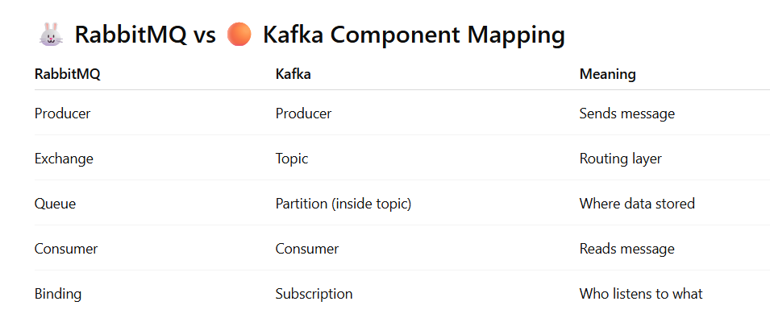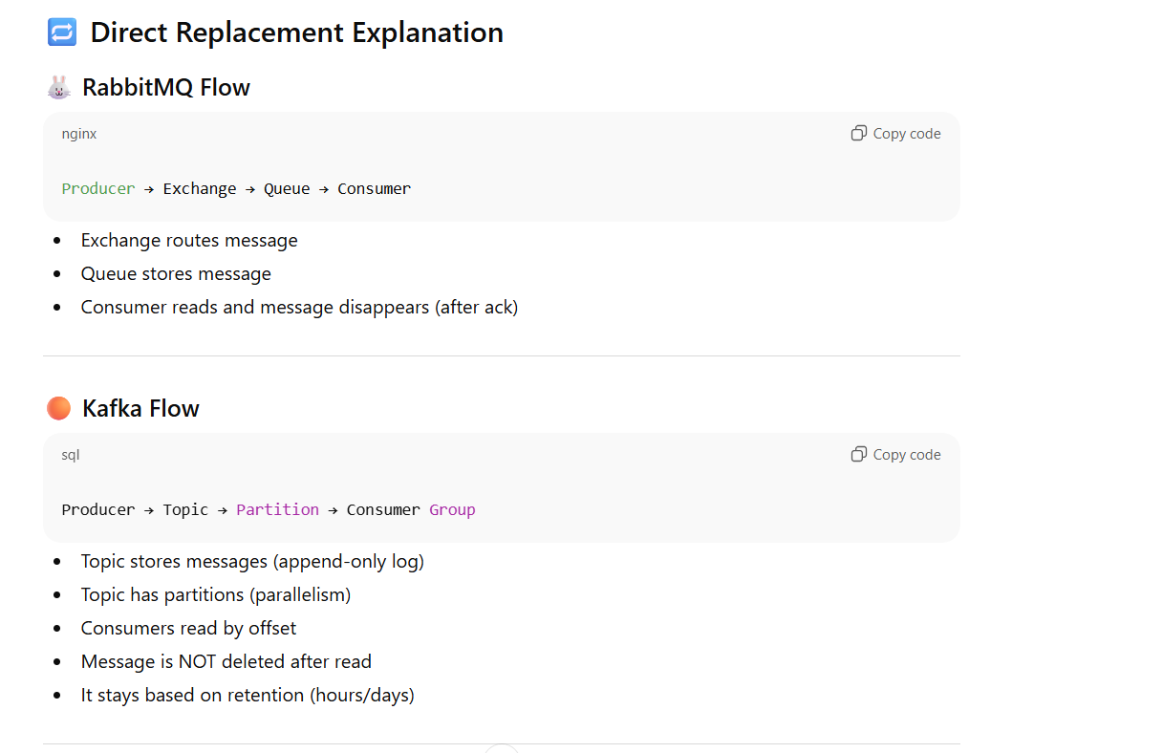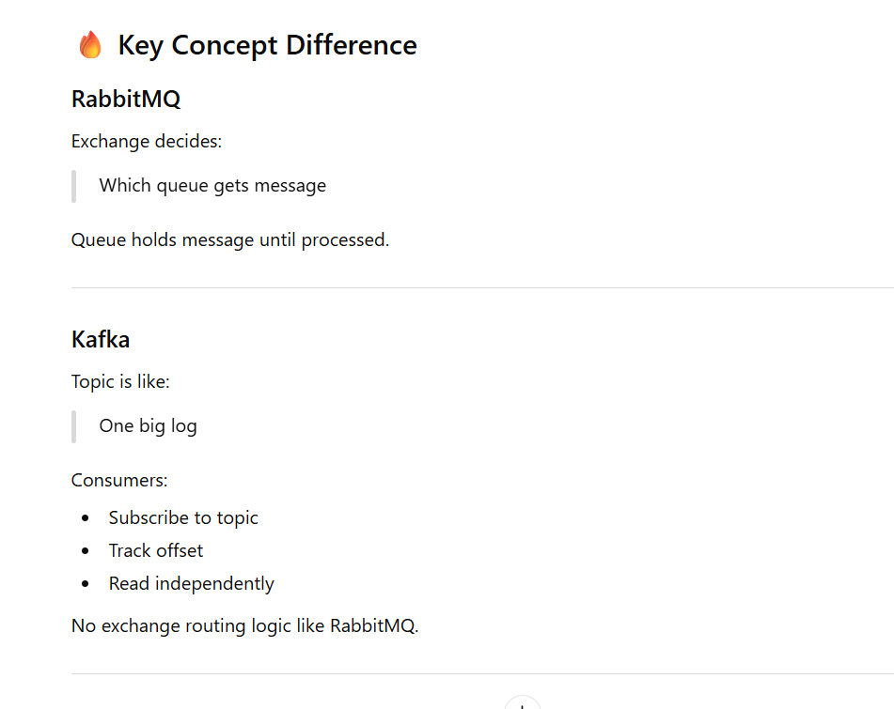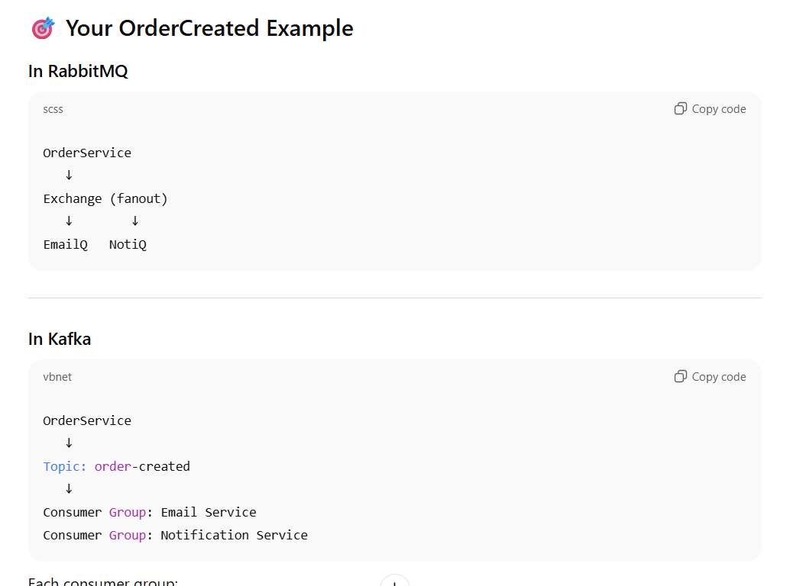
RabbitMQ = "Deliver this task"
Kafka = "Store this event forever and let systems read it"

Alibaba support
libaba Cloud RabbitMQ
Alibaba provides:
ApsaraMQ for RabbitMQ
Features:
- Fully managed RabbitMQ
- HA support
- Auto scaling (limited compared to Kafka)
- DLQ, retry support
- Compatible with standard AMQP
Good for:
- Traditional backend integration
- Work queue pattern
- Order processing
- Retry + delay use case
Not ideal for:
- Very high sustained throughput (10k–100k+/sec)
- Long-term event retention
- Large event streaming systems

🔴 Alibaba Cloud Kafka
Alibaba provides:
ApsaraMQ for Kafka
Features:
- Fully managed Kafka
- Partition-based scaling
- High throughput (very high)
- Built-in long retention
- Strong monitoring
- Works well with big data ecosystem
Very strong for:
- 10k+ TPS sustained
- Event replay
- Multi-consumer systems
- Analytics pipeline
- Future data platform expansion

🔥 Architect Comparison on Alibaba
Area | Alibaba RabbitMQ | Alibaba Kafka
Ease of setup | Easier | Slightly more complex
Throughput | Good | Very high
Retention | Short-term | Long-term configurable
Replay | Manual | Built-in
Future scalability | Medium | Very strong
Best for | Task queue | Event streaming

Architecture
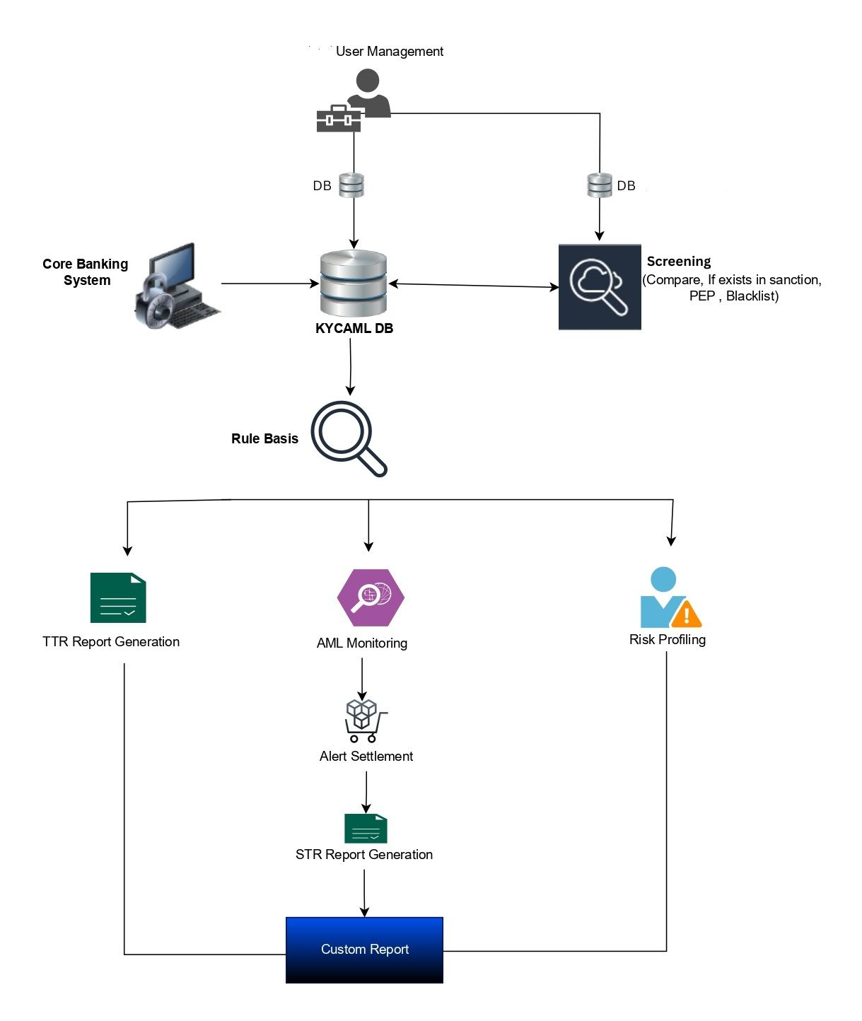

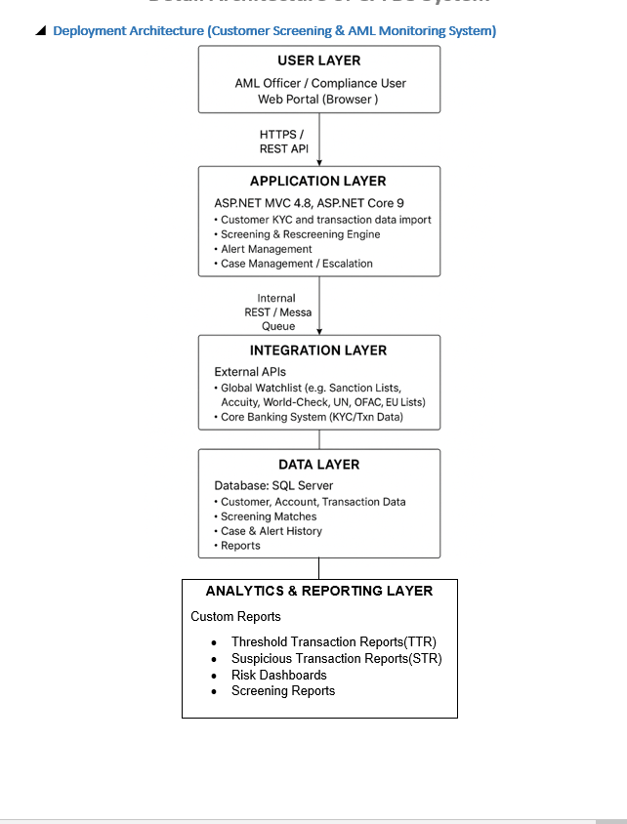

Question to be ask?
- Application layer means(frontend + backend ) monolithin app(whole app) so application layer need to link to db rather than link from integration layer

- Integration layers means separate backend app for linking to global and AML sys

- How caching use internal or external ?

- Is there any cron job and how many job construct and how it work?

- How queue work ?internal means collection or external

- If queue ,cache or cron is internal how it will fit to horizontal scaling>>

- How your audit trial work( data level or only user level) ?can we view auit trial from system ui or any other file.

I would like to take leave half-day leave for today( 24 Feb 2026) and tomorrow morning leave due to personnel matter related with army service form.

