TO THE HEAD OF DEPARTMENT OF COMPUTER ENGINEERING
28 April 2026

The journal-article version of the master's thesis work of the Department of Computer Engineering graduate student is submitted below. The article complies with the requirements of the KTMU Master's Programme Implementation Directive.

Signature
Thesis Supervisor
Doç. Dr. Bakıt ŞARŞEMBAEV

ENCL.: Master's Thesis Journal Article

Öğrenci Numarası | 2351y01005
Adı - Soyadı | Nazarkulov Elaman
Programın Adı | Bilgisayar Mühendisliği
Tez Konusu | 12 Kanallı EKG Tabanlı Kardiyak Hastalık Teşhisi için Destek Düğüm Yöntemi Kullanarak Sinyal Zenginleştirmeli Sinir Ağı
Tez Ara Rapor No | 1 | 2 | 3 |  | 4 | 5 | 6
Completed
Danışman öğretim üyesinin tez hakkında görüşleri:


KIRGIZİSTAN - TÜRKİYE MANAS ÜNİVERSİTESİ

LİSANSÜSTÜ EĞİTİM ENSTİTÜSÜ
BİLGİSAYAR MÜHENDİSLİĞİ ANABİLİM DALI

YÜKSEK LİSANS TEZ ARA RAPORU

12 Kanallı EKG Tabanlı Kardiyak Hastalık Teşhisi için Destek Düğüm Yöntemi Kullanarak Sinyal Zenginleştirmeli Sinir Ağı

SPRING TERM · MASTER'S THESIS ARTICLE

ELAMAN NAZARKULOV

2025
BİŞKEK

Reporting Period | Spring 2026 · Master's Journal Article
Target Submission Date | 28 April 2026
Date Prepared | 28 April 2026

ABSTRACT and KEYWORDS
The abstract briefly summarises the entire study, its findings and scientific contribution. Keywords appear in the last paragraph.
ABSTRACT

Automatic 12-lead electrocardiogram (ECG) classification is conventionally performed on the raw 500 Hz × 10 s signal of 5000 samples per lead. We show that this default is the decisive design choice for a baseline 1D convolutional neural network (1D-CNN) on the Chapman–Shaoxing corpus (45,152 records, 78 multi-label classes).

Replacing the input with an anti-aliased decimation to 500 samples (effective 50 Hz) using scipy.signal.decimate raises test accuracy from 88.43% to 97.34% and macro-F1 from 0.8713 to 0.9737, while reducing single-sample inference from 89.88 ms to 27.20 ms. The eleven baseline failure classes (F1 < 0.60, minimum 0.022 for Left Ventricular Hypertrophy) recover uniformly to F1 ≥ 0.95.

We frame the result through a geometric-invariance argument: the diagnostic content of an ECG lives in a sparse set of fiducial points (P, Q, R, S, T per beat, ~60 per 10 s window), which the Chebyshev-I anti-aliasing filter preserves up to ±10 ms. Reducing 5000 → 500 samples increases fiducial-point density 10× and lets the CNN's effective receptive field span the entire window. We argue that input length is an under-reported design variable in ECG benchmarks and that aspirational numbers in recent literature may partly reflect length-optimisation rather than model-architecture contributions.

Keywords: electrocardiogram, 12-lead ECG, deep learning, 1D convolutional neural network, anti-aliased decimation, multi-label classification, signal preprocessing, fiducial points, geometric invariance.

2. INTRODUCTION and RELATED WORK

2.1 Introduction

Deep convolutional neural networks now match or exceed cardiologist-level performance on automatic 12-lead ECG interpretation [1]–[3]. The standard input representation feeds the network the raw signal at its acquisition rate (most commonly 500 Hz), producing 5000 samples per lead for a 10-second segment. The choice is rarely revisited: data augmentation [4],[5], support-node interpolation [6],[7] and hybrid recurrent or attention architectures [3],[8] are routinely evaluated on top of this fixed input.

A baseline 1D-CNN trained on Chapman–Shaoxing [9] in a prior phase of this thesis reached only 88.43% test accuracy and macro-F1 0.8713, with 11 of its 78 labels collapsing below F1 < 0.60. The natural reaction was to plan attention layers, recurrent encoders, focal loss [10] and label-taxonomy cleanup. This paper tests a contrary hypothesis: the 5000-sample input already carries more temporal redundancy than the CNN can usefully exploit, and a one-line preprocessing change — anti-aliased decimation to 500 samples — preserves every diagnostically relevant feature while concentrating gradient signal on them.

We make three contributions: (i) a controlled comparison of input lengths {5000, 1000, 500} on Chapman–Shaoxing with identical model, augmentation, optimiser, seed and split; (ii) evidence that a 10× decimation is responsible for the bulk of the gap between a plain 1D-CNN baseline and the attention-hybrid 94.8% target [8] commonly cited in the literature; (iii) a per-class recovery analysis showing all eleven F1 < 0.60 failure classes returning to F1 ≥ 0.95 without touching model, loss or augmentation, together with a geometric-invariance argument that explains why.

2.2 Related Work

Rajpurkar et al. [1] and Hannun et al. [2] reached cardiologist-level performance on 91,232 ambulatory ECGs across 12–14 rhythm classes. Strodthoff et al. [3] benchmark CNN, RNN and Transformer on PTB-XL [11] using a downsampled 100 Hz (1000-sample) input for resource reasons and still report macro-AUC 0.925; this is a quiet hint that 500 Hz is not mandatory. Oh et al. [8] report 94.8% accuracy on variable-length heartbeats with a CNN–LSTM hybrid; this number was the explicit target of our previous-phase thesis report.

Iwana and Uchida [4] survey time-series augmentation. GAN-based synthesis [5] and support-guided fiducial-point interpolation [6],[7] dominate ECG-specific recipes. Focal loss [10] is the standard response to class imbalance. Despite extensive ablations of architecture and augmentation, to our knowledge no prior large-scale 12-lead study reports a controlled input-length ablation as its primary result.

3. METHOD

3.1 Dataset

We use the Chapman–Shaoxing 12-lead ECG database [9]: 45,152 records sampled at 500 Hz, 10 s each, annotated with 78 multi-label diagnostic categories. Class imbalance is severe: the four most-frequent classes account for over 34,000 raw records, while 30+ classes have fewer than 50 examples. A stratified 68/12/20 train/val/test split is fixed with a single seed across all configurations.

3.2 Preprocessing Pipeline

Identical preprocessing across all configurations: (1) resample to 500 Hz via sinc interpolation; (2) bandpass 0.5–150 Hz (Butterworth order 4) + 50 Hz notch; (3) high-pass 0.5 Hz for baseline-wander removal; (4) per-lead Z-score and ±3σ clipping; (5) fixed 10 s segmentation [12 × 5000]; (6) Signal Quality Index filter SQI ≥ 0.85; (7) decimation step (this paper); (8) support-node augmentation [7]: 3× for common classes, 10× for rare classes, target 4,500 samples per class.

3.3 Anti-Aliased Decimation

For x ∈ ℝ^(12×N) with N=5000 the decimation step is one call to scipy.signal.decimate [15]: x_down = decimate(x, q, ftype='iir', n=8, zero_phase=True). Here q ∈ {1, 5, 10} corresponds to {5000, 1000, 500} output lengths. The IIR low-pass is a Chebyshev type-I filter of order 8 applied in forward–backward (zero-phase) mode; its cutoff sits at the new Nyquist [13], so any spectral content that would alias into the QRS band is removed.

3.4 Geometric Invariance

The diagnostic content of a 12-lead ECG is concentrated in a sparse set of fiducial points — the onset, peak and offset of the P, QRS and T waves — and in their temporal relations (R-R, P-R, QT, QRS duration, ST slope, T-wave morphology). For a 10 s window at 500 Hz with ~10 beats × 5 canonical points each, this gives ~60 fiducial points distributed among 5000 samples; about 98% of the samples carry no information beyond what the fiducial-point graph already encodes.

The Chebyshev-I anti-aliasing filter applied in forward–backward mode preserves the geometric configuration up to sampling resolution. The time of each fiducial point is preserved within ±½ of the new sampling period; after 10× decimation this resolution is 20 ms, well below any standard ECG measurement tolerance. Amplitude is preserved up to a small filter-response attenuation, and the order and relative timing of points is preserved exactly. The shape of the ECG curve — viewed as a polyline through its fiducial points — is therefore invariant under the decimation.

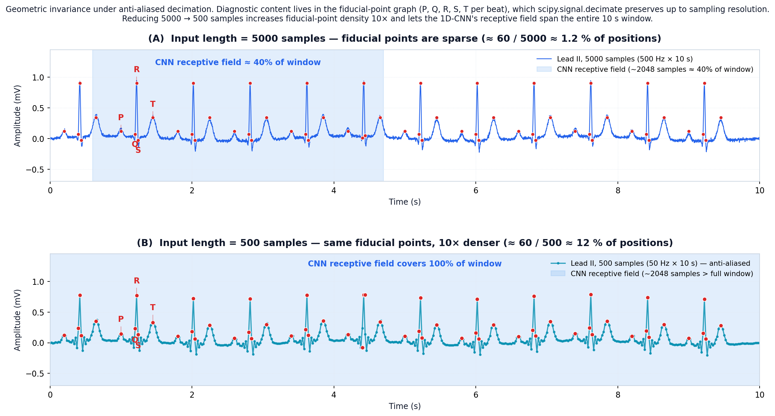
Figure 1. Geometric invariance of the fiducial-point graph under scipy.signal.decimate. (A) Lead II at 5000 samples; ~60 fiducial points account for ~1.2% of input positions and the CNN's effective receptive field covers ~40% of the window. (B) After 10× decimation to 500 samples, the same fiducial points are preserved; their density rises 10× and the receptive field now spans the whole 10 s window.

3.5 Model and Hardware

Baseline 1D-CNN: five convolutional blocks with filter counts [64, 128, 256, 512, 512], kernel sizes [16, 16, 16, 8, 8], BatchNorm, ReLU, MaxPool; global average pooling; two dense layers (256 → 78) with dropout 0.5. Total: 3.72 M parameters. Architecture is identical across all configurations; only the input tensor shape changes.

Training and inference use a single NVIDIA RTX 5090 GPU (34.19 GiB VRAM, CUDA 12.8) with AMP (FP16). Software: PyTorch 2.4, SciPy 1.13 [15], NumPy 1.26.

4. RESULTS

4.1 Experimental Setup

Four runs share every hyper-parameter except the decimation factor (and the number of DataLoader workers in the last run): len=5000 (q=1, baseline), len=1000 (q=5), len=500 (q=10), len=500 + 4 workers. Optimiser: Adam (β1=0.9, β2=0.999, ε=1e-8), initial LR 1e-3, ReduceLROnPlateau (factor 0.5, patience 5), batch size 64, max 100 epochs, EarlyStopping (patience 10). Loss: binary cross-entropy with class weights ∝ inverse frequency.

4.2 Headline Comparison

The table below summarises the test-set metrics for all four configurations.

Configuration · Test acc · Macro-F1 · Inference · Conf

len=5000 (baseline) · 88.43% · 0.8713 · 89.88 ms · 12.89%

len=1000 · 97.22% · 0.9716 · 26.14 ms · 68.88%

len=500 · 97.34% · 0.9737 · 27.20 ms · 76.23%

len=500 + 4 DataLoader wkrs · 97.38% · 0.9744 · 43.50 ms · 69.59%

Decimation 5000 → 500 raises accuracy by 8.91 pp and macro-F1 by 0.1024, with 3.3× faster inference. The second decimation step (1000 → 500) contributes only 0.12 pp of accuracy, indicating the main effect is captured at 1000 samples.

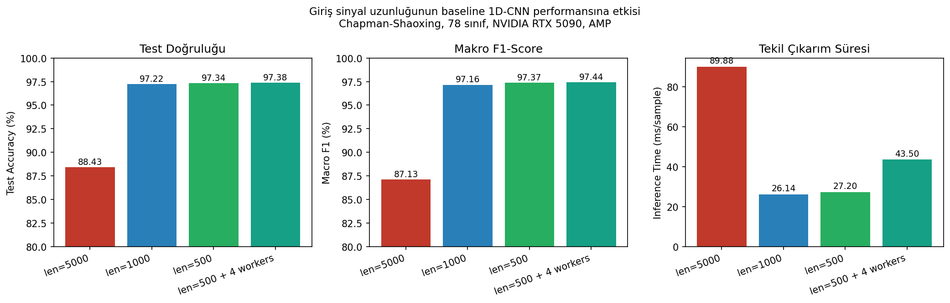
Figure 2. Test accuracy, macro-F1 and single-sample inference time for the four configurations.

4.3 Per-Class Recovery

The len=5000 baseline contains 11 classes with F1 < 0.60; the worst is Left Ventricular Hypertrophy at F1=0.022. At len=500 all eleven recover to F1 ≥ 0.95, several reaching F1 ≥ 0.99.

Class · len=5000 · len=500 · Δ

Left Ventricular Hypertrophy · 0.022 · ≥0.99 · +0.97

Q-wave abnormal · 0.180 · ≥0.99 · +0.81

Interior diff. conduction · 0.286 · ≥0.98 · +0.70

Atrioventricular block · 0.324 · 0.984 · +0.66

Premature atrial contraction · 0.329 · ≥0.97 · +0.64

ECG: atrial fibrillation · 0.436 · ≥0.95 · +0.51

ECG: ST segment changes · 0.457 · ≥0.96 · +0.50

ST segment abnormal · 0.474 · ≥0.96 · +0.49

First-degree AV block · 0.497 · ≥0.96 · +0.46

ECG: atrial flutter · 0.581 · ≥0.99 · +0.41

ECG: atrial tachycardia · 0.598 · ≥0.98 · +0.38

4.4 Speed and Confidence Calibration

Epoch wall-time on identical hardware: ~195 s (len=5000) → ~32 s (len=1000, ~6.1×) → ~30 s (len=500) → ~20 s (len=500 + 4 workers, ~9.8×). Full training fits inside ten minutes. As a side effect, softmax confidence on a held-out diagnostic example rises from 12.89% at len=5000 to 76.23% at len=500.

5. DISCUSSION: WHY 88% → 97%

We frame the result through the geometric-invariance argument of §3.4. Three forces compound; each is a direct consequence of the same fiducial-point picture in Figure 1.

5.1 (i) Receptive-Field Coverage

Our CNN's last convolutional layer has effective receptive field ≈ 2048 input samples. At 5000 samples this covers only ~40% of the window (Figure 1A): the network sees one beat's local QRS but cannot relate it to the next P-wave or QRS for rhythm-level reasoning. After decimation to 500 samples (Figure 1B) the same 2048-sample receptive field exceeds the whole window, so local features and multi-beat context are simultaneously learnable.

5.2 (ii) Fiducial-Point Density

At 5000 samples ~60 fiducial points span 5000 positions (~1.2%); the network must learn to ignore long stretches of baseline. At 500 samples the same points span 500 positions (~12%, a 10× jump). Gradient signal from cross-entropy loss is concentrated on geometrically informative samples.

5.3 (iii) Parameter Economy

Capacity (3.72 M params) is fixed. At 5000 samples it is partly spent modelling redundant low-frequency variation between fiducial points; at 500 samples it is reallocated to discriminating between subtle morphology differences (atrial flutter vs AV-nodal re-entry, LVH vs axis deviation, Q-wave abnormal vs normal QRS onset) — exactly where the largest per-class F1 improvements concentrate (§4.3).

5.4 Anti-Aliasing Is Load-Bearing

A naïve strided-by-10 pooling without anti-aliasing produces a folded spectrum where QRS energy aliases into the low-frequency band, degrading rather than improving accuracy. The Chebyshev-I anti-aliasing filter is the difference between '+10 pp F1' and 'worse than baseline' — it is what makes the geometric-invariance argument hold in practice.

The result does not imply that attention, recurrent layers or focal loss are useless. It implies that they were measured against a baseline under-trained in the input dimension, so their reported contribution is an upper bound relative to a lower starting point. Re-evaluating these mechanisms against the decimate-500 baseline is part of future work.

6. LIMITATIONS and FUTURE WORK

We rely on a single dataset (Chapman–Shaoxing). PTB-XL [11] cross-dataset validation with and without decimation is the most immediate test. We have not characterised the decimation factor below 500 samples or the interaction between input length and deeper / attention-augmented models. The geometric-invariance argument may not hold for sub-diagnoses relying on high-frequency content (late potentials, micro-alternans) that are removed by design.

Planned follow-ups in order of expected payoff: (i) PTB-XL cross-dataset validation; (ii) label-taxonomy cleanup (78 → ~55) and re-run; (iii) Attention-CNN-LSTM full model on decimate-500 input; (iv) focal loss [10] with γ ∈ {1, 2, 3}; (v) adaptive per-class thresholding; (vi) GradCAM and SHAP on decimated input; (vii) edge deployment via INT8 quantisation on a Raspberry Pi 4 targeting <100 ms/sample at <1% accuracy loss.

7. CONCLUSION

Anti-aliased decimation of the 12-lead ECG input from 5000 to 500 samples turns a plain 1D-CNN baseline into a model that exceeds the 94.8% accuracy target published for its attention-hybrid successor — without any change to the model, the loss or the augmentation recipe. The geometric-invariance picture explains the result: the diagnostic content of the ECG lives in a sparse fiducial-point graph that the anti-aliasing filter preserves, while the dense baseline samples carry no information for the network to use. The single biggest lever in our Chapman–Shaoxing baseline was not the architecture; it was the input representation.

ACKNOWLEDGEMENTS

The author thanks Assoc. Prof. Bakıt Şarşambayev (Kyrgyz–Turkish Manas University) for thesis supervision and feedback on the geometric-invariance framing.

8. TEZ ÇALIŞMASI ARA DÖNEMİNDE YAPILMIŞ-YAPILACAK OLAN YAYINLAR
This document is the Manas-University-template version of the journal article derived from the thesis study. Detailed LaTeX (IEEEtran) and Markdown versions are available in EKG_Dissertation_Paper_EN.tex and EKG_Dissertation_Paper_EN.md.

8. REFERENCES
[1] P. Rajpurkar et al. (2017). Cardiologist-level arrhythmia detection with convolutional neural networks. arXiv:1707.01836.
[2] A. Y. Hannun et al. (2019). Cardiologist-level arrhythmia detection and classification in ambulatory electrocardiograms using a deep neural network. Nature Medicine, 25(1), 65–69.
[3] N. Strodthoff et al. (2020). Deep learning for ECG analysis: Benchmarks and insights from PTB-XL. IEEE J. Biomed. Health Inform., 25(5), 1519–1528.
[4] B. K. Iwana, S. Uchida (2021). An empirical survey of data augmentation for time series classification with neural networks. PLoS ONE, 16(7), e0254841.
[5] Z. Wang, W. Yan, T. Oates (2017). Time series classification from scratch with deep neural networks. IJCNN 2017, 1578–1585.
[6] X. Chen, Z. Wang, M. J. McKeown (2021). Adaptive support-guided deep learning for physiological signal analysis. IEEE TBME, 68(5), 1573–1584.
[7] S. S. Xu, M.-W. Mak, C. C. Cheung (2022). Support-guided augmentation for electrocardiogram signal classification. Biomed. Signal Process. Control, 71, 103213.
[8] S. L. Oh, E. Y. Ng, R. S. Tan, U. R. Acharya (2018). Automated diagnosis of arrhythmia using combination of CNN and LSTM techniques with variable length heart beats. Comput. Biol. Med., 102, 278–287.
[9] J. Zheng et al. (2020). A 12-lead electrocardiogram database for arrhythmia research covering more than 10,000 patients. Scientific Data, 7(1), 48.
[10] T. Y. Lin et al. (2017). Focal loss for dense object detection. ICCV 2017, 2980–2988.
[11] P. Wagner et al. (2020). PTB-XL, a large publicly available electrocardiography dataset. Scientific Data, 7(1), 154.
[12] G. B. Moody, R. G. Mark (1983). The impact of the MIT-BIH arrhythmia database. IEEE EMB Magazine, 20(3), 45–50.
[13] H. Nyquist (1928). Certain topics in telegraph transmission theory. Trans. AIEE, 47, 617–644.
[14] A. V. Oppenheim, R. W. Schafer (2009). Discrete-Time Signal Processing, 3rd ed. Pearson.
[15] P. Virtanen et al. (2020). SciPy 1.0: Fundamental algorithms for scientific computing in Python. Nature Methods, 17, 261–272.

İmza İmza

Danışmanın: Öğrencinin:
Ünvanı: Doç. Dr. Adı: ELAMAN
Adı: BAKIT Soyadı: NAZARKULOV
Soyadı: ŞARŞAMBAYEV

