Download today’s handout here!

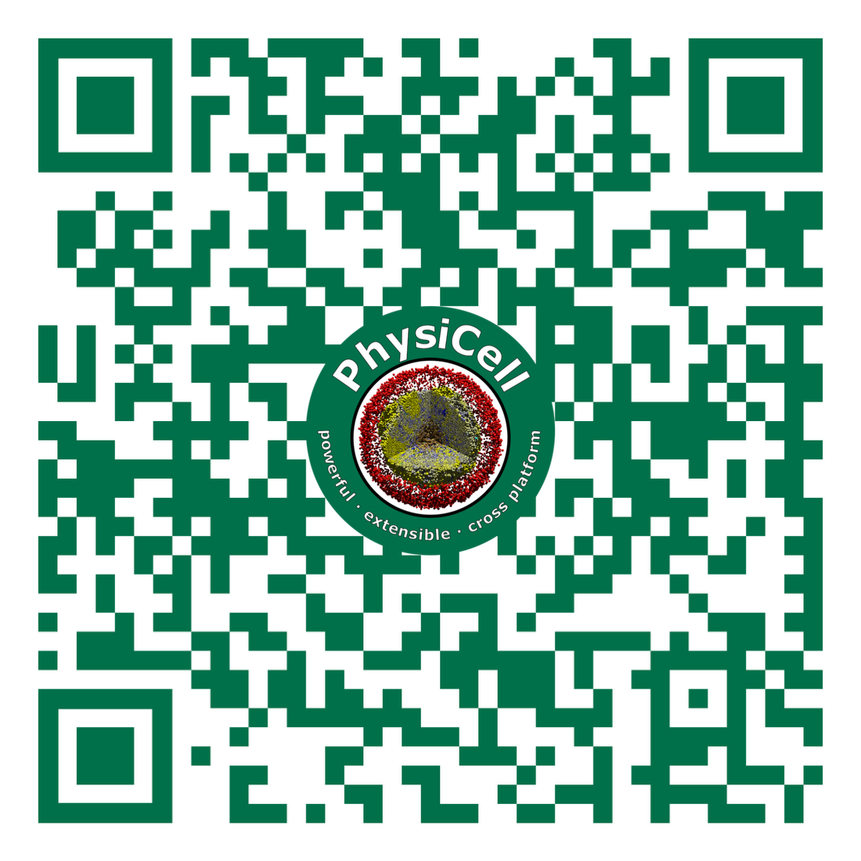

https://github.com/physicell-training/Luddy_TechFest

