Dr. Colleen Browne

NPI:178077482

DEA:BL5818969

9343 Butler Road, Portland, MI, 48875

Phone:5179743560

Fax:-NA-

Patient Information Medicare Insurance Information

Patient:1 Patient Group:-NA-

Address: 2 PCN:-NA-

Phone: 3 Member ID:10

Height: 4 Medicare Subscriber #:-NA-

Weight: 5 Secondary/Supplement Insurance Carrier:-NA-

Age: 6 Subscriber #:-NA-

Date of Birth: 7

Gender: 8

Patient Allergies

Allergies: 9

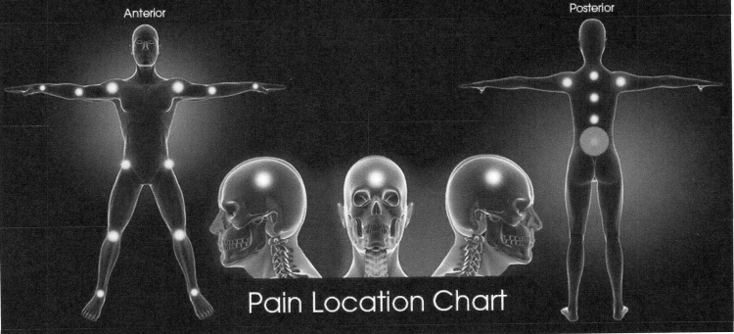

* Lower Back

General Intake Notes