# Getting a *very* rough estimate for thermal conductivity parameters – FEM model

*The log for these optimizations can be found in my optimization log for October 13, 2021. These optimizations are run 5(s88773), run 6 (s88776), run 7 (s88780) & run 8 (s86483). The log can be found here: <https://github.com/physicslifter/Thermal_Laser_Compression_Model/blob/main/python_wrapper/optimization_runs/Oct13_2021/ReadMe.md>

## Approach

Optimizing each shot using Nelder-Mead in python, independently. Shots and faces being fit are listed below:

S88773

Face 1 & Face 2

S88776

Face 1

S88780

Face 1 & Face 2

S86843

Face 1 & face 2

All optimizations start with “good” initial parameters:

Peak_temp=36000K

K=0.017*T+30

Start_time=20ns

## Estimation of Thermal Conductivity w/ error

Assume outer core conditions (T=4kK), assumption from Tyler

Error calculated using standard error of the average

Drawback of this method is error does not account for error due to systematic problems with our approach (ie if we’re chopping off too much data, standard error from the average will not contain any of this information).

Standard error of the mean given as:

$SE=\frac{s}{\sqrt{n}}$, where s, the standard deviation, is given as: $s=\sqrt{\frac{\sum_{i=1}^{n}{{\left(x_{i}-x_{avg}\right)}^{2}}}{n-1}}$

## Results

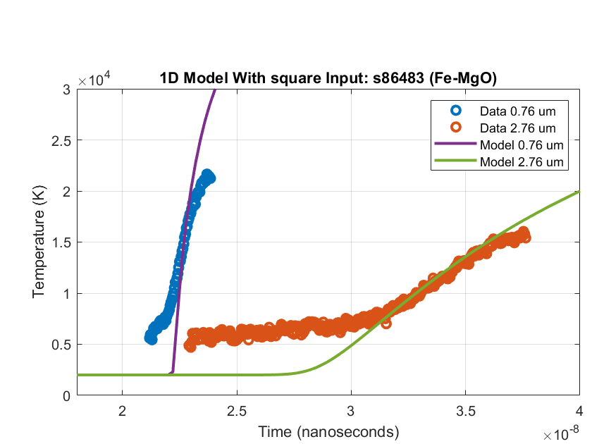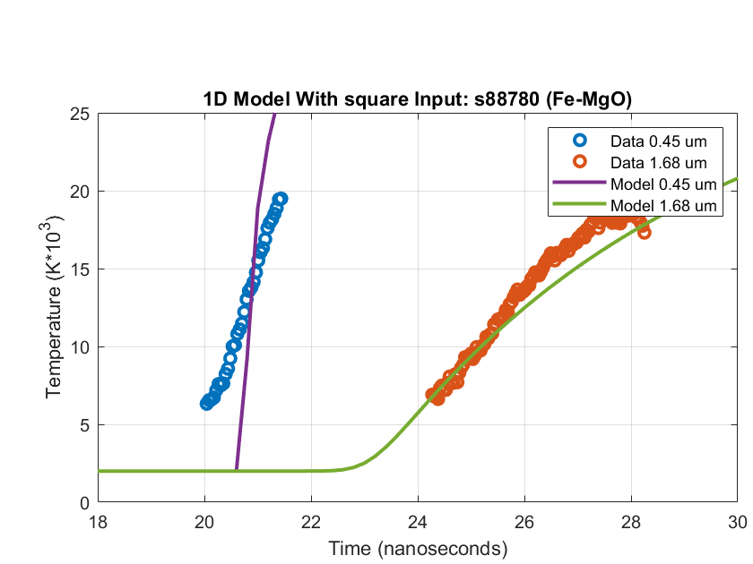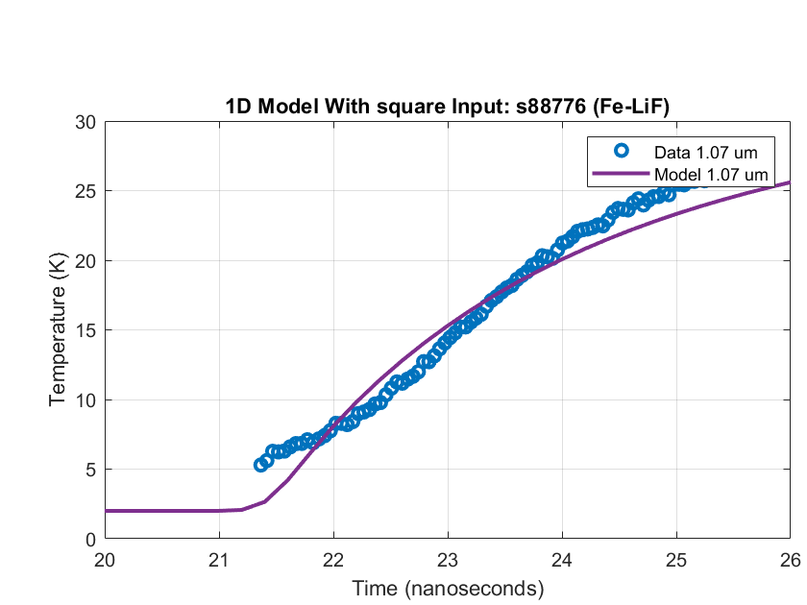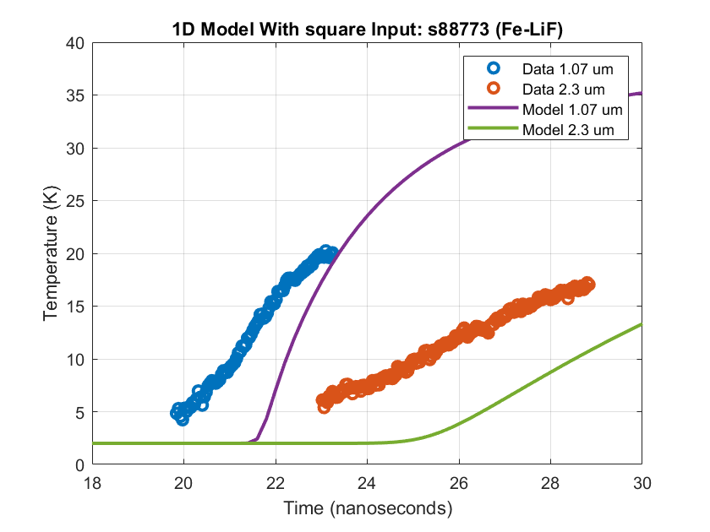

K=0.01948*T+27.1268

K=0.017128*T+29.2

K=0.017164*T+30.59

K=0.0169*T+21.4

This yields us with an average + standard error value for k of:

97.8 ± 3.3