1.1 Problem Summary

Efficient energy storage technology is the core technology to solve the volatility and intermittency of renewable energy and waste heat resources. Phase change heat storage is widely used because of its high energy storage density and heat storage and release at a nearly constant temperature. Now, a company needs to design the structure of heat transfer fins in the tank of the phase change heat storage system to further improve the heat transfer performance of heat storage products.

So, We use mathematical analysis to build a model that can improve the heat transfer performance of heat storage products. Then, we optimize the model according to the specific requirement and analyse the heat transfer performance between different models. Finally, we give the final result that we designed.

1.2 Data Sourse

1.3 Existing model

现有的模型是基于问题中给出的矩形和三角形散热片模型，但对于矩形散热片的具体分布、三角散热片的分布及大小参数并未有具体的规划，我们基于热力学热传导原理、散热片的拓扑结构定量计算了不同散热片的导热性能，进而进行优化提出自己的模型。

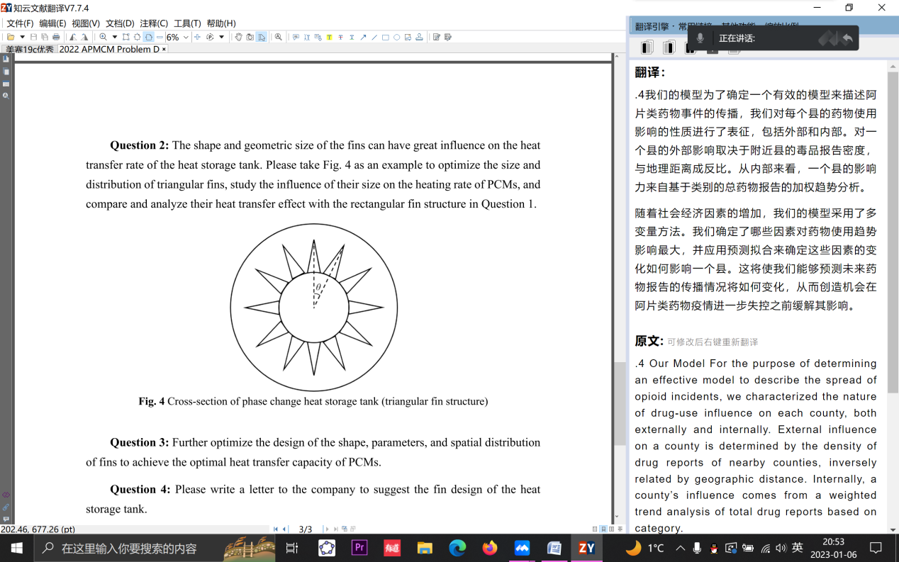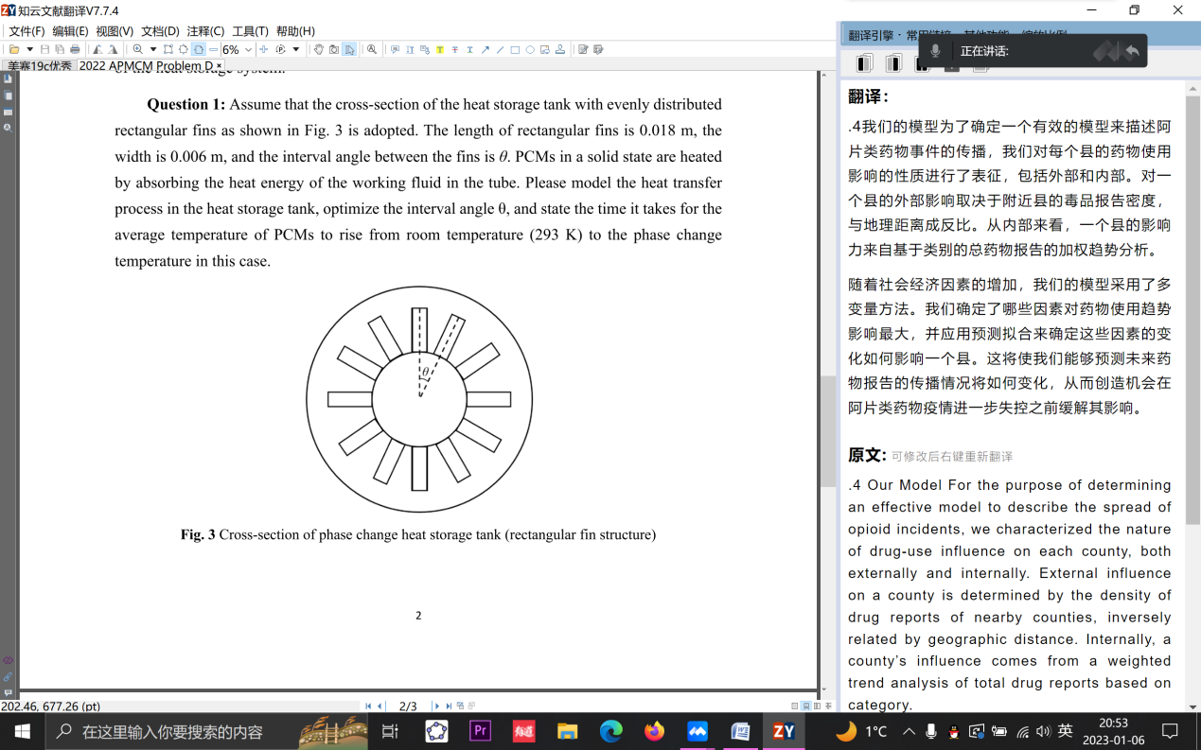

1.4 Our Model

为了使矩形散热片结构有更好的导热性，我们利用有限元网格，计算了每个PCM材质中网格点到散热片及内管的最短实际距离d，并以平均实际距离作为评价依据以此来消除由于不同模型散热片数量不同对于网格点个数的影响。之后考虑到散热片数量增多会导致热流体对流变差，影响热传导，我们引入热传导系数Ch ，热传导系Ch与实际距离d的乘积视为热传导距离dh。最终我们以平均热传导距离作为导热能力的评判依据。基于此优化得出矩形散热片的最优分布。

对于三角形散热片，为了消除热流体流量不同的影响，我们控制变量，使所有散热片总面积及每个散热片底边长与矩形模型相同。基于此再次计算不同散热片结构以及分布带来的导热性差异。

最后，我们调整散热片的形状，在保证热流体能够良好对流时，追求在同等面积下更大周长的散热片，因此我们设计了特殊的树状散热片，并给出了相关的导热性能分析。