A Test for ODT generation in LaTeXML
Michael Kohlhase
Jacobs University
m.kohlhase@jacobs-university.de
April 26, 2013
- Purpose (Heading 1)
The following sections illustrate various possibilities in ODF Text.
  - A simple series of paragraphs (Heading 2)
This section contains a series of paragraphs.
This is a second paragraph.
And a third paragraph.
  - A section with lists (Heading 2)
Elements to illustrate:
- hyperlinks
- italics and bold text
- lists (ordered and unordered)
How to figure out ODF
- work out the content.xml tags
- work styles into the mix
- figure out how to apply what we learned to spreadsheets and presentations
The URL for Flickr is http://www.flickr.com. The API page is http://www.flickr.com/services/api/
- A Table (Heading 1)
Website | Description | URL
Flickr | A social photo sharing site | http://www.flickr.com
Google Maps | An online map | http://maps.google.com
- Footnotes (Heading 1)
This sentence has an accompanying footnote. And another one .
- An Image
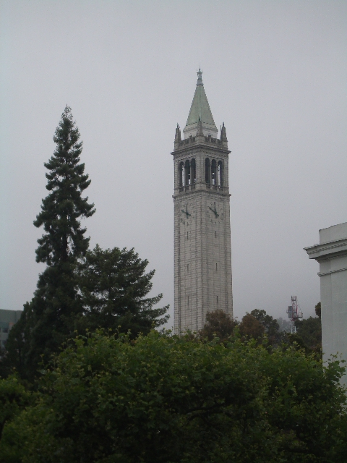
- A Figure
Figure 1: Testing a Figure
- Citations
a first citation [1] and a second one [2]
- Some Math
some inline math: and displayed math
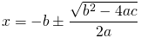
and an equation

References
- AAA (1011) The aaaa, the journal, pp. 222–333.
- BBB (2022) The book of bbbb, publisher.

You are reading a footnote.
another footnote

