A Test for ODT generation in LaTeXML

Michael Kohlhase  
Jacobs University  
m.kohlhase@jacobs-university.de

March 26, 2013

1. Purpose (Heading 1)

The following sections illustrate various possibilities in ODF Text.

* 1. A simple series of paragraphs (Heading 2)

This section contains a series of paragraphs.

This is a second paragraph.

And a third paragraph.

* 1. A section with lists (Heading 2)

Elements to illustrate:

* hyperlinks
* italics and bold text
* lists (ordered and unordered)

How to figure out ODF

1. work out the content.xml tags
2. work styles into the mix
3. figure out how to apply what we learned to spreadsheets and presentations

The URL for Flickr is [http://www.flickr.com](http://www.flickr.com/). The API page is <http://www.flickr.com/services/api/>

1. A Table (Heading 1)

|  |  |  |
| --- | --- | --- |
| Website | Description | URL |
| Flickr | A social photo sharing site | [http://www.flickr.com](http://www.flickr.com/) |
| Google Maps | An online map | [http://maps.google.com](http://maps.google.com/) |

1. Footnotes (Heading 1)

This sentence has an accompanying footnote.[1] And another one [2].

1. An Image

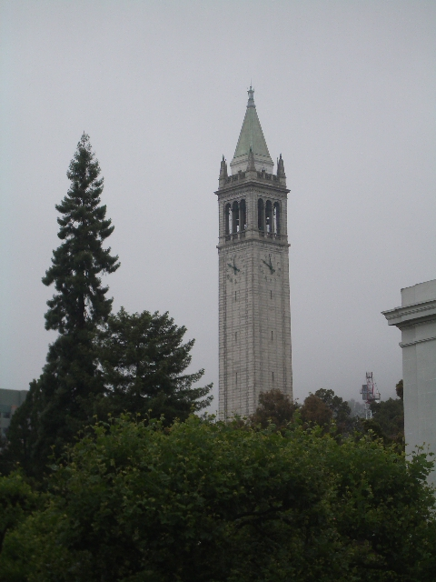

1. A Figure



Figure 1Testing a Figure

1. Citations

a first citation Bibliography entry and a second one Bibliography entry

References

1. You are reading a footnote.
2. another footnote