Illustration 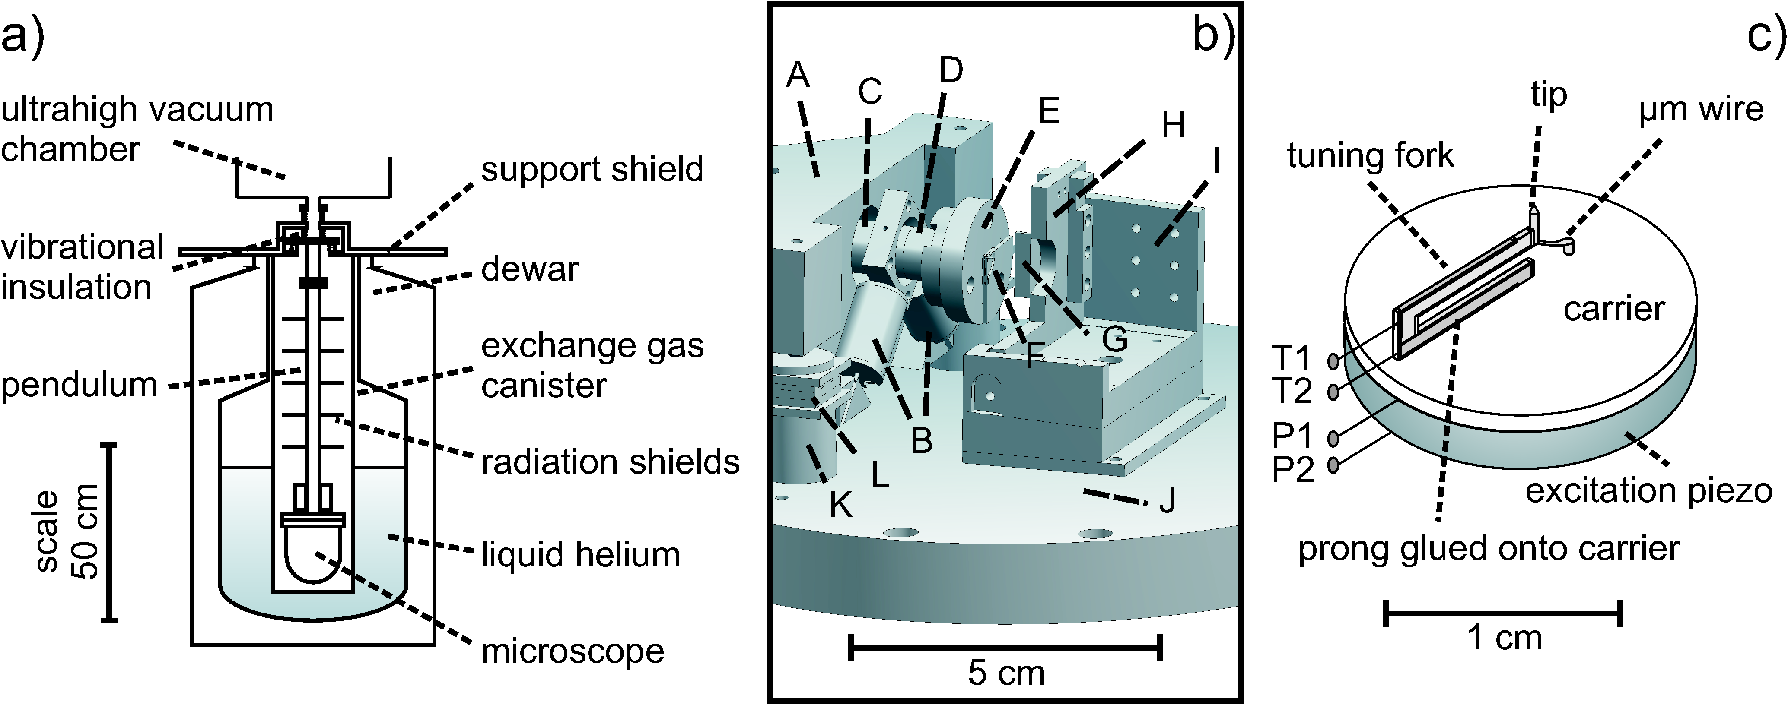1: I am a test picture, disregard me