eSPI PRU Firmware

Applies to Product Release: 01.00.00.00
Publication Date: December 4, 2018

Document License

This work is licensed under the Creative Commons Attribution-NoDerivs 3.0 Unported License. To view a copy of this license, visit http://creativecommons.org/licenses/by-nd/3.0/ or send a letter to Creative Commons, 171 Second Street, Suite 300, San Francisco, California, 94105, USA.

Contributors to this document

Copyright (C) 2018 Texas Instruments Incorporated - http://www.ti.com/

Texas Instruments, Incorporated
20450 Century Boulevard
Germantown, MD 20874 USA

Texas Instruments, Incorporated
20450 Century Boulevard
Germantown, MD 20874 USA

This document is intended for users who are interested in getting more detailed understanding of the firmware design and the interfacing driver design. It mentions the memory maps, structures and design flow of the firmware, as well as the design flow of the host driver.

Note: Those who just want to use ICSS eSPI firmware may not need to go through this document.

TABLE OF CONTENTS

LIST OF FIGURES 6
LIST OF TABLES 7
1 Introduction 8
1. Architecture Design Overview 9
1.1. Design Layers 9
1.2. PRU-BB 9
1.2.1. PRU-BB Memory 9
1.2.2. GPI/GPO 9
1.3. PRU-CC 9
1.3.1. PRU-CC Memory 10
1.4. Scratchpad (SPD) Registers 10
1.5. PRU-ICSS Shared Memory 10
1.5.1. ESPI Slave Registers 10
1.5.2. RX Buffers 10
1.5.3. TX Buffers 10
1.6. Host Core 10
1.6.1. Application 10
1.6.2. Driver 10
1.6.3. GPIO 11
1.7. HW Interface 11
2. Design Theory 11
2.1. ESPI Bit-Banging 11
2.1.1. Reset 11
2.1.2. Ready 11
2.1.3. Alert 11
2.1.4. Read Byte 12
2.1.5. Write Byte 12
2.2. ESPI Control 12
2.2.1. Reset 12
2.2.2. Ready 12
2.2.3. Read CMD 12
2.2.4. Handle CMD 12
2.3. Reset 13
2.4. Shared Registers 13
2.4.1. Data 13
2.4.2. Count 13
2.4.3. State 13
2.4.4. Error 13
2.5. Errors 13
2.5.1. NO_RESPONSE 14
2.5.2. Invalid CS# Deassert 14
2.5.3. FATAL_ERROR 14
2.5.4. NON_FATAL_ERROR 14
3. ESPI Protocol 14
3.1. Overview 14
3.2. Command Phase 14
3.3. TAR Phase 15
3.4. Response Phase 15
3.5. Alert Phase 16
3.6. Wait State 16
4. CRC Calculation 16
5. Slave Registers 16
5.1. Device Identification 16
5.2. General Capabilities and Configurations 16
5.3. Channel 0 Capabilities and Configurations 17
5.4. Channel 1 Capabilities and Configurations 18
5.5. Channel 2 Capabilities and Configurations 18
5.6. Channel 3 Capabilities and Configurations 19
6. Commands 19
6.1. Supported Commands 19
6.2. GET_STATUS 19
6.3. GET_CONFIGURATION 19
6.4. SET_CONFIGURATION 19
6.5. RESET 19
6.6. Posted Transaction 19
6.7. Non-Posted Transaction 20
6.8. Transaction Ordering 20
6.8.1. RX/TX In-Out Dependency 20
7. PRU/Host Communication 20
7.1. Memory Map 20
7.2. Save Status Register 20
7.3. Internal Status Register 20
7.4. IPC PRU to Host 21
7.4.1. RX Data Available 21
7.4.2. IPC Commands 21
7.5. RESERVED 22
7.6. IPC Host to PRU 22
7.7. RX/TX Buffers 22
7.7.1. Peripheral Channel 22
7.7.2. Virtual Wires Channel 22
7.7.3. OOB Message Channel 22
7.7.4. Flash Access Channel 22
8. RTOS Driver 22
8.1. ESPI_init 22
8.2. ESPI_open 22
8.2.1. IRQ Handler 22
8.3. ESPI_transfer 23
8.3.1. SPI_Transfer(read) 24
8.3.2. SPI_Transfer(write) 25
8.4. ESPI_control 25
8.5. ESPI_close 25
8.6. Reset 25
8.7. Application Layer 25
9. EVM Support 26
9.1. bbbAM335x 26
9.2. idkAM437x 26
10. External Board 27
10.1. General Design 27
10.2. bbbAM335x 28
10.3. idkAM437x 28
11. Testing 29
11.1. Total Phase Promira Serial Platform 29
12. Limitations 29
12.1. Limited Frequency Support 29
12.2. Limited Channel Support 29
12.3. Slow Clock Not Supported 29
12.4. Slave-Initiated Transactions 29
12.5. Response Modifiers 29
12.6. No Shared Alert# Pin 29
12.7. Queue Depth 29
13. References 29

LIST OF FIGURES
Figure 1: Architecture Overview 9
Figure 2. Bit-bang State Diagram 11
Figure 3. Control State Diagram 12
Figure 4. Command Phase Timing 14
Figure 5. TAR Phase Timing 15
Figure 6. Response Phase Timing 16
Figure 7. Driver IRQ Handler Flow 23
Figure 8. SPI_Transfer RX Flow 24
Figure 9. SPI_Transfer TX Flow 25
Figure 10. Basic Application Flow 26
Figure 11. External Hardware Design 27
Figure 12. bbbAM335x Test Hardware 28
Figure 13. idkAM437X Test Hardware 28

LIST OF TABLES
Table 1. ICSS Shared Memory Allocation 10
Table 2. RX Buffer Allocation 10
Table 3. TX Buffer Allocation 10
Table 4. Shared Register Allocation 13
Table 5. PRU-BB Error Codes 13
Table 6. General Capabilities and Configurations Slave Register 17
Table 7. Channel 0 Capabilities and Configurations 18
Table 8. Memory Map 20
Table 9. Internal Status Register 21
Table 10. IPC Commands 22
Table 11. bbbAM335x Pin Use 26
Table 12. idkAM437x Pin Use 27

Introduction
eSPI is a bi-directional serial protocol that provides a communication link between integrated circuits (ICs), effectively an optimized version of LPC. TI does not currently have hardware IP support for eSPI, and will be utilizing the ICSS to implement support in firmware.

Firmware is designed to run on PRU cores. Each ICSS has 2 PRUs, and the protocol operation will be split between each PRU. One PRU core will use its GPI/GPO pins to send and receive eSPI bytes on the wire. The other PRU core will control the protocol and is in charge of processing any bytes read by the first PRU and passing on any bytes which need to be written out on the wire to the first PRU. PRU programming is done using assembly instructions. Host cores in SOC will configure PRUs for receiving and sending data on the eSPI bus.

This Firmware design is not compatible with any of Ethernet based ICSS firmware design. It means one cannot load I2C firmware in one PRU for example PRU0 and Dual_emac Firmware in other PRU for example PRU1.

For full documentation of the eSPI protocol, refer to [1]

Architecture Design Overview

Design Layers
Application
Driver
PRU-X
(ESPI Bitbang)
GPI/GPO
PRU-Y
(ESPI Control)
Host Core
PRU-ICSS
GPIO
PRU-ICSS Shared Memory
ESPI Slave
ESPI Master
RESET
SCL
I/O[0:N]
Alert#
CS#
SCL
I/O[0:N]
Alert#
CS#
EN
RESET
SPD
PRU-X Memory
PRU-Y Memory
HW
Interface
Figure 1: Architecture Overview

PRU-BB
PRU-BB is in charge of bit-banging the communication with the master. PRU-BB can be either PRU0 or PRU1 depending on GPI/GPO pin availability on a specific board.

PRU-BB Memory
PRU-BB has 8kB dedicated DRAM which will be used to store its state jump table.

GPI/GPO
Bit-banging duties require access to external pins, this will be accomplished using the PRU-BB GPI/GPO. PRU does not support bi-directional GPIO support and will require external hardware to support bi-directional communication with the ESPI master (see: Section 11)

PRU-CC
PRU-CC is the second PRU subsystem in the PRU-ICSS (i.e. if PRU-BB is determined to be PRU0, PRU-CC is PRU1 and vice versa). PRU-CC is in charge of real-time control over the ESPI firmware such as determining PRU-BB states, decoding and handling incoming ESPI packets from the master, and communicating RX/TX data with the Host.

PRU-CC Memory
PRU-CC has 8kB dedicated DRAM which will be used for storing the ESPI Command jump table and the CRC calculation table.

Scratchpad (SPD) Registers
There are 3 banks of scratch registers on the PRU-ICSS, each of which provides single-cycle storing of PRU registers accessible by each PRU cores. This therefore allows for fast communication between PRU cores and is necessary

PRU-ICSS Shared Memory
Each PRU-ICSS has 12kB shared DRAM which will be allocated as follows:
0x0000 - 0x001F | ESPI Slave Registers
0x0020 - 0x17FF | RX Buffers
0x1800 - 0x2FFF | TX Buffers
Table 1. ICSS Shared Memory Allocation

ESPI Slave Registers
The ESPI Slave Registers are used to track configuration information on the ESPI slave. Most configurations are set by the ESPI Master, and a handful are set at compile-time reflecting system capabilities (see: Section 5).

RX Buffers
The RX buffers are where the slave PRU will store incoming packets from the master for the driver to handle (see: Section 7.7).
0x0020 - 0x061F | Ch0 RX Buffer(s)
0x0620 - 0x17FF | RESERVED
Table 2. RX Buffer Allocation

TX Buffers
The TX buffers are where the slave Host will store outgoing packets to send to the master (see: Section 7.7).
0x1800 - 0x1DFF | Ch0 TX Buffer(s)
0x1E00 - 0x2FFF | RESERVED
Table 3. TX Buffer Allocation

Host Core

Application
The application will ultimately drive the ESPI slave communication and will be in charge of handling ESPI packets (see: Section 9).

Driver
The ESPI driver communicates with the PRU-ICSS, configuring the PRU firmware and passing data between the PRU and Application (see: Section 8).

GPIO
PRU-ICSS is not interruptable without polling, so there is no efficient way to check for the RESET signal. Thus, the host driver will handle the RESET signal as an interrupt and reset the PRU firmware accordingly.

HW Interface
For more information on the Hardware Interface (see: Section 11).

Design Theory

ESPI Bit-Banging
Error
Reset
Read Byte
TAR
Write Byte
End
Ready
Alert
CS# Assert
Read new state
1.5 CC’s passed
Read new state
CS# Deassert
Status Reg Changed
Figure 2. Bit-bang State Diagram

Reset
The Reset state will initialize any local registers and then wait until the Host enables one of the eSPI channels in the slave registers.

Ready
The Ready state will poll the CS# pin and the Status Register for changes. If CS# asserts, begin reading. If the Status Register value is different than the previous poll, begin the Alert sequence.

Alert
Discussed in Section 3.5

Read Byte
Depending on the mode, read either 1, 2, or 4 bits from R31 on the rising edge of SCL# and pass them to PRU-CC via scratchpad. Check for improper CS# de-assertion during each clock cycle. PRU-BB will continue to read while in the Command Phase.

Write Byte
On each falling edge of SCL#, read a byte from PRU-CC and write either 1, 2, or 4 bits at time and assert the EN bit on R30. EN will be de-asserted in the TAR phase. Check for improper CS# de-assertion during each clock cycle.

ESPI Control
Reset
Ready
Read CMD
Handle CMD
Error
Jump table
Data avail from PRU-X?
CMD done
Figure 3. Control State Diagram

Reset
The Reset state will initialize any local registers and then wait until the Host enables one of the eSPI channels in the slave registers.

Ready
In the Ready state, PRU-CC will poll the shared Data and Count registers. If the count has increased then there is a byte of data to read. Save the byte and increase the internal PRU-CC count register to match the shared count.

Read CMD
Upon receiving the first byte from PRU-BB, PRU-CC will use a 256-entry jump table to jump to the proper CMD handling function or NO_RESPONSE.

Handle CMD
Each CMD will be handled differently. But generally, the packet header is unique to each Command so processing will be hardcoded for each. If there is data associated with the packet, that will be handled in a loop based on parameters in the Header. Once the packet has been completely read, any errors may be determined and handled accordingly. This function will facilitate the TAR and Response phase accordingly for each type of Command.

Reset
Hard Reset is triggered by the RESET# pin, which will interrupt the host. Upon interruption, the host will disable and clear all data on each PRU, reset each to main(), then enable each PRU and instruct them into the RESET state. Once in the Reset state, both PRUs will wait until the host has set the “Channel Ready” bit in one of the channels.

Shared Registers
The PRUs will use the scratchpad registers to communicate data between each core
R0 | RESERVED | Count | Data
R1 | RESERVED | State
R2 | RESERVED | Error
Table 4. Shared Register Allocation

Data
Each time a byte is read by PRU-BB it will place it in the Data register for PRU-CC to read and handle. Conversely, every time a byte needs to be written by PRU-CC, it will place it in the Data register for PRU-BB to read and output on the data lines.

Count
To quickly synchronize each PRU regarding available data, a count will be tracked. The obvious messaging scheme would be to set/clear a flag, but that takes precious extra clock-cycles. The number of bytes written/read will be tracked to synchronize each PRU core. PRU-BB will continually increment the shared count, and PRU-CC will track its own internal count and increment to match the shared count when data is received/written. The actual value of the count is unimportant and will persist between multiple reads/writes.

State
PRU-CC is in charge of controlling the state of PRU-BB, and this state will be communicated via the Scratchpad.

Error
If PRU-BB encounters any errors, it will put information about the specific error in the Error register and push to Scratchpad. The list of supported error codes is as follows:
Error Code | Description
0x00 | No error
0x01 | Invalid CS# de-assert
0x02-0xFFFF | RESERVED
Table 5. PRU-BB Error Codes

Errors
For detailed information on eSPI error handling, see [1]-9.2.

NO_RESPONSE
If there is an invalid CMD, CRC, or Cycle type, just wait until CS# deasserts and then head to Ready state.

Invalid CS# Deassert
If CS# is improperly deasserted, the hardware will automatically tri-state meeting the t_{SHQZ} timing requiremt. Immediately jump to Ready state.

FATAL_ERROR
Finish reading the packet, and then respond with FATAL_ERROR after the TAR.

NON_FATAL_ERROR
Finish reading the packet, and then respond with NON_FATAL_ERROR after the TAR.

ESPI Protocol

Overview
At its core, an ESPI transaction consists of a Command Phase, TAR Phase, and Response Phase. The master always initiates the transaction with the Command Phase, however the slave can signal that it wishes to communicate during the Alert Phase.

Command Phase
The following is an example Command Phase showing a generic transaction. For more information see section [1]-4.2.
…
CS# Assert
Begin Reading
CMD Byte
Read CMD Byte/Count++
Packet byte 1
Read Packet byte 1/Count++
Packet byte N
Read Packet byte N
Write CRC Byte
Read CRC Byte
Copy CMD
Handle Packet byte 1
Jump to CMD label
…
…
…
Handle Packet byte N
Handle CRC Byte
Update Bitbang State: TAR
D
C
S
E
D
C
S
E
D
C
S
E
D
C
S
E
D
C
S
E
D
C
S
E
D
C
S
E
D
C
S
E
D
C
S
E
Check Next State
Check Next State
Check Next State
Check Next State
Jump Next State
D
C
S
E
D
C
S
E
D
C
S
E
D
C
S
E
D
C
S
E
time
HW Pins
PRU0
PRU1
Scratchpad
D
C
S
E
Data
Count
State
Error
Unread
Just read
Figure 4. Command Phase Timing

TAR Phase
After 2 clock cycles, the slave must respond to the master. Below is the general TAR case. The next state and first byte to be written must be available by the last SCL Low, which would give us ~15 PRU clock cycles to Handle the CMD. To add extra time, we will send one WAIT_STATE which guarantees 2 eSPI clock cycles or 20 PRU clock cycles (for more see Section 3.6). Check for CS# deassertion each clock cycle. For more information see section [1]-4.3.
D
C
S
E
D
C
S
E
D
C
S
E
D
C
S
E
D
C
S
E
D
C
S
E
D
C
S
E
D
C
S
E
D
C
S
E
SCL High
Handle CMD
SCL Low
SCL High
Read Next State
SCL Low
Update Bitbang State: Write
Prepare Write Byte 0
Jump Next State
D
C
S
E
time
HW Pins
PRU0
Scratchpad
PRU1
SCL Low
D
C
S
E
Clear Alert#/EN
D
C
S
E
D
C
S
E
D
C
S
E
D
C
S
E
D
C
S
E
D
C
S
E
SCL Low
Write WAIT_STATE
(worst case 2 eSPI cycles)
SCL High
D
C
S
E
Data
Count
State
Error
Unread
Just read
Figure 5. TAR Phase Timing

Response Phase
Immediately after the TAR phase, the slave must respond after the falling edge of SCL and before the next rising edge and all data must be clocked out on the falling edge. The following is a generic Response transaction. For more information see section [1]-4.4.
D
C
S
E
D
C
S
E
D
C
S
E
D
C
S
E
D
C
S
E
D
C
S
E
D
C
S
E
D
C
S
E
Copy Byte 0
Check Count
time
HW Pins
PRU0
Scratchpad
PRU1
Prepare Write Byte 1
Count++
Byte 0
Copy Byte 1/Check Next State
Count++
Byte 1
…
Check Count
Write Byte 0
Write Byte 0
Prepare CRC Byte
Copy CRC Byte/Check State
…
…
…
D
C
S
E
Update Bitbang State: End
D
C
S
E
Write CRC Byte
Jump Next State
D
C
S
E
D
C
S
E
CRC Byte
D
C
S
E
Data
Count
State
Error
Unread
Just read
Figure 6. Response Phase Timing

Alert Phase
If the status register changes, raise the Alert# pin, update the previous STS register and return to the Ready state to wait for a CS#. Handle the read as normal, and lower the Alert# pin during the TAR or ERROR (whichever happens first).

Wait State
The master can configure the maximum number WAIT_STATES allowed before a response must be returned. We are guaranteed at least one WAIT_STATE, so to simplify implementation we will always send exactly one WAIT_STATE.

CRC Calculation
To quickly calculate CRC on each byte, PRU-CC memory holds a lookup table pre-computed based on the values in [1]-6.2. Refer to [2]-4.4 for details on pre-computing the lookup table and using the lookup table for CRC calculation.

Slave Registers

Device Identification
There is only one field in this register, which is the ESPI Version ID. (Red fields indicate unsupported features that break spec)

General Capabilities and Configurations
Bit # | R/W? | Init Val | Init Description | Register Name | Notes
31 | RW | 0x0 | Disabled | CRC Checking Enable
30 | RW | 0x0 | Disabled | Response Modifier Enable | Not supported
29 | RO | 0x0 |  | RESERVED
28 | RW | 0x1 | Alert# Pin | Alert Mode | Pin Only
27 | RW | 0x00 | Single I/O | I/O Mode Select
26
25 | RO | 0x11  (AM335x)  0x00  (AM437x) | Quad I/O (AM335x)  Single I/O (AM437x) | I/O Mode Support
24
23 | RW | 0x0 | Driven Alert# | Open Drain Alert# Select
22 | RW | 0x000 | 20 MHz | Operating Frequency
21
20
19 | RO | 0x0 | No open-drain | Open Drain Alert# Supported
18 | RO | 0x000 | 20MHz | Maximum Frequency Supported
17
16
15 | RW | 0x0 | 16 Wait States | Maximum WAIT_STATE Allowed
14
13
12
11 | RO | 0x0 |  | RESERVED
10
9
8
7 | RO | 0x0000  0001 | Peripheral Only | Channel Supported
6
5
4
3
2
1
0
Table 6. General Capabilities and Configurations Slave Register

Channel 0 Capabilities and Configurations
Bit # | R/W? | Init Val | Init Description | Register Name | Notes
31 | RO | 0x0 |  | RESERVED
30
29
28
27
26
25
24
23
22
21
20
19
18
17
16
15
14 | RW | 0x001 | 64 Bytes | Peripheral Channel Maximum Read Request Size
13
12
11 | RO | 0x0 |  | RESERVED
10 | RW | 0x001 | 64 Bytes | Peripheral Channel Maximum Payload Size Selected
9
8
7 | RO | 0x0 |  | RESERVED
6 | RO | 0x001 | 64 Bytes | Peripheral Channel Maximum Payload Size Supported
5
4
3 | RO | 0x0 |  | RESERVED
2 | RW | 0x0 | Disabled | Bus Master Enable
1 | RO | 0x0 | Disabled | Peripheral Channel Ready
0 | RW | 0x1 | Enabled | Peripheral Channel Enable
Table 7. Channel 0 Capabilities and Configurations

Channel 1 Capabilities and Configurations
Not supported.

Channel 2 Capabilities and Configurations
Not supported.

Channel 3 Capabilities and Configurations
Not supported.

Commands
For a full list of eSPI commands see Table 3 in [1]-4.2. Currently we are supporting commands required for basic eSPI operation as well as commands which mimic LPC functionality (i.e. the SHORT commands). All other commands are not currently supported.

Supported Commands
- GET_STATUS
- GET_CONFIGURATION
- SET_CONFIGURATION
- RESET
- PUT_IORD_SHORT (non-posted)
- PUT_IOWR_SHORT (non-posted)
- PUT_MEMRD32_SHORT (non-posted)
- PUT_MEMWR32_SHORT (posted)

GET_STATUS
Simply read the STS register and send it to the master.

GET_CONFIGURATION
If requested address is out of bounds (> 0x3000) respond with FATAL_ERROR. If address is Reserved, respond with 0x0000. There are only 6 valid addresses, so a jump table will be used to determine Reserved addresses.

SET_CONFIGURATION
If requested address is out of bounds, respond with FATAL_ERROR. If address is Reserved, don’t update the register. There are only 6 valid addresses, so a jump table will be used to determine Reserved addresses.

RESET
Write default values into the slave registers and head back to Ready state.

Posted Transaction
Posted transactions will read each byte of the packet into the next open queue slot for the appropriate channel (if available). If not available, immediately respond with FATAL ERROR. The header size of each packet type is known and once the variable data length is known, the firmware will read all data bytes in a loop, then update the bitbang state to TAR, and read/check the CRC byte. Check that the address is valid, if not immediately respond FATAL ERROR. At this point, the INTC can be used to send an interrupt to the Host signaling that there is data to handle. Finally, respond with ACCEPT.

Non-Posted Transaction
The first part of a Non-Posted transaction is handled the same as a Posted transaction. But once data is available to the Host with no errors, we will respond with DEFER. Once the Host has finished processing the request, it will update the Status Register triggering an Alert# so the Master knows new data is available.

Transaction Ordering
Posted transactions must be allowed to complete before Non-Posted transactions. In the driver, each queue will be managed by its own Task The driver needs to maintain ordering and must ensure that the NP_AVAIL bit isn’t set if there are pending Posted writes ahead of any Non-Posted reads ([1]-5.3). Currently only a single-item “queue” is supported so this will be handled by checking the PC_AVAIL bit when a new NP request arrives.

RX/TX In-Out Dependency
“An eSPI agent cannot make freeing up of the RX queue for a channel dependent on the forward progress of the corresponding TX queue.” ([1]-5.4) Currently this will be handled by responding with a NON_FATAL_ERROR when the TX queue is full (communicated via the Internal Status Register). The TXQ-full bit must be set before the RXQ-full bit is cleared. When the slave writes out a TX packet to the master, it will clear the TXQ-full bit.

PRU/Host Communication

Memory Map
0x00 | Slave Status Register
0x04 | Internal Status Register
0x08 | IPC PRU to Host
0x0C-0x1F | RESERVED
Table 8. Memory Map

Save Status Register
The Status Register will be held in shared DRAM and polled in the Ready state so the Alert# pin can be quickly raised when the host changes the register. This register will also be used to track the status data structures and IPC.

Internal Status Register
The host and PRU will use an internal status register to keep track of anything not covered by the Slave Status Register.
Bit | Description
31 | RESERVED
30
29
28
27
26
25
24
23
22
21
20
19
18
17
16
15
14
13
12
11
10
9
8
7
6
5
4
3
2
1 | Ch0 PC TXQ Full
0 | Ch0 NP TXQ Full
Table 9. Internal Status Register

IPC PRU to Host
There are 8 INTC channels which the PRU can use to interrupt the Host. eSPI will use 2 of those interrupt channels, one to signal that RX Data is available, and another to signal Error/Reset.

RX Data Available
The PRU will raise this interrupt every time data has been placed into the RX queue.

IPC Commands
The following commands are to be written into the IPC Command register when the Error/Reset interrupt is asserted:
Message # | Description
0x0000 | RESERVED
0x0001 | In-band Reset
0x0002 | ERROR
0x0003 – 0xFFFF | RESERVED
Table 10. IPC Commands

RESERVED
20 bytes are reserved to add any new registers in the future. For example, it may be necessary to add an IPC Host to PRU register.

IPC Host to PRU
The host will primarily communicate with the PRU by changing the “channel enable” statuses or by changing the Status Register. The host may also disable and reset the PRU if necessary.

RX/TX Buffers
For now, each buffer will be a fixed size and broken up into fixed number of packets. Each channel tracks its own buffers, so the packet size (and thus number of packets) may be different for each channel. Currently only a single-depth queue is supported.

Peripheral Channel
There are separate RX/TX queues for Posted and Non-Posted transactions. Currently each queue is only one 256-byte-slot deep. The largest Peripheral packet header is 11 bytes, therefore we can support 128 byte packages.

Virtual Wires Channel
Not currently supported.

OOB Message Channel
Not currently supported.

Flash Access Channel
Not currently supported.

RTOS Driver

ESPI_init
Create a semaphore for each PRU core and initialize all object fields to NULL.

ESPI_open
Initialize the PRUs, load code to each PRU, setup Pinmuxing, enable interrupts, setup semaphores, and finally enable active eSPI channels. Start IRQ handler Task.

IRQ Handler
Each time an RX available interrupt is fired by the PRU, the Host must determine which channel the interrupt is associated with and Post a semaphore, opening up operation for any pending tasks on that channel.
Figure 7. Driver IRQ Handler Flow

ESPI_transfer
SPI_Transfer(read) will check RX queues in order of priority (Posted first), if there are packets forward them to the application for processing. Else enable interrupts and Pend until interrupted when new data enters the queue. SPI_Transfer(write) will write the outgoing packet into the TX queue and update the Status Register accordingly. For now there has to be coupling between RX and TX processing where the RX operation will actually be setting the TXQ-full bit if a Non-Posted message comes in.

SPI_Transfer(read)
Figure 8. SPI_Transfer RX Flow

SPI_Transfer(write)
Figure 9. SPI_Transfer TX Flow

ESPI_control
At the moment ESPI_control doesn’t do anything, all running configuration is done by the master.

ESPI_close
Clear all PRU memories, disable all interrupts, destroy all semaphores. Stop IRQ Handler Task.

Reset
The driver will handle Reset as a hardware interrupt. Cancel the transfer, alert the application that a Reset has just taken place, disable both PRUs, set all PRU memory back to default state, reset both PRUs to main, and run anew.

Application Layer
Each channel will have its own Task, the general call flow within that Task is as follows:
Figure 10. Basic Application Flow

EVM Support

bbbAM335x
AM335x has only one ICSS thus we will be using ICSS1. The BeagleBone Black has limited output pins connected to the PRUs, but PRU1 has enough pins to run full quad-mode so PRU1 will be in charge of bitbanging, and PRU0 will be in charge of control.
Core | PRU | Pin Name | GPIO Pin | PRU PIN # | EVM Port | EVM Pin
ICSS1 | PRU1 | IN0 | LCD_DATA0 | R31:0 | P8 | 45
 |  | IN1 | LCD_DATA1 | R31:1 | P8 | 46
 |  | IN2 | LCD_DATA2 | R31:2 | P8 | 43
 |  | IN3 | LCD_DATA3 | R31:3 | P8 | 44
 |  | OUT0 | LCD_DATA0 | R30:4 | P8 | 41
 |  | OUT1 | LCD_DATA1 | R30:5 | P8 | 42
 |  | OUT2 | LCD_DATA2 | R30:6 | P8 | 39
 |  | OUT3 | LCD_DATA3 | R30:7 | P8 | 40
 |  | SCL | LCD_VSYNC | R31:8 | P8 | 27
 |  | ALERT | LCD_HSYNC | R30:9 | P8 | 29
 |  | EN | LCD_PCLK | R30:10 | P8 | 28
 |  | CS | LCD_AC_BIAS_EN | R31:11 | P8 | 30
A8 | n/a | RESET | GPIO3_19 | n/a | P9 | 26
Table 11. bbbAM335x Pin Use

idkAM437x
AM437x has two ICSS systems, but ICSS0 has no scratchpad, limited IEP access, and limited memory therefore ICSS1 must be used. IDKAM437x has a very limited external pin count connected to PRUs, but PRU0 has the most available and can support single-mode only, thus PRU0 will be in charge of bitbanging, and PRU1 will be in charge of control.
Core | PRU | Pin Name | GPIO Pin | EVM Port | EVM Pin
ICSS1 | PRU0 | IN0 | GPMC_AD14 | P16 | 42
 |  | OUT0 | LCD_DATA6 | P16 | 49
 |  | SCL | GPMC_AD12 | P16 | 46
 |  | ALERT | GPMC_AD13 | P16 | 48
 |  | EN | GPMC_CSN1 | J3 | 6
 |  | CS | GPMC_CSN2 | J3 | 8
A9 | n/a | RESET | GPIO5_9 | J16 | 32
Table 12. idkAM437x Pin Use

External Board
In order to meet timing requirements, voltage requirements, and to simulate GPIO, external hardware is needed.

General Design
The external board needs to tri-state the I/O lines t_{SHQZ} after CS is deasserted. The PRU output pins are set to 3.3V, and the eSPI spec calls for 1.8V so a voltage translator must be used. Also due to limitations of the PRU there are no shared GPIO pins, but separate GPI and GPO pins. This is accounted for by allowing the PRU to tristate the GPO pins when not in use with the EN pin.
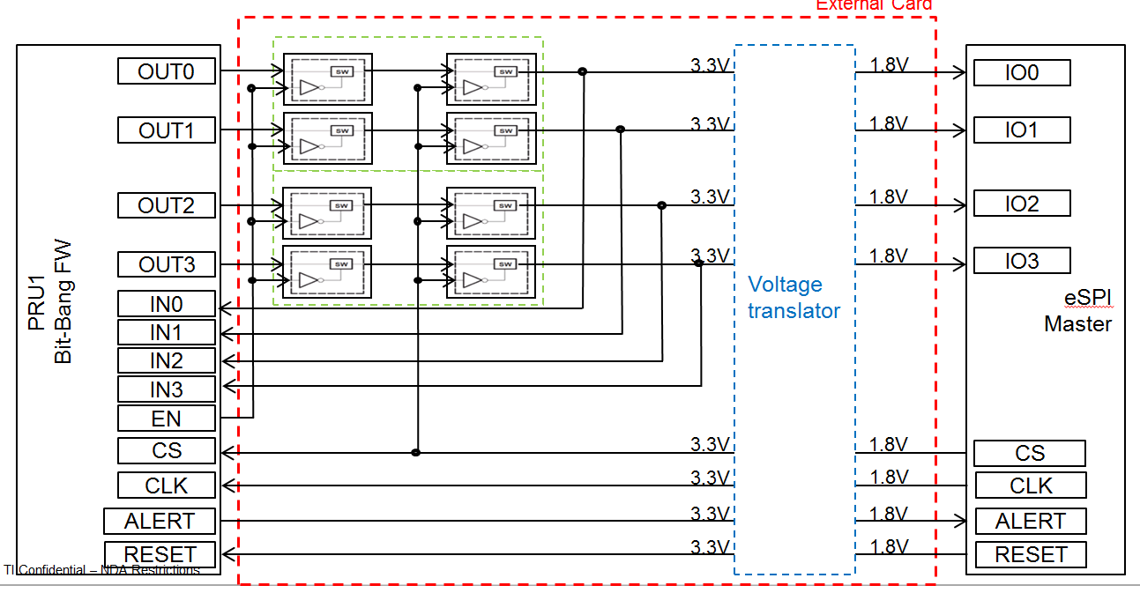
Figure 11. External Hardware Design

bbbAM335x
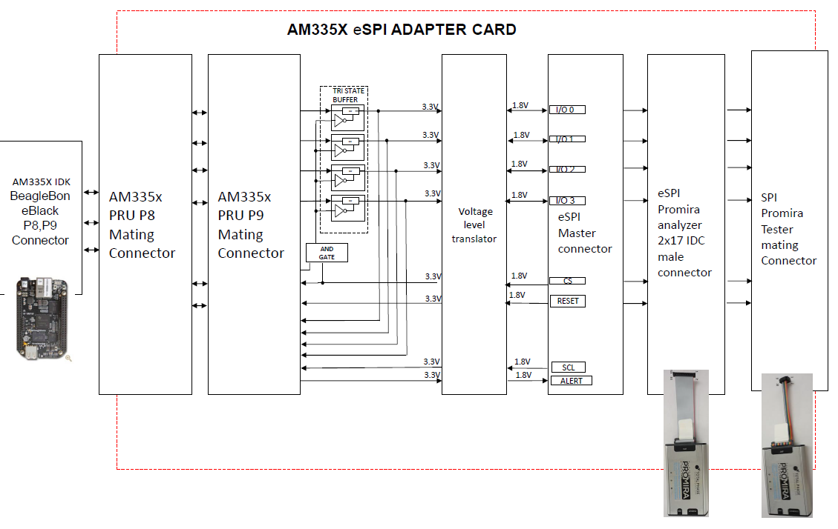
Figure 12. bbbAM335x Test Hardware

idkAM437x
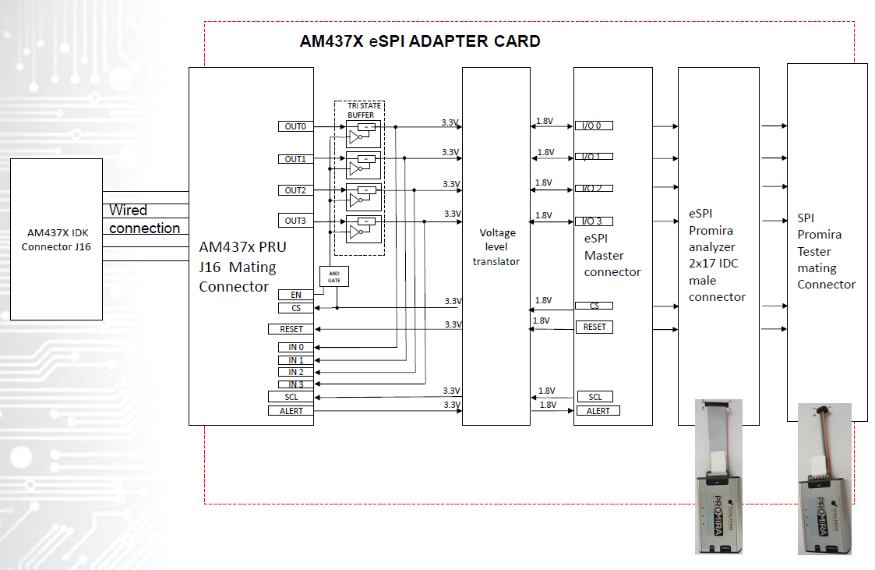
Figure 13. idkAM437X Test Hardware

Testing

Total Phase Promira Serial Platform
Total Phase makes a tool called the “Promira Serial Platform” which can act as both eSPI master and as a protocol analyzer. We will employ two for such purposes.

Limitations

Limited Frequency Support
Due to the 200MHz PRU-ICSS clock, only 20MHz eSPI is supported

Limited Channel Support
Only Channel 0 is currently supported, and within Channel 0 only the SHORT transactions are supported.

Slow Clock Not Supported
If the clock frequency drops below ~18MHz, data written by slave may be read early by the master.

Slave-Initiated Transactions
Following from 12.1, there are currently no slave-initiated transactions supported (SHORT transactions are master to slave only)

Response Modifiers
Response modifiers are not currently supported.

No Shared Alert# Pin
[1] defines an ability to use I/O[1] in place of a dedicated Alert# pin in Single mode. This is not currently supported.

Queue Depth
For this initial implementation, the simplest design possible is to use message “queues” with only one entry. However, it obviously benefits the protocol to handle multiple messages at a time so deeper queues should be supported in the future.

References
- [1] Intel Enhanced Serial Peripheral Interface (eSPI) Interface Base Specification Rev1.0
- [2] Understanding and implementing the CRC (Cyclic Redundancy Check) calculation http://www.sunshine2k.de/articles/coding/crc/understanding_crc.html#ch44

