Monte Carlo Simulation of
Non-equilibrium Dynamics in Statistical Physics

Bo Zheng
Zhejiang University

Contents

I Introduction

II Langevin Eq. and Monte Carlo dynamics

III Phase ordering dynamics

IV Critical dynamics far from equilibrium

V Disordered systems

VI Concluding remarks

I Introduction
Many-body Systems

difficult to solve the Eqs. of motion
Statistical Physics

Equilibrium Ensemble theory

Non-equilibrium ?

At macroscopic level
* Non-equilibrium state:
observable does evolve as time t
( t → ∞ )
* Equilibrium state:
observable does not evolve as time t

Exceptional
* Time-dependent perturbations:
t → ∞ stationary state ～ equilibrium
* External fields:
t → ∞ transportation
～ dynamic behavior

Non-equilibrium statistical physics
* Dynamic behavior in or around equilibrium:
long-time behavior
transportation
‘stationary state’
* Dynamic behavior far from equilibrium:
‘short time’ behavior

Equations of motion
* Microscopic fundamental Eqs.:
Newton, Heisenberg Eqs.
* Effective equations:
Liouville’s 、Boltzmann Eqs.
* Phenomenological Eqs.:
Langevin Eq., Monte Carlo dynamics
Master Eq. ……

Dynamics far from equilibrium
* Relaxational
* Phenomenological
Langevin Eq., Monte Carlo dynamics
Examples phase ordering
damage spreading
critical dynamics
spin glass dynamics
structural glass dynamics
interface growth
chemical reaction……

II Langevin Eq. and Monte Carlo dynamics

1、Langevin方程
问题：系统的作用量或Hamiltonian量为S
平衡态分布 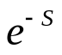
假设系统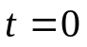时处于一初始状态
系统如何演化至平衡态？
如果初始状态不是平衡态，这便是一个驰豫动力学过程。
如果初始状态是平衡态，这是平衡态的动力学涨落问题。

单自由度的Langevin方程和Fokker-Planck方程
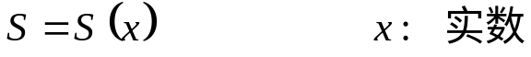
Langevin方程
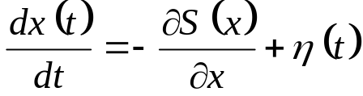
对固定
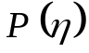 ∼ 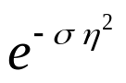
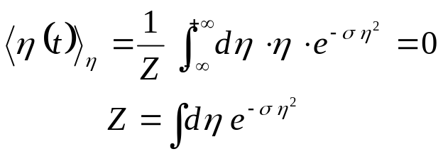
例如：布朗运动 —— 花粉在液体中的运动
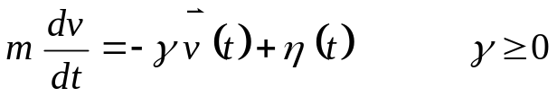
一维解 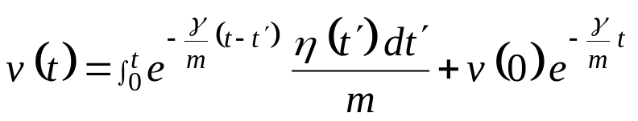
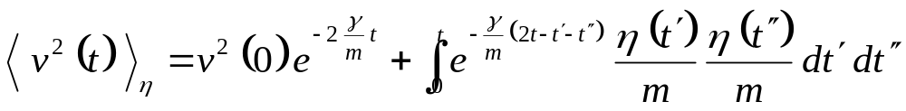
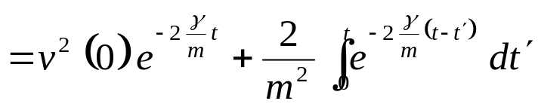
如 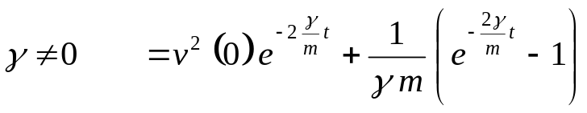
如 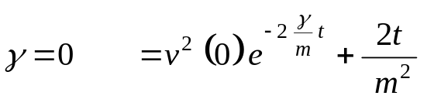

时间分立化  在数值模拟中应用
 较直观
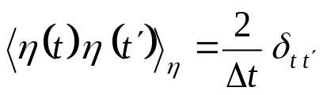，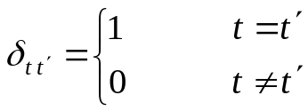
Z ∼ 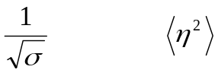 ∼ 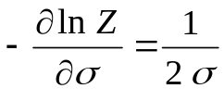
∴ 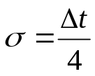
Langevin方程
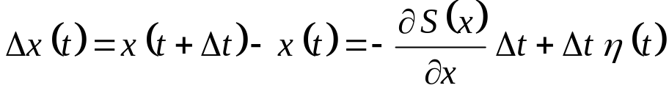
令 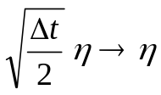
∴ 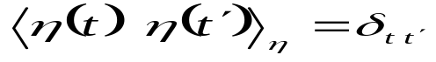
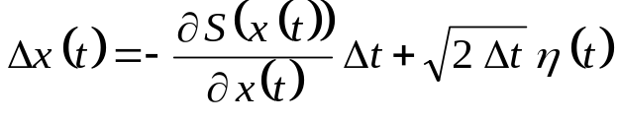
方程的解 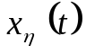是随机变量，在数值模拟中给定初始值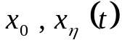还不确定，与随机力有关。也就是说，在t时刻，x 遵从一个分布

物理量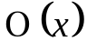的平均值
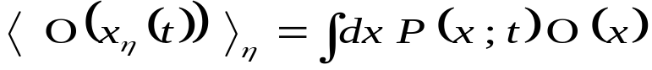
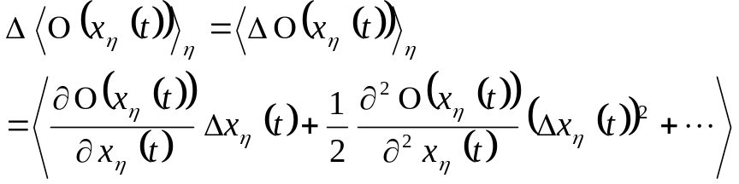
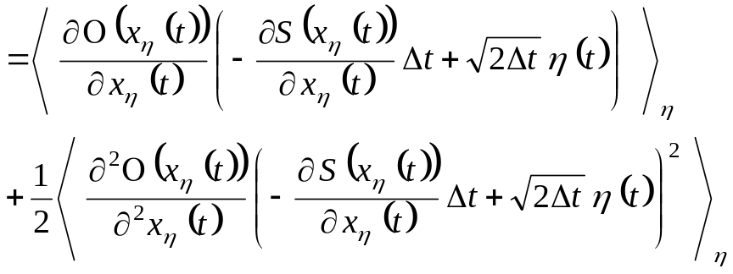
∵
∴ 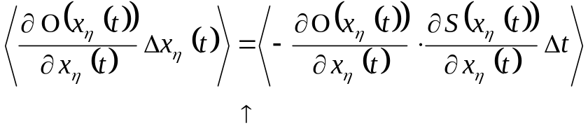
∵ 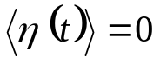

又 ∵ 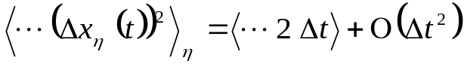
∴ 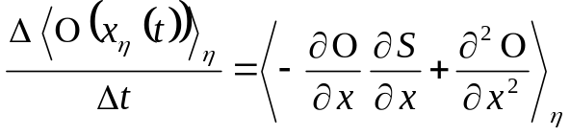
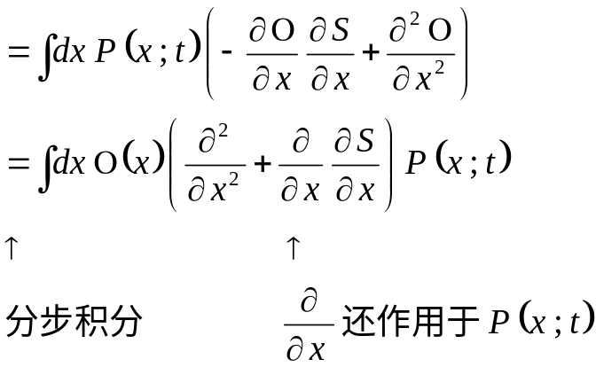
这里做分步积分时，假设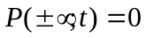
另一方面
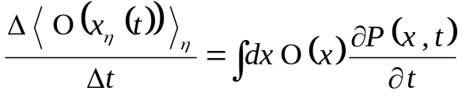
FoKker-Planck方程
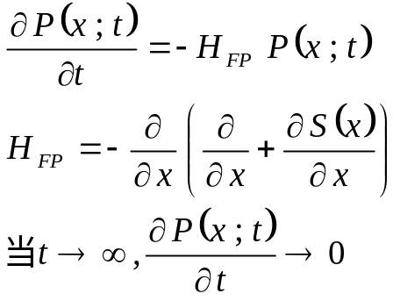
∴ 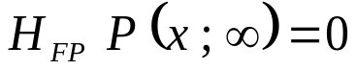
显然 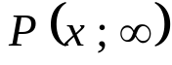 ∼ 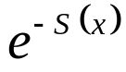
习题：试讨论为平衡态的条件
多自由度的Langevin方程和自由场
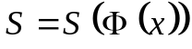 这里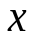是空间指标

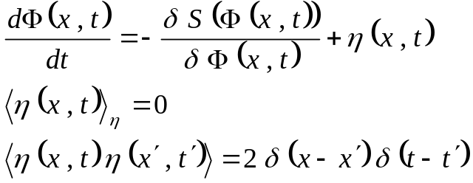

时空分立化
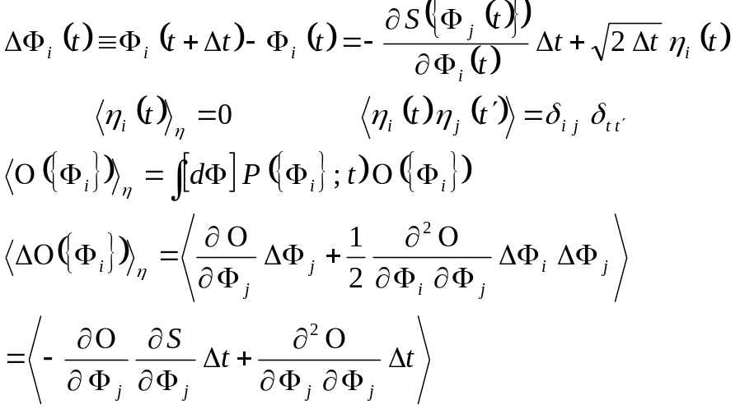
∴ 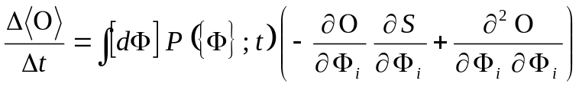
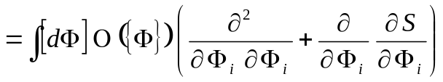
∴ 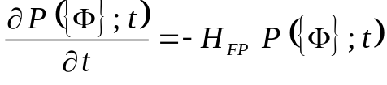
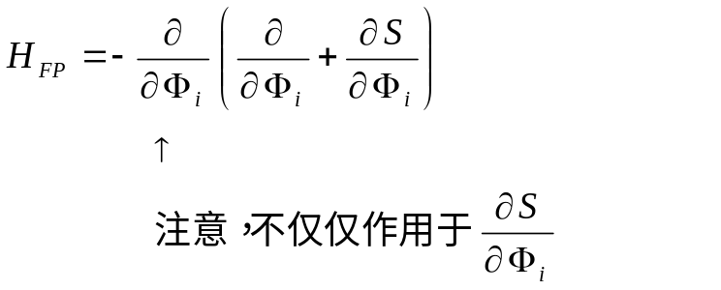
练习：推导F-P方程，证明平衡态为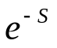。

自由场
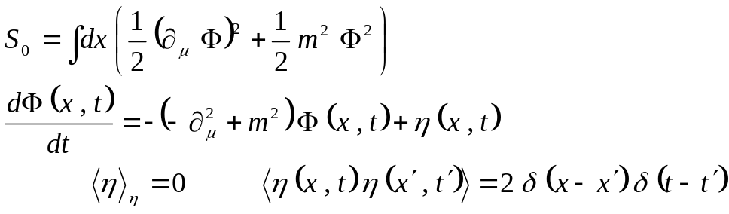
动量变换
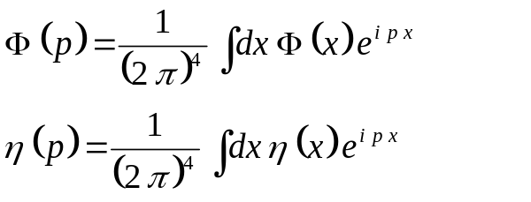
∴
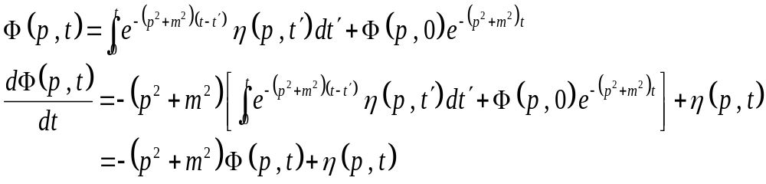

数值求解Langevin方程的困难：

1、 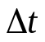 引起的误差

2、 动力学慢化

2、 Monte Carlo 动力学
Ising model
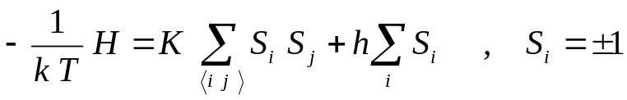
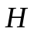称之为哈密顿量, 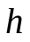为外磁场
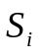置于格点上，例如正方格点
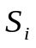
对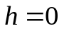
随机状态 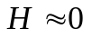
有序状态 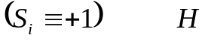极小
当体系和大热源接触达到“平衡”时，遵从正则分布
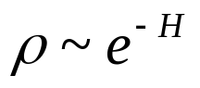
物理量的平均值
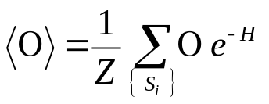， 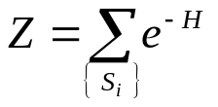 称配分函数
对MC模拟，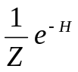可以给予概率分布的意义。
引入恰当随机过程，产生一系列自旋构形
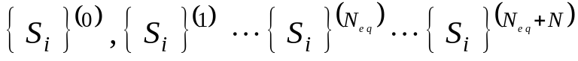
当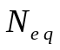足够大时，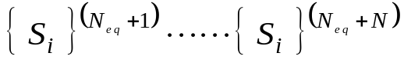 遵从分布
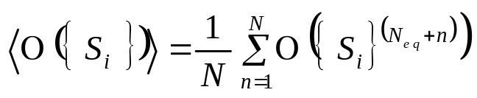
同时，Monte Carlo模拟产生的一系列自旋构形
也自然定义一种Monte Carlo动力学。
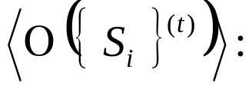 对初始条件和随机力的平均

Monte Carlo动力学和Langevin动力学处于同一普适类。
MC模拟可以给出较好的定量结果
MC模拟仍受临界慢化的困扰

如何解决临界慢化困难？
杰出的工作：Cluster方法
非局域的迭代方法
因此，不能研究定域的动力学

III Phase ordering dynamics
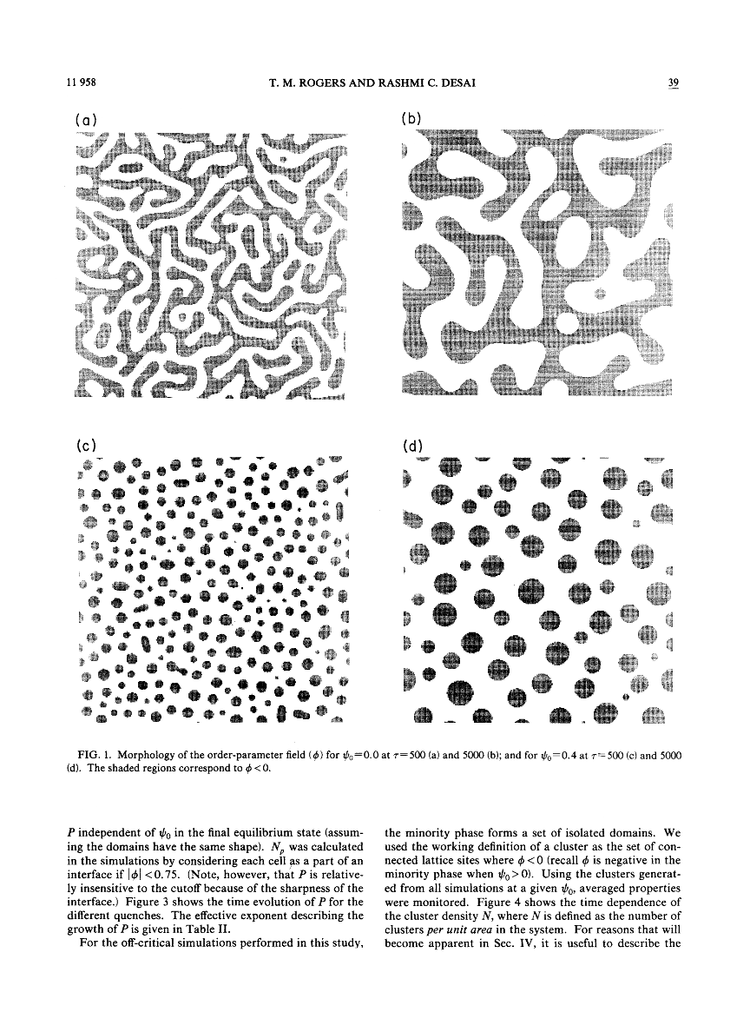
* Systems quenched from high temperature
to low temperature
* Spinodal decomposition of binary alloys
* Phase separation of fluids or binary liquids

Feature
Equilibrium is never reached
Scaling behavior at LATE stage

1. Dynamics of model A and model B

Hamiltonian or action
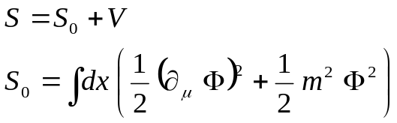
V is interaction

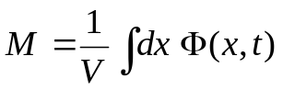

Dynamics

Model A
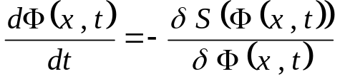
order parameter is not conserved
Model B
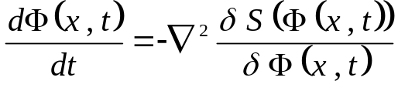
order parameter is conserved
1962, Lifshitz et al
90’ , renormalization group, A.J. Bray, G.F. Mazenko
Review by Bray, Advan. in Phys. 43(94)357; 51(02)481
Ising model
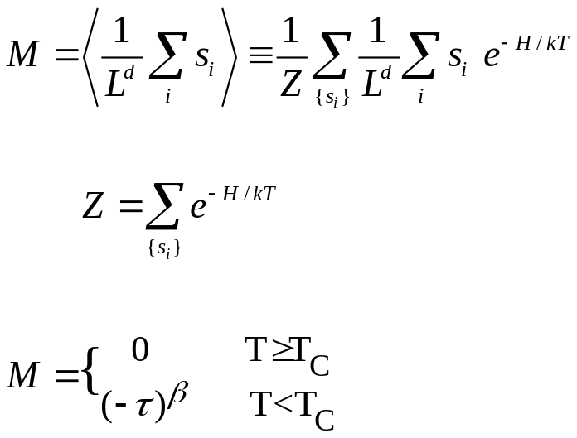
Tc
Model A
Single spin flip
e.g., Metropolis, heat-bath algorithms

Model B

Kawasaki dynamics: exchange two spins
e.g., Metropolis, heat-bath algorithms

For model A, it is a typical process of metastable, and the initial condition is important, the magnetization M ≈ 0.
For model B, the equilibrium state is trivial.
Therefore, only dynamics is interesting and important.

Equal-time correlation function
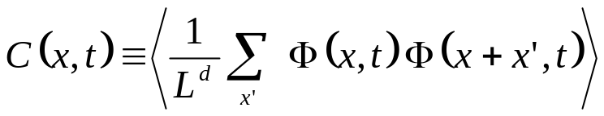

Scaling hypothesis
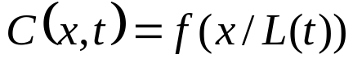

L(t) is the non-equilibrium length scale
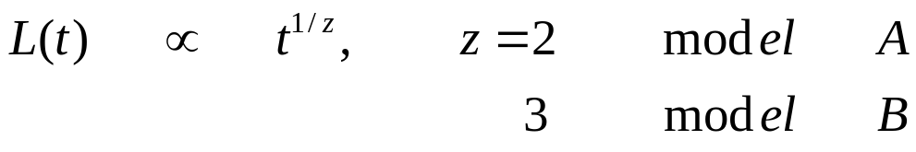
Scaling plot
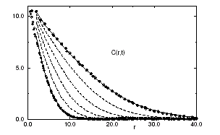

L(t) represents the averaged size of the domains, and it can be measured also from the domain growth
2. Dynamic systems with continuous symmetry
O(n) model
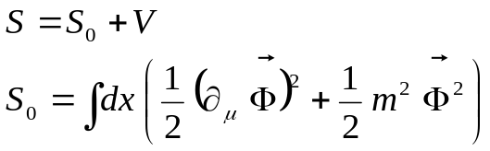
V is interaction
Langevin equation

XY model
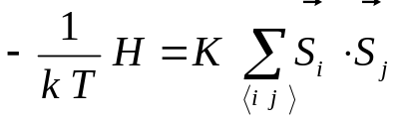

Langevin equation or
Monte Carlo dynamics

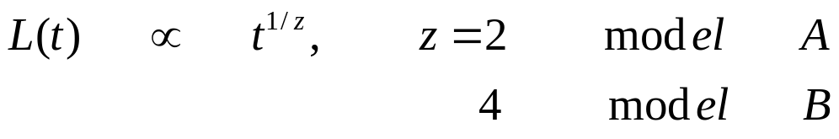
but with logarithmic corrections for n=2

Remarks:
- Results are in agreement with experiments
- The simplest example of non-equilibrium
dynamics with scaling behavior
- Applications to systems with complicated
order parameters
IV. Critical dynamics far from equilibrium
Model A
Phase ordering

Critical dynamics

-----------------<-|->---------------→-|
∞ Tc 0

Similarity between phase ordering and critical dynamics
Slow dynamics
Scaling behavior
Difference between phase ordering and critical dynamics
There is an equilibrium state for critical dynamics

NOT for phase ordering
Any initial states are possible for critical dynamics
NOT for phase ordering
There exist different time scales in critical dynamics
NOT for phase ordering

Critical dynamics is more difficult,
but also with more physics.

