V、 Disordered Systems
1、 Spin glass
Ising-spin glass
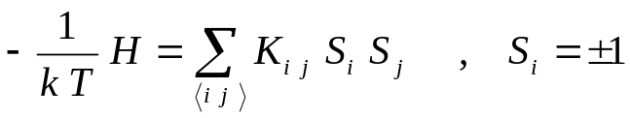
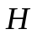为哈密顿量
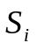置于格点上，例如正方格点
正则分布 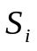
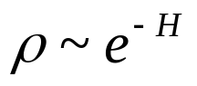
物理量的平均值
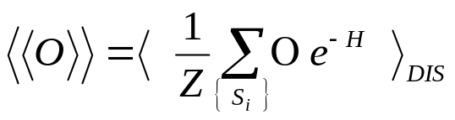， 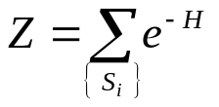
Overlap of two replicas
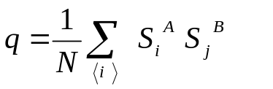
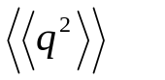is the susceptibility
Important !
now, the state with 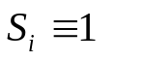is NOT a completely ordered state. 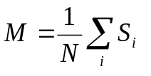can not be defined as
an order parameter. The order parameter is usually defined as 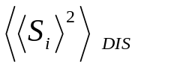.
For dynamic systems, dynamic scaling form
developed in second-order phase transitions
can not be fully applied with this order parameter.
e.g., if we start from an initial state with 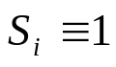, the relaxation process is NOT like a relaxation from an ordered state.

Pseudo-magnetization:
Assuming 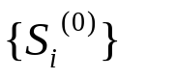is the ground state for a set of
couplings, it is defined as
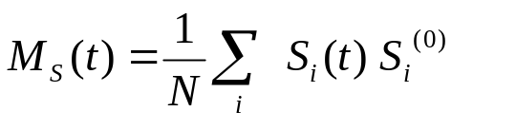
Then the standard scaling form may be applied. The resulting dynamic critical exponent 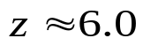
is consistent with experiments.
What we pay: to search for the ground state

References:
C. Pappas, et al, PRB 68 (2003) 054431
Mari and Campbell, PRB 65 (2002) 184409
- Efficient simulations, mechanism
- Dynamics, aging
2. Structural glass
supercooled liquid
Features
- Very slow dynamics
- Possible phase transition at a low temperature
- Stretched exponential behavior
- Correlating time increases faster than
exponential as the temperature deceases

Numerical simulations:
- Monet Carlo
- Molecular dynamics
Refernces:
Binder K, J. Non-Crystalline solids 274 (2000) 332
Binder K, et al, Prog. Polymer Science, 28 (2003) 115

Zheng, et al, PRB 59(1999)6717

The n-spin facilitated Ising model

Consideration
- coarse graining of
- reduction of degrees of freedom
- Monet Carlo dynamics
Ising model
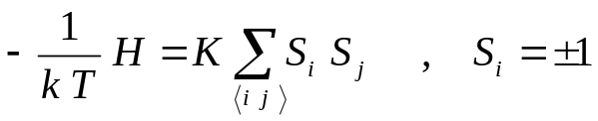
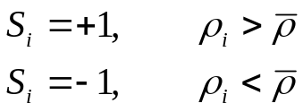
Monet Carlo dynamics with restriction
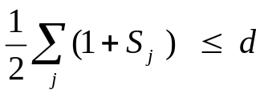
Auto-correlation
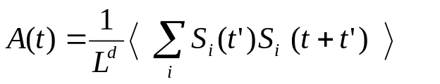
Stretched exponential behavior
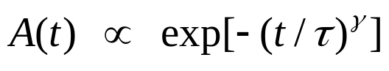
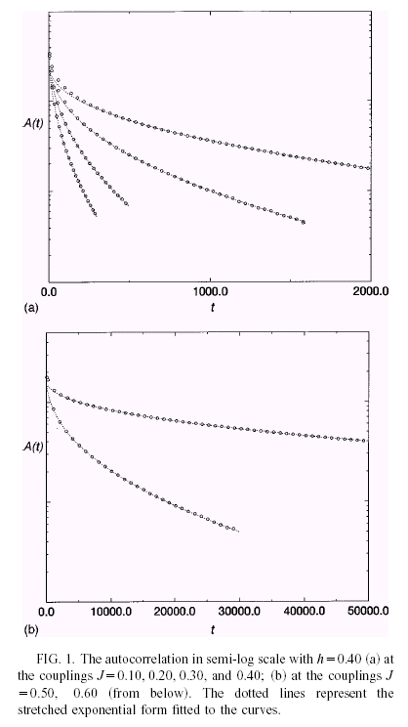

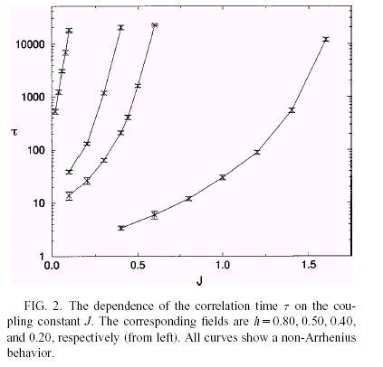

VI Concluding remarks

- We have discussed certain kinds of
non-equilibrium relaxation dynamics,
which are slow, and show scaling behavior.
- Under certain conditions, Monte Carlo
(or Langevin) dynamics could describe
the features of the dynamics.
- For critical dynamics or critical-like
dynamics, critical exponents in equilibrium
can be estimated from non-equilibrium
behavior of the system, since the long-range
temporal correlation induces memory effect
in the system.

