Software Requirements
Specification
for
Luminae
Version 1.0 approved

Prepared by Mahad Hassan Asim (2112145) and Mohammed Ali
Khowaja (2112150)

Shaheed Zulfiqar Ali Bhutto Institute of Science and Technology
University, Karachi

17th November 2024

Table of Contents

- Introduction 1
  - Purpose 1
  - Document Conventions 1
  - Intended Audience and Reading Suggestions 2
  - Product Scope 2
  - References 3
- Overall Description 4
  - Product Perspective 4
  - Product Functions 5
  - User Classes and Characteristics 5
  - Operating Environment 6
  - Design and Implementation Constraints 7
  - User Documentation 8
  - Assumptions and Dependencies 8
- External Interface Requirements 9
  - User Interfaces 9
  - Hardware Interfaces 10
  - Software Interfaces 11
  - Communications Interfaces 12
- System Features 12
  - System Feature 1 13
  - Sign-up Page 14
    - Description: 14
    - Stimulus/ Response Sequence: 14
  - Sign-in Page 16
    - Description: 16
    - Stimulus/Response Sequences: 16
  - Agency Creation 18
    - Description: 18
    - Stimulus/ Response Sequence: 18
    - Functional Requirements: 18
  - Dashboard 19
    - Description: 19
    - Stimulus/ Response Sequence: 19
    - Functional Requirements: 20
  - Team Management 20
    - Description: 20
    - Stimulus/ Response Sequence: 20
    - Functional Requirements: 21
  - Client Management 21
    - Description: 21
    - Stimulus/ Response Sequence: 21
    - Functional Requirements: 22
  - Kanban Board (Task Delegation) 22
    - Description: 22
    - Stimulus/ Response Sequence: 23
    - Functional Requirements: 23
  - Admin Panel Overview 24
    - Description: 24
    - Stimulus/ Response Sequence: 24
    - Functional Requirements: 24
  - Data/User Management Panel 25
    - Description: 25
    - Stimulus/ Response Sequence: 25
    - Functional Requirements: 25
  - Community Front Page 26
  - Agency Page 26
  - Community Forums 26
  - Assign custom package 26
  - Media Storage/Management 26
- Other Nonfunctional Requirements 26
  - Performance Requirements 26
  - Safety Requirements 27
  - Security Requirements 27
  - Software Quality Attributes 27
  - Business Rules 29
- Other Requirements 30
  - MoSCoW Analysis 31

Revision History

Name | Date | Reason For Changes | Version

Introduction

Purpose
The purpose of this Software Requirements Specification (SRS) is to define the requirements for Luminae, an innovative web-based platform designed for service-based agency owners to streamline client management, performance tracking, and community engagement. The current release focuses on delivering core functionality, including account management, onboarding workflows, and basic reporting features. The SRS will cover the development scope of Luminae, including its features, technology stack, and limitations, ensuring all stakeholders have a clear understanding of the system's functionalities and objectives.

Document Conventions
This Software Requirements Specification (SRS) follows the following conventions and standards:

Font Styles:
  - Bold text is used for section headers and requirement identifiers.
  - Italic text is used to highlight important concepts or definitions.
  - Monospaced font is used for code snippets, file names, or system commands.
  - Headings will be in 14px in Times New Roman font.
  - Text will be in 12px in Times New Roman font.

Numbering:
  - Requirements are numbered sequentially for easy reference (e.g., R1, R2, R3).
  - Sub-requirements or detailed requirements inherit the numbering from the parent requirement (e.g., R1.1, R1.2).

Requirement Prioritization:
  - Priorities are explicitly stated for each requirement, using terms like "High," "Medium," and "Low."
  - Detailed requirements inherit priorities from higher-level requirements unless otherwise specified.

Terminology:
  - Key terms and abbreviations are defined in the glossary to maintain consistency throughout the document.

Reference Standards:
  - The document follows industry standards for software documentation, such as IEEE 830-1998 (Recommended Practice for Software Requirements Specifications).
These conventions ensure clarity, consistency, and traceability across the entire document.

Intended Audience and Reading Suggestions
This document is intended for the following audiences:

- Developers: To understand the system’s architecture, as well as functional and non-functional requirements.
- Project Managers: To track the project’s scope, milestones, and deliverables.
- Testers: To create test cases and validation plans.
- Marketing Staff: To gain insight into the platform's features and how it aligns with market needs.
- End Users: Agency owners who may want to understand how the platform will address their pain points.
Readers should start with Section 1 (Introduction) for an overview, followed by Section 2 (Overall Description) to understand the system at a higher level, and then move into the detailed system features in Section 3.

Product Scope
Luminae is designed to streamline operational tasks for service-based agencies, such as social media marketing, digital marketing, and IT service providers. The platform will provide tools to manage multiple team accounts and clients, track performance, and foster collaboration via the community feature. Luminae aims to reduce the complexity of managing multiple team members, clients, and projects by consolidating core tasks into one unified platform. This will empower agency owners to scale their operations efficiently, maintain operational clarity, and improve productivity.

Key Objectives:
- Improve Efficiency: Unify and simplify agency workflows, reducing the manual effort required to manage tasks, clients, and teams.
- Enhance Decision-Making: Provide actionable insights through performance data to help agency owners make informed decisions.
- Support Scalability: Empower agencies to scale operations by providing robust client and team management tools.
- Increase Collaboration: Foster a collaborative environment through integrated community features, encouraging communication and resource sharing among team members.
- Simplify Onboarding: Streamline the onboarding process for new clients and team members, ensuring a seamless experience.
- Optimise Financial Management: Integrate payment systems, such as Stripe, for easy subscription handling and transaction tracking.
The project will focus on developing core features such as client account management, onboarding workflows, payment integration, performance metrics, the admin panel for Luminae developers to manage users, and the community feature to enable agency collaboration.

References
- Go High Level, “Go High Level Pricing: Costs & Limitations,” Go High Level, 2023. [Online]. Available: https://gohighlevel.com/. [Accessed: Sep. 19, 2024].

- Stripe Docs, “Testing in the Stripe Environment,” Stripe, 2024. [Online]. Available: https://stripe.com/docs/testing. [Accessed: Sep. 19, 2024].
- LinkedIn, “Upvote and Badge System,” LinkedIn, 2024. [Online]. Available: https://linkedin.com/. [Accessed: Sep. 19, 2024].
- Material Design, “Material Design 3,” Material.io, 2024. [Online]. Available: https://m3.material.io/. [Accessed: Sep. 19, 2024].

Overall Description

Product Perspective
Luminae is a new, self-contained platform specifically designed to address the challenges faced by service-based agency owners in managing multiple clients and projects. Unlike other tools that either focus solely on project management or community engagement, Luminae integrates both into one system, offering an all-in-one solution for client management, payment processing, and performance tracking.
This platform does not build on any existing software family but instead introduces a fresh approach to agency management by consolidating key operational features into one product. Luminae also interacts with third-party services like Stripe (for payment processing) and Clerk (for authentication), and these external systems must seamlessly interface with the platform’s backend. Below is a diagram illustrating the platform’s major components:

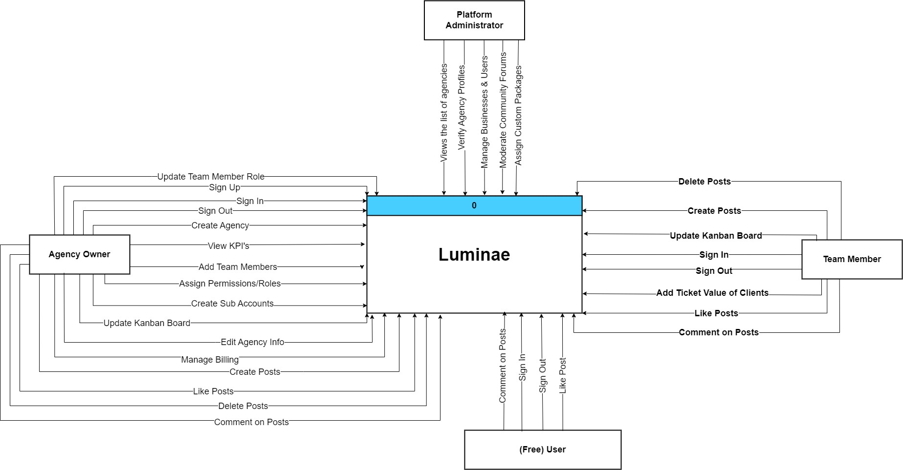

These components interact with each other to ensure seamless operation for agency owners.

Product Functions
At a high level, Luminae provides the following core functions to users:
- Team Account & Client Management: Allows agencies to manage multiple team accounts and clients and store relevant information.

- Onboarding Workflow: Provides a structured approach for onboarding new clients.
- Payment Integration: Supports secure payment processing through Stripe.
- Performance Tracking: Displays performance metrics for client campaigns.
- Task Management: Assigns tasks to team members and tracks progress.
- Admin Panel: Allows Luminae developers and admins to manage users and assign packages.
- Community Engagement: Enables agency owners to interact, share knowledge, and participate in discussions.
- Basic Reporting and Analytics: Offers basic reports on agency performance, with limited customization.
- User Permissions: Allows agency owners to assign roles and permissions within their teams.

User Classes and Characteristics
The following user classes are anticipated to use this product, differentiated based on their roles, access levels and interactions with the system:

User Class | Description | Frequency of Usage | Functions Used | Technical Expertise | Importance | Platform Used
Agency Owners | Responsible for managing team accounts, tracking performance, and overseeing overall operations. | Several times a week | Client account management, performance tracking, billing, and team management. | High | Critical | Desktop PCs, Laptop PCs, occasionally on tablets or smartphones.
Team Members (Agency  Employees) | Assigned tasks by agency owners or managers and responsible for executing deliverables. | Daily | Task management, reporting, and collaboration features. | Medium | Important | Desktop PCs, Laptop PCs, occasionally on tablets or smartphones.
Platform Admins  (Luminae Staff) | Responsible for managing user accounts, troubleshooting, and customising user permissions. | Daily | User management, auditing, agency verification, and platform moderation. | High | Critical | Desktop PCs or Laptop PCs.

Users | Granted access to participate in community features, providing input and engagement within the platform. | Variable (Daily or Regular, throughout the week) | Community features, viewing/commen ting on posts. | Low | Low | Desktop PCs, Laptop PCs, occasionally on tablets or smartphones.

Operating Environment
The software will operate in the following environments, ensuring compatibility and seamless integration with existing systems:

Server environment minimum recommendations:
- Processor: Any modern x86-64 processor (Intel or AMD)
- RAM: 8 GB (or higher)
- Storage: 20 GB HDD (or higher)
- Operating System: Windows 10 (build 1903 or later), Windows 11 or Linux (Ubuntu 20.04, Debian 11, Fedora 39 or newer)
- Node.js 20.x or newer
- MariaDB 11.5.2 or MySQL 8.0 (or newer)
- Apache 2.4 or Nginx 1.18 (or newer)
- Stripe for payment processing
- Clerk for authentication and authorisation
- Support for HTTP(S), REST APIs for real-time data communication

User environment minimum recommendation:
- Google Chrome, Mozilla Firefox, Microsoft Edge, Safari (latest version)
- Stable internet connection

This environment specification ensures that the software operates efficiently and effectively, allowing for integration with existing systems while maintaining compatibility across different platforms and devices.

Design and Implementation Constraints
The software platform is subject to several design and implementation constraints:

Technology Stack:
  - The platform is built using:
    - Next.js 15
    - React.js 19

    - Node.js 20 (or higher)
    - MySQL (SQL) Server
  - This limitation restricts developers from using alternative front-end or back-end technologies.
  - Any additional components must integrate seamlessly with the specified stack.

Developer Familiarity:
  - The selected technology stack was chosen because:
    - Developers are well-versed in Next.js, React.js, and Node.js.
    - JavaScript and its ecosystem provide a robust foundation for rapid prototyping and development.
    - JavaScript has consistently been the most popular programming language, as reported in the Stack Overflow Developer Survey since 2015 (StackOverflow Survey 2024).

Database Choice:
  - MySQL is selected as the relational database management system (RDBMS) because:
    - It is one of the most commonly used database software solutions, alongside
PostgreSQL and MariaDB.
    - The data involved is well-structured, making it unsuitable for unstructured databases (e.g., MongoDB or other non-relational databases).

User Documentation
The following user documentation will be provided with the system:

User Manual:
A comprehensive guide explaining how to use all features of the platform, including client management, performance tracking, and payment processing.

Tutorial Video:
A step-by-step video guiding users through common workflows like onboarding clients, managing payments, and interacting with the community feature.
Documentation will be provided in a web-accessible format (HTML or PDF), and help sections will be available directly within the platform's interface.

Assumptions and Dependencies
The following assumptions and dependencies could impact the project and the requirements stated in this SRS. These factors are assumed to be true but may not be confirmed or could change during the course of development, leading to potential project risks.

Assumptions:
- Stable Operating System Environment:
It is assumed that the operating environment (hardware and software) will remain stable

during development and deployment. Any major changes in hardware platforms, operating systems, or infrastructure may affect the product’s performance and compatibility.

Internet Connection:
The platform assumes a stable internet connection for all users, as it is web-based.

Availability of Third-Party Services:
It is assumed that the third-party services, or application programming interfaces (APIs), of payment processor (Stripe), will be available, stable and do not change their requirements.

Sufficient Development Resources:
It is assumed that the project will have consistent access to sufficient development, testing, and deployment resources (e.g., personnel, tools and budget). Any reduction in resources may cause delays or reduced functionality.

No AI-driven Features:
The current scope does not include advanced AI-driven analytics or machine learning models for predicting trends or automating decision-making.

No Mobile Application:
Luminae is solely a web application, and there are no plans for a mobile application in our current release.

Dependencies:
- Third-Party Runtimes, Libraries and Frameworks:
The project depends on external toolings (e.g., Node.js, MariaDB, Next.js, React.js, Stripe, Clerk) to build the software. If these third-party tools are deprecated, encounter security vulnerabilities, or fail to provide necessary updates, the project may face delays or need alternative solutions.

Development Tools and IDEs:
The project assumes that the development environment, including specific Integrated Development Environments (IDEs), text editors and version control systems (e.g., Git) remain stable. Any changes in these tools or compatibility issues could affect developer productivity.

Stripe Availability:
It is assumed that users will either have or can create a Stripe account.

External Interface Requirements

User Interfaces
The user interface of Luminae is designed to be intuitive and user-friendly, following a clean and minimalistic style. It incorporates standard design conventions used in most SaaS platforms. Key features include:
- Screen Layout for Dashboards: Each screen is divided into two primary sections—navigation on the left and content display on the right. Users can easily navigate between workspaces, tasks, community, and reports via a sidebar.

Standard Buttons and Functions:
  - Common action buttons like Save, Submit, and Cancel are consistently placed at either the bottom left of forms, or cover the full form width.
  - Error messages are displayed inline near the form field where the error occurs, along with user-friendly descriptions of what needs correction.

Homepage
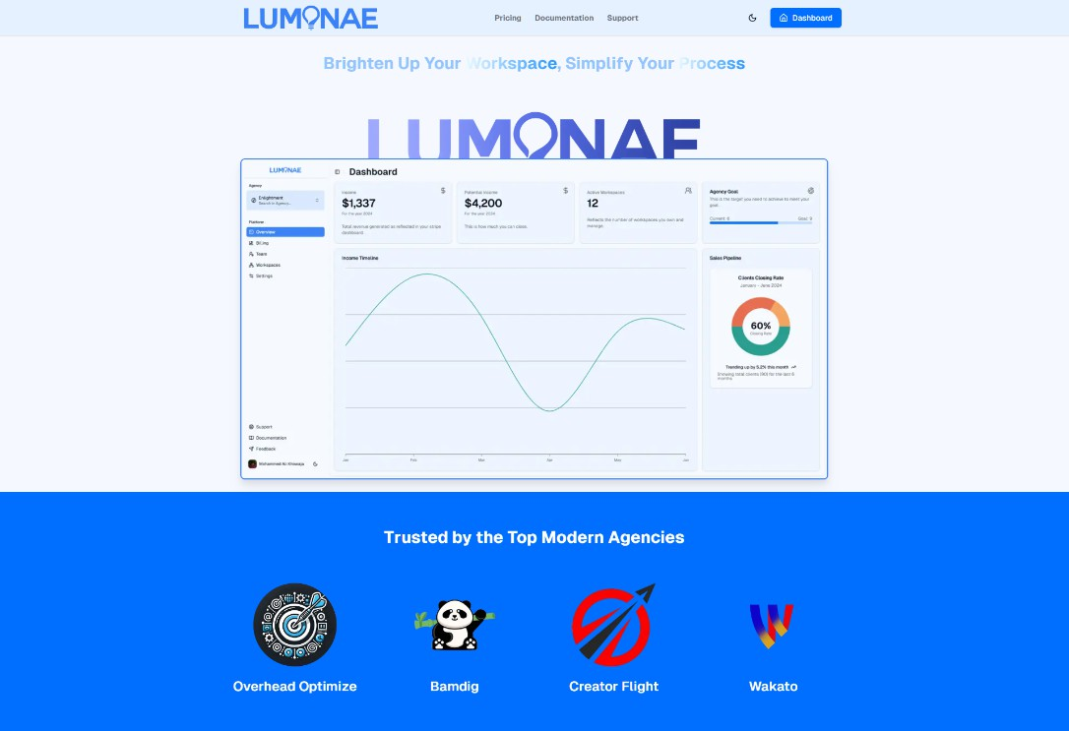

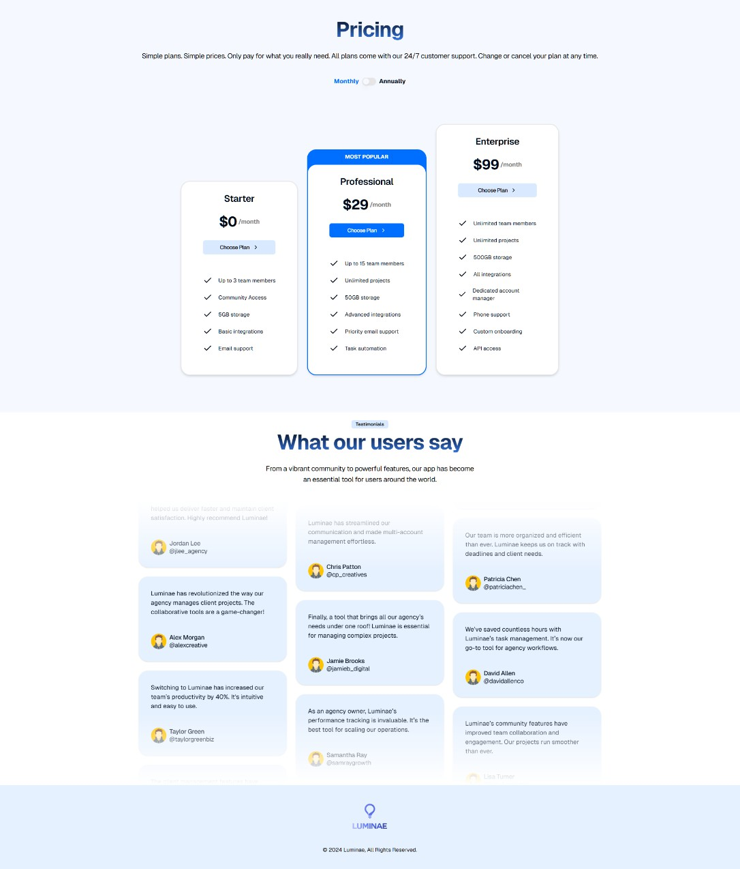

Figure 3.1.1 - Homepage

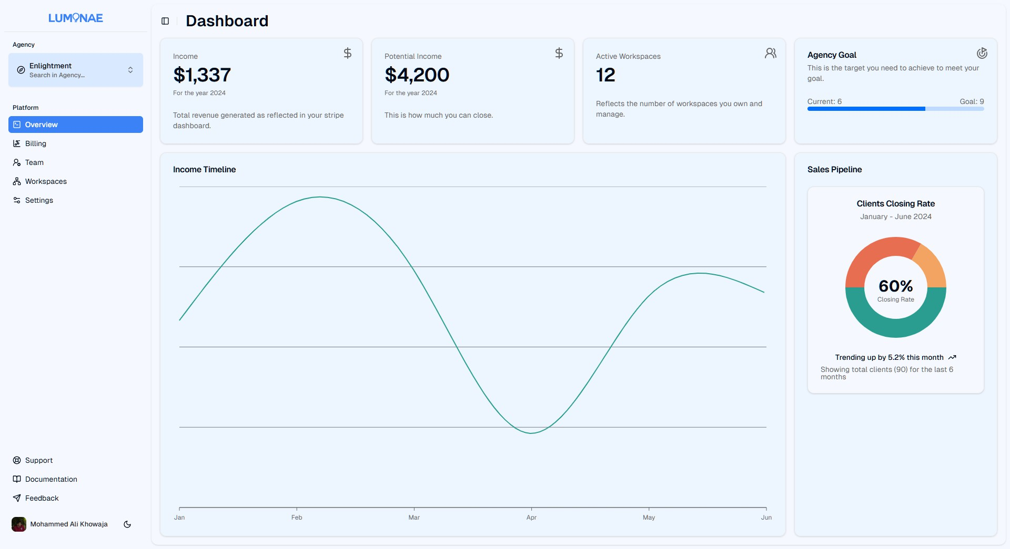
Dashboard

    - Sign In
Figure 3.1.2 - Dashboard

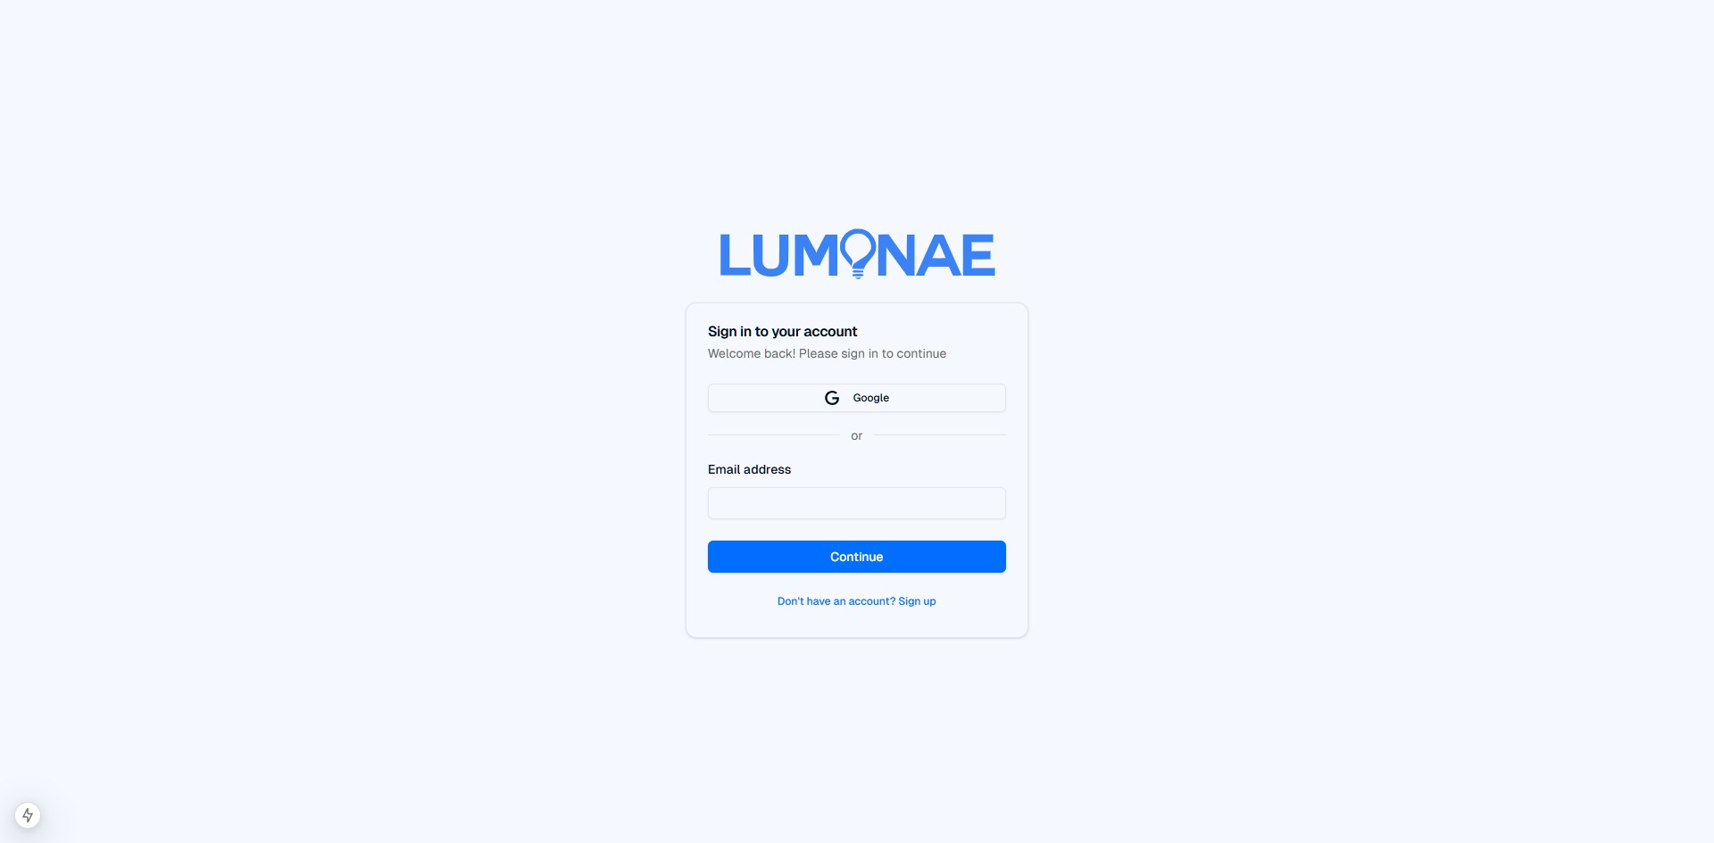

Sign Up
Figure 3.1.3 - Sign In

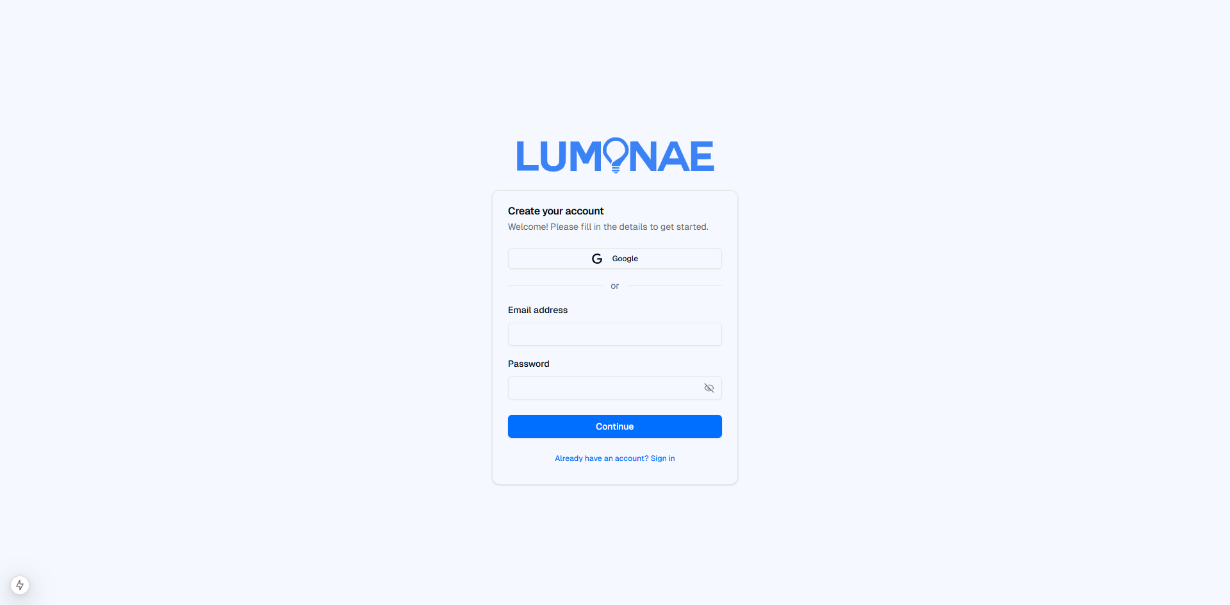
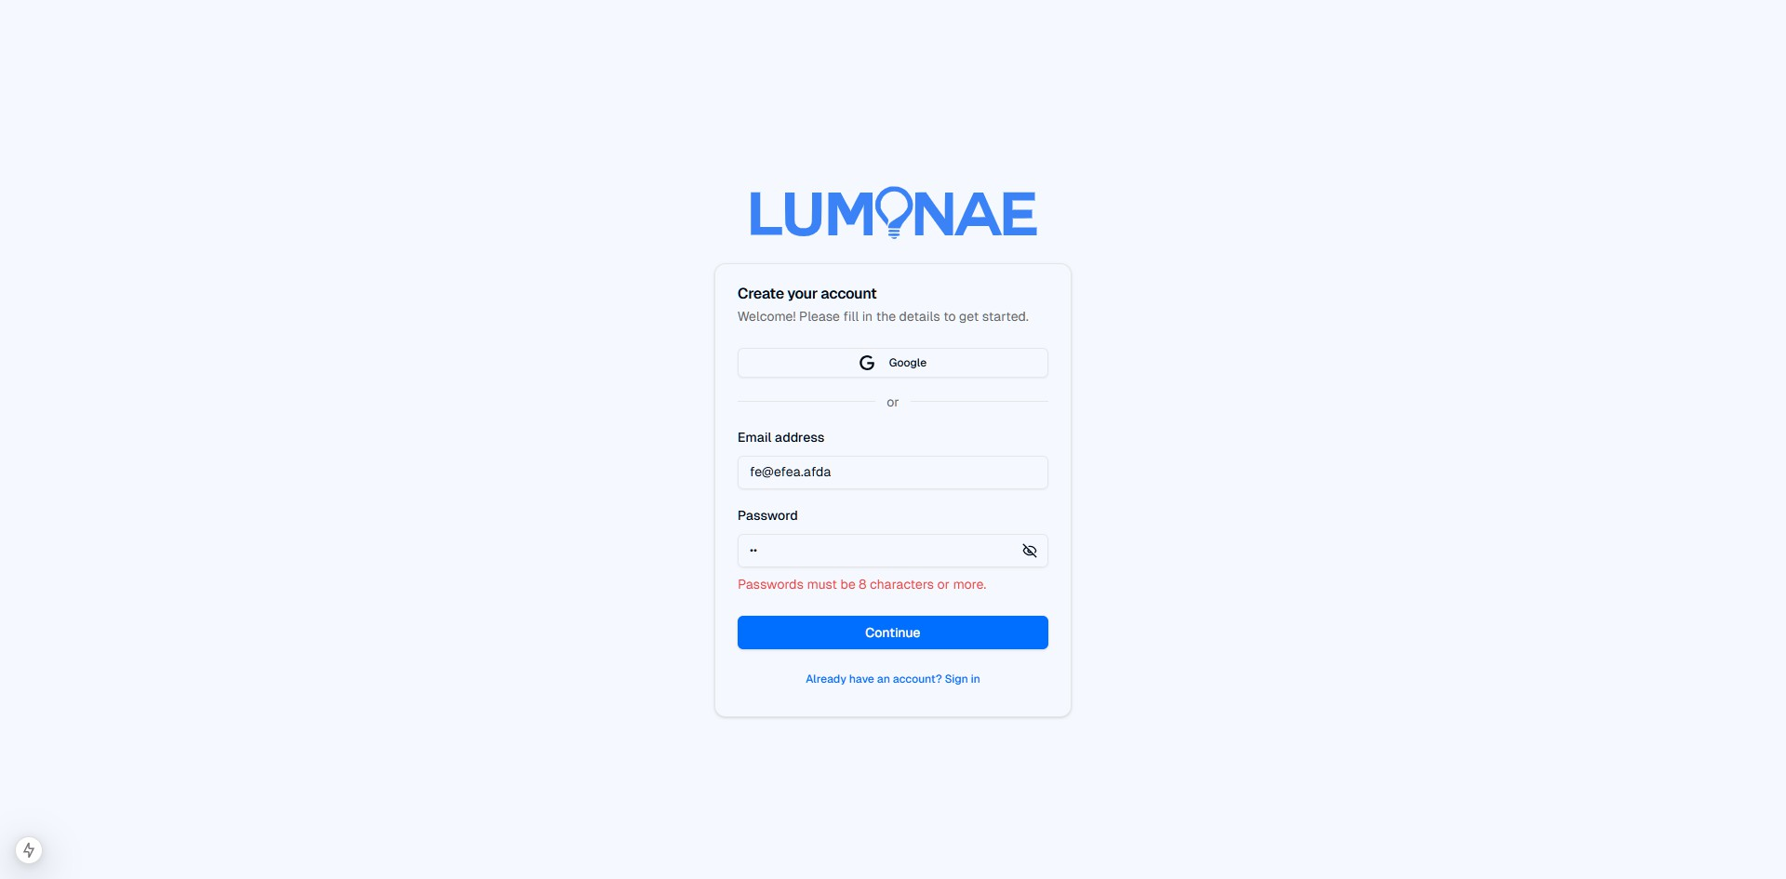

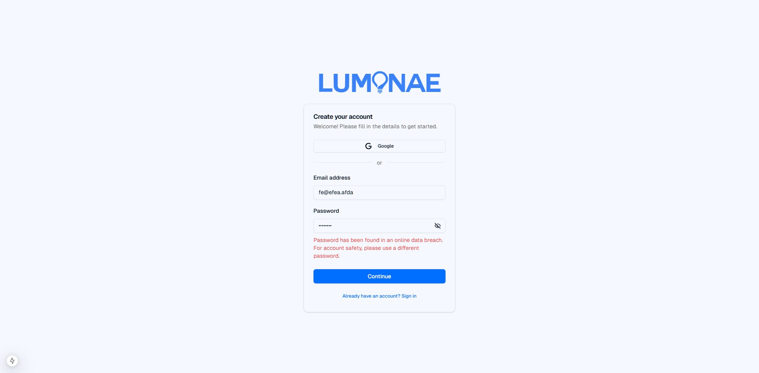

Accept Invitation
Figure 3.1.4 - Sign Up

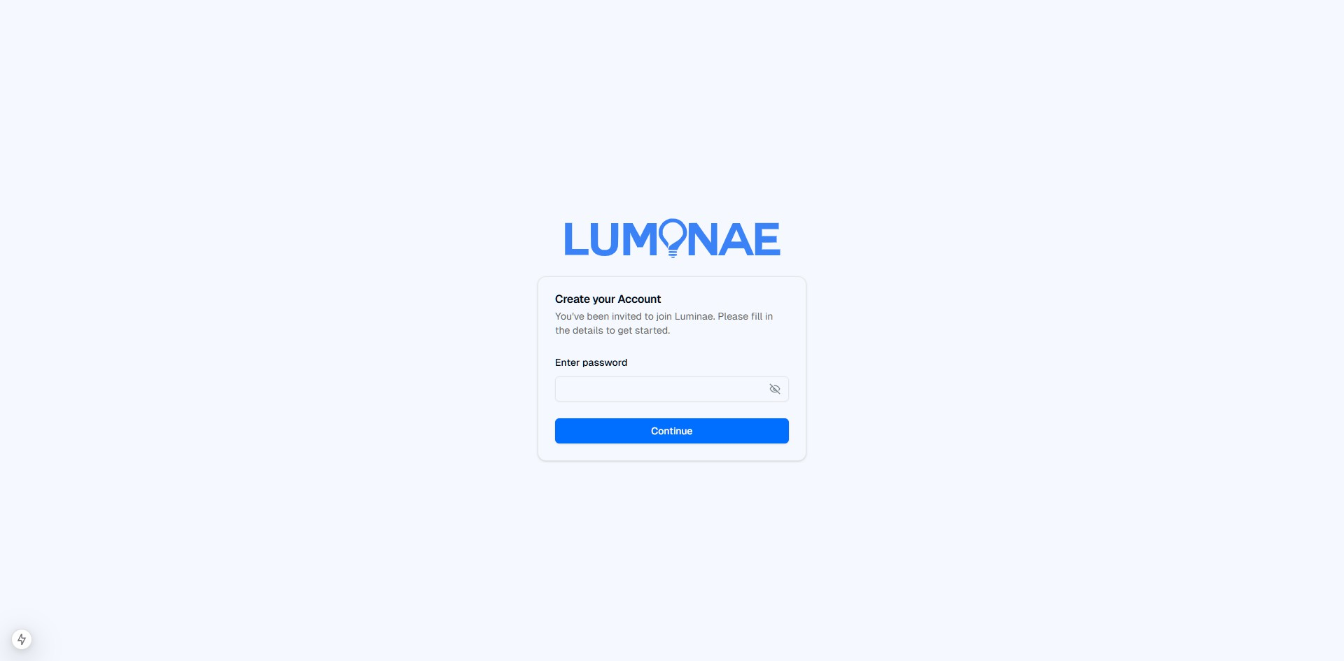

Contact Form
Figure 3.1.5 - Accept Invitation

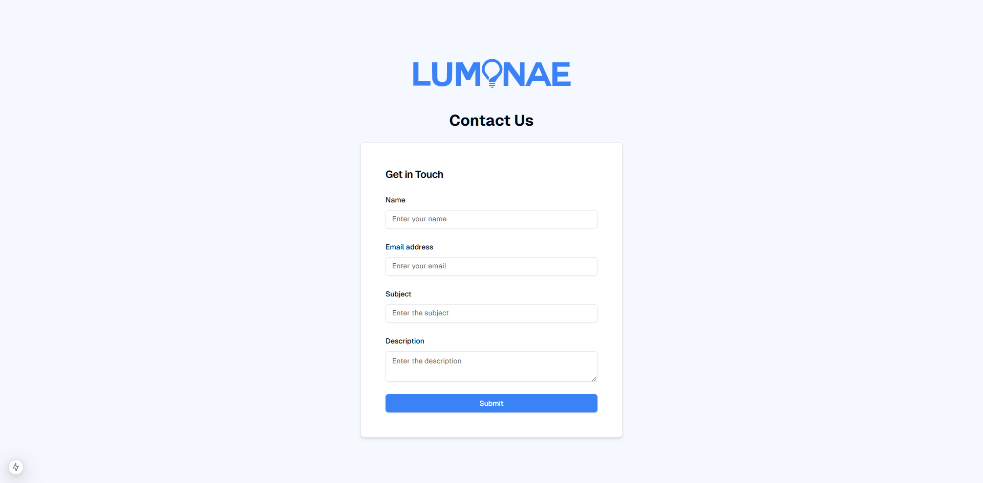

Forgot Password
Figure 3.1.6 - Contact Form

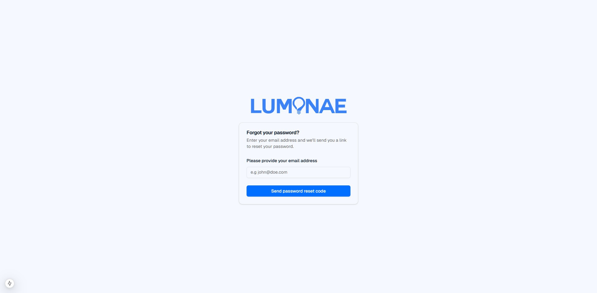

Agency Creation
Figure 3.1.7 - Forgot Password

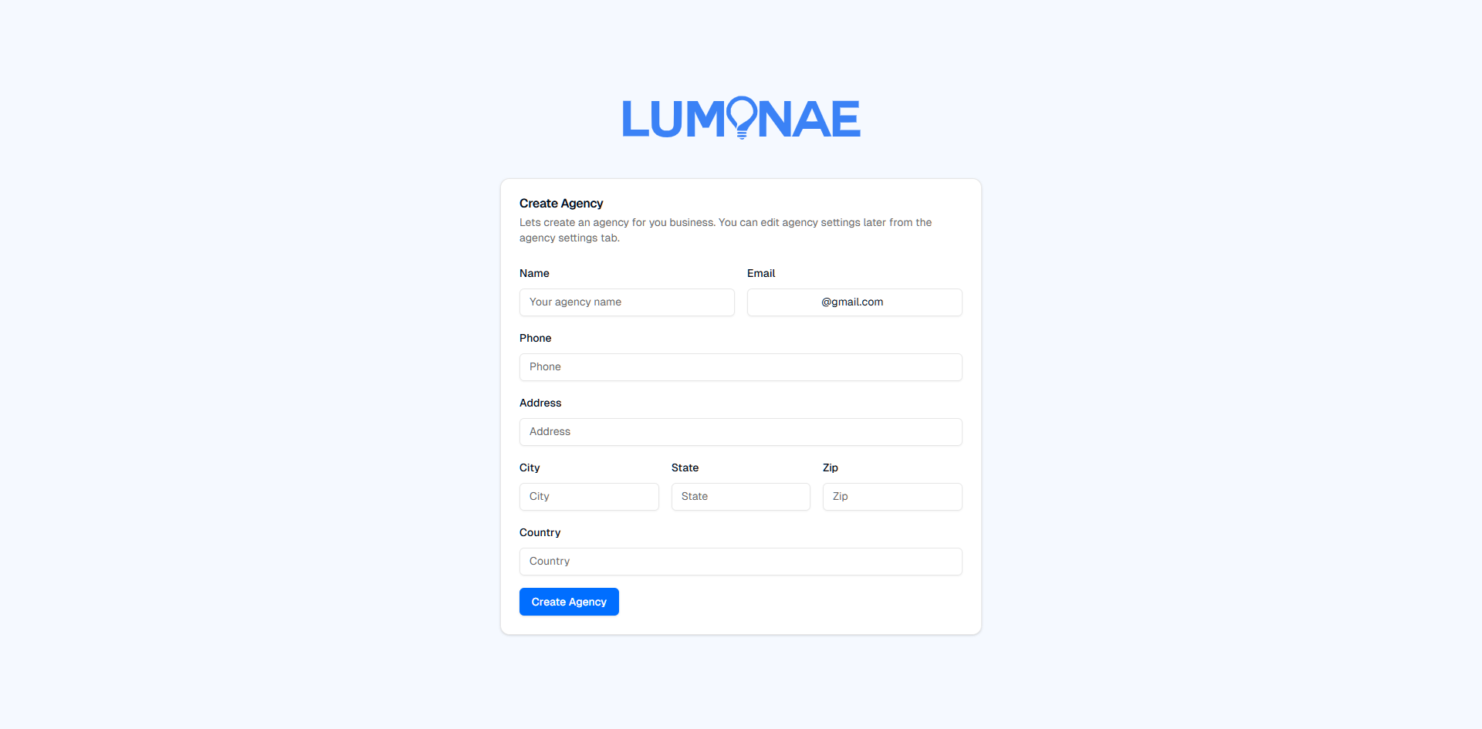
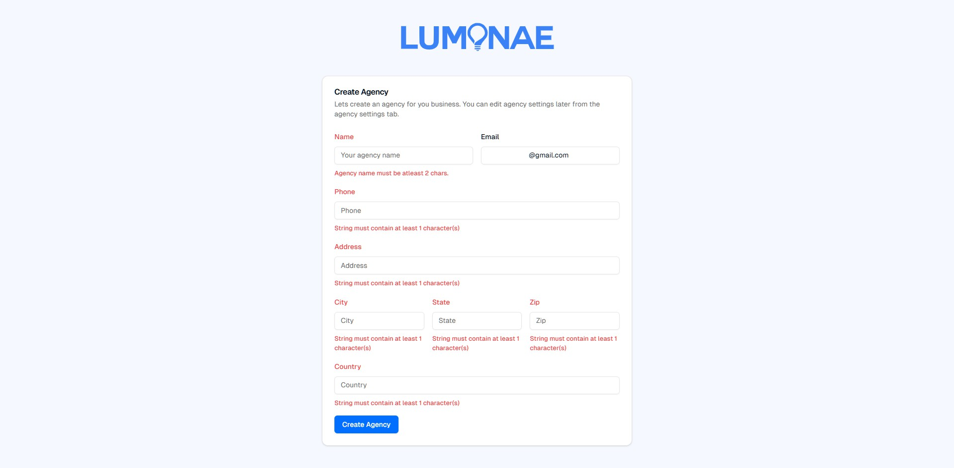

Agency Details Update
Figure 3.1.8 - Agency Creation

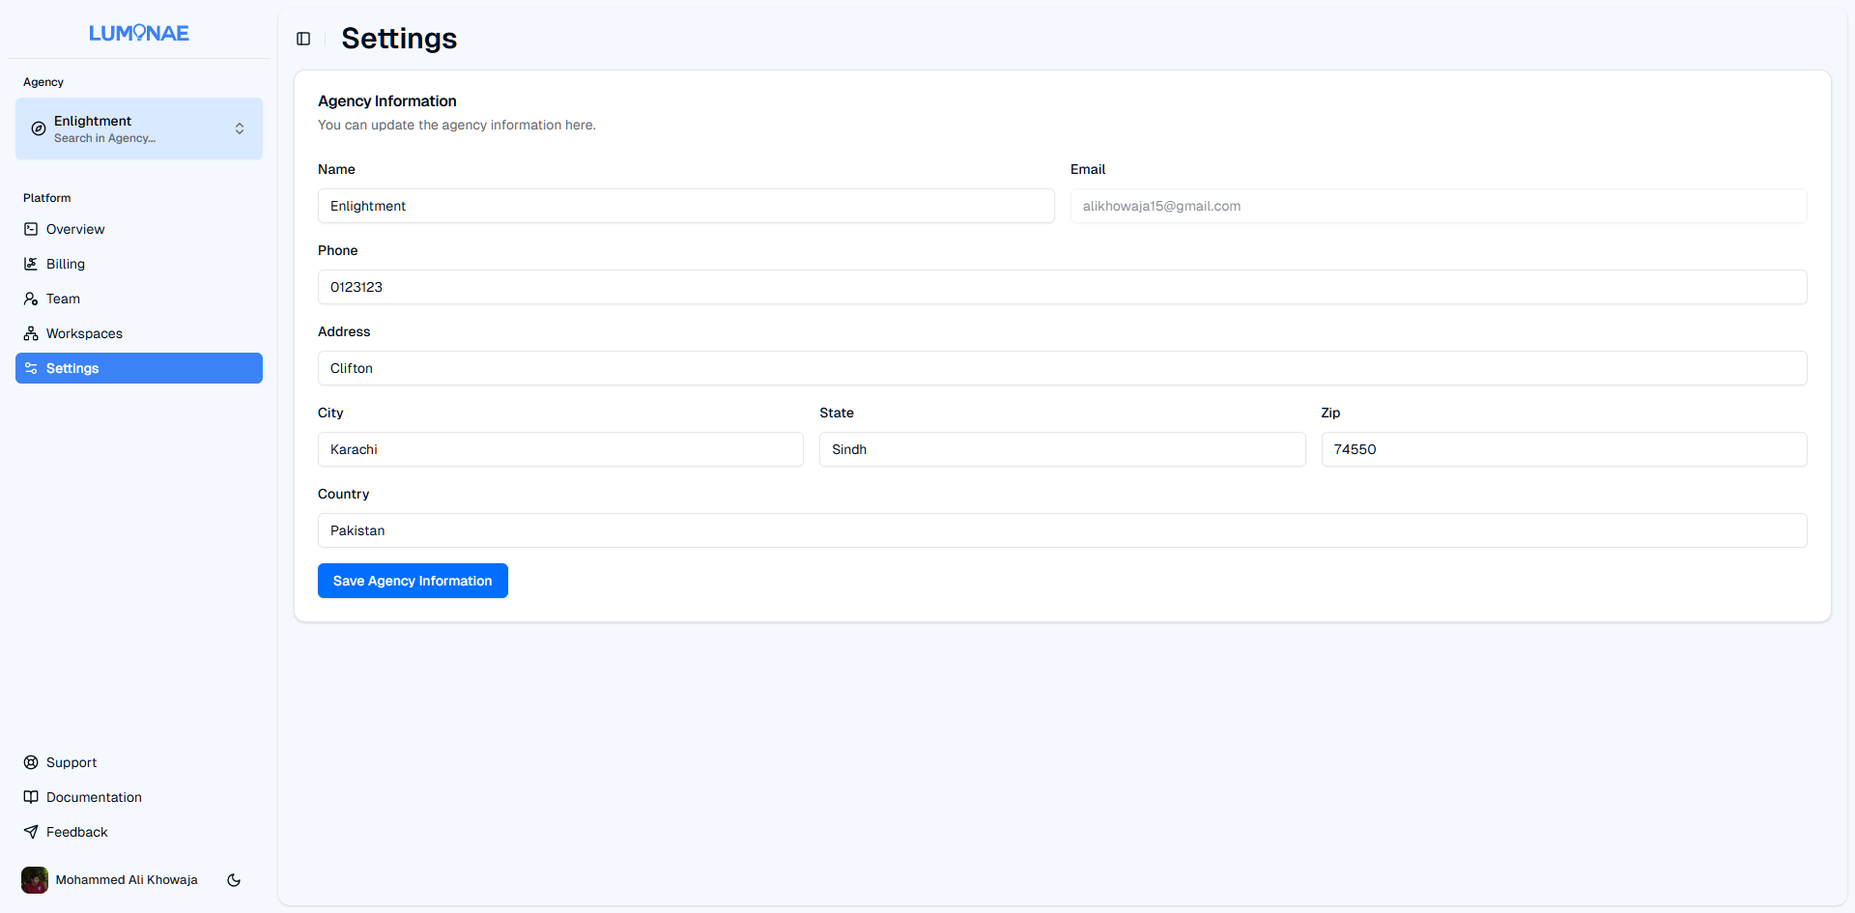

Figure 3.1.9 - Agency Details Update

Agency Workspaces
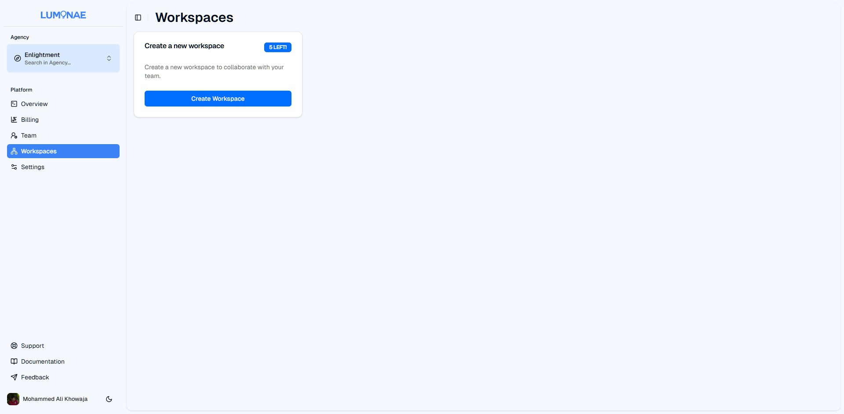

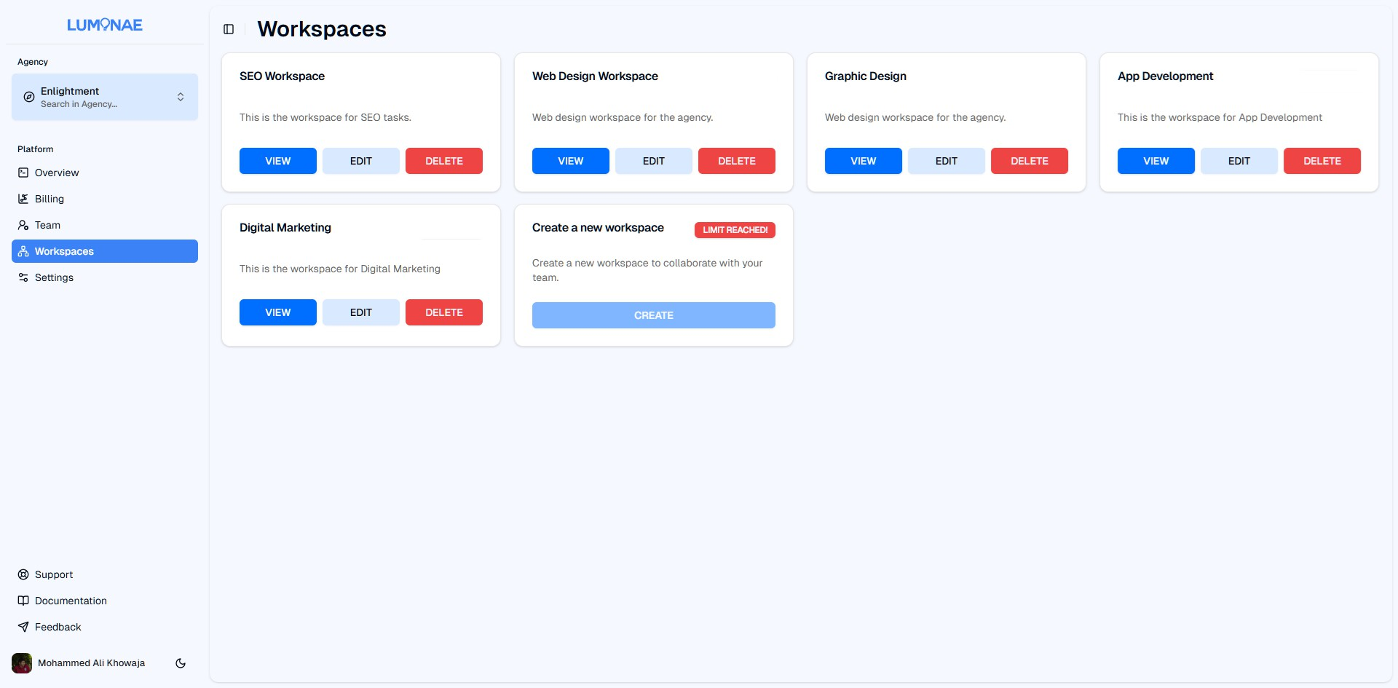

Figure 3.1.10 - Agency Workspaces List

Admin Dashboard
To be determined

Hardware Interfaces
Since Luminae is a web-based application, there are minimal hardware interface requirements. However, the system must work with the following hardware configurations:

Client:
Luminae is designed to be a hardware-agnostic application, ensuring compatibility with a wide range of devices including but not limited to desktop PCs, laptop PCs, tablets and smartphones. The software can be accessed through the web browser across various operating systems (Windows, MacOS, Linux, iOS, and Android). No specific hardware is required other than the ability to run a modern web browser that supports JavaScript and HTML5.

As for the data interactions between the software and hardware, it is facilitated via HTTP/HTTPS protocols. The platform, itself, does not directly interact with hardware components, rather relies on the web browser and the operating system’s functionalities to manage such peripheral interactions.

For network communication, the software relies on a steady internet connection over TCP/IP to ensure seamless communication between the different users of the platform.

Server:
Luminae is designed to run all server environments, as long as the environment is off the criteria as specified in heading 2.4, Operating Environment, and has access to a stable internet connection.

For data interactions between the client and the server, it is facilitated by the HTTP/HTTPS protocols. The platform, itself, does not directly interact with hardware components, rather relies on the interactivity provided by Node.js, the runtime environment for JavaScript applications.

For network communication, the software relies on a steady internet connection over TCP/IP to ensure seamless operation.

Software Interfaces
The software interacts with several software components. The primary software stack consists of:

- Node.js, which is a runtime environment for running JavaScript applications. Our full-stack web application, consisting of the front-end (user-facing) and back-end (application logic) is made with,
- Next.js 15, a powerful full-stack framework for web applications, based on React.js with several benefits such as server-side rendering for search engine optimization amongst others.
- React.js 19, to create very dynamic, interactive and responsive web interfaces using components.
- MySQL v8.0: Powers our data layer, which is our central data store and can be accessed by SQL queries. It stores and retrieves data related to the users, agencies, tasks and community posts. How the operating system interacts with the relational database is not exposed to the user and has no bearing.
- RESTful APIs, for communication between the front-end and back-end, RESTful APIs are employed. These APIs transmit data in JSON format over HTTP/HTTPS protocols and are stateless.
- Clerk Authentication, provides the user authentication and authorization, including password resets, one-time passwords and more.
  - Incoming Data: User credentials (username, password, and tokens).
  - Outgoing Data: User profile and access permissions.
- Payment Gateway: Luminae relies on Stripe (Sandbox) for all payment transactions, which handles payment authorization and settlements.
  - Incoming Data: Customer payment details, processed by Stripe.
  - Outgoing Data: Payment status updates sent back to the user’s interface.

The platform is designed to operate on any modern operating system that supports the required server and client environments (e.g., Windows, Linux, macOS).

All external dependencies (such as Next.js et cetera) are managed via npm, a package manager for Node.js ecosystem, with specific versions documented in the project’s package file.

Communications Interfaces
The following communications functions and protocols are required for the software to operate effectively. These include communication methods, protocols, security requirements, and message formatting standards.

Network Communication Protocols:
- HTTPS: The software will primarily communicate over HTTPS for secure data transmission between the client (web browser) and server.
- RESTful APIs: The software will expose and interact with third-party systems using RESTful APIs. All API requests and responses will use standard format, JSON, for data exchange.

System Features

Homepage

Description:
The Homepage serves as the landing page of the platform, providing navigation to other sections, showcasing the platform’s features, and guiding users to take action (e.g., choosing a plan). It includes multiple sections: Navigation bar, hero section, trusted by section, pricing, testimonials, and footer.

Stimulus/ Response Sequence:

Use Case Name: Navigation and Exploration of Homepage
Description: Users access the homepage to view platform features, navigate to other sections, and interact with the content.
Actors: Agency Owners, Users, Guests
Goal: To inform users about the platform and encourage them to take action.
Pre-Conditions: The homepage must be publicly accessible and fully loaded.
Basic Course of Events/ Main Flow:

1. User Action (Step 1):
The user opens the platform’s homepage.
System Response:

The system displays the homepage with the following sections: navbar, hero section, trusted by section, pricing, testimonials, and footer.
- User Action (Step 2)
The user uses the navbar to navigate to the documentation or support page.
System Response:
The system redirects the user to the selected page.

- User Action (Step 3):
The user scrolls to the pricing section and selects a plan.
System Response:
The system navigates the user to the checkout process for the selected plan.

- User Action (Step 4)
The user interacts with testimonials or views the "trusted by" section.
System Response:
The system displays testimonials and brand trust badges/logos.
Post Conditions: Agency owner is shown the Dashboard, User is shown the community page.
Table 1. Homepage Stimulus/Response Sequences

Functional Requirements:

Req.ID | Description | Priority | Status
Req 1 | The system shall display ‘Sign Up’ and ‘Sign In’ if not logged in, else ‘Dashboard’ if logged in. | High | Completed
Req 2 | The system shall include a pricing section allowing users to choose plans.. | High | Completed
Table 2. Homepage Functional Requirements

Sign-up Page

Description:
User sign-up feature allows new users to create an account by providing required details such as their name, email, password, and other optional information. This is the first step for users to access the platform.

Stimulus/ Response Sequence:

Use Case Name: Sign Up

Description: Users can sign up to create an account on the platform.
Actors: Agency Owners, Users
Goal: To create a new user account on the platform.
Pre-Conditions: User must not already have an account. Users must have a valid email address.
Basic Course of Events/ Main Flow:

- User Action (Step 1):
The user navigates to the nav bar and clicks on the "Sign-Up" button.
System Response:
The system presents the user with a sign-up form that includes fields for name, email, password, and optional fields like phone number or address.

- User Action (Step 2)
The user fills in the form and clicks on the "Submit" button.
System Response:
The system validates the input data:
  - Checks for valid email format.
  - Verifies password strength (e.g., minimum 8 characters, includes numbers/symbols).
  - Checks whether the password has been breached.
  - Ensures mandatory fields are not empty.

- User Action (Step 3):
The user submits the form with valid data.
System Response:
  - The system checks if the provided email is already in use.
  - If the email is already registered: The system shows an error message: "This email is already in use. Please log in or use a different email."
  - If the email is not registered: The system saves the new user’s data and sends a confirmation email to the provided email address.

- User Action (Step 4)
The user opens the confirmation email and clicks on the verification link.
System Response:
The system verifies the link and activates the user’s account. The user is then redirected to the login page with a success message.
Alternate Flow (Invalid Inputs): User Action:
The user submits the form with invalid data (e.g., incorrect email format, weak password).
System Response:
The system highlights the invalid fields and displays appropriate error messages such as:

- "Please enter a valid email address."
- "The password must be at least 8 characters long and contain both letters and numbers."
- “The password has been found in online breaches.”
Exception Flow (System Errors): System Failure:
If the system encounters a database or network error during submission:
System Response:
The system shows an error message like "System temporarily unavailable. Please try again later."
Post Conditions: Agency owner is shown the Dashboard, User is shown the community page.
Table 3. User Sign-Up Stimulus/Response Sequences

Functional Requirements:

Req.ID | Description | Priority | Status
Req 3 | The system shall display a sign-up form with fields for name, email, password, and optional fields like phone number and address. | High | Completed
Req 4 | The system shall validate the email format, password strength, and ensure required fields are filled before allowing form submission. | High | Completed
Req 5 | The system shall verify if the provided email address is already registered in the database. | High | Completed
Req 6 | The system shall store the user’s information in the database if the email is not already in use. | High | Completed
Req 7 | The system shall send a confirmation email containing a verification link after successful registration. | Medium | Completed
Req 8 | The system shall activate the user’s account once the verification link is clicked. | Medium | Completed
Req 9 | The system shall display appropriate error messages for any invalid input (e.g., email in use, weak password, or system error). | High | Completed
Table 4. User Sign-Up Functional Requirements

Sign-in Page

Description:
User sign-in feature allows new users to create an account by providing required details such as their name, email, password, and other optional information. This is the first step for users to access the platform.

Stimulus/Response Sequences:

Use Case Name: Sign In
Description: Users can sign in with their registered account.
Actors: Administrators, Agency Owners, Users
Goal: To sign into their already made account.
Pre-Conditions: User must not already have an account. Users must have a valid email address.
Basic Course of Events/ Main Flow:
- User Action (Step 1):
The user navigates to the home page and clicks on the "Sign-Up" button.
System Response:
The system presents the user with a sign-up form that includes fields for name, email, password, and optional fields like phone number or address.

- User Action (Step 2)
The user fills in the form and clicks on the "Submit" button.
System Response:
The system validates the input data:
  - Checks for valid email format.
  - Verifies password strength (e.g., minimum 8 characters, includes numbers/symbols).
  - Ensures mandatory fields are not empty.

- User Action (Step 3):
The user submits the form with valid data.
System Response:
  - The system checks if the provided email is already in use.
  - If the email is already registered: The system shows an error message: "This email is already in use. Please log in or use a different email."
  - If the email is not registered: The system saves the new user’s data and sends a confirmation email to the provided email address.

12. User Action (Step 4)
The user opens the confirmation email and clicks on the verification link.
System Response:
The system verifies the link and activates the user’s account. The user is then redirected to the login page with a success message.
Alternate Flow (Invalid Inputs) User Action:
The user submits the form with invalid data (e.g., incorrect email format, weak password).
System Response:
The system highlights the invalid fields and displays appropriate error messages such as:
- "Please enter a valid email address."
- "The password must be at least 8 characters long and contain both letters and numbers."
Exception Flow (System Errors): System Failure:
If the system encounters a database or network error during submission:
System Response:
The system shows an error message like "System temporarily unavailable. Please try again later."
Post Conditions: Agency owner is shown the Dashboard, User is shown the community page.
Table 5. User Sign-Up Stimulus/Response Sequences

Functional Requirements:
Req.ID | Description | Priority | Status
Req 10 | The system shall display a sign-up form with fields for name, email, password, and optional fields like phone number and address. | High | Completed
Req 11 | The system shall validate the email format, password strength, and ensure required fields are filled before allowing form submission. | High | Completed
Req 12 | The system shall verify if the provided email address is already registered in the database. | High | Completed
Req 13 | The system shall store the user’s information in the database if the email is not already in use. | High | Completed
Req 14 | The system shall send a confirmation email containing a verification link after successful registration. | Medium | Completed
Req 15 | The system shall activate the user’s account once the verification link is clicked. | Medium | Completed

Req 16 | The system shall display appropriate error messages for any invalid input (e.g., email in use, weak password, or system error). | High | Completed
Table 6. User Sign-Up Functional Requirements

Agency Creation

Description:
The Agency Creation Page allows agency owners to create and register their agencies after signing up. By filling out the required form with agency details, the owner will successfully set up their agency within the platform and be redirected to their agency dashboard for further management and customization.

Stimulus/ Response Sequence:

Use Case Name: Agency Registration
Description: Agency owners fill out a form to create their agency after signing up.
Actors: Agency Owners
Goal: To register and set up an agency profile on the platform.
Pre-Conditions: The agency owner must have completed the sign-up process and logged in.
Basic Course of Events/ Main Flow:
- User Action (Step 1):
Agency owner accesses the "Create Agency" page after signing up.
System Response:
The system displays a form with fields for agency details (logo, name, email, phone number, address, city, state, zip code, country).

- User Action (Step 2):
The agency owner fills in all the required fields and submits the form.
System Response:
The system validates the form data and creates the agency profile. Upon successful creation, the agency owner is redirected to the agency dashboard.
Alternate Flow (Invalid Inputs) User Action:

The user submits the form with insufficient or invalid data.
System Response:
The system highlights the invalid fields and displays appropriate error messages such as:
- "Please fill in all required fields correctly."
Post Conditions: The agency is now registered, and the owner has access to the dashboard for managing the agency’s operations.
Table 7. Agency Creation Stimulus/Response Sequences

Functional Requirements:

Req.ID | Description | Priority | Status
Req 17 | The system shall display a form for agency registration with the required fields. | High | Completed
Req 18 | The system shall validate the form inputs before processing the registration. | High | Completed
Req 19 | Upon successful submission, the system shall create the agency and redirect the owner to the dashboard. | High | Completed
Req 20 | The form shall include fields for agency logo, name, email, phone number, address, city, state, zip code, and country. | High | Completed
Table 8. Agency Creation Functional Requirements

Dashboard

Description:
The dashboard provides agency owners with an overview of their agency’s key metrics and allows them to track Key Performance Indicators (KPIs). It also serves as a launchpad for navigating various features via a dynamically generated sidebar. This includes managing agency performance, creating new workspaces, and overseeing financial transactions such as subscription fees. Agency owners can filter or search through sidebar options, and the platform integrates Stripe for subscription management and transaction fees.

Stimulus/ Response Sequence:

Use Case Name: Dashboard Navigation

Description: Agency owners can create their agency and view KPIs after successful sign-up.
Actors: Agency Owners
Goal: To provide a centralised view of agency performance and allow navigation through the sidebar.
Pre-Conditions: Agency creation must be completed successfully.
Basic Course of Events/ Main Flow:
- User Action (Step 1):
The agency owner logs into their account and is redirected to the dashboard.
System Response:
The dashboard displays key metrics such as the number of clients, revenue, and agency performance trends.

- User Action (Step 2):
The user accesses diﬀerent features using the sidebar (e.g., client management, billing, team management).
System Response:
The sidebar dynamically populates based on the agency owner's permissions and available features.
Alternate Flow (No Metrics Available) User Action:
The agency owner accesses the dashboard, but no KPIs are available due to lack of data.
System Response:
The system displays a placeholder message: "No metrics available. Start by creating workspaces or adding data to track performance."
Post Conditions: Users can view and manage their agency’s KPIs, create workspaces, and update billing.
Table 9. Agency Creation Stimulus/Response Sequences

Functional Requirements:

Req.ID | Description | Priority | Status
Req 21 | The system shall display a dashboard containing KPIs, such as number of clients, revenue, and active accounts. | High | Pending
Req 22 | The sidebar shall dynamically populate based on the user's role and permissions. | High | Completed

Req 23 | The dashboard shall integrate with Stripe to display financial data, including subscription fees and payments. | High | Pending
Table 10. Agency Creation Functional Requirements

Team Management

Description:
Agency owners can invite staﬀ members to assist in managing their agency. Owners can fine-tune access for each team member, assigning permissions at the workspace level. This feature supports email-based onboarding, allowing team members to create accounts with role-specific access.

Stimulus/ Response Sequence:

Use Case Name: Team Management
Description: Agency owners can add and manage staﬀ members and manage their permissions.
Actors: Agency Owners, Team Members.
Goal: To manage team members and delegate responsibilities.
Pre-Conditions: Agency must be created, and team members must have valid email addresses.
Basic Course of Events/ Main Flow:
- User Action (Step 1):
The agency owner or agency admin navigates to the Team Management section and selects “Invite Member.”
System Response:
The system presents a form for entering the staﬀ member's email address and role.

- User Action (Step 2):
The agency owner or admin assigns workspaces access and sends the invite.
System Response:
The staﬀ member receives an email to create an account and set a password.
Alternate Flow (Invalid Email) User Action:
The agency owner enters an invalid email address while inviting a team member, an already existing team member or an already sent out invitation.
System Response:
The system displays an error message:
- “Invalid email address entered. Please enter a valid email address.”

- “The specified email address is already invited.”
- “The specified email address already has joined your agency.”
Alternative Flow (Already Invited) User Action:
The agency owner enters an email address that is either already invited to join their agency or an email of a team member who is already part of the agency:
System Response:
The system displays an error message of:
- “The specified email address is already invited.”
- “The specified email address belongs to a team member who is already part of your agency.”
Alternative Flow (Invite Not Sent) User Action:
The system fails to send the invitation email due to server issues.
System Response:
The system notifies the user: "Invitation could not be sent. Please try again later."
Post Conditions: The team member is added with specific access levels to the agency and workspaces.
Table 9. Team Management Stimulus/Response Sequences

Functional Requirements:

Req.ID | Description | Priority | Status
Req 24 | The system shall allow agency owners to invite team members via email. | High | Pending
Req 25 | The system shall enable the agency owner to set specific permissions for each staff member across workspaces. | High | Pending
Req 26 | Team members shall have access to a dashboard view based on their assigned role and permissions. | Medium | Pending
Table 10. Team Management Functional Requirements

Workspace Creation

Description:

The Workspace Creation feature enables users to create dedicated workspaces for projects or clients, define their names and descriptions, and manage team collaboration eﬃciently.

Stimulus/ Response Sequence:

Use Case Name: Create a New Workspace
Description: Agency owners or admins create a new workspace and add its details, such as name and description.
Actors: Agency Owners, Team Members.
Goal: To organise projects and clients into distinct workspaces for streamlined management.
Pre-Conditions: Agency creation must be completed.
Basic Course of Events/ Main Flow:
- User Action (Step 1):
The agency owner clicks “Create Workspace” in the Workspace section or sidebar.
System Response:
The system displays a form for entering workspace details (e.g., name, description).

- User Action (Step 2):
The owner or admin fills out the form and submits it.
System Response:
The workspace is created, and added to the workspace section.
Alternate Flow (Duplicate Workspace Name) User Action:
The agency owner or admin attempts to create a workspace with a name that already exists for them.
System Response:
The system displays an error message: “A workspace with that name already exists in your agency. Please use a different name to avoid ambiguity.”
Alternate Flow (Missing Workspace Details): User Action:
The user tries to submit the form without entering required fields (e.g., workspace name).
System Response:
The system displays an error message: “Please fill in all required fields before proceeding.”
Post Conditions:
The new workspace is accessible by the owner and designated team members.
Table 11. Workspace Creation Stimulus/Response Sequences

Functional Requirements:

Req.ID | Description | Priority | Status
Req 27 | The system shall provide a “Create Workspace” option on the sidebar or workspace section. | High | Comple ted
Req 28 | The system shall display a form for entering workspace details, including name and description. | Medium | Pending
Req 29 | The system shall validate form submissions and display errors for missing required fields. | High | Pending
Table 12. Workspace Creation Functional Requirements

Kanban Board (Task Delegation)

Description:

The Kanban Board feature allows agency owners and their teams to create boards for tracking tasks and projects. Tickets can be assigned to team members and clients, tagged, and organised into lanes that reflect the project's status. This visual task management tool helps streamline workflows and collaboration.

Stimulus/ Response Sequence:

Use Case Name: Task Delegation
Description: Agency owners and team members create tickets and assign them to team members or clients.
Actors: Agency Owners, Team Members
Goal: To manage tasks through a visual Kanban board for agency projects.
Pre-Conditions: Agency creation must be completed, and the user must have workspaces or projects in place.
Basic Course of Events/ Main Flow:
21. User Action (Step 1):
The user creates a new Kanban board for a project.
System Response:
The system displays a board with lanes for diﬀerent project stages (e.g., “To Do,” “In Progress,” “Completed”).

22. User Action (Step 2):
The user creates a ticket and assigns it to a team member.
System Response:
The ticket is added to the appropriate lane, and the assigned team member is notified.
Alternate Flow (Empty Ticket Details) User Action:
The user creates a ticket but leaves the required fields empty (e.g. title, description etc.)
System Response:
The system displays an error message: “Please fill in all the required fields.”

Alternate Flow (Insufficient Permissions) User Action:
The user without the permissions tries to access the kanban board.
System Response:
The system displays an error message: “You do not have the necessary permissions to display this page.”
Post Conditions:
The ticket is updated in real time as the project progresses.
Table 13. Kanban Board Stimulus/Response Sequences

Functional Requirements:

Req.ID | Description | Priority | Status
Req 30 | The system shall provide a Kanban board with customizable lanes for managing tasks and projects. | High | Pending
Req 31 | Users shall be able to create, edit, and assign tickets within the Kanban board. | High | Pending
Req 32 | The system shall allow tagging and labelling of tickets for better task management. | Medium | Pending
Table 14. Kanban Board Functional Requirements

Admin Panel Overview

Description:

The Admin Panel Home Page serves as a central dashboard for platform administrators to navigate between various management sections. It includes an overview of agency activity, a list of agencies

that have signed up, and controls to approve or reject agency registrations. Additionally, it provides access to system metrics and platform settings.

Stimulus/ Response Sequence:

Use Case Name: Agency Approval
Description: Administrators can view and approve new agency registrations.
Actors: Platform Administrators
Goal: To verify and approve agencies for platform access.
Pre-Conditions: The agency must have submitted a complete registration form.
Basic Course of Events/ Main Flow:
- User Action (Step 1):
Administrator accesses the agency approval page from the home panel.
System Response:
The system displays a list of agencies awaiting approval.

- User Action (Step 2):
Administrator clicks "Approve" or "Reject" next to an agency’s name.
System Response:
The ticket is added to the appropriate lane, and the assigned team member is notified.
Alternate Flow (Agency Approval/Rejection Action Error) User Action:
The platform administrator attempts to approve or reject an agency, but the action fails
due to the agency being approved or rejected by another admin, possibly race condition or a system error.
System Response:
The system displays an error message: “Unable to perform the action. Please try again later .”
Post Conditions:
The ticket is updated in real time as the project progresses.
Table 15. Admin Panel Stimulus/Response Sequences

Functional Requirements:

Req.ID | Description | Priority | Status
Req 33 | The system shall display a list of agencies awaiting approval. | High | Pending
Req 34 | Administrators shall be able to approve or reject agency registrations. | High | Pending
Req 35 | The system shall notify agencies of approval or rejection decisions. | Medium | Pending
Table 16. Admin Panel Functional Requirements

Data/User Management Panel

Description:

The Data Management Panel provides platform administrators with full CRUD (Create, Read, Update, Delete) functionality for key data tables such as user accounts, agency profiles, and content moderation. It is the primary interface for managing system data and maintaining database integrity.

Stimulus/ Response Sequence:

Use Case Name: User Account Management
Description: Administrators can create, update, or delete user accounts.
Actors: Platform Administrators
Goal: To manage user data and ensure the integrity of the user database.
Pre-Conditions: The administrator must have full system privileges.
Basic Course of Events/ Main Flow:
- User Action (Step 1):
Administrator selects "User Management" from the Data Management Panel.
System Response:
The system displays a list of existing user accounts.

- User Action (Step 2):
Administrator selects an account and performs a create, update, or delete action.
System Response:
The system executes the CRUD operations and updates the user account database.
Alternate Flow (Invalid Operation) User Action:
The platform administrator attempts to delete a user account associated with an active

workspace.
System Response:
The system displays an error message: “Cannot perform that operation. That user account is part of an active workspace or agency.”
Post Conditions:
The changes are reflected in the system, and the user account data is updated accordingly.
Table 17. Data/User Management Panel Stimulus/Response Sequences

Functional Requirements:

Req.ID | Description | Priority | Status
Req 36 | The system shall provide CRUD functionality for managing user accounts. | High | Pending
Req 37 | Administrators shall be able to update, create, or delete agency profiles. | High | Pending
Req 38 | Administrators shall be able to update, create, or delete agency profiles. | Medium | Pending
Table 18. Data/User Management Panel Functional Requirements

Package Purchase

Description:

Allows users to select a subscription plan and proceed with the payment process to access premium features.

Stimulus/ Response Sequence:

Use Case Name: Choose a Subscription Plan
Description: Users can choose a plan, make a payment, and activate premium access.
Actors: Agency Owners

Goal: To enable users to purchase and activate a subscription plan.
Pre-Conditions:
- The user must be logged in.
- The system must support online payment gateways (e.g., Stripe).
Basic Course of Events/ Main Flow:
- User Action (Step 1):
The user clicks on "Choose a Plan" from the pricing page.
System Response:
The system displays available subscription plans.

- User Action (Step 2):
The user selects a plan and clicks "Proceed to Payment."
System Response:
The system redirects the user to the payment gateway.

- User Action (Step 3):
The user enters payment details and completes the transaction.
System Response:
The system processes the payment and displays a confirmation message.
Alternate Flow (Invalid Operation) User Action:
The payment fails due to insufficient funds or gateway errors.
System Response:
The system displays an error message: "Payment failed. Please try again."
Post Conditions:
On successful payment, the user’s account is upgraded, and they gain access to premium features.
Table 19. Package Purchase Stimulus/Response Sequences

Functional Requirements:

Req.ID | Description | Priority | Status
Req 39 | The system shall display available subscription plans. | High | Pending
Req 40 | The system shall redirect users to a secure payment gateway. | High | Pending
Req 41 | The system shall process payment transactions and confirm success or failure. | High | Pending

Req 42 | The system shall upgrade the user’s account after successful payment. | High | Pending
Req 43 | The system shall display appropriate error messages for failed payments | Medium | Pending

Table 20. Package Purchase Functional Requirements

Forgot Password

Description:

Enables users to reset their password by providing their registered email address and following a recovery process.

Stimulus/ Response Sequence:

Use Case Name: Forgot Password
Description: Users can reset their password by receiving a recovery link via email.
Actors: Agency Owners, Users
Goal: To allow users to recover access to their account.
Pre-Conditions:
- Users must have a registered email address.
Basic Course of Events/ Main Flow:
- User Action (Step 1):
The user clicks on the "Forgot Password" link on the login page.
System Response:
The system displays a form to enter the registered email address.

- User Action (Step 2):
The user enters their email address and clicks "Submit."
System Response:
The system verifies the email and sends a recovery link.

- User Action (Step 3):
The user clicks the recovery link and enters a new password.
System Response:
The system validates the new password, updates it in the database, and confirms success.

Alternate Flow (Invalid Operation) User Action:
The user submits an unregistered email address.
System Response:
The system displays an error message: "Email address not found."
Post Conditions:
The user can log in with the new password.
Table 21. Forgot Password Stimulus/Response Sequences

Functional Requirements:

Req.ID | Description | Priority | Status
Req 44 | The system shall display a "Forgot Password" link on the login page. | High | Completed
Req 45 | The system shall verify that the entered email exists in the database. | High | Completed
Req 46 | The system shall send a password recovery link to the registered email address. | High | Pending
Req 47 | The system shall validate and save the new password after user submission. | High | Pending
Req 48 | The system shall display appropriate error messages for invalid or unregistered email addresses. | Medium | Pending

Table 22. Forgot Password Functional Requirements

Login with Google

Description:

This feature allows users to log into the platform using their Google credentials. It simplifies the login process and eliminates the need to remember separate login details.

Stimulus/ Response Sequence:

Use Case Name: Login with Google

Description: Users can login to their existing account with Google credentials.
Actors: Agency Owners, Users
Goal: To enable quick and secure login via Google.
Pre-Conditions:
- Users must have an existing Google account.
- User already has an account registered on Luminae with that Google account.
- The system must be configured with OAuth 2.0 for Gmail authentication.
Basic Course of Events/ Main Flow:
- User Action (Step 1):
The user navigates to the login page and clicks on the "Login with Google" button.
System Response:
The system redirects the user to the Google OAuth authentication page.

- User Action (Step 2):
The user selects a Gmail account and grants permission to access their email address, and authenticates to the platform.
System Response:
The system verifies, and retrieves the user’s account linked to that Google account. If the account is not registered, then it creates a new account, otherwise logs in.
Post Conditions:
The user is logged in and redirected to the dashboard or community page.
Table 23. Login with Google Stimulus/Response Sequences

Functional Requirements:

Req.ID | Description | Priority | Status
Req 49 | The system shall display a "Login with Google" button on the login page. | High | Completed
Req 50 | The system shall use OAuth 2.0 for Gmail authentication. | High | Completed
Req 51 | The system shall redirect authenticated users to the dashboard. | High | Completed

Table 24. Login with Google Functional Requirements

Sign Up with Google

Description:

This feature allows users to create an account on the platform using their Google credentials. It simplifies the sign up process and eliminates the need to remember separate login details.

Stimulus/ Response Sequence:

Use Case Name: Sign Up with Google
Description: Users can sign up a new account with their existing Google account.
Actors: Agency Owners
Goal: To enable quick and secure account creation via Google.
Pre-Conditions:
- Users must have an existing Google account.
- The system must be configured with OAuth 2.0 for Gmail authentication.
Basic Course of Events/ Main Flow:
- User Action (Step 1):
The user navigates to the sign-up page and clicks the "Sign Up with Google" button.
System Response:
The system redirects the user to the Google OAuth authentication page.

- User Action (Step 2):
The user selects a Google account, grants permission to access their email address, and authenticates.
System Response:
The system retrieves the user's email and creates a new account associated with it. The user is redirected to the dashboard.
Alternate Flow (Account Already Exists):
User Action: The user attempts to sign up with a Google account already registered.
System Response: The system instead logs the user into their existing account.
Post Conditions:
The user is registered and redirected to the dashboard or community page.
Table 25. Sign up with Google Stimulus/Response Sequences

Functional Requirements:

Req.ID | Description | Priority | Status
Req 52 | The system shall display a "Register with Google" button on the login page. | High | Completed
Req 53 | The system shall use OAuth 2.0 for Gmail authentication. | High | Completed
Req 54 | The system shall redirect authenticated users to the dashboard. | High | Completed

Table 26. Sign up with Google Functional Requirements

Contact/ Support Form

Description:

The Contact/Support page allows users to reach out for support by submitting a contact form with their details and message.

Stimulus/ Response Sequence:

Use Case Name: Submit a Contact Form
Description: Users can fill out and submit a contact form to send a support query or message to the platform team.
Actors: Users
Goal: To enable users to seek support or provide feedback.
Pre-Conditions:
- The contact form must be functional.
Basic Course of Events/ Main Flow:
- User Action (Step 1):
The user navigates to the Contact/Support page.
System Response:
The system displays the contact form with fields for name, email, subject, and message.

- User Action (Step 2):
The user fills out the form and clicks the "Send" button.
System Response:
The system validates the form, sends the message via email, and displays a success message: “Your message has been sent successfully.”

Alternate Flow (Account Already Exists):
User Action: The user submits the form without filling all required fields.
System Response: The system displays an error message: “Please fill in all required fields.”
Post Conditions:
The user’s query is sent successfully, and they receive a confirmation message
Table 27. Contact Form Stimulus/Response Sequences

Functional Requirements:

Req.ID | Description | Priority | Status
Req 55 | The system shall display a contact form with fields for name, email, subject, and message. | High | Pending
Req 56 | The system shall validate form submissions and display error messages for incomplete forms. | High | Pending
Req 57 | The system shall send form data to the platform administrators. | Medium | Pending
Req 58 | The system shall display success messages upon successful form submission. | Medium | Pending

Table 28. Contact Form Functional Requirements

Notifications & Alerts

Description:

The Notifications and Alerts feature keeps users informed about key events, such as task assignments, team member activity, and workspace updates.

Stimulus/ Response Sequence:

Use Case Name: Create a New Workspace
Description: Notify team members when they are assigned a task. Notify agency admins/owners when a team member accepts or declines an invitation to join the workspace.
Actors: Agency Owners, Team Members

Goal: To keep stakeholders updated and informed of key actions.
Basic Course of Events/ Main Flow:
- User Action:
The agency owner assigns a task to a team member.
System Response:
The system displays a form for entering workspace details (e.g., name, description).

- User Action:
A team member accepts an invite to join the workspace.
System Response:
The system sends a notification to the agency admin/owner: “[Team Member Name] has accepted your invitation to join the workspace.”
Post Conditions:
Notifications are sent to relevant stakeholders, ensuring all actions are communicated promptly.
Table 29. Notification & Alerts Stimulus/Response Sequences

Functional Requirements:

Req.ID | Description | Priority | Status
Req 59 | The system shall send task assignment notifications to the relevant team members. | High | Pending
Req 60 | The system shall send notifications when a team member accepts an invitation to join a workspace. | High | Pending
Req 61 | The system shall send notifications when a team member declines an invitation to join a workspace. | High | Pending
Table 30. Notifications & Alerts Functional Requirements

Media Storage/ Management

Description:

The Media Storage/Management feature allows users to upload, organise, and manage files within a workspace. Files can be categorised, tagged, and shared with team members or clients, ensuring smooth collaboration and eﬃcient resource access.

Stimulus/ Response Sequence:

Use Case Name: File Upload and Organization
Description: Agency owners and team members upload, manage, and share files for project purposes.
Actors: Agency Owners, Team Members
Goal: To centralise media storage and simplify collaboration.
Basic Course of Events/ Main Flow:
- User Action (Step 1):
The user navigates to the media storage section within a workspace.
System Response:
The system displays options to upload files and view existing media.

- User Action (Step 2):
The user uploads a new file.
System Response:
The system uploads the file, and stores it securely.
Alternate Flow (Insuﬃcient Storage):
User Action: The user attempts to upload a file exceeding the allocated storage limit. System Response: The system displays an error message: “Storage limit exceeded. Please free up space or upgrade your plan.”
Post Conditions:
The media file is stored securely and accessible for team collaboration.
Table 31. Media Storage Stimulus/Response Sequences

Functional Requirements:

Req.ID | Description | Priority | Status
Req 62 | The system shall allow users to upload files in supported formats (e.g., PNG, JPG, PDF, et cetera) | High | Pending
Req 63 | The system shall generate a shareable link for files to be shared with team members or clients. | High | Pending
Req 64 | The system shall display an error message for unsupported file formats. | High | Pending
Req 65 | The system shall check and enforce storage limits during file | High | Pending

uploads.
Table 32. Media Storage Functional Requirements

Adding Team Member to Workspace

Description:

This feature allows users to add an existing team member to a specific workspace by navigating to the Teams page, selecting the team member, and assigning them via a pop-up interface.

Stimulus/ Response Sequence:

Use Case Name: Add Team Member to Workspace
Description: Agency owners or admins can assign team members to a specific workspace for collaboration.
Actors: Agency Owners, Team Members
Goal: To enable team members to access and collaborate within designated workspaces.
Pre-Conditions:
- The team member must already exist in the system.
Basic Course of Events/ Main Flow:
- User Action (Step 1):
The user navigates to the Teams page and clicks on the team member’s name.
System Response:
The system displays a pop-up with the option to add the team member to a workspace.

- User Action (Step 2):
The user selects the desired workspace from the pop-up menu and confirms the action.
System Response:
The system assigns the team member to the selected workspace and sends a notification to the team member.
Alternate Flow (Missing Required Information):
User Action: The user tries to add a team member without completing required fields in the pop-up (e.g., selecting a workspace).
System Response: The system displays an error message:
“Please complete all required fields before adding a team member to the workspace.”
Post Conditions:
The team member is successfully added to the workspace and gains access to its resources and tasks.

Table 33. Adding Team Member Stimulus/Response Sequences

Functional Requirements:

Req.ID | Description | Priority | Status
Req 66 | The system shall allow users to view a pop-up for assigning team members to a workspace. | High | Pending
Req 67 | The system shall notify the team member once they are added to the workspace. | High | Pending
Table 34. Adding Team Member Functional Requirements

Adding Client Details to a Workspace

Description:

This feature allows users to add client details to a workspace for better organisation and tracking of client-specific tasks and projects.

Stimulus/ Response Sequence:

Use Case Name: Add Client Details to Workspace
Description: Agency owners or admins can add client details such as name, contact, location, status, and ticket size to a workspace.
Actors: Agency Owners, Team Members
Goal: To associate clients with specific workspaces for streamlined management.
Pre-Conditions:
- The user must have permissions to edit the workspace.
Basic Course of Events/ Main Flow:
- User Action (Step 1):
The user navigates to the workspace and selects the “Add Client” option.
System Response:
The system displays a form for entering client details (name, contact, city, state, country, status, ticket size).

- User Action (Step 2):
The user fills in the required fields and submits the form.
System Response:

The system validates the input, adds the client details to the workspace, and displays a confirmation message.
Alternate Flow (Missing Required Information):
User Action: The user submits the form without completing all required fields.
System Response: The system displays an error message: “Please fill in all required fields before submitting.”
Post Conditions:
The client details are stored in the workspace and are visible to users with the appropriate access permissions.
Table 35. Adding Client Details Stimulus/Response Sequences

Functional Requirements:

Req.ID | Description | Priority | Status
Req 68 | The system shall provide a form to enter client details, including name, contact, city, state, and country. | High | Pending
Req 69 | The system shall validate the form fields before saving client details. | High | Pending
Req 70 | The system shall allow users to assign a status and ticket size to the client. | Medium | Pending
Req 71 | The system shall store client details in the workspace database and display them in the client section. | High | Pending
Req 72 | The system shall display an error message for incomplete or invalid form submissions. | Medium | Pending
Req 73 | The system shall restrict client addition to users with workspace editing permissions. | High | Pending
Table 36. Adding Client Details Functional Requirements

Community Front Page
TBD

Agency Page
TBD

Community Forums
TBD

Community Posting
TBD

Editing Posts
TBD

Deleting Posts
TBD

Assign custom package
TBD

Other Nonfunctional Requirements

Performance Requirements
- The system should have a small turnaround time (not more than 2 seconds) in displaying the user’s action.
- The system should support many users at an instance without performance degradation.
- The system should be able to handle a large number of transactions, such as client management updates, task completions, and payment submissions.

Safety Requirements
The system must include regular backups of the database to prevent data loss in the event of a server failure.

Security Requirements
- The system should encrypt all user authentication data.
- The system should destroy all of the user’s session data after logout.
- Sensitive information such as payment details should not be stored in the system but handled securely through Stripe.
- All data in transit must be encrypted using SSL/TLS protocols.

Software Quality Attributes
- Adaptability: Luminae must be flexible enough to accommodate future enhancements, such as adding new features or modules without significant redesign. This can be achieved through a modular design.

- Availability: The platform should ensure 99.9% uptime, guaranteeing minimal downtime for users. Planned maintenance should be scheduled during oﬀ-peak hours and communicated to users well in advance.

- Correctness: All features and functions of Luminae must perform as expected and deliver accurate results, ensuring that all calculations, data updates, and reports are error-free.

- Flexibility: The system should allow easy configuration to meet the unique requirements of diﬀerent agency users, including customizable dashboards, reports, and user workflows.

- Interoperability: Luminae must seamlessly integrate with third-party services and tools such as Stripe and Clerk ensuring that data flows smoothly between these systems.

- Maintainability: The system should be easy to maintain. All the system documents should be easy to understand and the codebase should follow standard development practices to ensure it can be easily updated or modified in the future.

Portability: Luminae should be deployable across multiple operating systems and cloud platforms with minimal configuration changes, ensuring that users can access the platform from various devices and environments.

- Reliability: The platform must demonstrate high reliability with a focus on redundancy and
failover mechanisms to handle any system or network failures.

- Reusability: Key components of the platform, such as the authentication module, task management, and reporting functions, should be designed for reuse in other future projects or modules.

- Robustness: Luminae must handle unexpected user inputs, system load fluctuations, and hardware or software failures gracefully, ensuring the platform remains stable under various conditions.

- Testability: The system must include built-in testing mechanisms to validate functionalities at every stage of development. All features should be easily testable with automated testing frameworks like Jest for frontend and unit testing for backend services.

- Usability: The user interface should be intuitive and accessible, allowing users of varying technical expertise to interact with the system easily. The interface should minimise the learning curve, oﬀering clear navigation and functionality.

- Scalability: The system will scale vertically by utilising more powerful hardware. Changes to the architecture may be required to scale horizontally.

Business Rules
The following business rules outline the operating principles of the Luminae platform, specifying which user roles can perform particular functions under certain circumstances. These rules ensure proper access control and user management across the system.

Agency Owners:

      - Functionality:
        - Can create and manage multiple client accounts and sub-accounts.
        - Have full access to performance tracking tools, billing options, and financial reporting.
        - Can invite team members and assign roles within the platform.
        - Can upgrade or downgrade subscription plans and access premium features.

        - Can modify agency-wide settings, including Stripe payment integration.

Access Permissions:
        - Full control over all agency-related functions and features.
        - Can assign and revoke access rights for team members and clients.

Team Members (Agency Employees)
      - Functionality:
        - Can view and manage tasks assigned by the agency owner.
        - Have access to reporting features relevant to the tasks they are responsible for.
        - Can collaborate with other team members within assigned projects.

Access Permissions:
        - Limited access to task management and reporting features.
        - Cannot modify agency settings or client accounts.
        - Only access the parts of the system that the agency owner has assigned.

Platform Administrators (Luminae staff)

      - Functionality:
        - Manage user accounts and permissions across the entire platform.
        - Verify new agencies and audit user activity to ensure platform compliance.
        - Troubleshoot system issues and apply patches or updates as needed.
        - Oversee billing and subscription management across all agencies.

Access Permissions:
        - Full access to the system, including administrative tools, user management, and auditing.
        - Can suspend or deactivate user accounts in case of non-compliance or breaches of terms.

Users

      - Functionality:
        - Can participate in community discussions and engage with posts.
        - Can comment, like, or share content within the community features.

Access Permissions:
  - Limited to read-only or community interaction features.
  - Cannot access administrative tools, task management, or client accounts.

Other Requirements

MoSCoW Analysis
The MoSCoW method helps prioritise system features by categorising them into Must have, Should have, Could have, and Won't have. Below are the considerations for Luminae:

Could Have:
- Question Submission and Participation for Free Users
This feature would allow free users to post queries in a designated section of the community, where agencies could participate by answering these questions. It provides a space for knowledge sharing and interaction, fostering engagement within the platform.
  - Benefit: Encourages user participation and helps agencies showcase their expertise.
  - Priority: Could be included in future phases, depending on resource and time allocation.

Won't Have:
- Calendar Booking System & Chat System
Luminae will not include a calendar booking system like Calendly or a real-time chat system. These features are outside the scope of the platform’s current focus and would add complexity, diverting attention from core functionality like client management, performance tracking, and community collaboration.
  - Reasoning: The platform's primary aim is to streamline operations and foster agency collaboration, and adding real-time chat or booking functionalities would overcomplicate the initial build and maintenance.

Appendix A: Glossary

Term | Definition
API | Application Programming Interface. Allows communication between different software applications.
Authentication | The process of verifying the identity of a user or system.
Authorization | The process of granting or denying access to a resource.
Client | A company or individual who contracts an agency for services.
Clerk | A third-party service used by Luminae for user authentication and authorization.
JSON | JavaScript Object Notation. A lightweight data-interchange format.
MySQL | A relational database management system used for managing Luminae's data storage.
RESTful API | Representational State Transfer. A web service that allows interaction with external systems using HTTP methods like GET, POST, and DELETE.
SaaS | Software as a Service. A software distribution model where applications are hosted in the cloud and accessed via the internet.
Stripe | A payment processing service used by Luminae for handling transactions.
TBD | To Be Determined. A placeholder for missing or uncertain information.
Two-Factor Authentication (2FA) | A security process where a user provides two different authentication factors to verify their identity.
x86 Architecture | A family of instruction set architectures used by most modern personal computers and servers.

Appendix B: Analysis Models
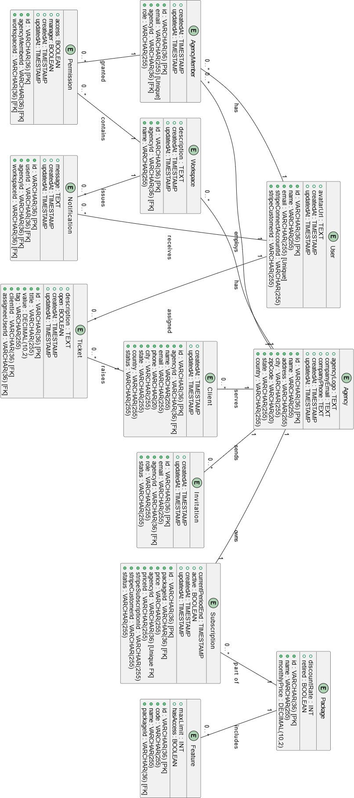
ERD:

Appendix C: To Be Determined List

TBD  Number | Description | Section
TBD 1 | Diagrams such as the use class, activity, and system diagrams, showing how data is structured and related within the system are to be defined. | Appendix B: Analysis Models
TBD 2 | The User Interface (UI) design for key user-facing elements of the platform, including dashboards, forms, and navigation menus, remains to be defined. | Section 3.1: User Interfaces
TBD 3 | All system features, including the Community Front Page, Agency Page, Community Forums, and Assign Custom Package, are yet to be fully defined and detailed. | Section 4: System Features

