For example, let us parallelize the following for loop
sum = 0;
#pragma omp parallel for shared(sum)
for (i = 0; i < 9; i++)
{
sum += a[i]
}
But a parallelization of the above for loops is tricky. There is a shared variable (sum ) which is modified in every iteration. If we are not careful when parallelizing such for loops, we might introduce data races.

#include<stdio.h>
#include<omp.h>
main()
{
float *Array, serial_sum, sum;
int array_size, i;
printf("Enter the size of the array\n");
scanf("%d", &array_size);
if (array_size <= 0) {
printf("Array Size Should Be Of Positive Value ");
exit(1);
}
/* Dynamic Memory Allocation */

Array = (float *) malloc(sizeof(float) * array_size);
/* Array Elements Initialization */
for (i = 0; i < array_size; i++) {
Array[i] = i * 5;

}
printf("The Array Elements Are \n");
for (i = 0; i < array_size; i++)
printf("Array[%d]=%f\n", i, Array[i]);

sum = 0.0;
/* OpenMP Parallel For Directive */
#pragma omp parallel for shared(sum)
for (i = 0; i < array_size; i++)
{
sum = sum + Array[i];
}
serial_sum = 0.0;
/* Serail Calculation */
for (i = 0; i < array_size; i++)
serial_sum = serial_sum + Array[i];
if (serial_sum == sum)
printf("\nThe Serial And Parallel Sums Are Equal\n");
else {
printf("\nThe Serial And Parallel Sums Are UnEqual\n");

}

/* Freeing Memory */
free(Array);
printf("\nThe SumOfElements Of The Array Using OpenMP Directives Is %f\n", sum);
printf("\nThe SumOfElements Of The Array By Serial Calculation Is %f\n", serial_sum);
}

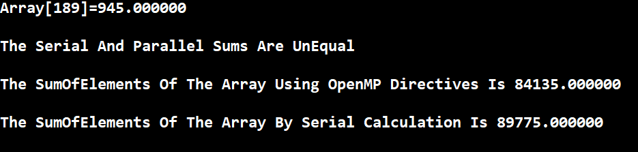

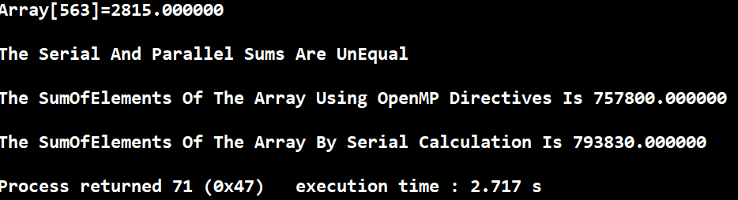
Parallel loop Reduction
A private copy for each list variable is created and initialized for each thread. At the end of the reduction, the reduction variable is applied to all private copies of the shared variable, and the final result is written to the global shared variable.

SYNTAX
reduction(operator:var)

Eg:
reduction(+:sum)

where,
operator
The operator for the operation to perform on the variables (var) at the end of the parallel region.
var
One more variables on which to perform scalar reduction. If more than one variable is specified, separate variable names with a comma.

Implementation
How does OpenMP parallelize a for loop declared with a reduction clause? OpenMP creates a team of threads and then shares the iterations of the for loop between the threads. Each thread has its own local copy of the reduction variable. The thread modifies only the local copy of this variable. Therefore, there is no data race. When the threads join together, all the local copies of the reduction variable are combined to the global shared variable.
For example, let us parallelize the following for loop
sum = 0;
#pragma omp parallel for shared(sum, a) reduction(+: sum)
for (i = 0; i < 9; i++)
{
sum += a[i]
}
and let there be three threads in the team of threads. Each thread has sumloc, which is a local copy of the reduction variable. The threads then perform the following computations
- Thread 1
sumloc_1 = a[0] + a[1] + a[2]
- Thread 2
sumloc_2 = a[3] + a[4] + a[5]
- Thread 3
sumloc_3 = a[6] + a[7] + a[8]
In the end, when the treads join together, OpenMP reduces local copies to the shared reduction variable
sum = sumloc_1 + sumloc_2 + sumloc_3
The following figure is another representation of this process.
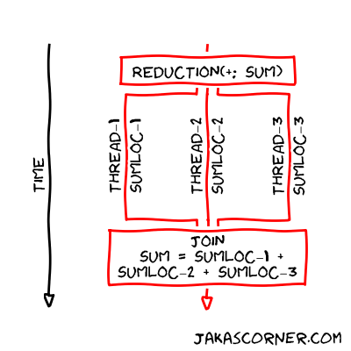
Arithmetic reductions: +,∗,−,max,min
Logical operator reductions in C: & && | || ^

Combined parallel loop reduction

#include <omp.h>
#include <stdio.h>
#include <stdlib.h>

int main (int argc, char *argv[])
{
int i, n;
float a[100],sum;

/* Some initializations */
n = 12;
for (i=0; i < n; i++)
a[i] = i * 1.0;
sum = 0.0;

#pragma omp parallel for reduction(+:sum)
for (i=0; i < n; i++)
sum = sum +a[i];

printf(" Sum = %f\n",sum);

}

Orphaned parallel loop reduction

#include <omp.h>
#include <stdio.h>
#include <stdlib.h>
#define VECLEN 12

float a[VECLEN], b[VECLEN], sum;

float dotprod ()
{
int i,tid;

tid = omp_get_thread_num();
#pragma omp for reduction(+:sum)
for (i=0; i < VECLEN; i++)
{
sum = sum + (a[i]*b[i]);
printf(" tid= %d i=%d\n",tid,i);
}
}

int main (int argc, char *argv[]) {
int i;

for (i=0; i < VECLEN; i++)
a[i] = b[i] = 1.0 * i;
sum = 0.0;

#pragma omp parallel
dotprod();

printf("Sum = %f\n",sum);

}

Combined parallel loop reduction

#include <omp.h>
#include <stdio.h>
#include <stdlib.h>

int main (int argc, char *argv[])
{
int i, n, tid;
float a[100], b[100], sum;

/* Some initializations */
n = 12;
for (i=0; i < n; i++)
a[i] = b[i] = i * 1.0;
sum = 0.0;
#pragma omp parallel for reduction(+:sum)
for (i=0; i < n; i++)
{
tid = omp_get_thread_num();
sum = sum + (a[i] * b[i]);
printf(" tid= %d i=%d\n",tid,i);
}
printf(" Sum = %f\n",sum);

}

Exercise

1. Write a parallel loop that computes the maximum and minimum values in an array.

