Assignment 2:LCD and Reaction Timer V1

Image
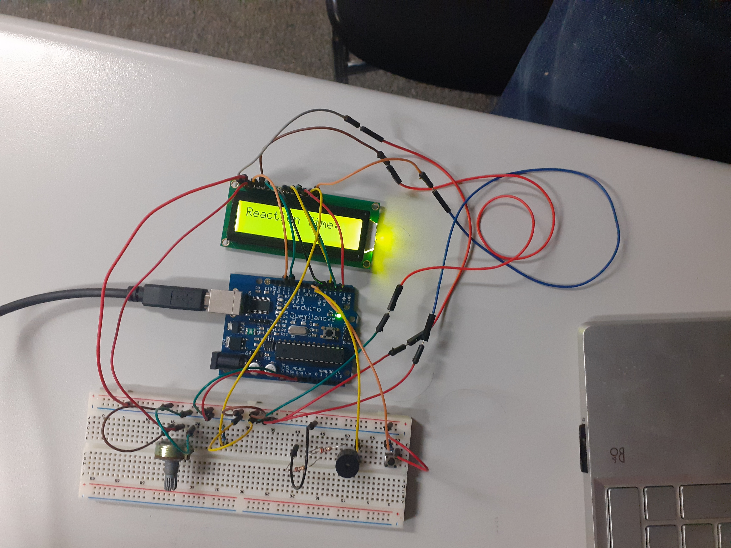

Circuit Diagram
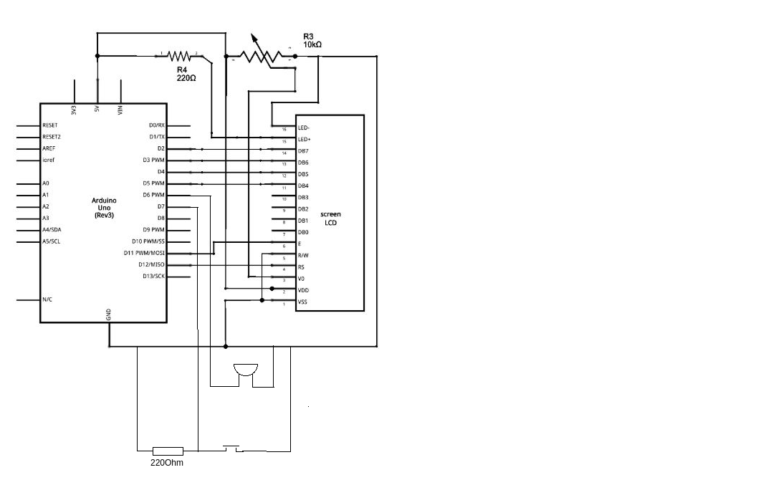

Code
/*
LiquidCrystal Library - Hello World

Demonstrates the use a 16x2 LCD display. The LiquidCrystal
library works with all LCD displays that are compatible with the
Hitachi HD44780 driver. There are many of them out there, and you
can usually tell them by the 16-pin interface.

This sketch prints "Hello World!" to the LCD
and shows the time.

The circuit:
LCD RS pin to digital pin 12
LCD Enable pin to digital pin 11
LCD D4 pin to digital pin 5
LCD D5 pin to digital pin 4
LCD D6 pin to digital pin 3
LCD D7 pin to digital pin 2
LCD R/W pin to ground
LCD VSS pin to ground
LCD VCC pin to 5V
10K resistor:
ends to +5V and ground
wiper to LCD VO pin (pin 3)

Library originally added 18 Apr 2008
by David A. Mellis
library modified 5 Jul 2009
by Limor Fried (http://www.ladyada.net)
example added 9 Jul 2009
by Tom Igoe
modified 22 Nov 2010
by Tom Igoe
modified 7 Nov 2016
by Arturo Guadalupi

This example code is in the public domain.

http://www.arduino.cc/en/Tutorial/LiquidCrystalHelloWorld

*/

// include the library code:
#include <LiquidCrystal.h>
#define BUZZER 6
#define BUTTON 7

// initialize the library by associating any needed LCD interface pin
// with the arduino pin number it is connected to
const int rs = 12, en = 11, d4 = 5, d5 = 4, d6 = 3, d7 = 2;
LiquidCrystal lcd(rs, en, d4, d5, d6, d7);
const int time_before_buzz = random(10000);
bool buzzed = false;
bool pressed = false;
void setup() {
// set up the LCD's number of columns and rows:
lcd.begin(16, 2);
// Print a message to the LCD.
lcd.print("Reaction Time:");
pinMode(BUZZER, OUTPUT);
pinMode(BUTTON, INPUT);
Serial.begin(9600);

}

void loop() {
static int buzz_time;
lcd.setCursor(0,1);
// if the random amount of time has passed and this is our first time round the loop
if (millis() >= time_before_buzz && !buzzed) {
// set the buzzer pin to high
PORTD |= 0b01000000;
buzzed = true;
buzz_time = millis();
}
if (PIND&0b10000000 && !pressed && buzzed){
Serial.println("button pressed");
PORTD &= 0b10111111;
lcd.print(millis()- buzz_time);
pressed=true;
}

}

