

An Analysis of 10 Drugs for the Treatment of

Squamous Cell Carcinoma (SCC),

**Prepared for Pymaceuticals Inc by:**

**Firdosh Patel**

**March 7th, 2020**

=====================================================================================

TABLE OF CONTENTS

=====================================================================================

**SUMMARY** 2

**KEY FINDINGS / CONCLUSIONS** 3

====================================================================================

# **SUMMARY**

===================================================================================

Pymaceuticals Inc., a burgeoning pharmaceutical company based out of San Diego, specializes in anti-cancer pharmaceuticals. In its most recent efforts, it began screening for potential treatments for squamous cell carcinoma (SCC), a commonly occurring form of skin cancer.

We were given access to the complete data by Pymaceuticals from their most recent animal study. In this study, 249 mice identified with SCC tumor growth were treated across 10 drug regimens, over the course of 45 days, wherein the tumor development in the mice were observed and measured.

The data provided to us consisted of the following details for the 249 mice spread across 10 Drug Regimens over 45 days:

* **Mouse ID**
* **Sex**
* **Age (months)**
* **Weight (g)**
* **Tumor Volume (mm3)**
* **Drug Regimen**

We analyzed the dataset using **pandas** (which is a software library written for the Python programming language for data manipulation and analysis) and **matplotlib** (which is a Matplotlib is a plotting library for the Python programming language).

This Paper presents the key findings / conclusions that we believe should help Pymaceuticals with valuable insights regarding the most promising Drug Regimens (Capomulin and Ramicane).

====================================================================================

# **KEY FINDINGS / CONCLUSIONS**

===================================================================================

1. **Drug Regimens with the Lowest Average Tumor Volume:**
   1. Of the 10 total Drug Regimens in the entire Dataset, Pymaceuticals asked us to analyze the 4 most promising Drug Regimens (Capomulin, Ceftamin, Infubinol and Ramicane).
   2. Based on our analysis of these 4 promising Drugs, the 2 best Drugs were:
      1. Capomulin, and
      2. Ramicane
   3. These results are visually displayed in the BoxPlot below that shows the Final Tumor Volume for each of the 25 mice that were treated with the 4 Drugs.

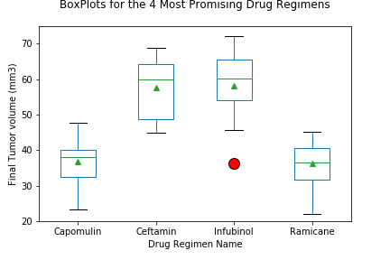

* 1. As can be seen in the BoxPlot on the previous page, the average Final Tumor Volumes (mm3) were:
     1. Capomulin:
        1. Quartile 1 (25th Percentile): 32.38
        2. Quartile 3 (25th Percentile): 40.16
        3. Inter-Quartile Range: 7.78
     2. Ramicane:
        1. Quartile 1 (25th Percentile): 31.56
        2. Quartile 3 (25th Percentile): 40.66
        3. Inter-Quartile Range: 9.10
     3. Ceftamin:
        1. Quartile 1 (25th Percentile): 48.72
        2. Quartile 3 (25th Percentile): 64.30
        3. Inter-Quartile Range: 15.58
     4. Infubinol:
        1. Quartile 1 (25th Percentile): 54.05
        2. Quartile 3 (25th Percentile): 65.53
        3. Inter-Quartile Range: 11.48
  2. As can be seen above, Capomulin and Ramicane had the lowest average tumor volume.

1. **Drug Regimens with the Highest Survival Rate:**
   1. Of the 10 total Drug Regimens in the entire Dataset, Pymaceuticals asked us to analyze the 4 most promising Drug Regimens (Capomulin, Ceftamin, Infubinol and Ramicane).
   2. Based on our analysis of these 4 most promising Drugs, the 2 Drugs with the best survival rates were:
      1. Capomulin, and
      2. Ramicane
   3. These results are visually displayed in the Bar Chart below that shows the number of Mice at the Start (Day 0) and End (Day 45) of the Test Trials for each of the 4 Drugs



* 1. As can be seen in the Chart above, all 4 Drugs had 25 Mice at the Start (Day 0).
  2. However, by Day 45 the number of surviving mice were:
     1. Capomulin: 21
     2. Ramicane: 20
     3. Ceftamin: 13
     4. Infubinol: 09

1. **Relationship between Weight (g) and Tumor Volume (mm3):**
   1. Given findings 1 and 2, we decided to focus on the 2 most promising Drugs Capomulin and Ramicane, and looked at the relationship between Weight (g) and the Average Tumor Volume (mm3).
   2. **Capomulin:**
      1. There is a positive relationship between Weight and the Average Tumor Volume.
      2. The correlation between Weight and the Average Tumor Volume is **0.84**.
      3. The Regression Line Equation is as follows:

**Average Mouse Tumor Volume (mm3) = 0.95 times Mouse Weight (g) + 21.55**

* + 1. This can be visually seen in the Scatter Plot below:

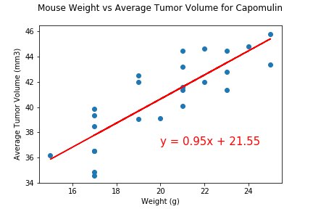

* 1. **Ramicane:**
     1. There is a positive relationship between Weight and the Average Tumor Volume.
     2. The correlation between Weight and the Average Tumor Volume is **0.81**.
     3. The Regression Line Equation is as follows:

**Average Mouse Tumor Volume (mm3) = 0.77 times Mouse Weight (g) + 25.16**

* + 1. This can be visually seen in the Scatter Plot below:

