# ERD_DB_Pewlett_Hackard_Employees Documentation

Link to schema: <https://app.quickdatabasediagrams.com/#/d/OhVrmh>

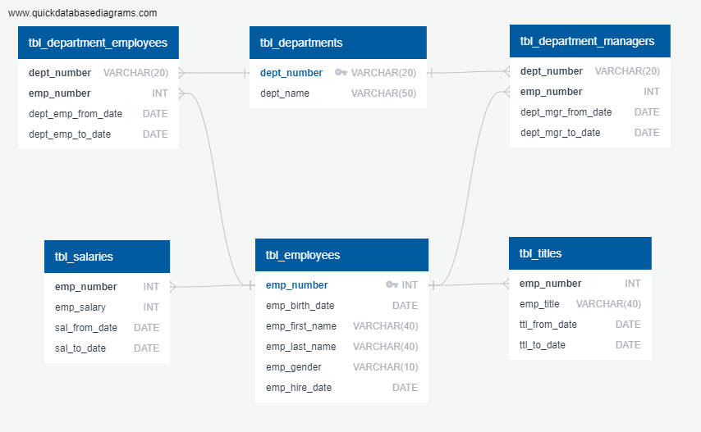

ERD Description:

As can be seen in the ERD on Page 1, we have 6 tables in this Database.

We have primary keys in 2 tables as follows:

1. tbl_departments:
   1. The Primary Key is the column dept_number.
   2. It has unique values.
2. tbl_employees:
   1. The Primary Key is the column emp_number.
   2. It has unique values.

We have foreign keys in 4 tables as follows:

1. tbl_salaries:
   1. We have one Foreign Key:
      1. It is the column emp _number.
         1. It references the column emp_number in the table “tbl_employees”.
         2. This is set up as a one-to-many relationship, because the salary of an employee can change over time i.e. you could have more than one record per employee in the table “tbl_salaries”.
2. tbl_titles:
   1. We have one Foreign Key:
      1. It is the column emp _number.
         1. It references the column emp_number in the table “tbl_employees”.
         2. This is set up as a one-to-many relationship, because the title of an employee can change over time i.e. you could have more than one record per employee in the table “tbl_titles”.
3. tbl_department_employees:
   1. We have two Foreign Key:
      1. The first Foreign Key is the column emp _number.
         1. It references the column emp_number in the table “tbl_employees”.
         2. This is set up as a one-to-many relationship, because the department of an employee can change over time i.e. you could have more than one record per employee in the table “tbl_department_employees”.
      2. The second Foreign Key is the column dept _number.
         1. It references the column dept_number in the table “tbl_departments”.
         2. This is set up as a one-to-many relationship, because the department of an employee can change over time i.e. you could have more than one record per employee in the table “tbl_department_employees”.
4. tbl_department_managers:
   1. We have two Foreign Key:
      1. The first Foreign Key is the column emp _number.
         1. It references the column emp_number in the table “tbl_employees”.
         2. This is set up as a one-to-many relationship, because the manager of a department can change over time i.e. you could have more than one record per department in the table “tbl_department_managers”.
      2. The second Foreign Key is the column dept _number.
         1. It references the column dept_number in the table “tbl_departments”.
         2. This is set up as a one-to-many relationship, because the manager of a department can change over time i.e. you could have more than one record per department in the table “tbl_department_managers”.

The following pages provide a detailed description of the fields in each of these 6 tables.

## tbl_departments

| Field | Description | Type | Default | Other |
| --- | --- | --- | --- | --- |
| dept_number | Department Number | VARCHAR(20) | None | PK |
| dept_name | Department Name | VARCHAR(50) | None |  |

## tbl_employees

| Field | Description | Type | Default | Other |
| --- | --- | --- | --- | --- |
| emp_number | Employee Number | INT | None | PK |
| emp_birth_date | Employee Birth Date | DATE | None |  |
| emp_first_name | Employee First Name | VARCHAR(40) | None |  |
| emp_last_name | Employee Last Name | VARCHAR(40) | None |  |
| emp_gender | Employee Gender | VARCHAR(10) | None |  |
| emp_hire_date | Employee Hire Date | DATE | None |  |

## tbl_salaries

| Field | Description | Type | Default | Other |
| --- | --- | --- | --- | --- |
| emp_number | Employee Number | INT |  | FK |
| emp_salary | Employee Salary | INT |  |  |
| sal_from_date | From Date | DATE |  |  |
| sal_to_date | To Date | DATE |  |  |

## tbl_titles

| Field | Description | Type | Default | Other |
| --- | --- | --- | --- | --- |
| emp_number | Employee Number | INT |  | FK |
| emp_title | Employee Title | VARCHAR(40) |  |  |
| ttl_from_date | From Date | DATE |  |  |
| ttl_to_date | To Date | DATE |  |  |

## tbl_department_employees

| Field | Description | Type | Default | Other |
| --- | --- | --- | --- | --- |
| dept_number | Department Number | VARCHAR(20) | None | FK |
| emp_number | Employee Number | INT | None | FK |
| dept_emp_from_date | From Date | DATE | None |  |
| dept_emp_to_date | To Date | DATE | None |  |

## tbl_department_managers

| Field | Description | Type | Default | Other |
| --- | --- | --- | --- | --- |
| dept_number | Department Number | VARCHAR(20) | None | FK |
| emp_number | Employee Number | INT | None | FK |
| dept_mgr_from_date | From Date | DATE | None |  |
| dept_mgr_to_date | To Date | DATE | None |  |