Count the customers with grades above Bangalore’s average

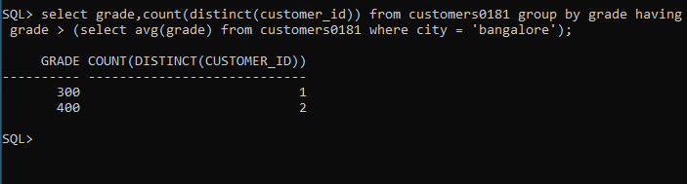

Find the name and numbers of all salesman who had more than one customer

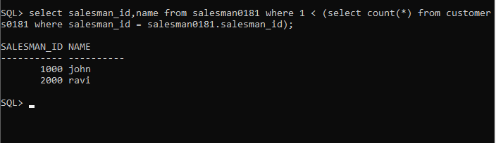

List all salesman names and customer names for whom order amount is more than 4000

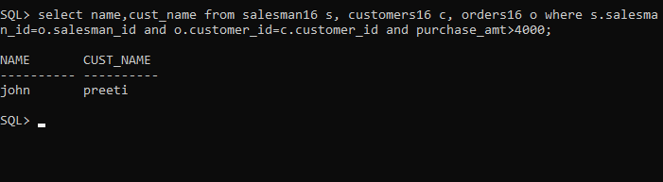

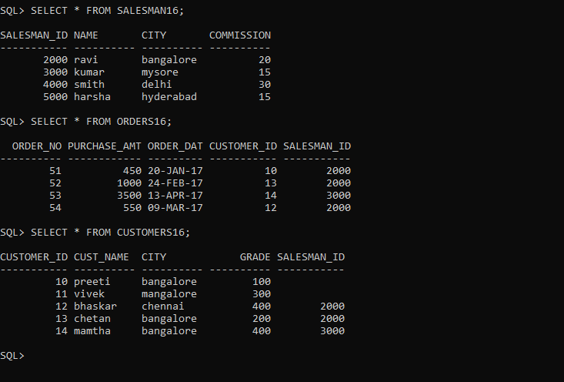Demonstrate the delete operation by removing salesman with id 1000. All his orders must also be deleted