- https://gpay10.com/new/admin/epay-modal/edit/2 admin mode a discription a link system kora jay na . link jate kaz kore , and button er name deoa jay but button er sathe o akta link korar system thkbe
- https://gpay10.com/new/admin/review
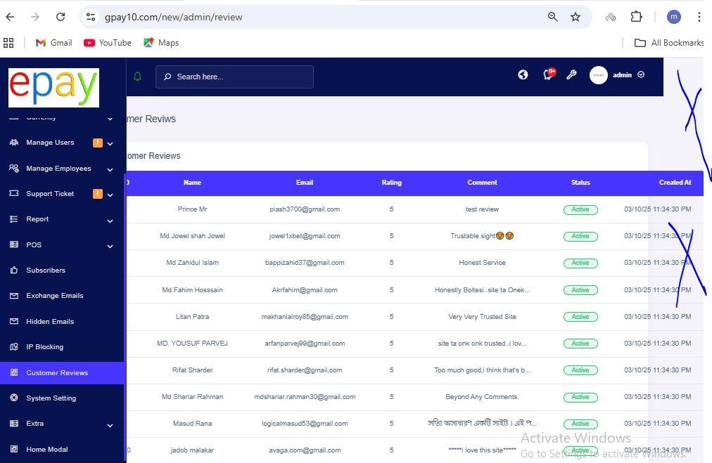
design ta te somossa padding thik nai
- https://gpay10.com/new/admin/blocked-ip ata ip block aga kaz korto akhn kortase na
- https://gpay10.com/new/admin/forward-emails email dubol astase
- https://gpay10.com/new/admin/report/referral/commission ata kivabe kaz kore dekte hobe
- https://gpay10.com/new/contact login sara kao Contact With Us a submit button a click korte parbe na . click korle user k notification dibe j login first
- https://gpay10.com/new/admin/employees emply to make kora jay but same to same power er super admin kora jay na
- https://gpay10.com/new/admin/users/send-notification Send via firebase system ta ki ? kivabe kaz kore ? and kaz kore naki chk kore slv kore dite hobe .
- https://gpay10.com/new/admin/exchange/details/13292 user jokhn usdt sale day tokon rate change korle o change kora rate show kore na kano ? slv korben and ki karone amon hoy dekhe onno kono tay o jate amon somossa na hoy seta dekben … amar mone hoy USD
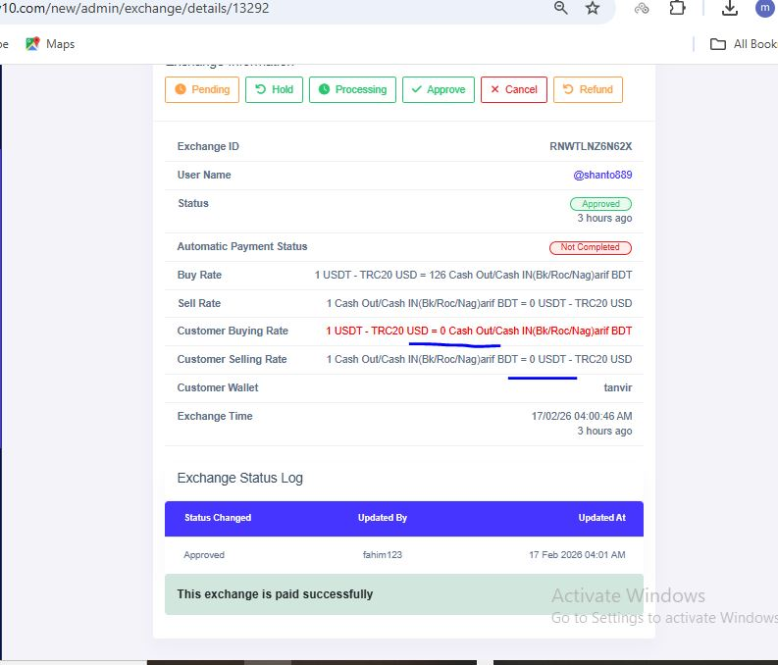
,euro currency hole amon hoy defolt a BDT ase . so akto bujhe nien kano amon hoy . rate 00 dekhasse
- Ai rate ta 4 digit er dekhate hobe .. ata koto digit seta ki hard code kora naki kono option theke passe ?
- Employ ra akhn o pending order k cncl korte pare na , processing a niya er por cncl kora lage ,, and time er o jame la ase may b
- Amra to chaile exchange list theke file download korte pari ,, upload er o akta system banate hobe …. Upload korle sob pending a thkbe er por confirm korle kothay kothy effect porbe ta aga e akbar bolsilam and kora o silo .
- https://gpay10.com/new/admin/setting/system-configuration ai systm gula sob chk korte hobe .
- Aga akhn a see all name a akta button asto akhn astase na kano dekte hobe
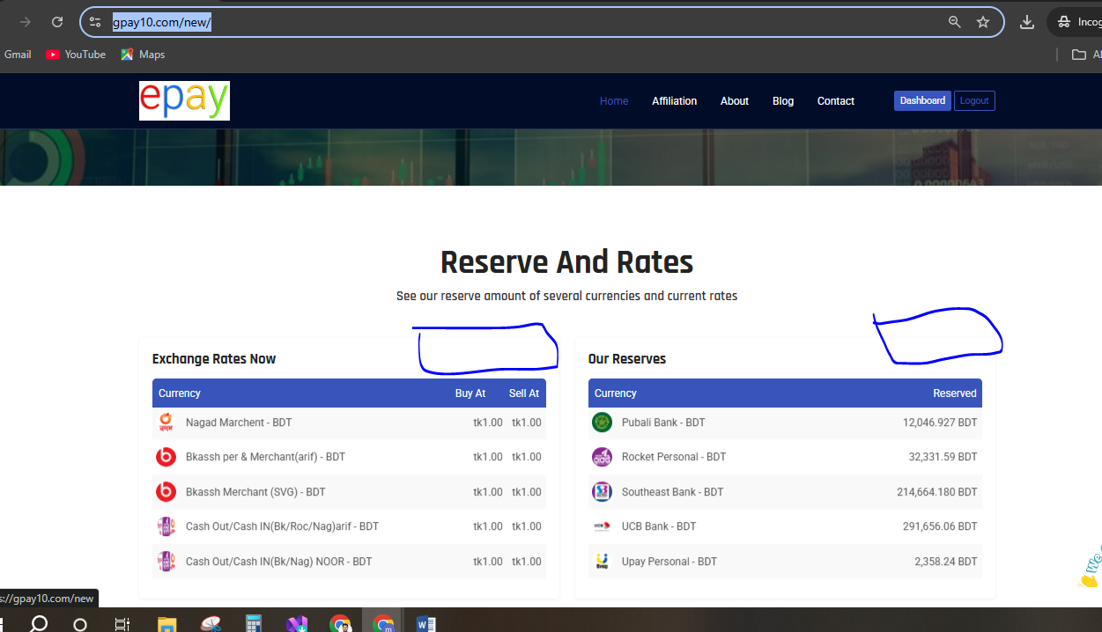
- https://script.viserlab.com/changalab/demo/ home page er desing a amader tay akta ase r akhn a dui ta ata thik korte hobe
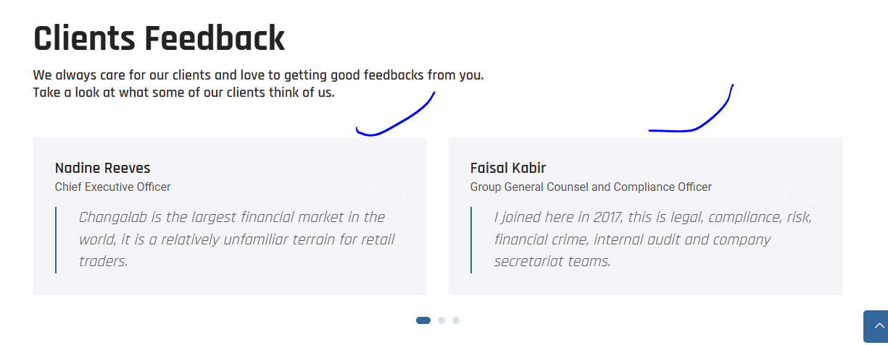
- Exchange list er Ai filter gula akhn a na diya jar jar sathe mathr upor diya dite hobe and auto search hobe . and r o kisu filter barate hobe , auto filte r na dite parle o somossa nai .
ata niya amar sathe akto kotha bole niben kaz e raga ..
status , update buy ,plase by er moddhe multi filter system ante hobe . additional field search kora jabe
update just line by line with related filter
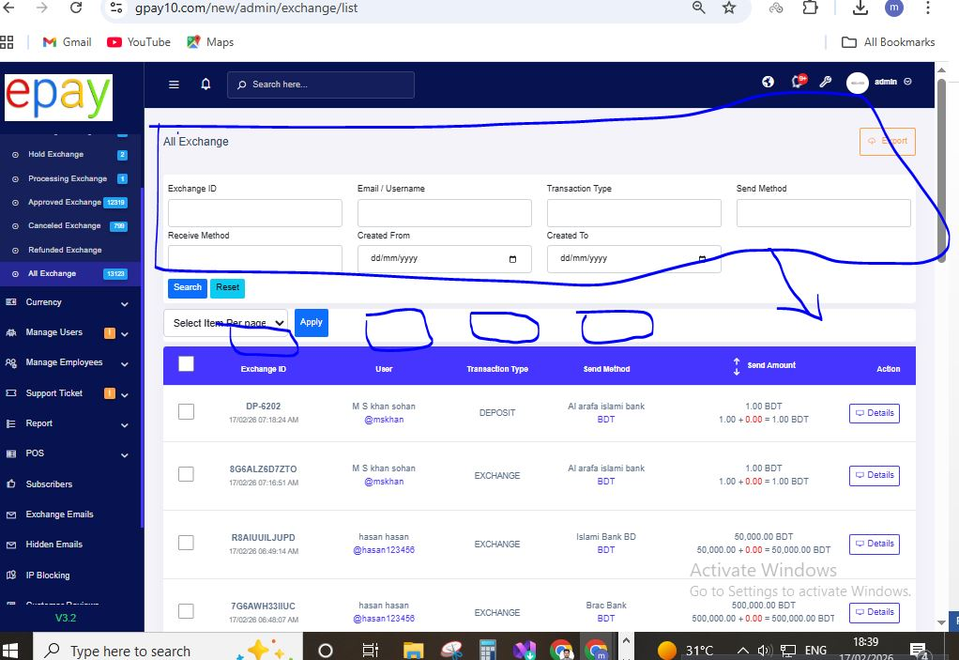
- https://gpay10.com/new/admin/notification/sms/setting bulk sms systm ta chk kora hoy nai korte hobe
sms dile may b jasse but body full jasse na ,
email eu same problem
- https://gpay10.com/new/admin/gateway/automatic payon bank er system ta chk korte hobe
- https://script.viserlab.com/changalab/demo/admin/cron/index akhn a corn job er setup ta dekhe amader tay o thik korte hobe
https://gpay10.com/new/admin/cron/index
- Employ ra pending r processing a mark all system pabe action button a sudhu approve option ta e thkbe
- In The Exchange Email There should be a filter for note and archiving functionality.

