BTRC EOI Response - Specific Experience
Part 2: CDR Analyzer System (CAS)

BTRC Requirement:
Bidder shall have at least 2 (two) practical experiences in developing monitoring/analytics/SAS/OSS/BSS/QoS platforms or integrated service management platforms with integration to at least 3 external systems (e.g. NMS, billing, CRM, ERP).

Project: CDR Analyzer System (CAS)
Client | Bangladesh Telecommunication Regulatory Commission (BTRC)
Location | BTRC Data Center, Dhaka
Platform Type | CDR Mediation & Central Billing System for all ICX operators
Data Scale | 400+ Million CDRs per day
Status | Production - Running

Project Description:
The CDR Analyzer System (CAS) is a large-scale CDR data processing system deployed at BTRC Data Center that generates analytics and QoS data from massive volumes of Call Detail Records. The system processes over 400 million CDRs daily from all ICX (Interconnection Exchange) operators in Bangladesh.

QoS Analytics Generated:
- • ASR (Answer Seizure Ratio) - Critical metric for voice call quality
- • ACD (Average Call Duration) - Key indicator for IP call quality assessment
- • Traffic volume analytics and trend analysis
- • Call completion statistics per operator/route
- • Revenue reconciliation and billing verification

Technical Complexity:
The system requires tremendous expertise in decoding and integrating with various switch vendor CDR formats. Each vendor has proprietary CDR structures requiring custom parsers and data transformation logic.

Switch Vendor CDR Integration:
- • Huawei
- • ZTE
- • Nokia
- • Cataleya
- • Dialogic
- • Genband
- • WTL (World Telecom Labs)

External System Integrations (42+ Systems):

Integration with 42 Softswitches of all ICX operators supporting both IP and TDM protocols.

Integration Type | Count | Description
Softswitch CDR Feed | 42 | Real-time CDR collection from all ICX softswitches
IP Protocol Integration | Multiple | SIP, H.323, SIGTRAN based CDR formats
TDM Protocol Integration | Multiple | SS7/ISUP based CDR formats
Billing System | 1 | Central billing reconciliation
BTRC Reporting Portal | 1 | Analytics dashboard integration
Operator Portals | Multiple | Individual ICX operator access

Requirement Compliance:
This project demonstrates Telcobright's capability in developing large-scale analytics/QoS platforms with integration to significantly more than 3 external systems (42+ softswitch integrations plus billing and reporting systems).

Technical Documentation & Screenshots:
[Screenshots and technical diagrams to be added]
BTRC CAS ICX Portal User Manual for Daily Report Submission

1. Login
- Open the BTRC CAS ICX Portal.
- Enter your Username and Password.
- Click Login.
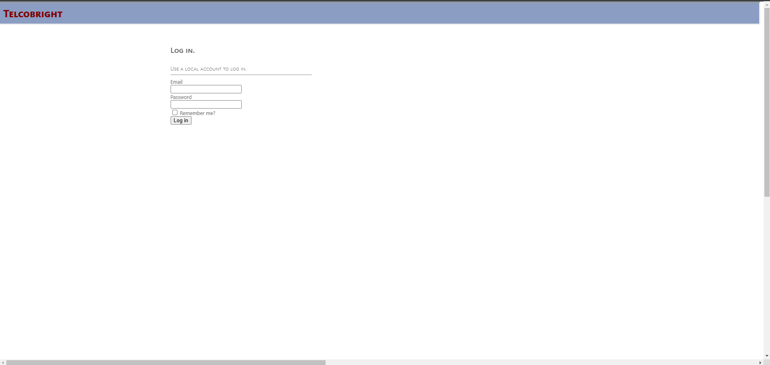

2. Dashboard Overview
Once logged in, you will see the Dashboard, which provides:
- A summary of Domestic, International Incoming, and International Outgoing data.
- The CDR processing status.
- Alerts if any TGs (Trunk Groups) are missing.

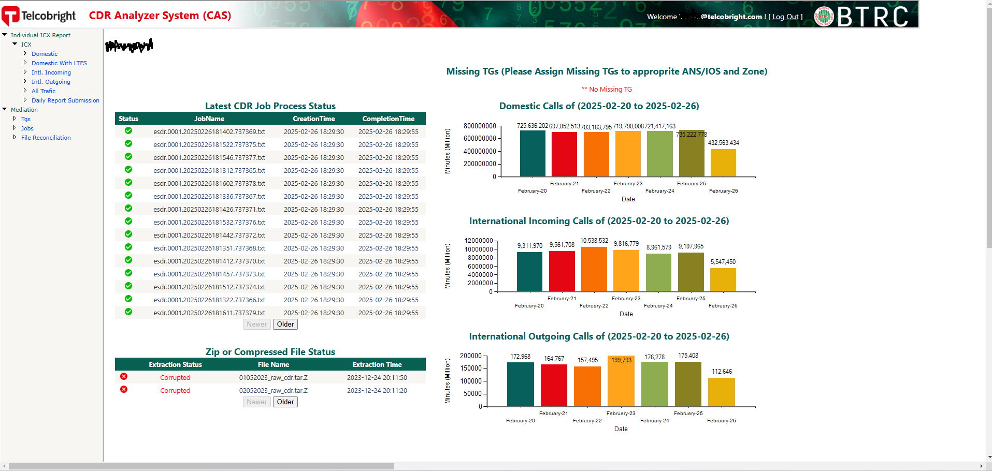

3. Submitting Daily Reports

Step 1: Navigate to the Submission Page
- Click on Daily Report Submission from the sidebar.
- The Daily Report Submission page will appear.

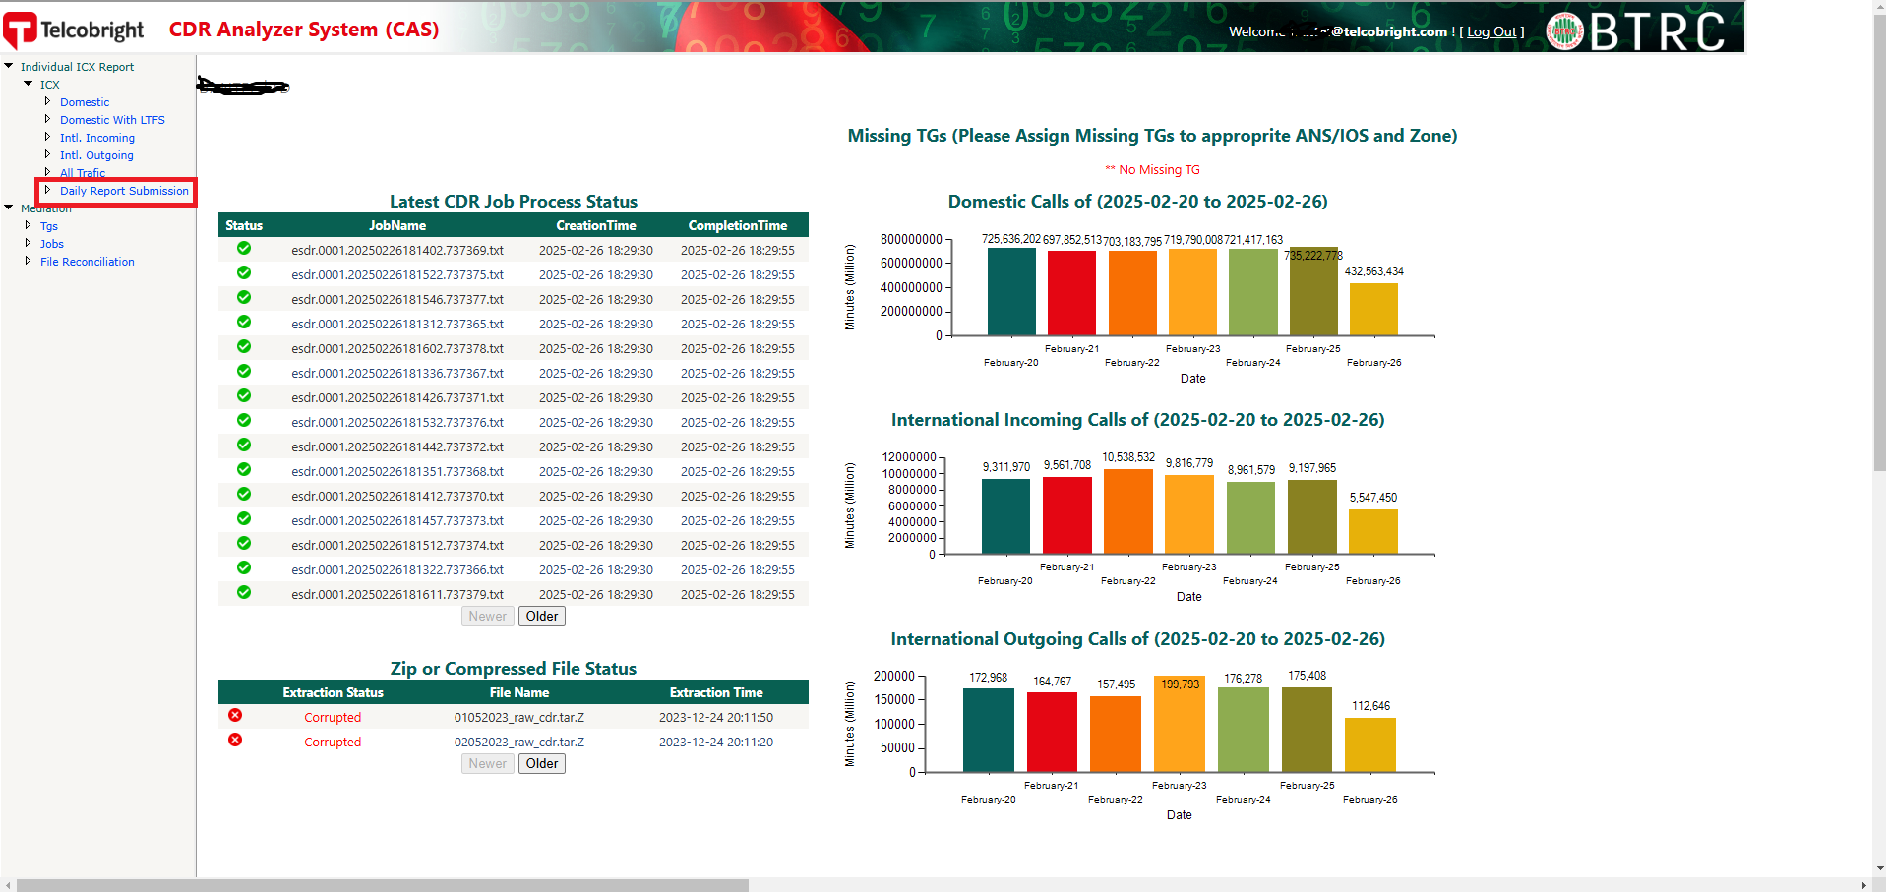

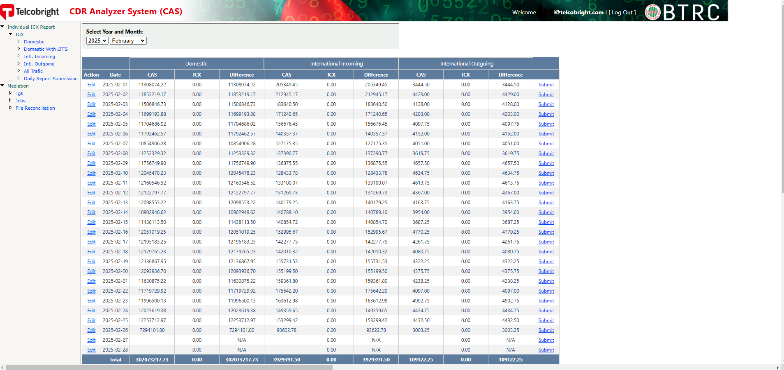

Step 2: Enter Billing Data
- Click the Edit button.
- Input your daily billed duration for:
  - Domestic
  - International Incoming
  - International Outgoing
- Click Update to save the data.
- The Difference column will show any discrepancies.

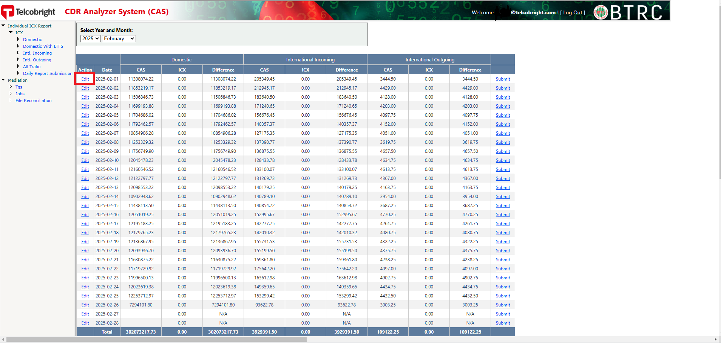

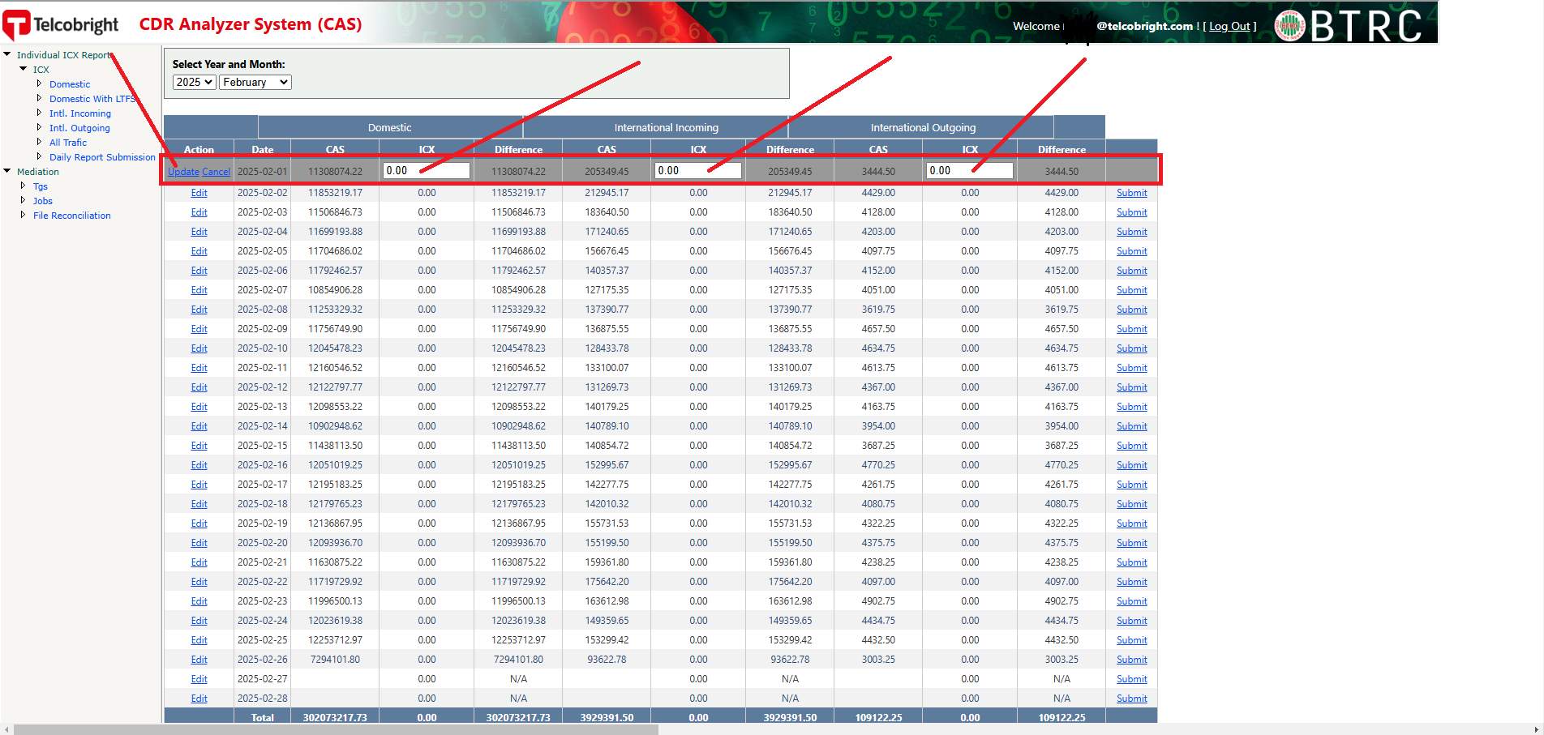

Step 3: Submit the Report
- If all data is correct and no disputes are found, click Submit.
- Your daily report is now successfully submitted.

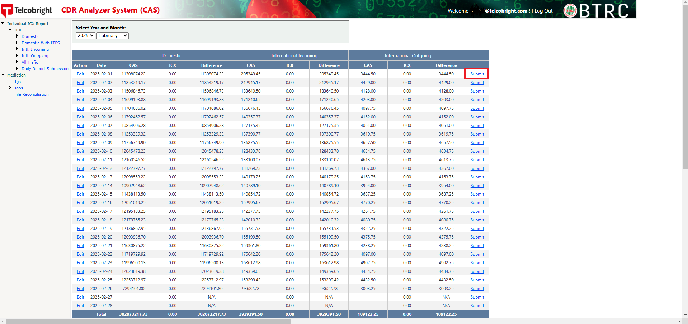

Monitoring System Overview
The following slides provide an overview of the monitoring system architecture and capabilities.

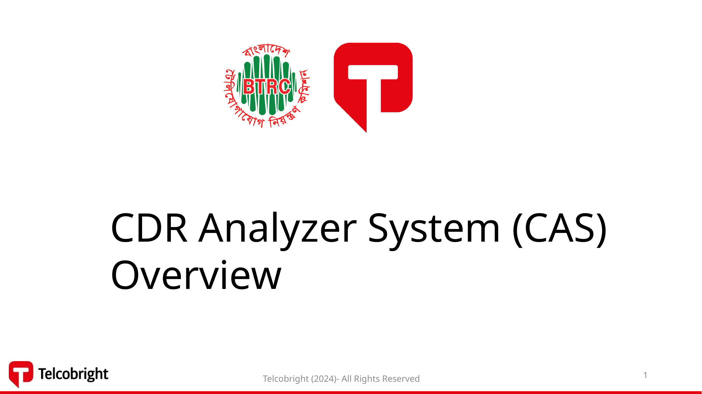
Slide 1

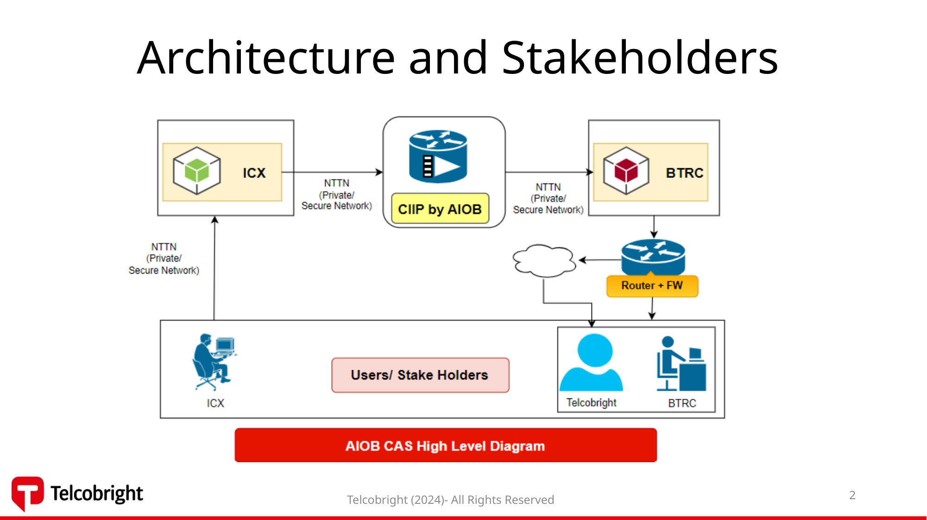
Slide 2

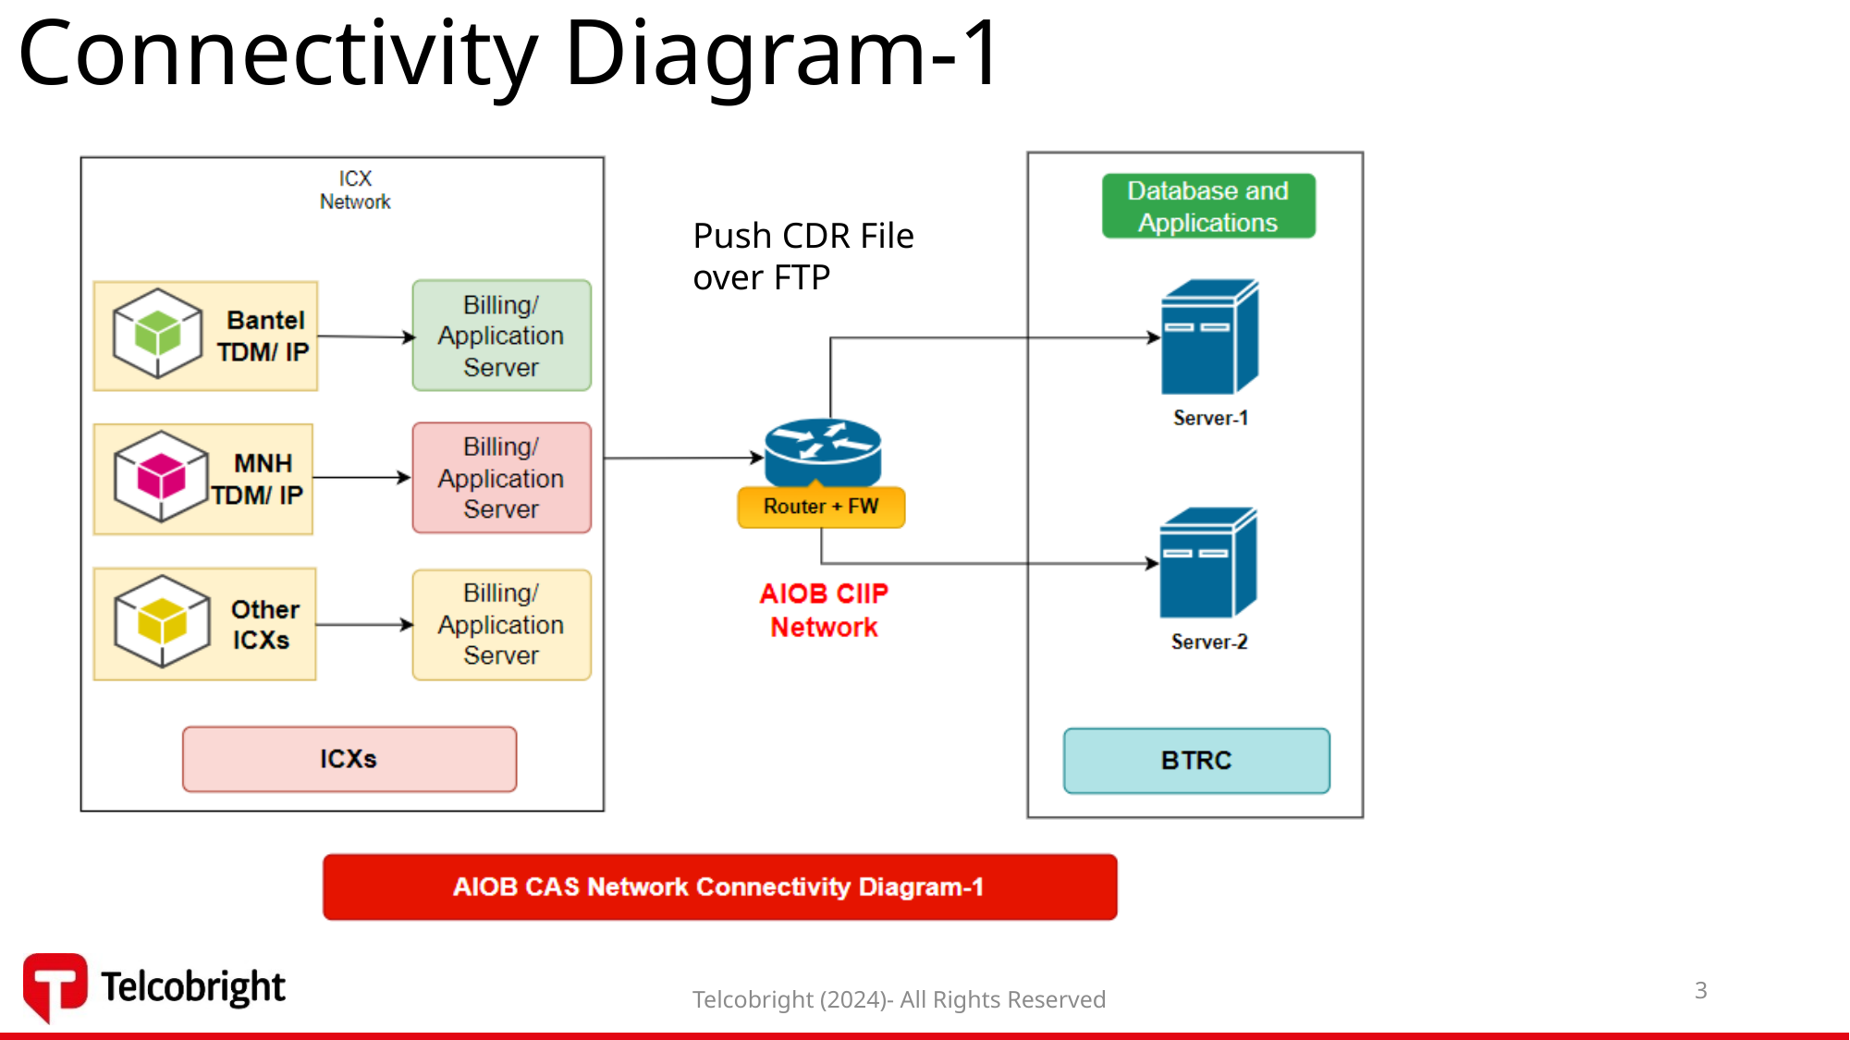
Slide 3

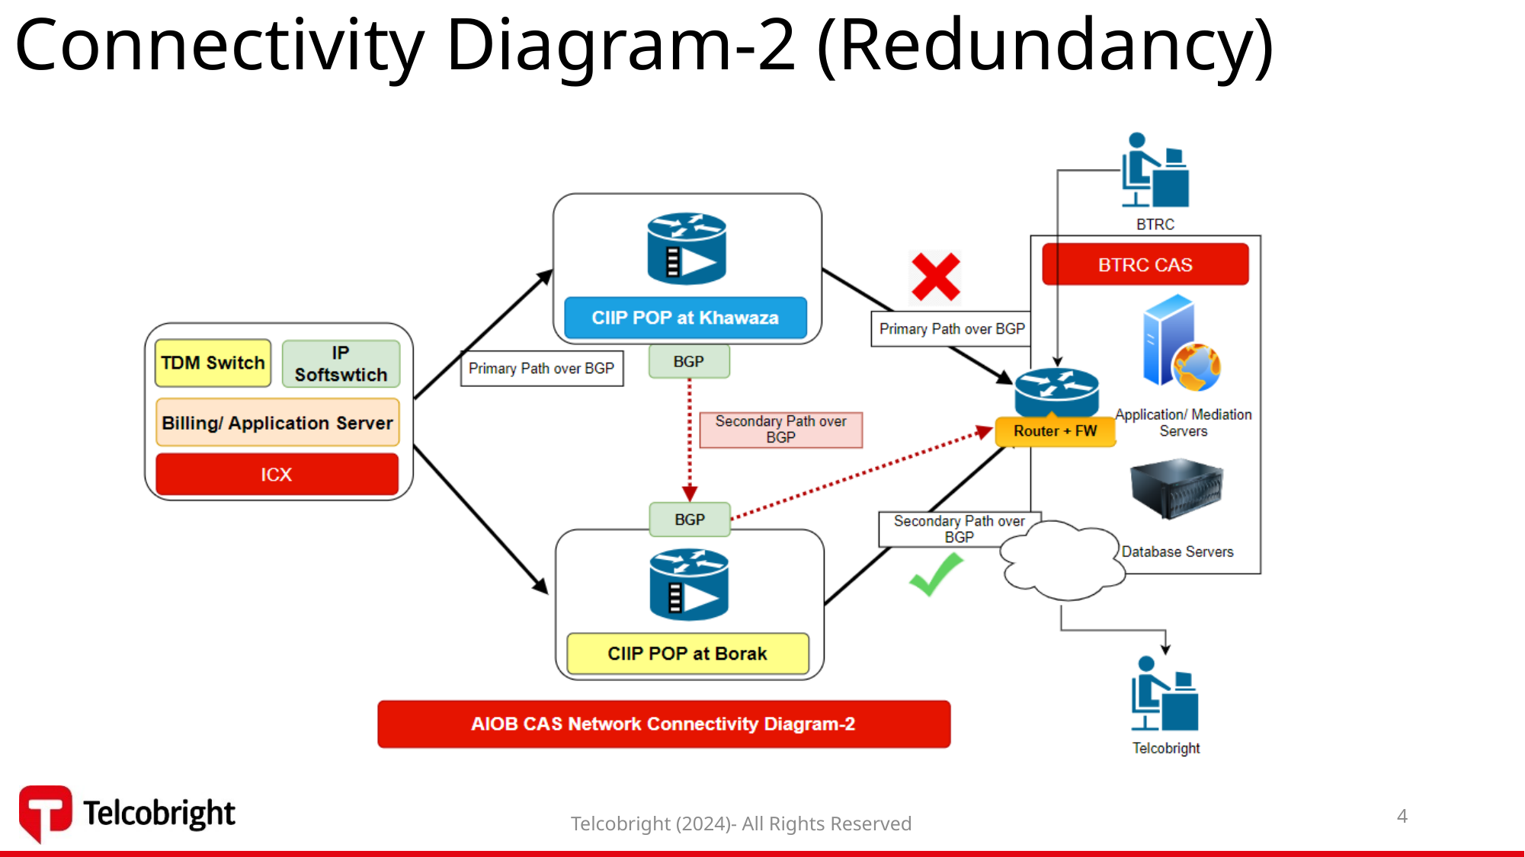
Slide 4

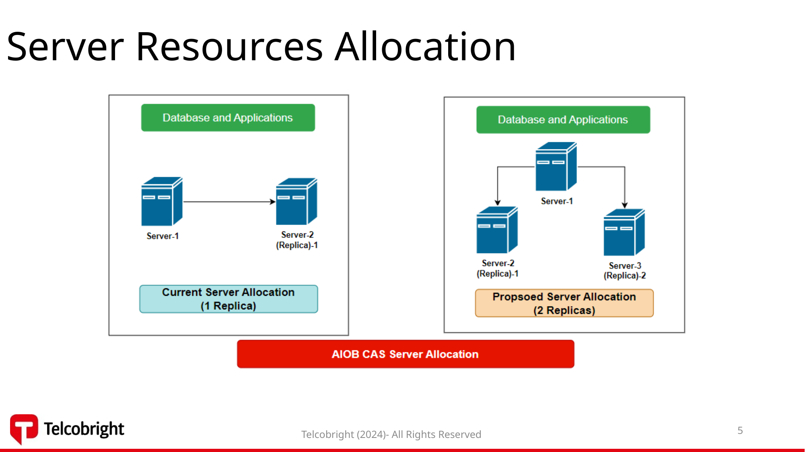
Slide 5

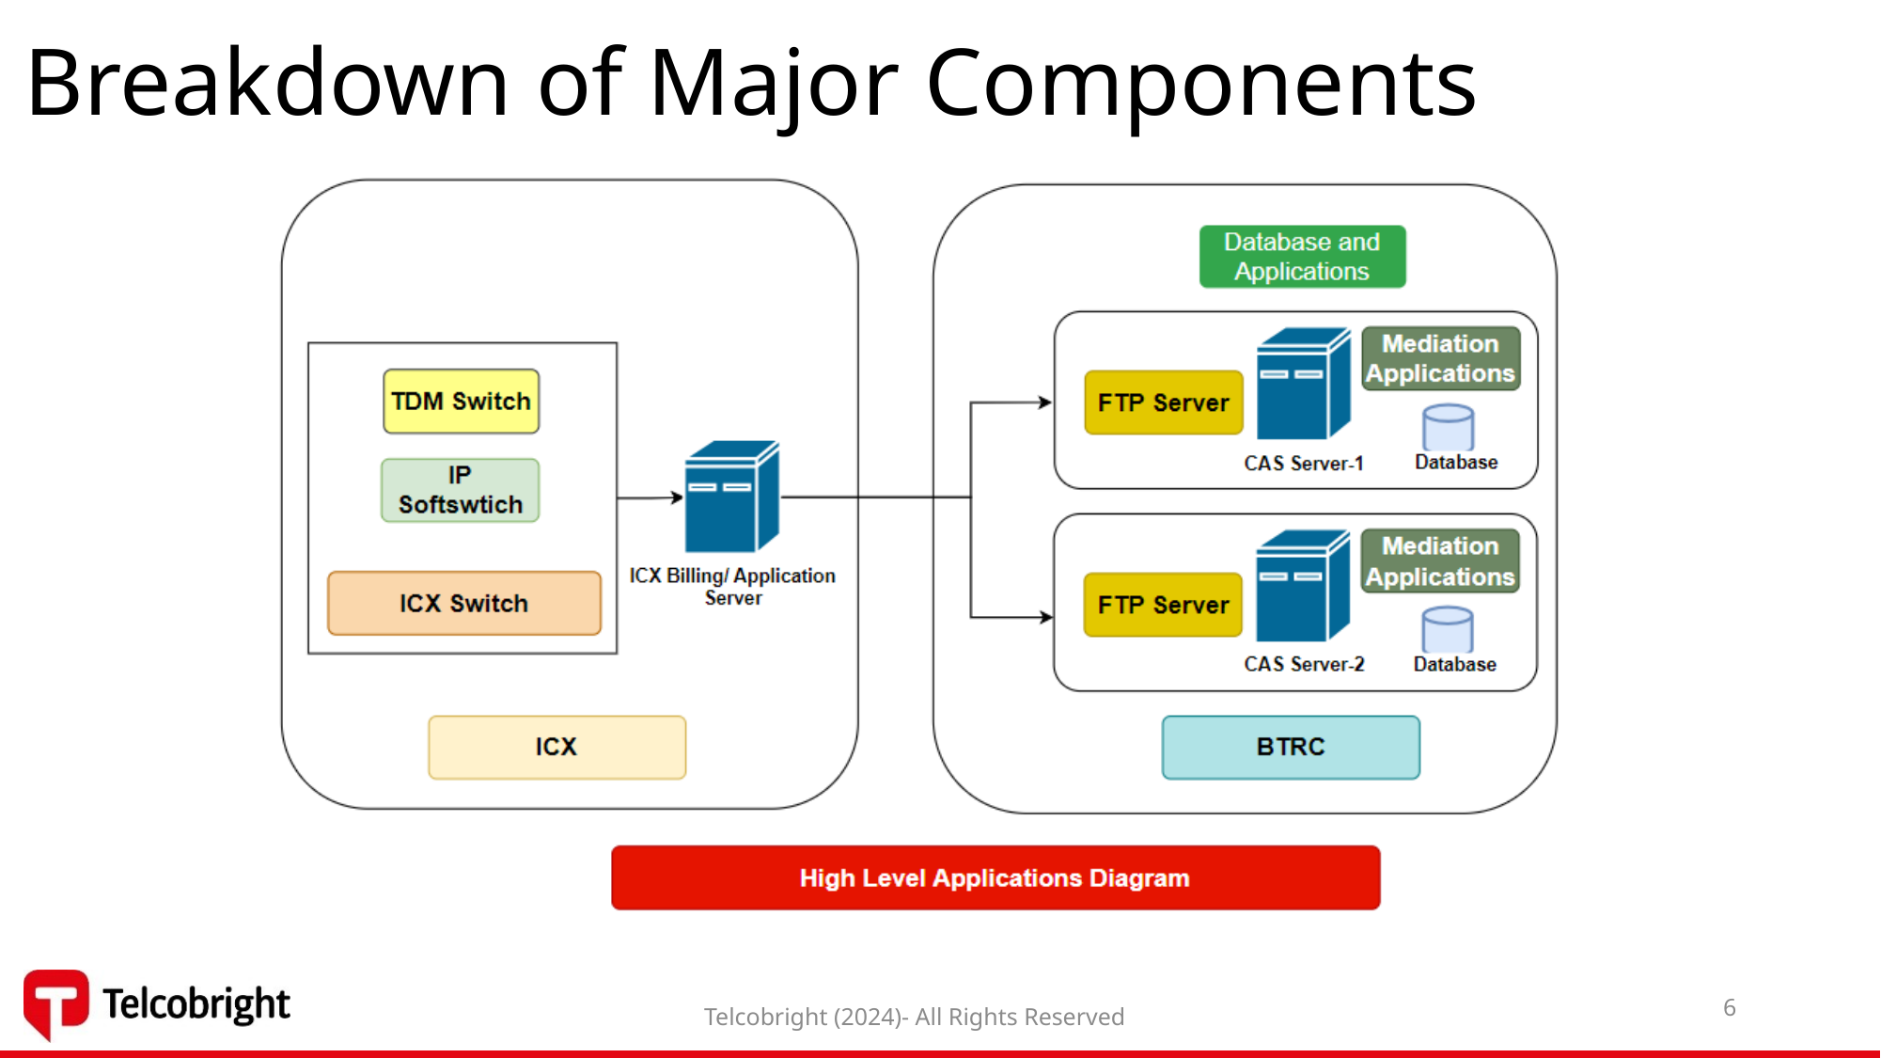
Slide 6

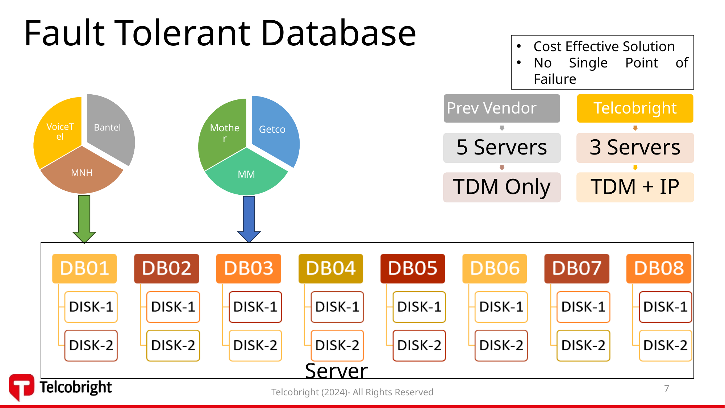
Slide 7

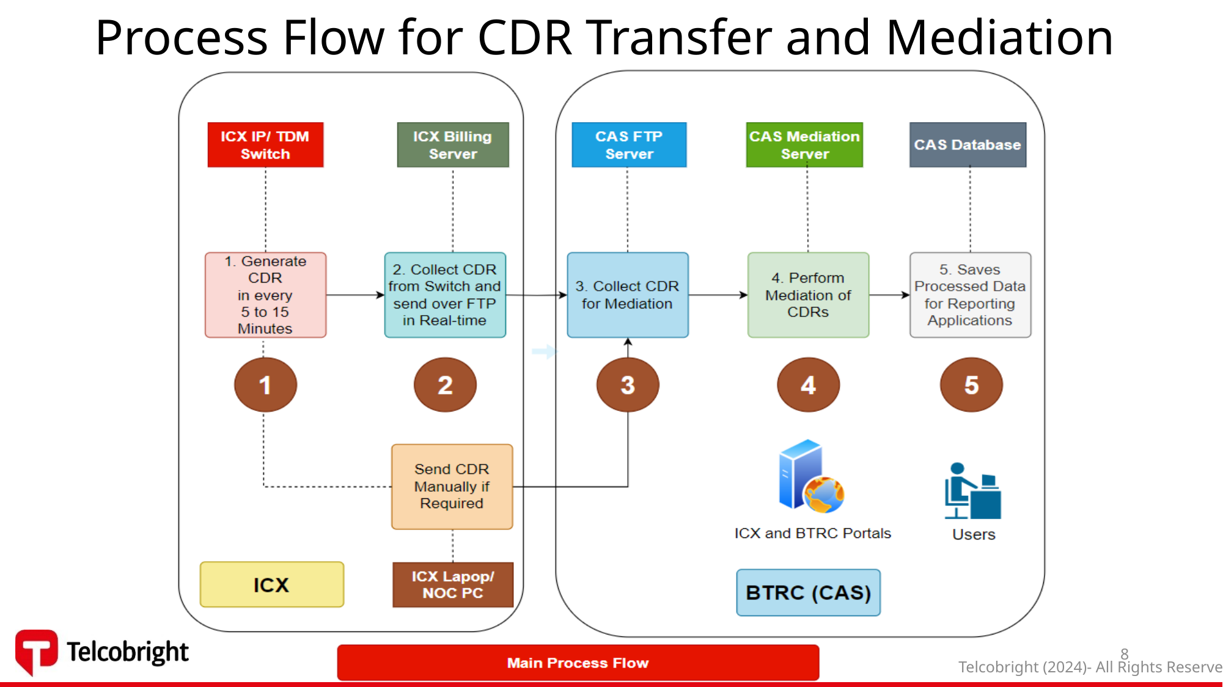
Slide 8

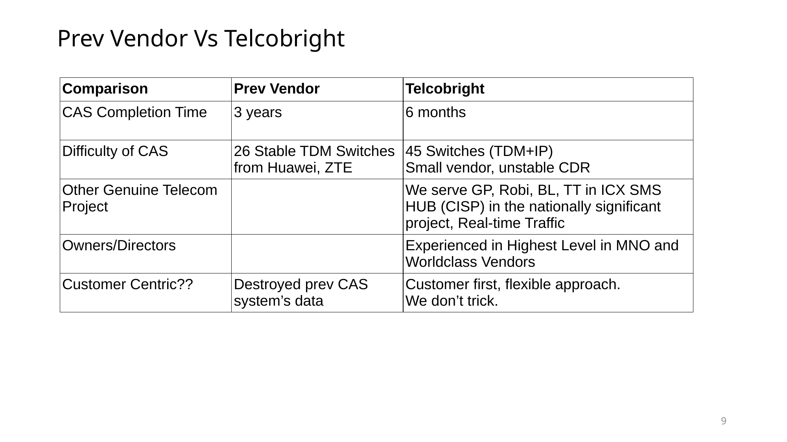
Slide 9


Slide 10

