BTRC EOI Response - Specific Experience
Part 3: SAS/CRM/BSS Platform Experience

BTRC Requirement:
Bidder shall have at least 2 (two) practical experiences in developing monitoring/analytics/SAS/OSS/BSS/QoS platforms or integrated service management platforms with integration to at least 3 external systems (e.g. NMS, billing, CRM, ERP).

============================================================

Project 1: BTCL SMSC, SBC, Hosted Contact Center, Hosted PBX, Voice Broadcasting

Client | Bangladesh Telecommunications Company Limited (BTCL)
Platform Type | SMSC, Bulk SMS Platform, SBC, Hosted Contact Center, Hosted PBX, Voice Broadcasting
Status | Supplied - PO Submitted
Integration Type | SAS (Software as a Service) / BSS

SMSC & Bulk SMS Platform Integration:

Recently, Telcobright has supplied SMSC and Bulk SMS Platform to BTCL with the following integrations:

- 1. BTCL Alap App Integration (REST API):
• Outgoing SMS: Alap mobile app users send SMS to valid mobile numbers through REST API integration with BTCL SMSC
• Incoming SMS: Mobile-originated SMS delivered to Alap app users via reverse path
• Real-time bidirectional messaging support

- 2. SIGTRAN Protocol Integration:
• SS7 signaling over IP (SIGTRAN) for interconnection with all MNOs
• Protocol Stack: GSM MAP → TCAP → SCCP → M3UA → SCTP → IP
• Connection to AIOB CISP (Common Interconnection SMS Platform) at Borak and Khaza towers
• MNP (Mobile Number Portability) lookup integration for routing optimization

- 3. MNO Interconnections via CISP:
• Grameenphone (GP)
• Robi Axiata
• Banglalink (BL)
• Teletalk (TT)
• Other IPTSPs

Hosted Contact Center (Ongoing Project):

A true multi-tenant SAS (Software as a Service) project where clients purchase subscriptions and use hosted contact center capabilities.

- Platform Features:
• Multi-tenant architecture with subscription-based billing
• Voice call handling (inbound/outbound)
• SMS integration for customer communications
• Facebook Messenger integration
• WhatsApp Business API integration
• Unified agent dashboard for omnichannel support

============================================================

Project 2: Cosmopolitan Limited (CCL) - Softswitch & Hosted Contact Center

Client | Cosmopolitan Limited (CCL) - ISP
Platform Type | Softswitch, Hosted Contact Center
Status | Completed - Completion Certificate Submitted
Integration Type | BSS with ERP/CRM Integration

ERP/CRM Integration:

- Dolibarr ERP Integration:
• Invoice management - automated billing from platform usage
• Payment management - payment tracking and reconciliation
• Customer data synchronization
• Service provisioning integration

Supporting Documentation:

- • Purchase Order (PO) - BTCL Project
- • Purchase Order (PO) - CCL Project
- • Completion Certificate - CCL Project

Requirement Compliance Summary:

Requirement | Evidence | Status
SAS Platform Experience | BTCL Hosted Contact Center (multi-tenant) | Compliant
BSS Platform Experience | CCL Softswitch + Contact Center | Compliant
3+ External Integrations | REST API, SIGTRAN, MNP, ERP/CRM, Facebook, WhatsApp | Compliant
Documentation | PO + Completion Certificate submitted | Compliant

Attachments:
[PO and Completion Certificate documents to be attached]

CRM Integration Screenshots

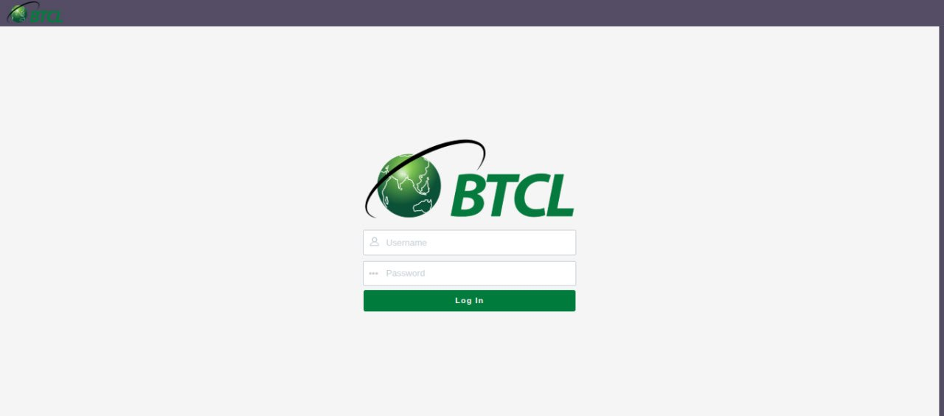
Figure 1: CRM Integration

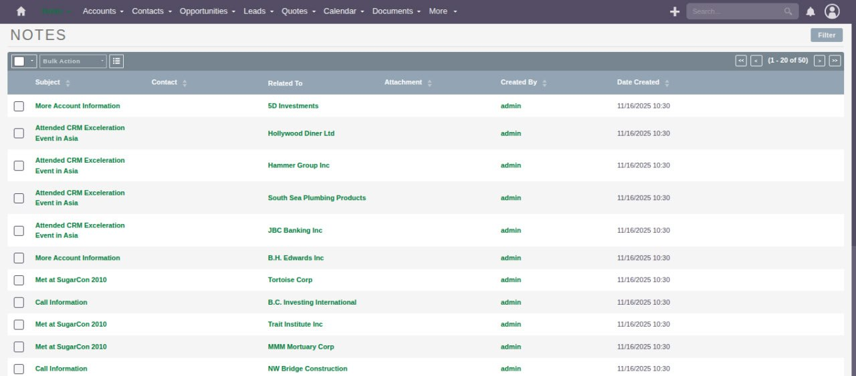
Figure 2: CRM Integration

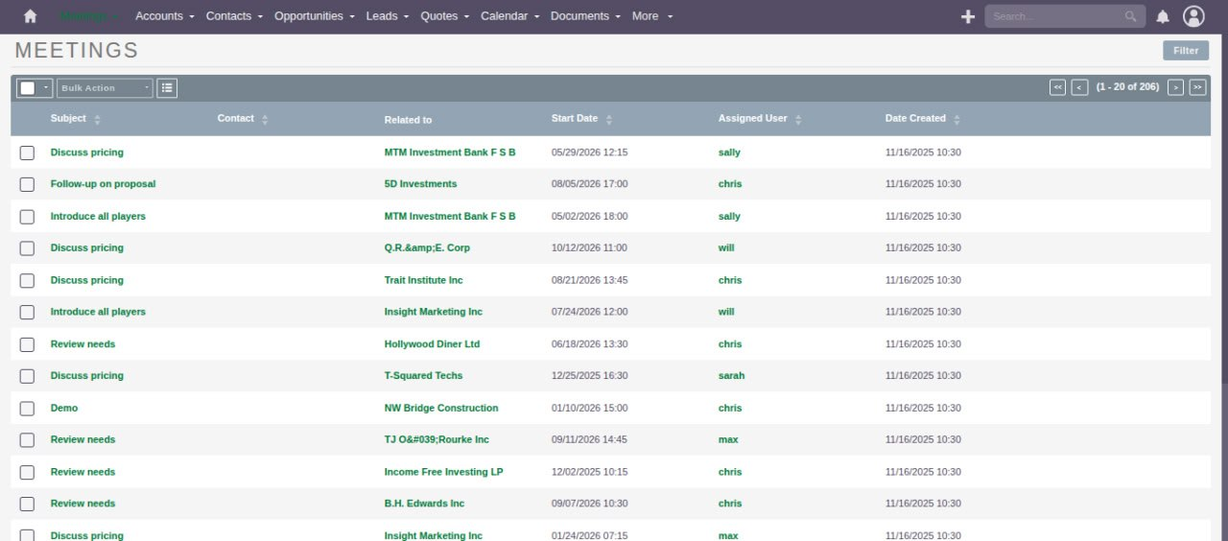
Figure 3: CRM Integration

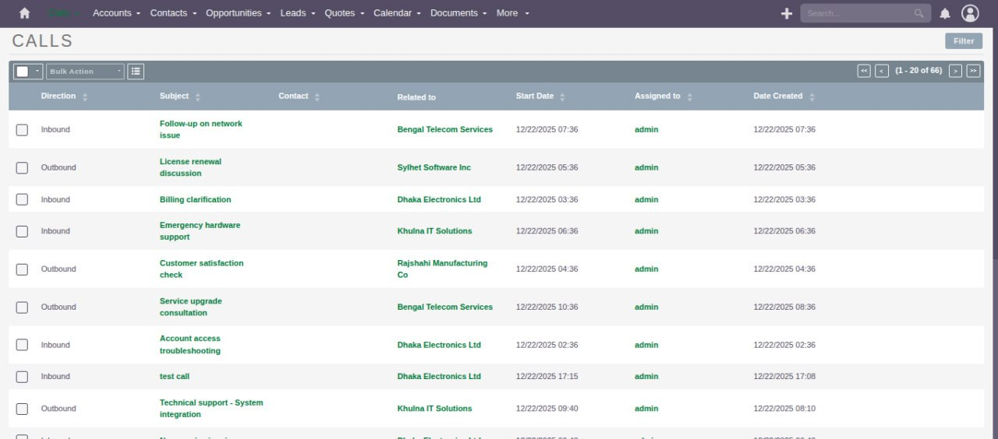
Figure 4: CRM Integration

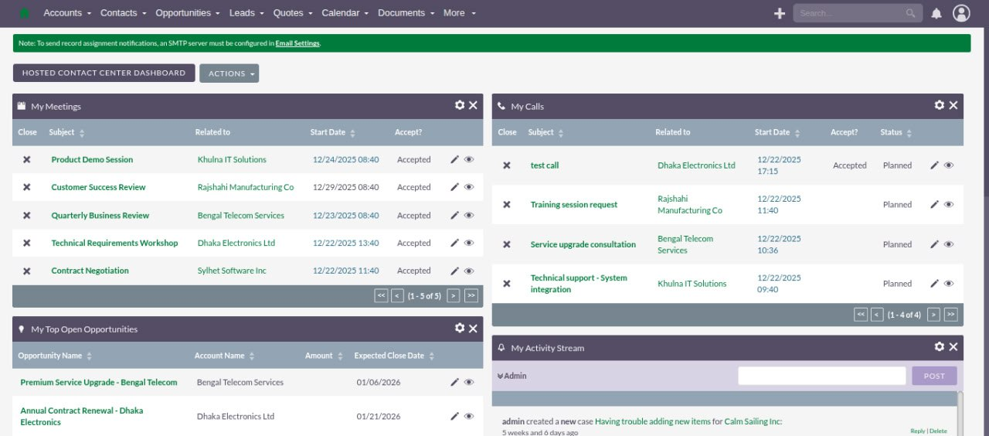
Figure 5: CRM Integration

ERP/Invoice Integration Screenshots (Dolibarr)

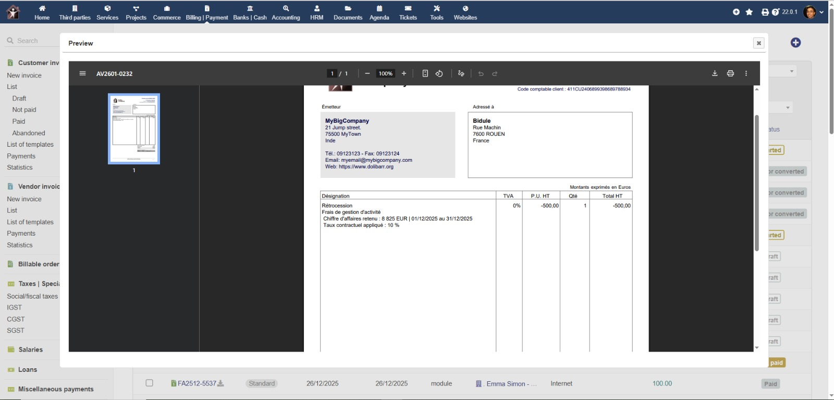
Figure 6: Dolibarr ERP - Invoice/Payment Integration

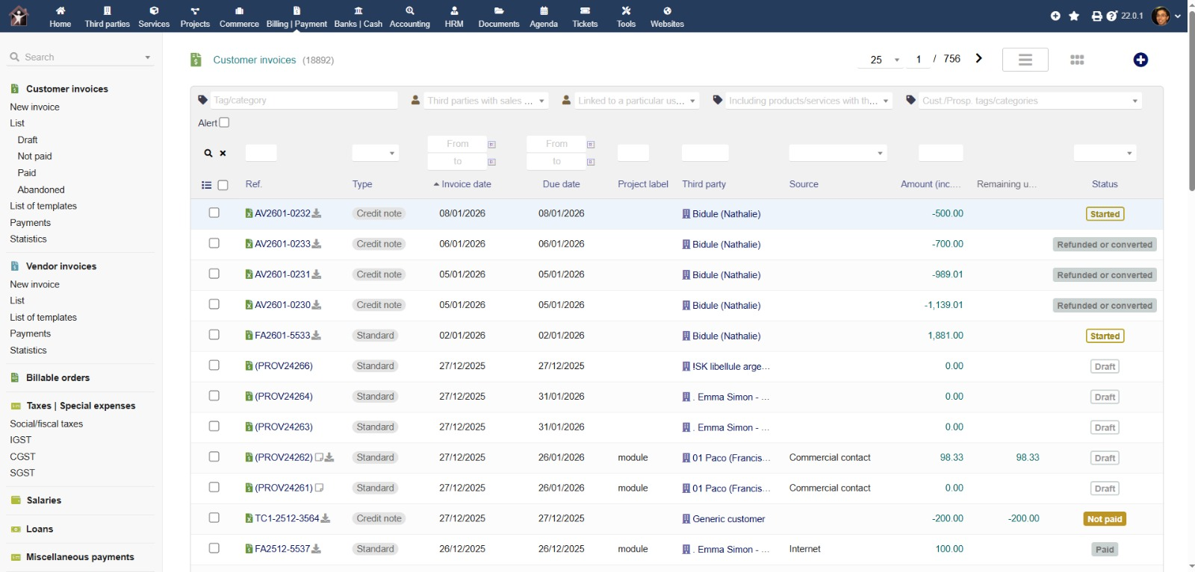
Figure 7: Dolibarr ERP - Invoice/Payment Integration

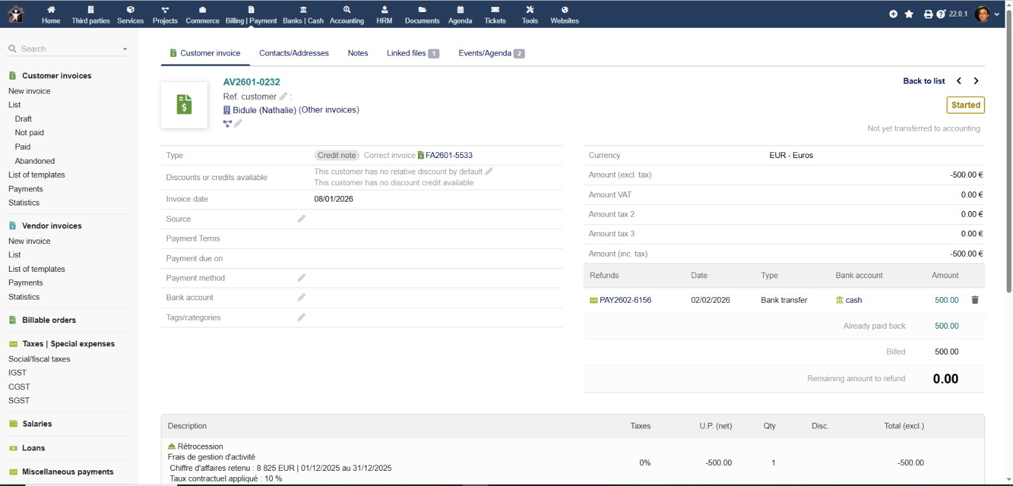
Figure 8: Dolibarr ERP - Invoice/Payment Integration

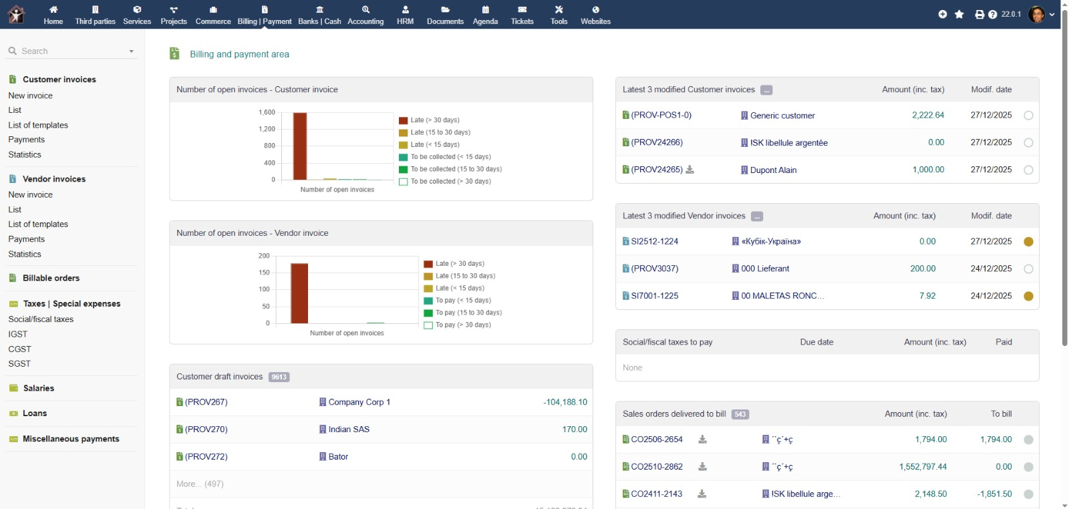
Figure 9: Dolibarr ERP - Invoice/Payment Integration

