1. Proposed Position | : | Software Engineer |  |  | 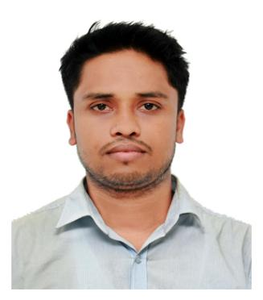
2. Name of Staff | : | Tanvir Hasan
3. Date of Birth | : | Dec 08 1996
4. Nationality | : | Bangladeshi
5. Membership in Professional Society | : | - N/A
6. Education | : | - B.Sc.Eng in Computer Science & Engineering  - Chittagong University of Engineering & Technology  - Feb 2017- Oct 2022  - Higher Secondary School Certificate Examination  - Sonar Bangla University & College  - Jun 2014-Jun 2016  Secondary School Certificate Examination  Nimsar High School  Jan 2009- Mar 2014
7. Other Training | :
  SL | Training/Certification Title
  1 | Machine Learning Stanford University Online  by Andrew Ng (coursera)
  2 | Python for Data Science, AI & Development powered by IBM
  3 | Cybersecurity for Everyone University of Maryland  Charles Harry (coursera)
  4 | Introduction to DevOps by John Rofrano
8. Languages & Degree of Proficiency | : | Language Speaking Reading Writing  English Excellent Excellent Excellent  Bangla (mother tongue) Excellent Excellent Excellent
9. Countries of Work Experience | : | Bangladesh – 03 years
10. Employment Records & Experience:
Employer |  |  | : | From |  | To
1. Telcobright Ltd.  Software Engineer |  |  | : | May 2021 |  | Till Date
Experience:
• Improve the back-end infrastructure for the billing solution for BTRC(Bangladesh
Telecommunication Regulatory Commission) CAS(Call Analyzer System).It’s a
business solution developed for all ICX (International Call Exchanger) telecom-
munication based companies in Bangladesh.
• Design Database for all ICX to improve it performance for manipulating data
for large amount of data.
• Assisted in creating new features WebPortal for BTRC and ICX team to web-
site interactive, realizable & solve production issues on the platforms.
• As a Software Engineer assisted to Containerized applications using Docker to ensure consistent environments for development, testing, and production.Created and managed Docker images, containers, and networks for microservices architecture.
11. Subject Matter Specializations
- Language:C/C++,JAVA,C#,JavaScript
- Tools: MySQL,Docker,kubernetes,Git,Kafka,Freeswitch
- FrameWorks: .NET,ASP.NET,Spring,SpringBoot,NodeJs,VueJs.
- Specialist: Problem Solving,Competitive Programming.
- Expart: DataStructure, Algorithm,Relational Database,

Certification:
I, the undersigned, certify that (i) I was not a former employee of the client immediately before the submission of this proposal, and, (ii) I have not offered my CV to be proposed by a Firm other than this Consultant for this assignment, and (iii) to the best of my knowledge and belief, this bio data correctly describes myself, my qualifications, and my experience. I understand that any willful misstatement described herein may lead to my disqualification or dismissal, if engaged.

I have been employed by Telcobright Limited. as an Engineer. Indicate “Yes” or “No” in the boxes below:

YES |  | NO
Signature |  |  | 
Date of Signing |  |  | 01 / 06 / 2024  (Day / Month / Year)

