Remove UTF8 – Korean Row Manual

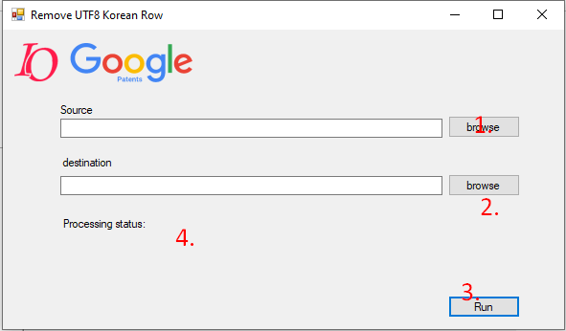

1. Select source directory which there are PCT xlsx files what have to remove Korean row
2. Select destination directory which there will be saving PCT xlsx files
3. Run execute
4. Display processing status

