**Change History**

|  |  |  |  |  |
| --- | --- | --- | --- | --- |
| Version | Date | Reason | Author | Approved |
| 1.0 | 19th May 2010 | Initial Version | Dell Topel  Chih Hsiang Tang  Jane Harrison  Justin Mancinelli  Wei Yeap Cheng  Xing-Shu Liu |  |
| 1.1 | 30th Aug 2010 | Minor changes of product perspective, typo correction, and typographic consistency across documentation | Justin Mancinelli |  |
| 1.2 | 31st Aug 2010 | Update of style according to specification in Project Plan document | Justin Mancinelli |  |

Tiffany Gold Mine Environmental Management Reporting System Software Requirements Specification

1 Introduction 4

1.1 Purpose 4

1.2 Scope 4

1.3 Definitions, Acronyms, Bbbreviations 5

1.4 References and Applicable Documents 5

2 General Description 6

2.1 Product Perspectives 6

2.1.1 System Interfaces 6

2.1.2 User Interfaces 6

2.1.3 Hardware Interfaces 7

2.1.4 Software Interfaces 7

2.1.5 Communication Interfaces 8

2.1.6 Memory Constraints 8

2.1.7 Operations 8

2.1.8 Site Adaptation Requirements 8

2.2 Product Functions 9

2.2.1 Laboratory Staff 9

2.2.2 Contractors 9

2.2.3 Tiffany Environmental Officers 10

2.2.4 Tiffany Administration Staff 11

2.3 Assumptions 12

2.4 Constraints 12

3 Specific Requirements 13

3.1 Use Case Specifications 13

3.1.1 Login 13

3.1.2 Bulk Upload Sample Data 14

3.1.3 Validate Sample Data 15

3.1.4 Modify Sample Data 16

3.1.5 View Contractor Details 17

3.1.6 Add Laboratory 18

3.1.7 Add New User Account 19

3.1.8 Assign Sample Location to Laboratory 20

3.1.9 Update Laboratory 21

3.1.10 Add Media File to Sampler 22

3.1.11 Update Sampler Media File 23

3.1.12 Send Sample to Laboratory 24

3.1.13 Update Password 25

3.1.14 Add Sampler 26

3.1.15 Add Water Body 28

3.1.16 Update Contractor 29

3.1.17 Update Sampler 30

3.1.18 Update Water Body 31

3.1.19 Assign Sampler to Contractor 32

3.1.20 Enter Sampling Frequencies 33

3.1.21 Manage Exceedance Values 34

3.1.22 Select Sampling Location 36

3.1.23 Perform Screening Program 37

3.1.24 Schedule of Sampling Frequencies 39

3.1.25 Create Environmental Audit Report 40

3.1.26 Create Exceedance Report 42

3.1.27 Add Environmental Officer 43

3.1.28 Add Contractor 44

3.1.29 Manage User Account 45

3.1.30 Create System Utilisation Report 46

3.2 Supplementary Specifications 46

3.2.1 Initial Data Load 46

3.2.2 Help Manuals 47

3.2.3 Security 47

4 Appendix 48

4.1 Glossary 48

4.2 Sample Reports 49

# Introduction

## Purpose

This document provides a complete description for both functional and nonfunctional requirements and specifications for Tiffany Gold Mine Environmental Management Reporting System (TiGERS).

This document details the framework of the Tiffany Gold Mine Environmental Management Reporting System and the user interface description of the system. The target audience for this project is the employees of Tiffany Gold Mine.

It also serves as an agreement between Project Group C and University of Queensland to ensure fulfillment of project requirements and its interaction with the client.

## Scope

This document covers the description of the system framework as well as functional and non-functional behavior to provide a complete and comprehensive description of TiGERS, a web based application which will runs in any internet browser. Its aim is to solve current issues with dealing with increasingly large data sets by streamlining processes, and also by tailoring a more flexible system to better fit the working environment. Functions of the system include data entry, report generation, analysis tools, and other management or administration features such as maintaining user accounts and assigned roles for all end users and the ability to modify sampling locations.

On completion of the project, the development team will provide the project sponsor with full installation and facilitates the deployment of the system at Tiffany Gold Mine to its designated offices. To achieve the optimal performance for the business process, two separate manuals will be given, namely System manual and User manual, one each. The user manual documents procedures for data entry into the system, using the system for report generation, and other miscellaneous procedures, such as assigning sampling locations to external consultants whereas the system manual covers all aspects of managing the system for system administrators and other relevant administration staff. For better understanding of the internal structure of the application, all the source code relevant to the application and related scripts involved with the database including database schemas, and all the necessary configuration files required by the executable application will be given as well.

A post-implementation review will also be performed after the completion of this project, in order to measure the overall success and effectiveness of the project. In particular, it will gauge how well the implemented system achieves the project’s objectives.

The project will be deemed successful if the implemented system meets its goals, such as allowing users to quickly and easily enter data into the system and request reports to be generated, and able to do all the above mentioned tasks accurately and is a stable and reliable platform for Tiffany Gold Mine to base its environmental monitoring operations on. The system should increase the business productivities without having the need to compromise by hiring more employees or conduct extra training for them. Having no significant additional costs to be incurred other than those that have already been allocated for this project, and with all required products to be completed and delivered before the agreed date will be beneficial.

## Definitions, Acronyms, Bbbreviations

|  |  |
| --- | --- |
| Term | Description |
| TiGERS | Tiffany Gold Mine Environmental Management Reporting System |

## References and Applicable Documents

Pudmenzky, Alex. Initial email. 1st March 2010. Web.

Pudmenzky, Alex. Business Requirements Specification. 23rd February 2010. Web.

# General Description

## Product Perspectives

This section will describe high-level requirements from different perspectives of the project’s system and users.

### System Interfaces

The system being developed for this project (TiGERS) will not be integrated with any other system. TiGERS is implemented as a standalone system consisting of a web-based user interface, a database for data storage and retrieval, and a robust software backend for complete system integration.

### User Interfaces

TiGERS consists of four web-based interfaces for user interaction with the system. All interfaces are protected with a secure authentication component.

##### Laboratory Interface

The laboratory interface allows laboratory staff to upload sampling data and send emails to the party requesting analysis. In order to send emails to the correct party, laboratory staff will be able to view information about the contractor who has requested a particular analysis.

The authentication component will assure that they cannot modify data uploaded by others. The laboratory staff will also be able to list, edit and remove any data uploaded by them.

##### Contractor Interface

The contractor interface will allow contractors to add information to the system about their subcontracted laboratories and upload media files to detail sampling locations. Contractors will also be able to receive emails through the system as outlined in the above laboratory interface description.

The authentication component will assure that contractors cannot modify data uploaded by other contractors. Contractors will be able to edit existing laboratory information and delete or replace sampler media files and their captions.

##### Tiffany Environmental Officer Interface

The Tiffany environmental officer interface will allow Tiffany environmental officers to add information to the system about contractors, water bodies and related exceedance values, and samplers and their screening frequencies. They will be able to view any and all media files added by any and all contractors. They will also be able to send email to contractors via the system.

The authentication component will assure that Tiffany environmental officers cannot modify data uploaded by contractors. They will be able to modify information which they are able to create as described in the above paragraph. They will also be able to delete samplers in the database and on the map that do not contain parameter data.

Tiffany environmental officers must also have an interface for generating reports as required.

##### System Administrator Interface

The system administrator interface will allow system administrators to manage accounts. They will be able to create and delete accounts. They will also be able to edit information associated with the accounts such as resetting passwords

The authentication component will assure that only system administrators have access to the system administrator interface and any information available therein.

System administrators must also have an interface or generating reports as required.

### Hardware Interfaces

This section will detail what hardware must be used to interact with the system. TiGERS uses a web-based interface and, as such, data will be entered via a keyboard into a form. The hardware used to gather data is not relevant for TiGERS.

It is necessary for users to have access to a network enabled computer. Staff working on Tiffany grounds will be able to use the Tiffany intranet to access the system. Consultants and staff working from home must have internet connectivity.

The web-interface is polished and simple so a screen of 256 colours will be sufficient and there is no recommended screen-size however, the system does require a minimum 800x600-pixel resolution.

System administrators must have access to terminals which can directly interface with the backend and database servers. The backend is written in Java and so only needs a text-editor to modify but the database relies on Oracle software.

### Software Interfaces

This section will detail what software must be used to interact with the system. TiGERS uses a web-based interface and, as such, basic internet access software and an up-to-date web-browser capable of displaying HTML, CSS and JavaScript are necessary for all users. Some users require other software as detailed below.

System administrators must have access to Oracle software and Java application development software to discover, diagnose, and solve everyday problems or necessary changes to basic user and system information.

Maintainers of the system must have knowledge and access to Java EE development software, Maven build manager for dependency resolution, Oracle software, and web-design technologies such as HTML, CSS and JavaScript.

### Communication Interfaces

This section will detail how the system will communicate with other systems.

TiGERS will be written primarily in Java so connecting to the web-server is a simple matter of starting the server process on the same machine as the java classes.

Email functionality is extremely important to TiGERS users. Email will be sent and retrieved through TiGERS via the mailhub.itee.uq.edu.au mail server as defined in the business requirements.

TiGERS will have a large data storage server running Oracle. The backend Java software must communicate with the Oracle server residing at students.itee.uq.edu.au on port 1521 as explained on the school of ITEE FAQ (http://studenthelp.itee.uq.edu.au/faq/).

### Memory Constraints

This section will detail any constraints the system must adhere to in terms of memory and performance.

There are no known memory constraints.

### Operations

This section will detail how operations performed by the organisation may affect or be affected by the system.

It is unknown at this time whether operations at the Tiffany mine will affect or be affected by the system.

### Site Adaptation Requirements

This section will detail specific requirements which must be observed when installing the system at different client sites.

TiGERS is a web-based system which means the main servers for data, processing, and communication are housed in a central location.

Clients will be able to connect to the web-server from any class of internet connection and use any modern web-browser with HTML, CSS, and JavaScript capabilities as outlined in section 2.1.2. above.

Initial installation requirements are detailed in sections 1.2.3. to 1.2.5 above. There is no need for further installation except for basic client hardware and software as detailed in section 2.1.2. above.

## Product Functions

The system is required to provide functions to support different kind of users. The users are external parties, environmental officers and administration officers. External parties are divided into two groups, laboratory staff (perform chemical analysis) and consultants who sub-contract laboratories but also enter the site media files. The functions for these users will be discussed in this section.

### Laboratory Staff

The laboratory staff will access the system via a web browser. In order to access the system, a password-protected account on the system is required. Once staffs have logged in, they will be able to attach analysed parameter data values with corresponding dates to samplers that the contractor has assigned to them previously and to inform the requestor of an analysis of its completion via email.

A single laboratory will be responsible for the analysis of all parameters at a location that is assigned to them. The system will allow laboratory staffs to select a sampling location (not from a map for confidentiality reasons) and start a bulk upload of analysed data. The data will be present in a spreadsheet (.csv format) containing parameter names as column headers and dates as row headers, the remaining cells in the matrix filled with analysed data values. In order to prevent blank cells left by mistake, any values not measured will be marked as NaN (not a number). Some parameter values in the sample may be less than the instrument detection limit and are indicated by a less than sign before the detection limit (e.g. <0.8). In this case, the detection limit should be recorded and a special mechanism should be provided in order to distinguish the values from real measured values when an environmental officer analyses/graphs the data. The system is also required to validate the inputs, for example, the value of pH has to be in a range from 1 to 14 and all other values must be positive and the sampling date must be a valid date. The laboratory staff will not be able to see or upload data to any sampling locations that are not assigned to them.

The laboratory staff will also be able to list, edit and remove any data uploaded by them and view the information about the contractors who have requested a particular analysis. A “job complete” email notification can also be issued via the system by the laboratory staffs.

### Contractors

The contractors will access the system via a web browser. In order to access the system, a password-protected account on the system is required. Once contractors have logged in, they will be able to add information to the system about the laboratories that are performing the water analysis for them, the water samplers allocated to each laboratory and the media files for each sampling location that were taken when the contractor sampled the water. The system should allow contractors to download sampler locations as .kml files for insertion into Google Earth. The contractors will also receive an automated email through the system from the Tiffany environmental officers with instructions to start sample collection for analysis.

The laboratory information will be in textual form and each laboratory must have an email address. During execution of a screening program, samplers may be photographed or the sampling procedure may be videotaped, so the system must allow contractors to add these media files to their respective samplers with a small caption describing what is being shown.

Contractors will also be able to edit the existing laboratory information and delete or replace sampler media files and their captions.

### Tiffany Environmental Officers

The environmental officers will access the system via a web browser. In order to access the system, a password-protected account on the system is required. Once staffs have logged in, they will be able to add information of contractor, water bodies and related exceedance values, samplers and their screening frequencies. The officers will also be able to view media files taken during the execution of a screening program and added to the samplers by contractors.

The system should allow environmental officers to request individual analysis or screening programs to be performed by contractors via email. The reports and graphs of parameter values and exceedance values of samplers within a specified date range should be able to be generated by the system.

##### Water Body

The information of water body can be divided into two groups, ground water and surface water. Ground water is contained in aquifers; each aquifer may have different exceeding minimum and/or maximum limits for all parameters that are monitored. Surface water bodies are creeks and rivers which also have their own exceeding minimum and/or maximum limits for monitoring.

##### Sampler

The water samplers are identified by their alphanumeric tag (e.g. GW123) and have a geographical position that should be reflected on a map with the option to enter the latitude and longitude either from the keyboard or .kml files. Samplers need to be assigned to the water body contractors monitored.

Ground water samplers have a license number (e.g. 20BL846484) and a monitoring purpose description. Ground water samplers also have

1. A screening frequency at which a defined subset of parameters is screened.
2. A comprehensive screening frequency at which all parameters are screened.
3. A depth monitoring frequency at which time the water depth to collar is measured to calculate.
4. Ground water level above sea level.

Surface water samplers are carrying a monitoring purpose description and the same screening frequency information as the ground water except the depth of river or creek that the sample taken from. The parameters measured for ground and surface water are shown in the table below:

**Table 2.2.1: Parameters of Ground Water and Surface Water**

|  |  |  |
| --- | --- | --- |
|  | Ground Water | Surface Water |
| PH | ○ | ○ |
| EC [μS/cm] | ○ | ○ |
| Temperature [°C] | ○ | ○ |
| Depth to collar [m] | ○ | X |
| Fluoride [mg/L] | X | ○ |
| Chromium [mg/L] | X | ○ |
| Arsenic [mg/L] | ○ | ○ |
| Oil | ○ | ○ |
| Grease [ppm] | ○ | ○ |

The screening frequencies are: daily, weekly, fortnightly, monthly, half yearly and yearly.

The system should be able to generate reports and graphs. The reports can be divided into two parts: audit reports and exceeding value reports. The audit reports will contain a table of all parameter values (column heading) collected at all dates (row heading) grouped by sampling points for a selectable water body. The graphs will be included for each water body sampler for a selectable list of parameters. The graphs will contain a horizontal line for each of the exceeding applicable to the selected parameters which are also selectable. The exceeding value reports will consist of a table generated by selecting a sampler from a map and containing the parameters, dates and measured values together with the exceedance values and the magnitude of exceedance values. All detection limits should be marked as such and not be presented as measured values.

The information of contractors, water bodies and samplers including location can be edited by environmental officers and samplers can be reassigned to different contractors. The samplers in the database and on the map can also be deleted.

### Tiffany Administration Staff

The administration staff will access the system via a web browser. The system should not only be accessed from the terminals at Tiffany Gold Mine but also from the internet. In order to access the system, a password-protected account on the system is required. Once staffs have logged in, they will be able to manage accounts and update system settings.

The system administrators will be able to create or delete accounts. The information associated with accounts should be able to be edited including password. The system should also be able to generate accounts reports for administrators. The report shall contain information pertaining to all users of the system sorted by access privilege.

## Assumptions

The system will be run on computers which are hosted at the ITEE labs in the GP south building at UQ. The operating system of the computers are customised Windows XP.

The Java framework used to develop the system is AppFuse integrated with Spring MVC and Acegi Security. Jetty will be the application server. The interface between the database the backend will be Hibernate.

## Constraints

The database used to develop the system is Oracle database and the oracle server is located at UQ. Since the language used for developing the system is Java, the standard Java libraries will be used. However, in order to create a connection to the Oracle database, an additional Java library, ojdbc14.jar, will be required to add to the class library.

The operating system used for the system is customised Windows XP which is also a constraint for the development.

# Specific Requirements

## Use Case Specifications

### Login

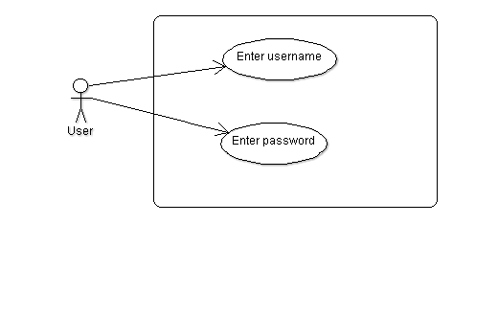

|  |  |
| --- | --- |
| **Use Case** | **Login** |
| Brief Description | Login to system |
| Actors | Users |
| Preconditions | The user has already navigated to the system. |
| Main Flow of Events | The user enters their user name and password and proceeds with the transaction.  The user name and password are checked and approved.  The user is allowed into the system |
| Alternative Flow of Events | Logon Failed - if the user name and password are not matched, an error message is displayed and the user is able to try again. |
| Alternative Flow of Events | The user is logging on for the first time. They then have to enter a new password. |
| Post Conditions | User is transferred to appropriate part of the system according to their role. |

### Bulk Upload Sample Data

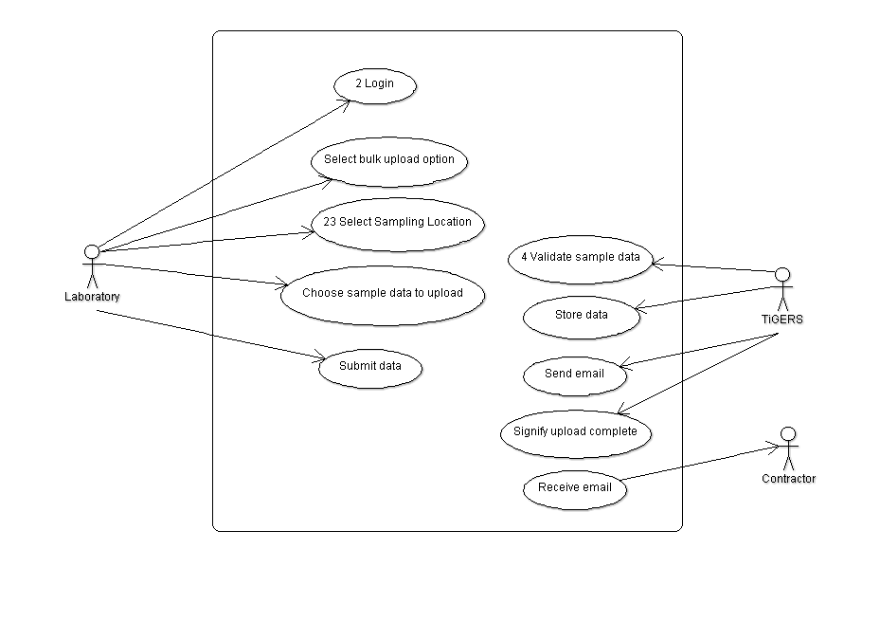

|  |  |
| --- | --- |
| **Use Case** | **Bulk Upload Sample Data** |
| Brief Description | Laboratory bulk uploads sample data |
| Actors | Laboratory, TiGERS, Contractor |
| Preconditions | Laboratory has data to upload |
| Main Flow of Events | Lab. logs in to system and selects option to upload data. They select a sampling location from a list of locations allocated to them. Lab. chooses which sample data to upload and submits the upload. Sample data is transferred to TiGERS along with the id of the lab. The system validates the sample data and stores it in the database. System acknowledges that job is complete and email is sent automatically to Contractor who requested the analysis. Contractor receives email. |
| Alternative Flow of Events | If data is invalid then it won’t be stored in the database. |
| Post Conditions | Database is uploaded with sample data. |

### Validate Sample Data

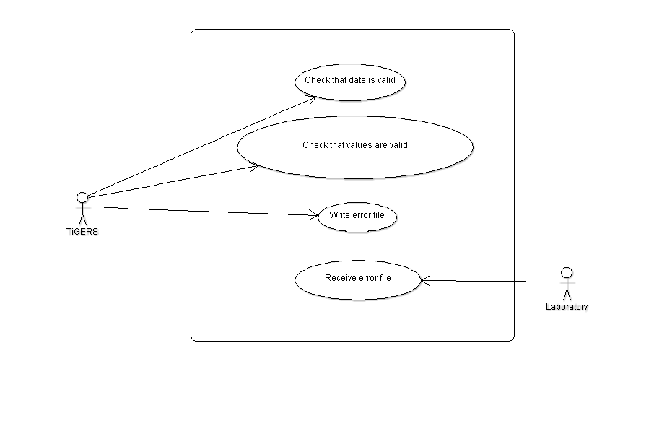

|  |  |
| --- | --- |
| **Use Case** | **Validate Sample Data** |
| Brief Description | Validate sampling data uploaded by Laboratory |
| Actors | TiGERS, Laboratory |
| Preconditions | Sample data file has been uploaded |
| Main Flow of Events | Each sample record is validated. Date checked to ensure it is a valid date. Field values checked to ensure that they are positive numbers or in the form “<x” where x is a detection limit. For example, pH is checked to ensure it is between 1 and 14. If any errors are found, the entire sample item is written to an error file which gets sent back to the Laboratory. |
| Alternative Flow of Events | Assume that it’s rare that an uploaded sample file will have no errors. In this case, no error file is written. |
| Post Conditions | All sample items are either added to the database or written to an error file. |

### Modify Sample Data

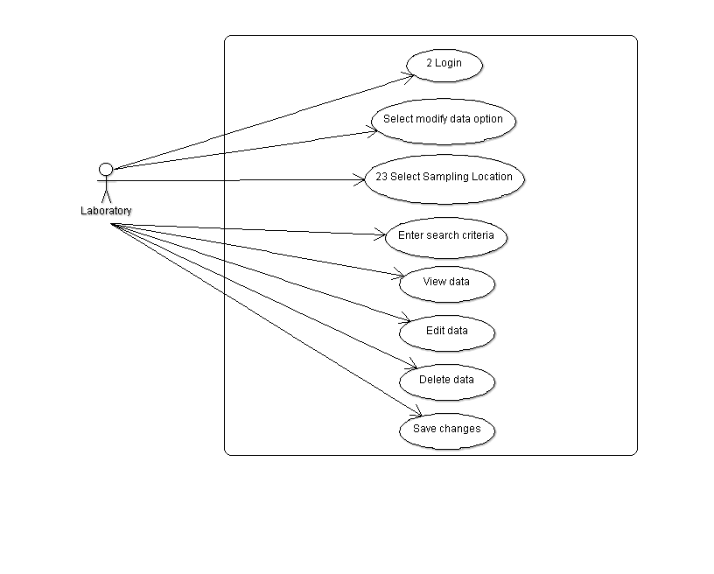

|  |  |
| --- | --- |
| **Use Case** | **Modify Sample Data** |
| Brief Description | List, edit and remove sample data |
| Actors | Laboratory |
| Preconditions | Laboratory can only process data it uploaded |
| Main Flow of Events | Laboratory logs in and selects option to modify uploaded data. Lab. can select data by entering filtering criteria (Sampling location and date/time. Date and time are optional). Sample data will then be listed in date order. Lab. can then edit the sample parameter values and save changes. Fields are validated using the same rules as for bulk upload. Lab. can also delete a sample record. |
| Alternative Flow of Events | Lab. can cancel editing before saving and changes won’t be saved to the database. |
| Post Conditions | Any changes made to the data will be reflected in the database. |

### View Contractor Details

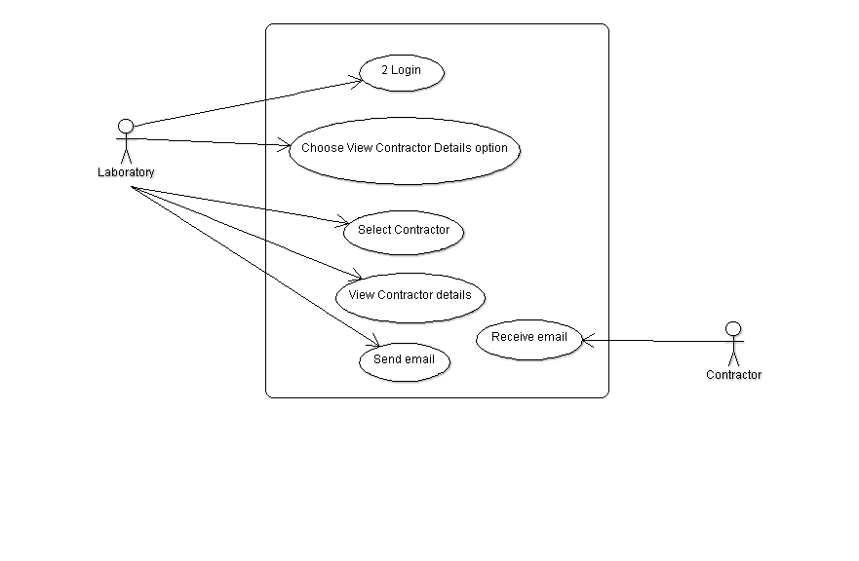

|  |  |
| --- | --- |
| **Use Case** | **View Contractor details** |
| Brief Description | A Laboratory can view details of Contractors who have engaged them to take samples. |
| Actors | Laboratory, Contractor |
| Preconditions | Lab. can only view Contractors who have engaged them to analyse samples. |
| Main Flow of Events | Laboratory logs in and selects option to view Contractors. They are then presented with a list of Contractors. The lab. selects a Contractor to view basic their contact details (contact name, address, telephone, email address). They use the email address to open their email application so they can send a message. |
| Alternative Flow of Events | The lab. doesn’t have to send an email. They can just view the details. |
| Post Conditions |  |

### Add Laboratory

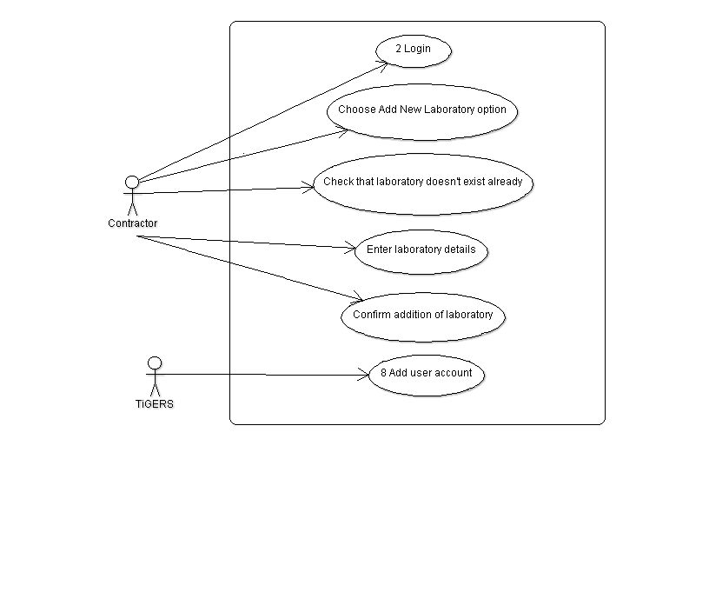

|  |  |
| --- | --- |
| **Use Case** | **Add Laboratory** |
| Brief Description | A Contractor adds a new Laboratory into the system. |
| Actors | Contractor |
| Preconditions | Each Laboratory has only user one account. |
| Main Flow of Events | The Contractor logs on to the system and chooses the add new Laboratory option. They then search by Laboratory name to see if the Laboratory has been added previously.  The Contractor then enters a name, contact name, telephone number and email address for the Laboratory. The Contractor submits the data and a new user account is generated by the system. |
| Alternative Flow of Events | If Laboratory already exists then no new account is created. |
| Post Conditions | A new user account is created for the Laboratory. |

### Add New User Account

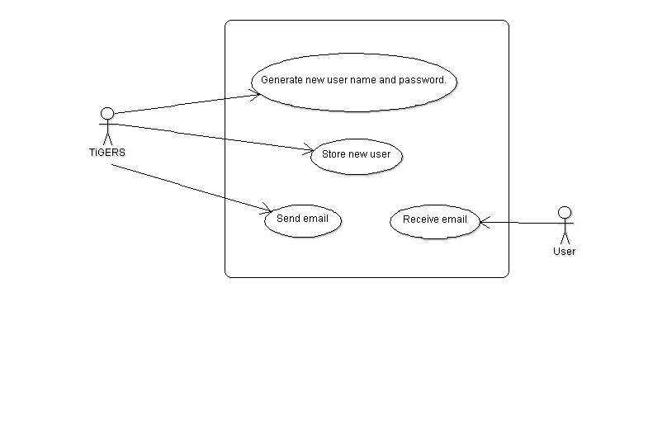

|  |  |
| --- | --- |
| **Use Case** | **Add New User Account** |
| Brief Description | The system generates new username and password. |
| Actors | System, User |
| Preconditions | Either a Contractor has added a new Laboratory or a System Administrator has added a new User. |
| Main Flow of Events | A new username is allocated and a random password generated. These details are added to the database. An email with these details is then sent to the User. |
| Alternative Flow of Events |  |
| Post Conditions | A new user account is set up. |

### Assign Sample Location to Laboratory

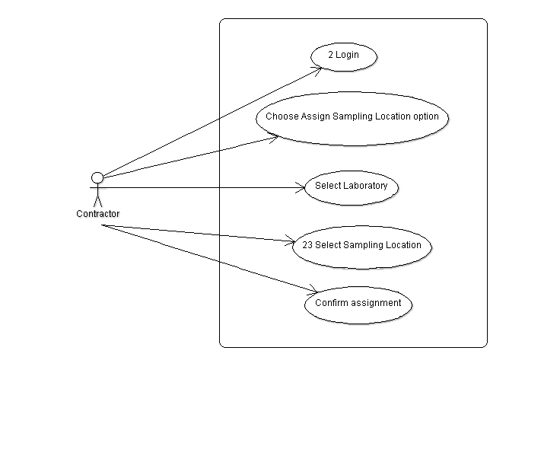

|  |  |
| --- | --- |
| **Use Case** | **Assign Sample Location to Laboratory** |
| Brief Description | Each sample location is assigned to a single Laboratory which does all the analysis of water samples taken at that location. A Contractor assigns a location to a Laboratory. |
| Actors | Contractor |
| Preconditions |  |
| Main Flow of Events | The Contractor logs on to the system and chooses the Assign Location to Laboratory option. They select a sampling location and then choose a Laboratory to assign it to. They confirm the assignment and the database is updated. |
| Alternative Flow of Events |  |
| Post Conditions | Assignment of location to Laboratory is reflected in the database. |

### Update Laboratory

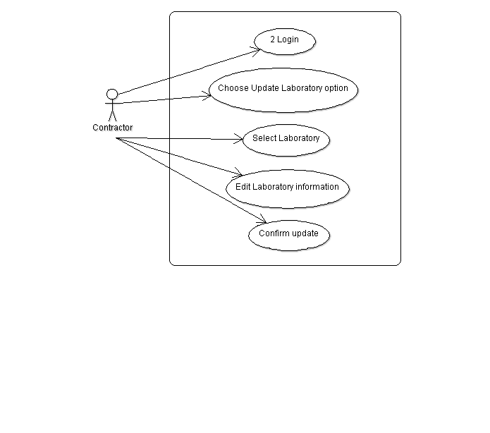

|  |  |
| --- | --- |
| **Use Case** | **Update Laboratory** |
| Brief Description | The Contractor can amend information about a Laboratory. |
| Actors | Contractor |
| Preconditions |  |
| Main Flow of Events | The Contractor logs on to the system and chooses the update Laboratory option. They then select the Laboratory that they wish to update. Any of the Laboratory name, contact name, telephone number and email address may be amended. The Contractor then confirms the update and the database is updated. |
| Alternative Flow of Events | The Contractor can choose not to save their changes by not confirming the update. |
| Post Conditions | Changes are updated to the database. |

### Add Media File to Sampler

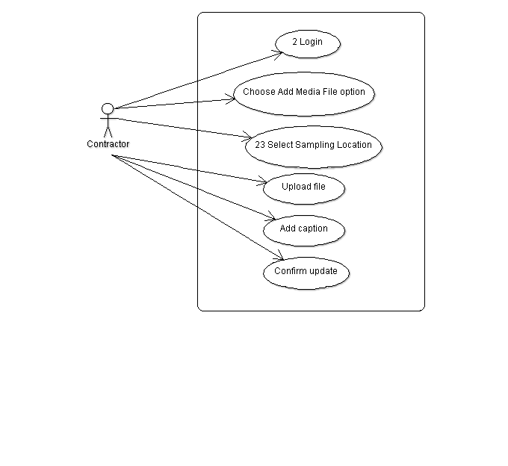

|  |  |
| --- | --- |
| **Use Case** | **Add Media File to Sampler** |
| Brief Description | Contractors can add images or videos of the sampler location taken at the same time as the water sample. |
| Actors | Contractor |
| Preconditions | Only 10 media files can be stored per sampling location. |
| Main Flow of Events | The Contractor logs on and chooses the Add Media File option. They then select a sampler location. They choose the file they want to upload and then enter a text caption to describe the file content. They then confirm the file upload. |
| Alternative Flow of Events | If the Contractor tries to add more than 10 media files then the system prevents this. |
| Post Conditions | Media record is stored in the database. |

### Update Sampler Media File

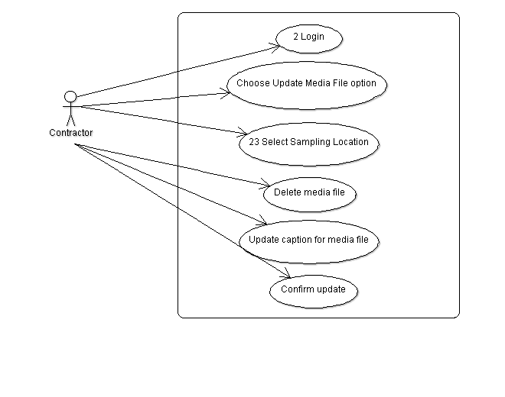

|  |  |
| --- | --- |
| **Use Case** | **Update Sampler Media File** |
| Brief Description | The Contractor can delete media files or change the caption of a media file. |
| Actors | Contractor |
| Preconditions |  |
| Main Flow of Events | The Contractor logs on and chooses the Update Media File option. They then select a sampler location. All media files for this location will be listed. They can then choose to delete a file or edit the text caption associated with a file. They then confirm their update. |
| Alternative Flow of Events |  |
| Post Conditions | Data changes will be reflected in the database. |

### Send Sample to Laboratory

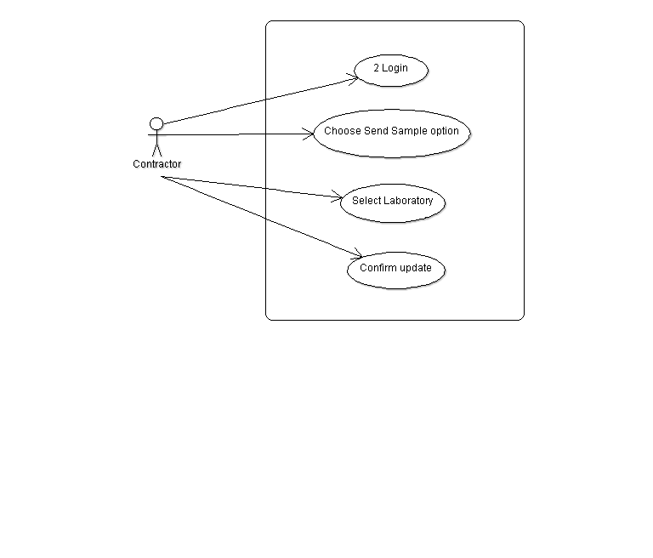

|  |  |
| --- | --- |
| **Use Case** | **Send Sample to Laboratory** |
| Brief Description | The Contractor makes the system aware that a water sample has been send to a Laboratory for analysis. |
| Actors | Contractor |
| Preconditions | Contractor has sent a water sample to a Laboratory. |
| Main Flow of Events | The Contractor logs on and chooses the Send Sample option. They then select a Laboratory and confirm. The database is updated with the date the sample was sent and the Laboratory it was sent to. |
| Alternative Flow of Events |  |
| Post Conditions | Database is updated. |

### Update Password

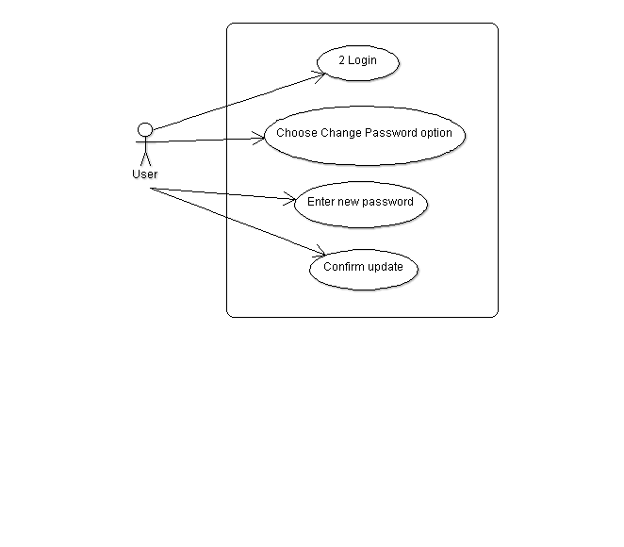

|  |  |
| --- | --- |
| **Use Case** | **Update Password** |
| Brief Description | Any user can update their password. |
| Actors | User |
| Preconditions | User has an account |
| Main Flow of Events | The user logs on and chooses the Update Password option. They then enter a new password and confirm the change. The database is updated with the new password. |
| Alternative Flow of Events |  |
| Post Conditions | Database is updated. |

### Add Sampler

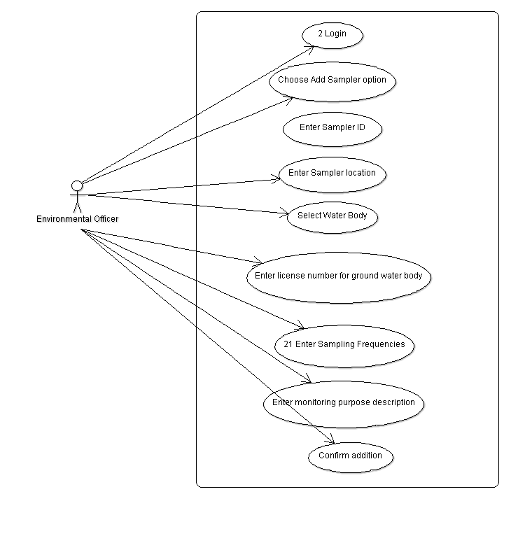

|  |  |
| --- | --- |
| **Use Case** | **Add Sampler** |
| Brief Description | An Environmental Officer (EO) adds a new Sampler Location to a Water Body. |
| Actors | Environmental Officer |
| Preconditions |  |
| Main Flow of Events | The EO logs in and chooses the Add New Sampler option. They enter a unique alphanumeric ID. They enter a location either as a latitude/longitude pair or as a kml file via the Google Earth user interface. They select the water body containing the Sampler, and enter the frequencies that water samples will be taken. If the sampler is for a ground water body, then a licence number is entered. They enter a monitoring purpose description. They then confirm the addition of a new Sampler. |
| Alternative Flow of Events | If any of the entered values are invalid, an error message will be displayed. |
| Post Conditions | New Sampler is added to the database. |

### Add Water Body

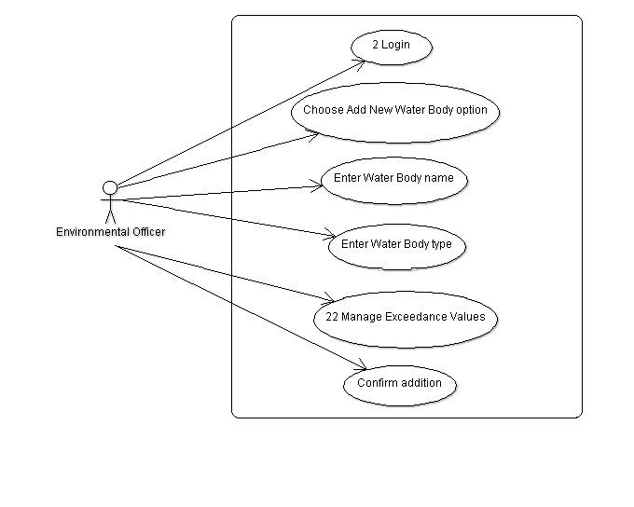

|  |  |
| --- | --- |
| **Use Case** | **Add Water Body** |
| Brief Description | An Environmental Officer (EO) adds a new Water Body. |
| Actors | Environmental Officer |
| Preconditions |  |
| Main Flow of Events | The EO logs in and chooses the Add New Water Body option. They enter a unique name and specify if its surface water (a creek or river) or ground water (an aquifer). They enter the exceedance limits for the parameters to be analysed. They then confirm the addition. |
| Alternative Flow of Events | If any of the entered values are invalid, an error message will be displayed and the Water Body will not be added until the errors are corrected. |
| Post Conditions | Water Body added to database. |

### Update Contractor

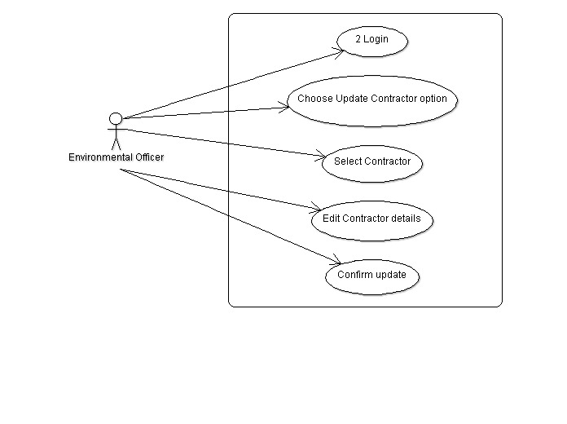

|  |  |
| --- | --- |
| **Use Case** | **Update Contractor** |
| Brief Description | The Environmental Officer can amend information about a Contractor. |
| Actors | Environmental Officer |
| Preconditions |  |
| Main Flow of Events | The EO logs on to the system and chooses the update Contractor option. They then select the Contractor that they wish to update. Any of the Contractor name, contact name, telephone number and email address may be amended. The EO then confirms the update and the database is updated. |
| Alternative Flow of Events | The EO can choose not to save their changes by not confirming the update. |
| Post Conditions | Changes are updated to the database. |

### Update Sampler

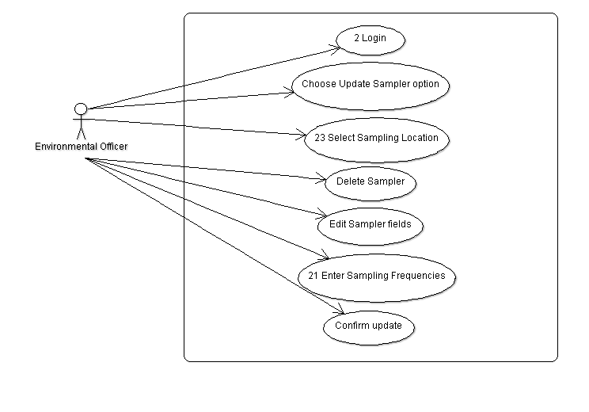

|  |  |
| --- | --- |
| **Use Case** | **Update Sampler** |
| Brief Description | An Environmental Officer (EO) updates Sampler information. |
| Actors | Environmental Officer |
| Preconditions |  |
| Main Flow of Events | The EO logs in and chooses the Update Sampler option. They then choose the Sampler they want to change. They can delete a Sampler providing that no Sample data has been added for that Sampler yet. The location can be changed either by entering a latitude/longitude pair or as a kml file via the Google Earth user interface. The ilcense number, sampling frequencies and monitoring purpose description may all be edited. The EO then confirms the update. |
| Alternative Flow of Events | If any of the entered values are invalid, an error message will be displayed. |
| Post Conditions | When a Sampler is deleted, it is removed entirely and does not show up on maps. All changes are reflected in the database. |

### Update Water Body

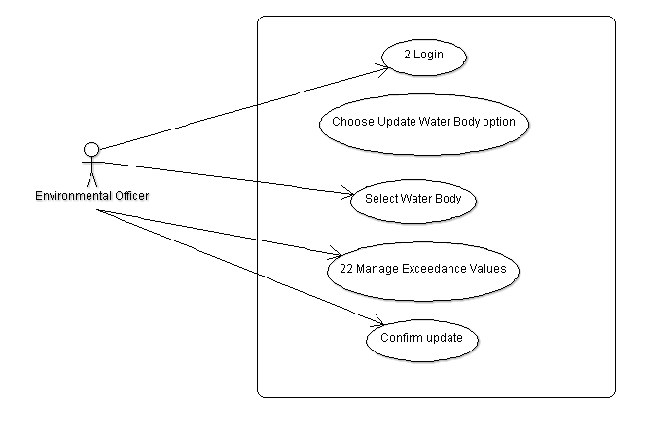

|  |  |
| --- | --- |
| **Use Case** | **Update Water Body** |
| Brief Description | An Environmental Officer (EO) updates Water Body details. |
| Actors | Environmental Officer |
| Preconditions |  |
| Main Flow of Events | The EO logs in and chooses the Update Water Body option. They select the water body they want to update. They edit the exceedance limits for the parameters to be analysed. They then confirm the update. |
| Alternative Flow of Events | If any of the entered values are invalid, an error message will be displayed and the Water Body will not be updated until the errors are corrected. |
| Post Conditions | Changes reflected in database. |

### Assign Sampler to Contractor

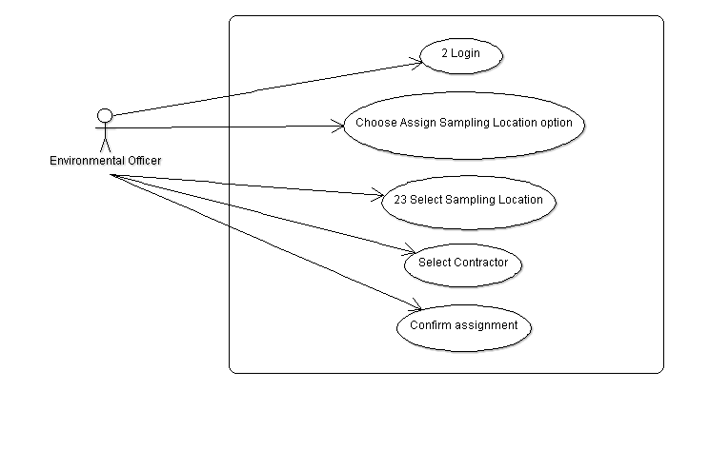

|  |  |
| --- | --- |
| **Use Case** | **Assign Sampler to Contractor** |
| Brief Description | Each Contractor is assigned a set of Samplers to monitor. Samplers are assigned by Environmental Officers (EO). |
| Actors | Environmental Officer |
| Preconditions |  |
| Main Flow of Events | The EO logs on to the system and chooses the Assign Sampler to Contractor option. They select a sampling location and then choose a Contractor to assign it to. They confirm the assignment and the database is updated. |
| Alternative Flow of Events | Sampler has been previously assigned to another Contractor. In this case, the assignment is removed from the old Contractor and given to the new. |
| Post Conditions | Assignment of Sampler to Contractor is reflected in the database. |

### Enter Sampling Frequencies

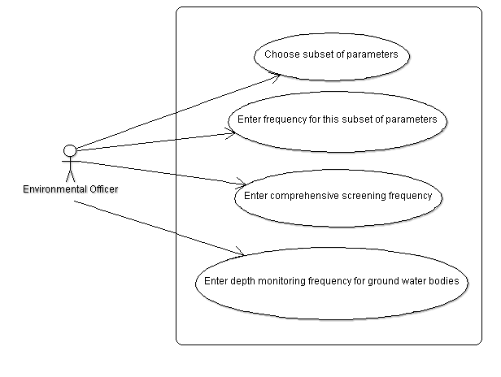

|  |  |
| --- | --- |
| **Use Case** | **Enter Sampling Frequencies** |
| Brief Description | This use case is part of the Add/Update Sampler use cases. |
| Actors | Environmental Officer (EO) |
| Preconditions | EO is adding or updating Sampler information. |
| Main Flow of Events | The EO selects a subset of parameters which may be tested at this location and enters the frequency at which these parameters will be screened. Frequency is one of daily, weekly, fortnightly, monthly, half yearly and yearly.  The EO enters a comprehensive screening frequency which is when all parameters will be screened. If Sampler is for a ground Water Body then a depth monitoring frequency is entered. |
| Alternative Flow of Events | All frequencies will be entered for a new Sampler, but any subset of frequencies may be amended. |
| Post Conditions | Database is updated with screening frequencies. |

### Manage Exceedance Values

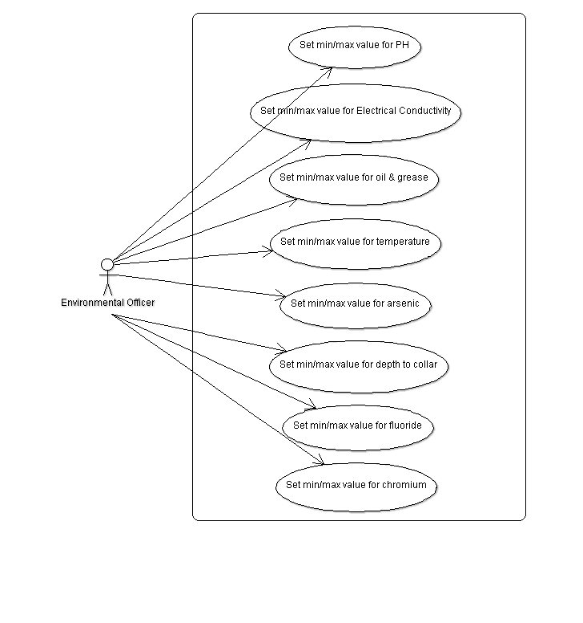

|  |  |
| --- | --- |
| **Use Case** | **Manage Exceedance Values** |
| Brief Description | This use case is part of the Add/Update Water Bodies use cases. |
| Actors | Environmental Officer (EO) |
| Preconditions | EO is adding or updating Water Body information. |
| Main Flow of Events | EO sets both a minimum and a maximum exceedance value for PH. EO sets both a minimum and a maximum exceedance value for electrical conductivity. EO sets both a minimum and a maximum exceedance value for temperature. EO sets both a minimum and a maximum exceedance value for arsenic. EO sets both a minimum and a maximum exceedance value for oil & grease. If the Water Body is ground water EO sets both a minimum and a maximum exceedance value for depth to collar. If the Water Body is surface water EO sets both a minimum and a maximum exceedance value for fluoride. If the Water Body is surface water EO sets both a minimum and a maximum exceedance value for chromium. |
| Alternative Flow of Events | All exceedance values will be entered for a new Water Body, but any subset of exceedances may be amended. |
| Post Conditions | Exceedance data is updated in the database. |

### Select Sampling Location

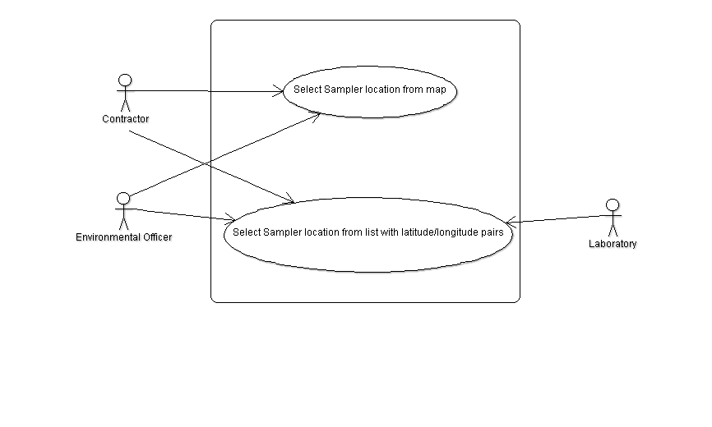

|  |  |
| --- | --- |
| **Use Case** | **Select Sampling Location** |
| Brief Description | In various places, the user can select a sampler. |
| Actors | Laboratory, Contractor, Environmental Officer |
| Preconditions | User needs to select Sampler. |
| Main Flow of Events | If the user is a Contractor or Environmental Officer then they can select a Sampler by clicking on its location on a map, or by selecting it from a list of Sampler locations. A Laboratory can only select from a list. A Laboratory and Contractor can only select from those Samplers that have been assigned to them. |
| Alternative Flow of Events | User cancels and doesn’t select anything. |
| Post Conditions | User selects Sampler. |

### Perform Screening Program

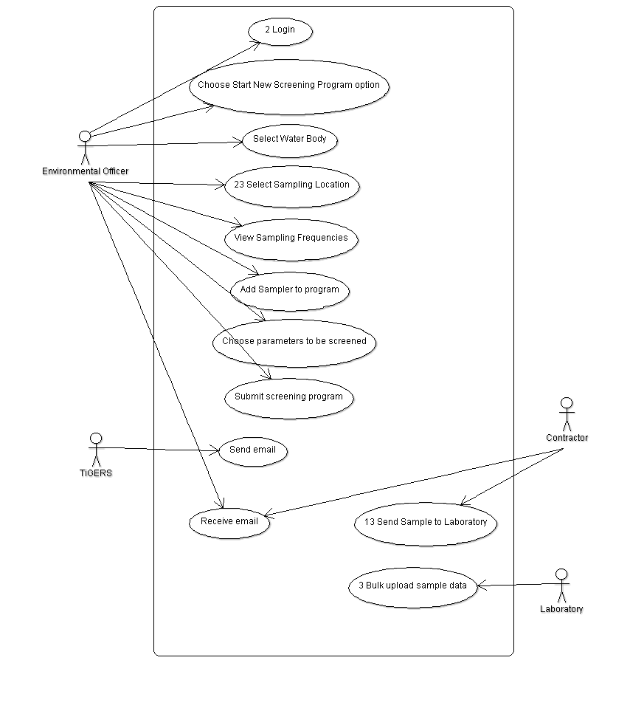

|  |  |
| --- | --- |
| **Use Case** | **Perform Screening Program** |
| Brief Description | Environmental Officer sets up a new screening program, Contractors take Samples and send them to Laboratories for analysis. Laboratories then load the results into the system. |
| Actors | Environmental Officer |
| Preconditions | A separate Screening Program is performed for each Water Body. |
| Main Flow of Events | The EO logs on to the system and chooses the Start New Screening Program option. They select a Water Body. They can then view the sampling locations on a map and select one. They then view the sampling frequencies. Any parameters which need sampling are then added to the program. This is repeated for all Samplers for the Water Body. The program is then submitted. An email is sent to the Contractors assigned to each Sampler, requesting them to take a Sample and listing which Parameters are to be analysed. The contractors take Samples and send them to the Laboratory assigned to each Sampler, along with Parameter details. The Contractor updates the system so that it knows a Sample has been sent. The Laboratories analyse the Samples and bulk upload the results. When all Samples have been analysed, an email is sent automatically to the EO, advising them that the Screening Program has been completed. |
| Alternative Flow of Events |  |
| Post Conditions | Sample results for all requested Samplers are added to the database. |

### Schedule of Sampling Frequencies

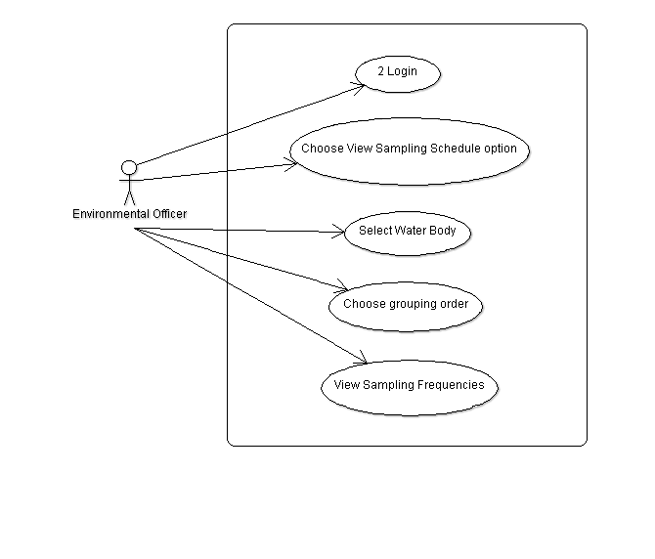

|  |  |
| --- | --- |
| **Use Case** | **Schedule of Sampling Frequencies** |
| Brief Description | Environmental Officer views sampling frequencies for a given water body. |
| Actors | Environmental Officer (EO) |
| Preconditions |  |
| Main Flow of Events | The EO logs on to the system and chooses the Schedule of Sampling Frequencies option. They select a Water Body and then choose to group the data either by Sampler/Frequency/Screening Parameter or by Sampler/Frequency/ Sampler/Screening Parameter. A list of screening frequencies is then displayed. |
| Alternative Flow of Events |  |
| Post Conditions |  |

### Create Environmental Audit Report

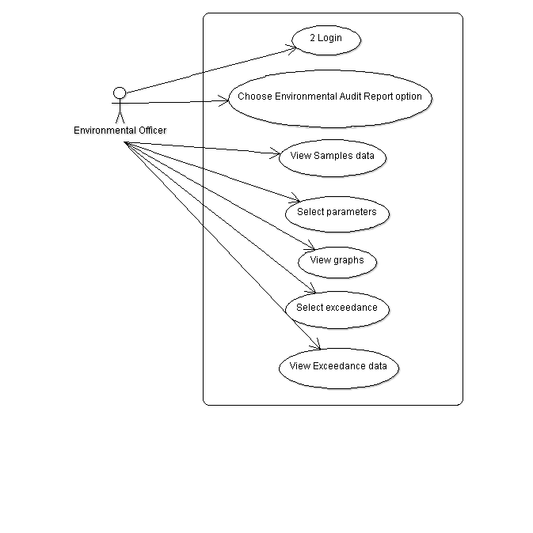

|  |  |
| --- | --- |
| **Use Case** | **Create Environmental Audit Report** |
| Brief Description | The Environmental Officer (EO) creates a report listing Samples data. |
| Actors | Environmental Officer |
| Preconditions |  |
| Main Flow of Events | The EO logs on to the system and chooses the Create Environmental Audit Report option. A report is generated containing a table of Samples records with all parameter values, grouped by Water Body and Sampler, sorted by date. The EO selects a Water Body and selects parameters analysed at that body. A graph is shown with these parameters and a horizontal line representing the exceedances applicable to each selected parameter. The EO selects an exceedance line and information about that exceedance is displayed (which parameter it applies to its value). Where a detection limit has been recorded, rather than an actual value, then this will be highlighted on the report. |
| Alternative Flow of Events |  |
| Post Conditions |  |

### Create Exceedance Report

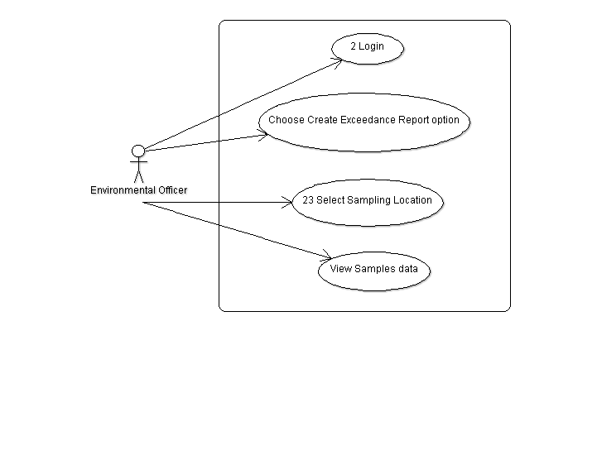

|  |  |
| --- | --- |
| **Use Case** | **Create Exceedance Report** |
| Brief Description | The Environmental Officer (EO) creates a report listing Samples records where an exceedance was recorded. |
| Actors | Environmental Officer |
| Preconditions |  |
| Main Flow of Events | The EO logs on to the system and chooses the Create Exceedance Report option. They select a Sampler location from a map. The report consists of a table showing only those Samples where an exceedance was recorded for a parameter. The records will be in date order (most recent first), and will contain date, parameter whose value was exceeded, the parameter value, the exceedance and the magnitude of exceedance. Where a detection limit has been recorded, rather than an actual value, then this will be highlighted on the report. |
| Alternative Flow of Events |  |
| Post Conditions |  |

### Add Environmental Officer

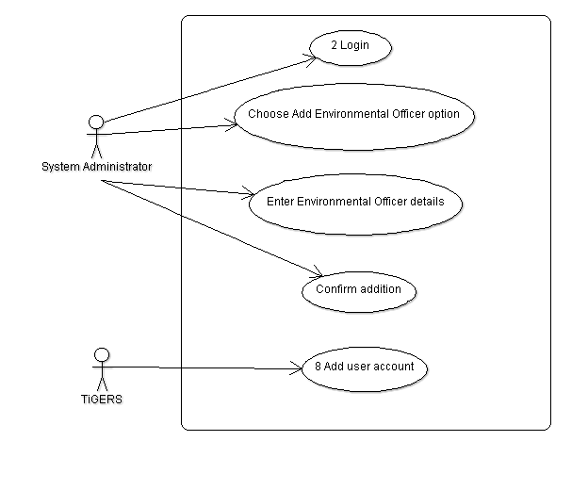

|  |  |
| --- | --- |
| **Use Case** | **Add Environmental Officer** |
| Brief Description | A System Administrator adds a new Environmental Officer into the system. |
| Actors | System Administrator |
| Preconditions |  |
| Main Flow of Events | The System Administrator logs on to the system and chooses the Add Environmental Officer option. The System Administrator then enters a name, contact name, telephone number and email. The System Administrator submits the data and a new user account is generated by the system. |
| Alternative Flow of Events | If any data entered is invalid then an error message is displayed and the new account is not added. |
| Post Conditions | A new user account is created for the Environmental Officer. |

### Add Contractor

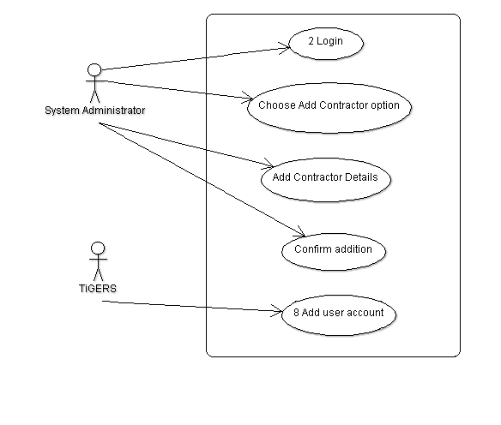

|  |  |
| --- | --- |
| **Use Case** | **Add Contractor** |
| Brief Description | A System Administrator adds a new Contractor into the system. |
| Actors | System Administrator |
| Preconditions | A Contractor has only one user account. |
| Main Flow of Events | The System Administrator logs on to the system and chooses the Add Contractor option. The System Administrator then enters a name, contact name, telephone number and email. The System Administrator submits the data and a new user account is generated by the system. |
| Alternative Flow of Events | If any data entered is invalid then an error message is displayed and the new account is not added. |
| Post Conditions | A new user account is created for the Contractor. |

### Manage User Account

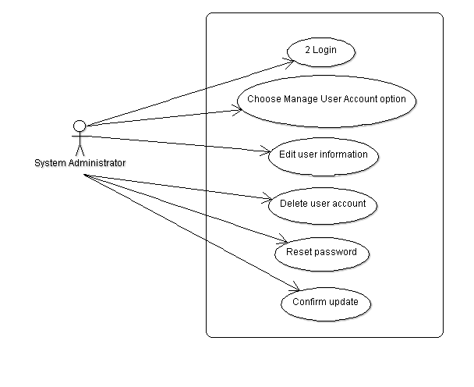

|  |  |
| --- | --- |
| **Use Case** | **Manage User Account** |
| Brief Description | System Administrator edits information associated with user accounts, deletes user accounts and resets passwords. |
| Actors | System Administrator |
| Preconditions |  |
| Main Flow of Events | The System Administrator logs on to the system and chooses the Add Manage Account option. The System Administrator amends any of name, contact name, telephone number and email. The System Administrator deletes an account. The System administrator can reset the password. The System Administrator confirms updates before any data is changed on the database. |
| Alternative Flow of Events | An account is removed entirely if there has been no activity on the system for that account. |
| Post Conditions | When account is deleted, only username and password fields are removed as user information needs to be kept for future reference. Any changes made are reflected in the database. |

### Create System Utilisation Report

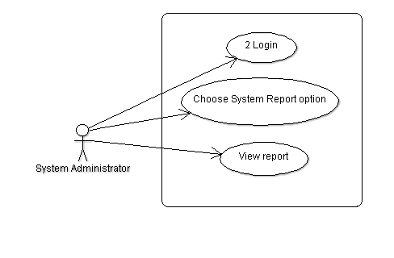

|  |  |
| --- | --- |
| **Use Case** | **Create System Utilisation Report** |
| Brief Description | The System Administrator can view a report listing all users of the System. |
| Actors | System Administrator |
| Preconditions |  |
| Main Flow of Events | The System Administrator logs on to the system and chooses the System Report option. The System Administrator then views a list of all user accounts grouped by user type (Environmental Officer first then Contractor then Laboratory). |
| Alternative Flow of Events |  |
| Post Conditions |  |

## Supplementary Specifications



### Initial Data Load

Samples data has previously been stored in spreadsheets. A one-off data load will take these spreadsheets as input and load them to the database. Several other spreadsheets will be developed. There is currently 20 years worth of historical data.

There will be several spreadsheets:

* Samples data in the format documented in the Business Requirements Specification with an extra field for the user name of the Laboratory which uploaded the data.
* Environmental Officer data which will contain name, telephone number and email address.
* Contractor data which will contain company name, contact name, telephone number and email address.
* Laboratory data which is in the same format as for Contractor.
* Water Body data which contains name, type and exceedance values (min & max).
* Sampler data which contains ID, location (both as a latitude/longitude pair and the name of any kml file, water body, sampling frequencies, monitoring purpose description and if the sampler is for a ground water body, a licence number.

Kml files will be created for Samplers if required.

### Help Manuals

There will be two manuals delivered with the final product:

* A System manual, including configuration and maintenance information.
* A User Manual for environmental officers, in hard-copy and online versions.

The online User Manual should be visible only to users of Environmental Officer accounts.

The online version of the User Manual will be based on the printed versions and adapted for online media delivery. The Online Help will provide suitable navigation mechanisms to allow browsing by hierarchical categories.

### Security

Data will be transferred across the internet using SSL encryption. Only authorised users will have access to the system.

# Appendix

## Glossary

This section provides the definition of all terms required to properly interpret this document. It contains some terms that have a special meaning in this project.

|  |  |
| --- | --- |
| Term | Definition |
| Map | A visual representation of the mine site in form of an aerial photo. |
| Sampler | A generic term for an observation station that is set up at a specific sampling location to allow samples to be taken. |
| Sampling location | A geographical position at the Tiffany Gold Mine defined by a latitude/longitude pair and represented by a marker on a map at which a water sample is taken at a prescribed frequency. Samples can be taken above ground (creek, domestic water tank) and below ground (bore). |
| (Environmental) parameter | An numerical description of an observed property of the environment such as pH or EC. |
| (Screening) frequency | The period of time between sampling events which may vary from sampler to sampler and from parameter to parameter. Frequencies are divided into *screening frequency* (only some parameters are analysed) and *comprehensive screening frequency* (all parameters are analysed). The latter always occurs less often. |
| Screening program | An activity in which many pre-defined sampling locations are visited to retrieve samples that have to be analysed for a set of parameters at that time. |
| Sampling date | Date at which a water sample is taken for later analysis in a laboratory. |
| EC | Electrical conductivity measured in micro Siemens per centimetre (μS/cm), one of the many environmental parameters measured in a water sample indicative of salinity. |
| .kml | KML is a file format used to display geographic data in an Earth browser such as Google Earth, Google Maps |

## Sample Reports

|  |  |  |  |  |  |  |  |  |
| --- | --- | --- | --- | --- | --- | --- | --- | --- |
| Tiffany Gold Mine Environmental Reporting System | | | | | | | | |
| Environmental Exceedance Summary Report | | | | | | |  |  |
|  |  |  |  |  |  |  |  |  |
| **Selected Water Body** | | | Mt Tiffany Lake | |  |  |  |  |
| **Reporting Period** | |  | 01/09/1989 to 12/09/1989 | | |  |  |  |
| |  | | --- | |  | |  |  |  |  |  |  |  |  |
|  |  |  |  |  |  |  |  |  |
|  |  |  |  |  |  |  |  |  |
|  |  |  |  |  |  |  |  |  |
|  |  |  |  |  |  |  |  |  |
|  |  |  |  |  |  |  |  |  |
|  |  |  |  |  |  |  |  |  |
|  |  |  |  |  |  |  |  |  |
|  |  |  |  |  |  |  |  |  |
|  |  |  |  |  |  |  |  |  |
|  |  |  |  |  |  |  |  |  |
|  |  |  |  |  |  |  |  |  |
|  |  |  |  |  |  |  |  |  |
|  |  |  |  |  |  |  |  |  |
|  |  |  |  |  |  |  |  |  |
|  |  |  |  |  |  |  |  |  |
| |  | | --- | |  | |  |  |  |  |  |  |  |  |
|  |  |  |  |  |  |  |  |  |
|  |  |  |  |  |  |  |  |  |
|  |  |  |  |  |  |  |  |  |
|  |  |  |  |  |  |  |  |  |
|  |  |  |  |  |  |  |  |  |
|  |  |  |  |  |  |  |  |  |
|  |  |  |  |  |  |  |  |  |
|  |  |  |  |  |  |  |  |  |
|  |  |  |  |  |  |  |  |  |
|  |  |  |  |  |  |  |  |  |
|  |  |  |  |  |  |  |  |  |
|  |  |  |  |  |  |  |  |  |
|  |  |  |  |  |  |  |  |  |
|  |  |  |  |  |  |  |  |  |

|  |  |  |  |  |  |  |  |  |  |
| --- | --- | --- | --- | --- | --- | --- | --- | --- | --- |
| Tiffany Gold Mine Environmental Reporting System | | | | | | | |  |  |
| Environmental Exceedance Report | | | |  |  |  |  |  |  |
|  |  |  |  |  |  |  |  |  |  |
| **Selected Water Body** | |  | Mt Tiffany Lake | |  |  |  |  |  |
| **Reporting Period** | |  | 01/09/1989 to 12/09/1989 | | |  |  |  |  |
|  |  |  |  |  |  |  |  |  |  |
|  | **Exceedance Thresholds** | |  |  |  |  |  |  |  |
|  | **Parameter** | **Minimum** | **Maximum** |  |  |  |  |  |  |
|  | pH | 4.5 | 7 |  |  |  |  |  |  |
|  | EC [uS/cm] | 500 | 870 |  |  |  |  |  |  |
|  | Temperature [C] | 20 | 27 |  |  |  |  |  |  |
|  | DTC [m] | 120 | 289 |  |  |  |  |  |  |
|  | As [mg/L] | 0 | 0.005 |  |  |  |  |  |  |
|  | Oil and Grease [ppm] | 2 | 11 |  |  |  |  |  |  |
|  |  |  |  |  |  |  |  |  |  |
|  |  |  |  |  |  |  |  |  |  |
| Sampling Point A | |  |  |  |  | Exceedance Summary |  |  |  |
| **Date** | **Parameter** | **Value** | **Exceedance Magnitude** | | | **Parameter** | **No. Exceedances** | |  |
| 2/09/1989 | EC [uS/cm] | 880 | 10 |  |  | pH | 0 |  |  |
| 3/09/1989 | Oil and Grease [ppm] | 68 | 57 |  |  | EC | 3 |  |  |
| 4/09/1989 | EC [uS/cm] | 470 | 30 |  |  | Temperature | 1 |  |  |
| 7/09/1989 | DTC [m] | 290 | 1 |  |  | DTC | 1 |  |  |
| 12/09/1989 | EC [uS/cm] | 896 | 26 |  |  | As | 0 |  |  |
|  | Temperature [C] | 27.4 | 0.4 |  |  | Oil and Grease | 1 |  |  |
|  |  |  |  |  |  | **Total** | **6** |  |  |
|  |  |  |  |  |  |  |  |  |  |
| Sampling Point B | |  |  |  |  | Exceedance Summary |  |  |  |
| **Date** | **Parameter** | **Value** | **Exceedance Magnitude** | | | **Parameter** | **No. Exceedances** | |  |
| 5/09/1989 | EC [uS/cm] | 884 | 14 |  |  | pH | 4 |  |  |
|  | Temperature [C] | 27.1 | 0.1 |  |  | EC | 2 |  |  |
| 7/09/1989 | pH | 7.57 | 0.07 |  |  | Temperature | 2 |  |  |
|  | As [mg/L] | 0.006 | 0.001 |  |  | DTC | 1 |  |  |
| 8/09/1989 | pH | 7.94 | 0.44 |  |  | As | 1 |  |  |
|  | Temperature [C] | 27.4 | 0.4 |  |  | Oil and Grease | 1 |  |  |
| 10/09/1989 | DTC [m] | 116 | 4 |  |  | **Total** | **11** |  |  |
| 11/09/1989 | pH | 7.93 | 0.43 |  |  |  |  |  |  |
|  | Oil and Grease [ppm] | 12 | 1 |  |  |  |  |  |  |
| 12/09/1989 | pH | 7.8 | 0.3 |  |  |  |  |  |  |
|  | EC [uS/cm] | 976 | 106 |  |  |  |  |  |  |

|  |  |  |  |  |  |  |  |  |
| --- | --- | --- | --- | --- | --- | --- | --- | --- |
| Tiffany Gold Mine Environmental Reporting System | | | | | | | | |
| Environmental Exceedance Summary Report | | | | | | |  |  |
|  |  |  |  |  |  |  |  |  |
| **Selected Water Body** | | | Mt Tiffany Lake | |  |  |  |  |
| **Reporting Period** | |  | 01/09/1989 to 12/09/1989 | | |  |  |  |
| |  | | --- | |  | |  |  |  |  |  |  |  |  |
|  |  |  |  |  |  |  |  |  |
|  |  |  |  |  |  |  |  |  |
|  |  |  |  |  |  |  |  |  |
|  |  |  |  |  |  |  |  |  |
|  |  |  |  |  |  |  |  |  |
|  |  |  |  |  |  |  |  |  |
|  |  |  |  |  |  |  |  |  |
|  |  |  |  |  |  |  |  |  |
|  |  |  |  |  |  |  |  |  |
|  |  |  |  |  |  |  |  |  |
|  |  |  |  |  |  |  |  |  |
|  |  |  |  |  |  |  |  |  |
|  |  |  |  |  |  |  |  |  |
|  |  |  |  |  |  |  |  |  |
|  |  |  |  |  |  |  |  |  |
| |  | | --- | |  | |  |  |  |  |  |  |  |  |
|  |  |  |  |  |  |  |  |  |
|  |  |  |  |  |  |  |  |  |
|  |  |  |  |  |  |  |  |  |
|  |  |  |  |  |  |  |  |  |
|  |  |  |  |  |  |  |  |  |
|  |  |  |  |  |  |  |  |  |
|  |  |  |  |  |  |  |  |  |
|  |  |  |  |  |  |  |  |  |
|  |  |  |  |  |  |  |  |  |
|  |  |  |  |  |  |  |  |  |
|  |  |  |  |  |  |  |  |  |
|  |  |  |  |  |  |  |  |  |
|  |  |  |  |  |  |  |  |  |
|  |  |  |  |  |  |  |  |  |
|  |  |  |  |  |  |  |  |  |