LAB Manual

PART A

(PART A : TO BE REFFERED BY STUDENTS)

**Experiment No.02**

**A.1 Aim:**

**Implementation of Point Processing image enhancement Operations in Spatial Domain.**

**A.2 Prerequisite:**

1 MATLAB programming syntax (Refer the MATLAB manual).

2.Knowledge of point processing operations.

3. Availability of Soft copy of your Photograph for experiment.

**A.3 Outcome:**

**After successful completion of this experiment students will be able to**

1. Implement following point processing image enhancement operations.

a. Negation of an image

b. Thresholding of an image

c. Contrast Stretching of an image

d. Gray level Slicing

e. Bit Plane slicing.

1. Understand the effect of point processing operations on an Image.
2. Identify the real-life application of point processing techniques implemented.

**A.4 Theory:**

1. ***Negation of an image***

The negative of an image with gray levels in the range [ 0, L-1] is obtained by using the negative transformation given by the expression

S= L – 1 – r …… Equation (1)

This is according to the transformation S = T ( r ) In above transformation ( 1 ) , the intensity of the output image decreases as the intensity of the input increases. The type of processing is particularly suited for enhancing white or gray detail embedded in dark regions of an image especially when black areas are dominants in site.



**Figure 1: The concept of image negation**

1. ***Thresholding of an Image***

**Theory:**

Thresholding is a simple process to separate the interested object from the background. It gives the binary image. The formula for achieving thresholding is as follows

s = 0; if r <= t ……Equation (2)

s = L-1; if r > t



**Figure 2: The concept of image thresholding**

1. ***Contrast Stretching of an Image***

***Theory:***

Low contrast images can result from poor illumination, lack of dynamic range in the imaging sensor etc. The idea behind contrast stretching is to increase the dynamic range of the gray levels in the image being processed. The transformation function for contrast stretching is given by

….Equation (3)

Where: f(x, y) is the Piecewise Linear Contrast Stretch in the image, a, b, and c are appropriate constants, which are the slopes in the respective regions and B is the maximum intensity value.



**Figure 3: The concept of Contrast stretching**

The location of the points (r1 , s1) & (r2 , s2) control the shape of the transformation function.

1. **Gray Level Slicing ( Intensity Level Slicing) :**

**Theory:**

Highlighting a specific range of gray-levels in an image is often desired. Applications include enhancing features such as masses of water, crop regions, or certain elevation area in satellite imagery. Another application is enhancing flaws in x-ray. There are two main different approaches:

•        highlight a range of intensities while diminishing all others to a constant low level.

•        highlight a range of intensities but preserve all others.

The fig. illustrates the intensity level slicing process. The left figures show a transformation function that highlights a range [A,B] while diminishing all the others. The right figures highlights a range [A,B] but preserves all the others.

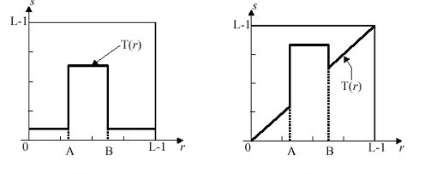

**Figure 4: The concept of Gray level slicing with and without background**

The formulation for grey level slicing without background is

S = L-1 ; if A ≤ r ≤ B … Equation (4)

S = 0; Otherwise

The formulation for grey level slicing with background is

S = L-1 ; if A ≤ r ≤ B ….Equation (5)

S = r; Otherwise

1. **Bit Plane Slicing:**

**Theory:**

Bit plane slicing is new way of looking at an image. In bit plane slicing the image is considered to be a stack of binary images. The images closes to the bottom are least significant and the images on top are most significant. Instead of highlighting intensity ranges, highlighting the contribution made to the total image appearance by specific bit might be desired. Imagine that the image is composed of eight 1-bit planes, ranging from plane 0 for least significant bit to plane 7 for the most significant bit.

|  |
| --- |
| http://bme.med.upatras.gr/improc/bit_plane_slicing1.jpg |
| **Figure 5. A model of the  bit-planes** |

**A.5 Procedure/Algorithm:**

**A.5.1 TASK 1:**

**Negation of an image**

1. Read i/p image

2. Read maximum gray level pixel of i/p image

3. Replace input image by ( maximum – i/p ) = o/p

4. Display o/p image

5. Observe the output and complete PART B of lab manual.

6. Save and close the file and name it as **EXP2_Task1_your Roll no.m**

**A.5.2 TASK 2:**

***Thresholding of an Image***

1. Read input image

2. Enter thresholding value t

3. If image pixel is less than t replace it by zero.

4. If image pixel is > t replace it by 255

5. Display input image

6. Display threshold image

7. Display input image

8. Display threshold image

9. Observe the output and complete PART B of lab manual.

10. Save and close the file and name it as **EXP2_Task2_your Roll no.m**

**A.5.3 TASK 3:**

***Contrast Stretching of an Image***

1. Read input image

2. Enter values r1,r2,s1,s2

3. Calculate alpha, beta and gamma slopes.

4. if input pixel value is <= r1 then o/p = alpha x input

5. If input pixel is > r1and <=r2 then o/p = beta x (r-r1)+s1

6. otherwise o/p = gamma x (r-r2)+s2

7. Display i/p image

8. Display o/p image.

9. Observe the output and complete PART B of lab manual.

10. Save and close the file and name it as **EXP2_Task3_your Roll no.m**

**A.5.4 TASK 4:**

**Gray Level Slicing ( Intensity Level Slicing)**

1. Read input image

2. Enter values A, B.

3. Use the appropriate formula for without background and with background.

4. Find the output image for without background and with background.

5. Display i/p image

6. Display o/p images.

7. Observe the output and complete PART B of lab manual.

8. Save and close the file and name it as **EXP2_Task4_your Roll no.m**

**A.5.5 TASK 5:**

**Bit Plane Slicing**

1. Read input image.

2. For bit value from 1 to 8, find corresponding image planes.

3. Display i/p image

4. Display all 8 o/p image planes separately

5. Observe the output and complete PART B of lab manual.

6. Save and close the file and name it as **EXP2_Task5_your Roll no.m**

**********************

PART B

(PART B : TO BE COMPLETED BY STUDENTS)

***(Students must submit the soft copy as per following segments within two hours of the practical. The soft copy must be uploaded on the Blackboard or emailed to the concerned lab in charge faculties at the end of the practical in case the there is no Black board access available)***

|  |  |
| --- | --- |
| **Roll No.:** N230 | **Name:** Rishul Ghosh |
| **Class :** MBA Tech CS Div. B | **Batch :** B |
| **Date of Experiment:** 4-8-21 | **Date of Submission:** 4-8-21 |
| **Grade :** |  |

**B.1 Software Code written by student:**

**TASK-1:**

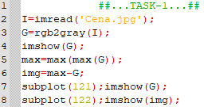

**TASK-2:**

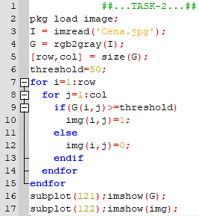

**TASK-3:**

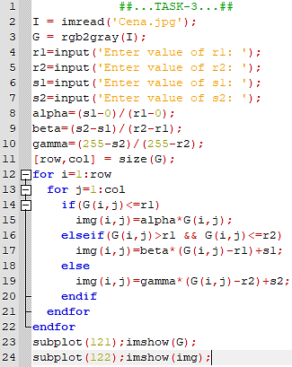

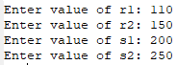

**TASK-4:**

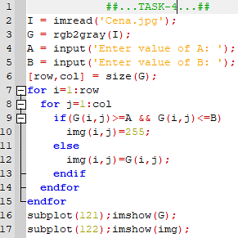



**TASK-5:**

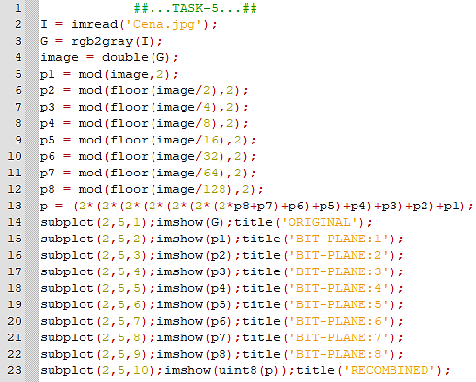

**B.2 Input and Output:**

**Input Images:**



**Output:**

**TASK-1:**

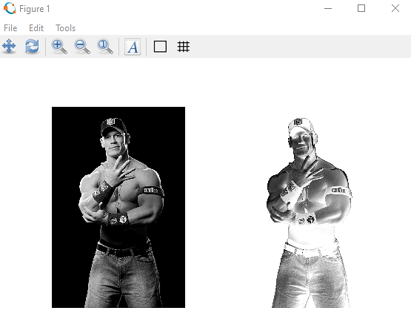

**TASK-2:**

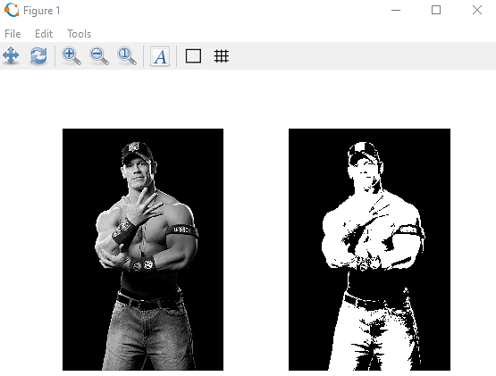

**TASK-3:**

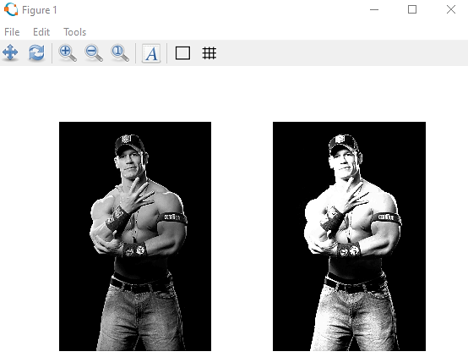

**TASK-4:**

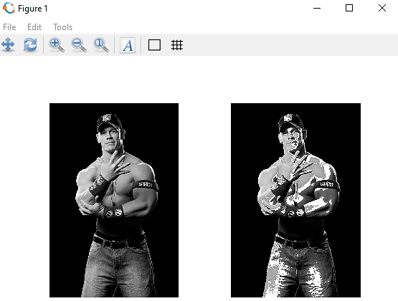

**TASK-5:**

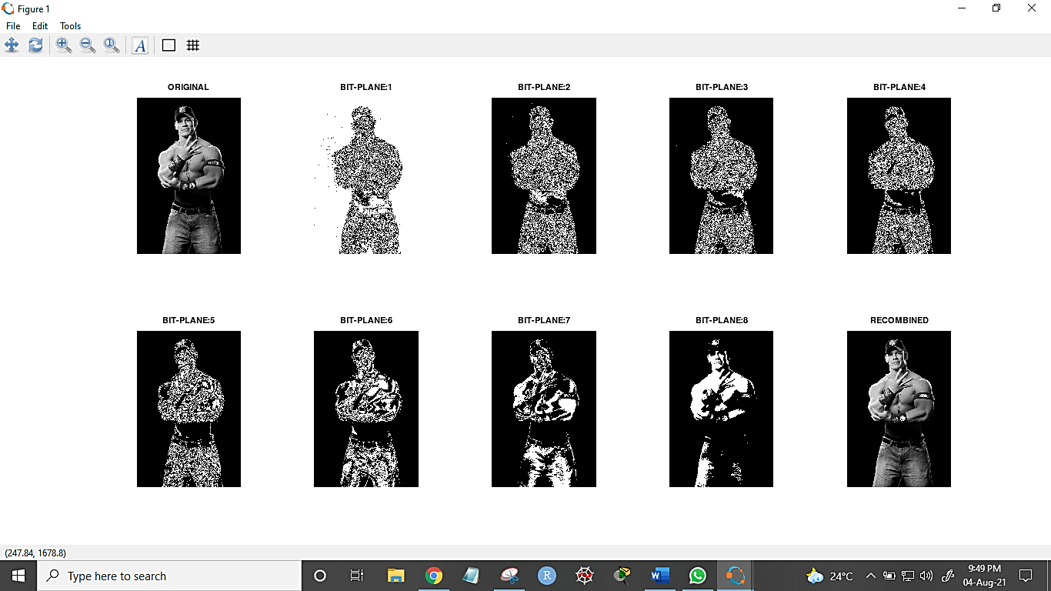

**B.3 Observations and learning:**

From the above experiment, we observed and learned various MATLAB functions of image processing. We were introduced to negation, contrast stretching, grey level slicing, bit level slicing and thresholding of image.

**B.4 Conclusion:**

Thus, the aim of implementation of Point Processing image enhancement Operations in Spatial Domain is completed.

**B.5 Question of Curiosity**

***Application of image enhancement in real life.***

The aim of image enhancement is to improve the interpretability or perception of information in images for human viewers, or to provide `better' input for other automated image processing techniques. Frequency domain methods, which operate on the Fourier transform of an image.

Image enhancement techniques are used to emphasize and sharpen image features such as to obtain a visually more pleasant, more detailed, or less noisy output image.

Some of the important applications of image processing in the field of science and technology include computer vision, remote sensing, feature extraction, face detection, forecasting, optical character recognition, finger-print detection, optical sorting, argument reality, microscope imaging, lane departure caution.

************************