LAB Manual

PART A

(PART A : TO BE REFFERED BY STUDENTS)

**Experiment No. 03**

**A.1 Aim:**

**Implementing image enhancement using Histogram techniques**

1. **Finding histogram of an image**
2. **Histogram Stretching**

**c. Histogram equalization**

**A.2 Prerequisite:**

1 MATLAB programming syntax (Refer the MATLAB manual).

2.Knowledge of histogram processing operations.

3. Availability of Soft copy of your Photograph for experiment.

**A.3 Outcome:**

**After successful completion of this experiment students will be able to**

Compute and analyze effects of various image transformation techniques of spatial domain.

**A.4 Theory:**

An image histogram is a type of histogram that acts as a graphical representation of the tonal distribution in a digital image. It plots the number of pixels for each tonal value. By looking at the histogram for a specific image a viewer will be able to judge the entire tonal distribution at a glance.

Image histograms are present on many modern digital cameras. Photographers can use them as an aid to show the distribution of tones captured, and whether image detail has been lost to blown-out highlights or blacked-out shadows. This is less useful when using a raw image format, as the dynamic range of the displayed image may only be an approximation to that in the raw file.

The horizontal axis of the graph represents the tonal variations, while the vertical axis represents the number of pixels in that particular tone. The left side of the horizontal axis represents the black and dark areas, the middle represents medium grey and the right hand side represents light and pure white areas. The vertical axis represents the size of the area that is captured in each one of these zones. Thus, the histogram for a very dark image will have the majority of its data points on the left side and center of the graph. Conversely, the histogram for a very bright image with few dark areas and/or shadows will have most of its data points on the right side and center of the graph.

**A.5 Procedure/Algorithm:**

**Histogram Plotting:**

1. Read grey scale image in one variable
2. Change datatype to double
3. Extract the values of rows & columns
4. Declare array to store Histogram Value
5. Make all zero intensity to one
6. Plot Histogram of image
7. Take the values of pixel
8. Incrementing the corresponding counter.

**Histogram Equalization**

1. Declare another array to store Histogram of equalized image
2. Calculate PDF of input Image
3. Calculate CDF
4. Obtain new levels for output image
5. Obtain the equalized image
6. Plot Histogram of output image
7. Display result

PART B

(PART B : TO BE COMPLETED BY STUDENTS)

***(Students must submit the soft copy as per following segments within two hours of the practical. The soft copy must be uploaded on the web portal or emailed to the concerned lab in charge faculties at the end of the practical in case the there is no Wb portal access available)***

|  |  |
| --- | --- |
| **Roll No.:** N230 | **Name:** Rishul Ghosh |
| **Class :** MBA Tech CS 3rd year | **Batch :** Div. B Batch A |
| **Date of Experiment:** 11/8/21 | **Date of Submission:** 11/8/21 |
| **Grade** : |  |

**B.1 Software Code written by student:**

**TASK-1:**

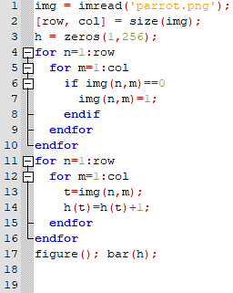

**HISTOGRAM STRETCHING:**

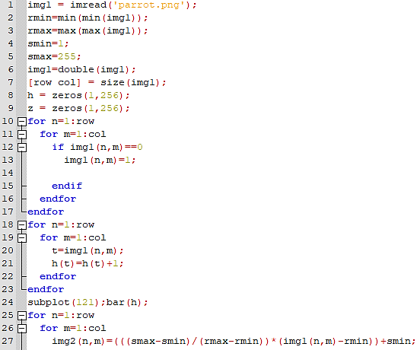

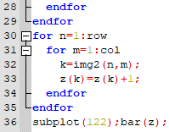

**TASK-2:**

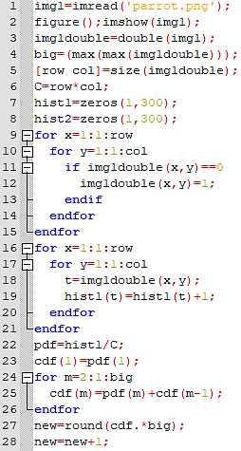

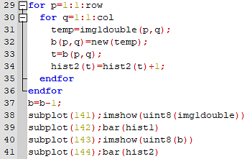

**B.2 Input and Output:**

**Input Images: Your photographs**

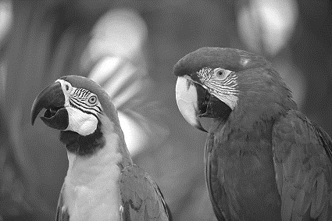

**Output:**

**TASK-1:**

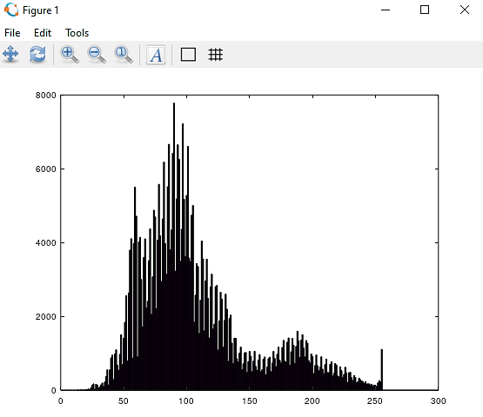

**HISTOGRAM STRETCHING:**

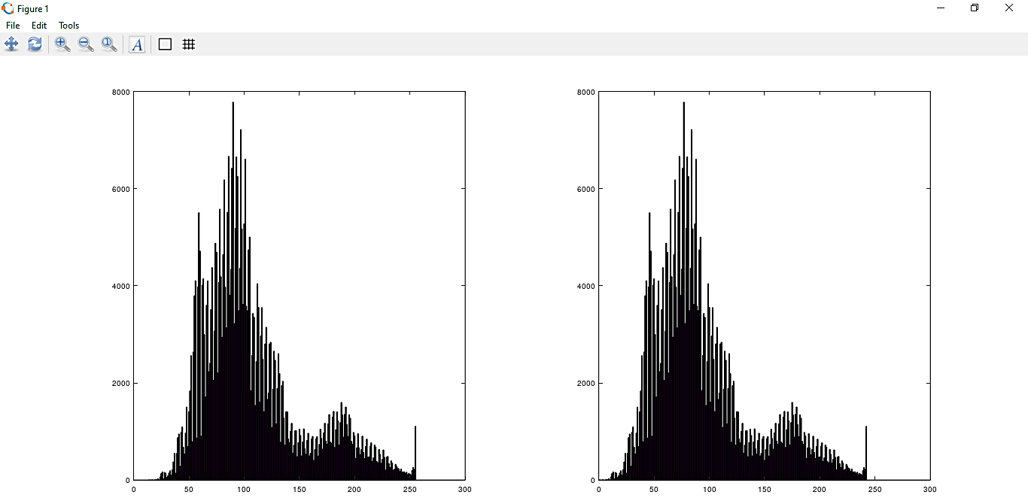

**TASK-2**

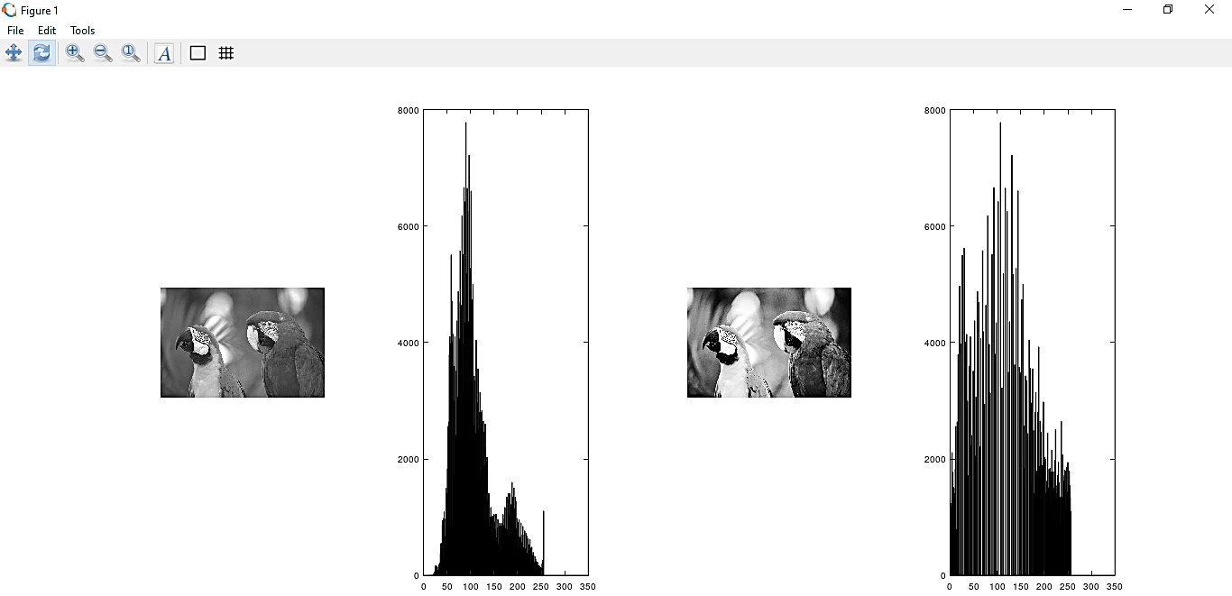

**B.3 Observations and learning:**

From the above experiment, we observed and learned operations on an image via histogram techniques. We learned to plot a histogram of image, and also performed various other methods of it like equalization and stretching.

**B.4 Conclusion:**

Thus, the aim of implementing image enhancement using Histogram techniques is completed.

**B.5 Question of Curiosity**

What is the logic of histogram equalization?

Histogram Equalization is a computer image processing technique used to improve contrast in images. It accomplishes this by effectively spreading out the most frequent intensity values, i.e. stretching out the intensity range of the image. This method usually increases the global contrast of images when its usable data is represented by close contrast values. This allows for areas of lower local contrast to gain a higher contrast.

An example given below: -



